Министерство образования Республики Беларусь Учреждение образования
«БЕЛОРУССКИЙ ГОСУДАРСТВЕННЫЙ УНИВЕРСИТЕТ ИНФОРМАТИКИ И РАДИОЭЛЕКТРОНИКИ»
Кафедра электронных вычислительных машин

ОТЧЕТ
О ЛАБОРАТОРНОЙ РАБОТЕ № 4
Error logging/handling
по дисциплине «Программирование на языках высокого уровня»

Выполнил ст. гр. 450502 Е.Ю. Новицкий
Проверил асс. каф. ЭВМ И.Г. Скиба

Минск 2026

1 ПОСТАНОВКА ЗАДАЧИ

1 Реализовать глобальную обработку ошибок через @ControllerAdvice.
2 Добавить валидацию входных данных через @Valid.
3 Реализовать единый формат ошибки для всех endpoint.
4 Настроить логирование через logback:
- уровни логирования
- ротация логов
5 Реализовать аспект (AOP) для логирования времени выполнения сервисных методов.
6 Подключить Swagger/OpenAPI с описанием endpoint и DTO.
2 СТРУКТУРА ПРОЕКТА

finance-tracker
├── pom.xml
├── src
│ ├── main
│ │ ├── java
│ │ │ └── com/finance/tracker
│ │ │ ├── FinanceTrackerApplication.java
│ │ │ ├── aop
│ │ │ │ └── ServiceLoggingAspect.java
│ │ │ ├── cache
│ │ │ │ ├── TransactionSearchCacheKey.java
│ │ │ │ ├── TransactionSearchIndex.java
│ │ │ │ └── TransactionSearchIndexInvalidator.java
│ │ │ ├── config
│ │ │ │ └── OpenApiConfig.java
│ │ │ ├── controller
│ │ │ │ ├── AccountController.java
│ │ │ │ ├── BudgetController.java
│ │ │ │ ├── CategoryController.java
│ │ │ │ ├── TransactionController.java
│ │ │ │ ├── UserController.java
│ │ │ │ └── api
│ │ │ │ ├── AccountControllerApi.java
│ │ │ │ ├── BudgetControllerApi.java
│ │ │ │ ├── CategoryControllerApi.java
│ │ │ │ ├── TransactionControllerApi.java
│ │ │ │ └── UserControllerApi.java
│ │ │ ├── domain
│ │ │ │ ├── Account.java
│ │ │ │ ├── AccountType.java
│ │ │ │ ├── Budget.java
│ │ │ │ ├── Category.java
│ │ │ │ ├── Transaction.java
│ │ │ │ ├── TransactionType.java
│ │ │ │ └── User.java
│ │ │ ├── dto
│ │ │ │ ├── request
│ │ │ │ │ ├── AccountRequest.java
│ │ │ │ │ ├── AccountUpdateRequest.java
│ │ │ │ │ ├── BudgetRequest.java
│ │ │ │ │ ├── BudgetUpdateRequest.java
│ │ │ │ │ ├── CategoryRequest.java
│ │ │ │ │ ├── CategoryUpdateRequest.java
│ │ │ │ │ ├── TransactionRequest.java
│ │ │ │ │ ├── TransactionSearchQueryMode.java
│ │ │ │ │ ├── TransactionSearchRequest.java
│ │ │ │ │ ├── TransactionUpdateRequest.java
│ │ │ │ │ ├── TransferDemoRequest.java
│ │ │ │ │ ├── UserRequest.java
│ │ │ │ │ ├── UserUpdateRequest.java
│ │ │ │ │ └── UserWithAccountsAndBudgetsCreateRequest.java
│ │ │ │ └── response
│ │ │ │ ├── AccountResponse.java
│ │ │ │ ├── BudgetResponse.java
│ │ │ │ ├── CategoryResponse.java
│ │ │ │ ├── PageMetadataResponse.java
│ │ │ │ ├── TransactionResponse.java
│ │ │ │ ├── TransactionSearchPageResponse.java
│ │ │ │ ├── TransactionSearchResult.java
│ │ │ │ ├── TransactionSearchSource.java
│ │ │ │ ├── TransferDemoResponse.java
│ │ │ │ └── UserResponse.java
│ │ │ ├── exception
│ │ │ │ ├── ApiException.java
│ │ │ │ ├── ApiErrorField.java
│ │ │ │ ├── ApiErrorResponse.java
│ │ │ │ ├── BadRequestException.java
│ │ │ │ ├── ConflictException.java
│ │ │ │ ├── DuplicateResourceException.java
│ │ │ │ ├── GlobalExceptionHandler.java
│ │ │ │ ├── LoggingException.java
│ │ │ │ └── ResourceNotFoundException.java
│ │ │ ├── mapper
│ │ │ │ ├── AccountMapper.java
│ │ │ │ ├── BudgetMapper.java
│ │ │ │ ├── CategoryMapper.java
│ │ │ │ ├── TransactionMapper.java
│ │ │ │ └── UserMapper.java
│ │ │ ├── repository
│ │ │ │ ├── AccountRepository.java
│ │ │ │ ├── BudgetRepository.java
│ │ │ │ ├── CategoryRepository.java
│ │ │ │ ├── TransactionRepository.java
│ │ │ │ └── UserRepository.java
│ │ │ └── service
│ │ │ ├── AccountService.java
│ │ │ ├── BudgetService.java
│ │ │ ├── CategoryService.java
│ │ │ ├── TransactionService.java
│ │ │ ├── UserService.java
│ │ │ └── impl
│ │ │ ├── AccountServiceImpl.java
│ │ │ ├── BudgetServiceImpl.java
│ │ │ ├── CategoryServiceImpl.java
│ │ │ ├── TransactionServiceImpl.java
│ │ │ └── UserServiceImpl.java
│ │ └── resources
│ │ ├── application.properties
│ │ ├── logback-spring.xml
│ │
└── README.md

3 ЛИСТИНГ КОДА

Файл ServiceLoggingAspect.java

package com.finance.tracker.aop;

import lombok.extern.slf4j.Slf4j;
import org.aspectj.lang.ProceedingJoinPoint;
import org.aspectj.lang.annotation.Around;
import org.aspectj.lang.annotation.Aspect;
import org.springframework.stereotype.Component;

@Aspect
@Component
@Slf4j
public class ServiceLoggingAspect {

@Around("within(com.finance.tracker.service.impl..*)")
public Object logExecutionTime(ProceedingJoinPoint joinPoint) throws Throwable {
long startTime = System.nanoTime();
String method = joinPoint.getSignature().toShortString();

try {
Object result = joinPoint.proceed();
long executionTimeMs = (System.nanoTime() - startTime) / 1_000_000;
log.info("Service method {} completed in {} ms", method, executionTimeMs);
return result;
} catch (Throwable exception) {
long executionTimeMs = (System.nanoTime() - startTime) / 1_000_000;
log.warn(
"Service method {} failed in {} ms: {}",
method,
executionTimeMs,
exception.getMessage());
throw exception;
}
}
}
Файл AccountControllerApi.java

package com.finance.tracker.controller.api;

import com.finance.tracker.dto.request.AccountRequest;
import com.finance.tracker.dto.request.TransferDemoRequest;
import com.finance.tracker.dto.response.AccountResponse;
import com.finance.tracker.dto.response.TransferDemoResponse;
import io.swagger.v3.oas.annotations.Operation;
import io.swagger.v3.oas.annotations.Parameter;
import io.swagger.v3.oas.annotations.tags.Tag;
import jakarta.validation.Valid;
import jakarta.validation.constraints.Positive;
import java.util.List;
import org.springframework.http.ResponseEntity;

@Tag(name = "Accounts", description = "Operations with user accounts and transfer demo")
public interface AccountControllerApi {

@Operation(summary = "Get account by id")
ResponseEntity<AccountResponse> getById(@Positive Long id);

@Operation(summary = "Get all accounts")
ResponseEntity<List<AccountResponse>> getAll();

@Operation(summary = "Create an account")
ResponseEntity<AccountResponse> create(@Valid AccountRequest request);

@Operation(summary = "Update an account")
ResponseEntity<AccountResponse> update(@Positive Long id, @Valid AccountRequest request);

@Operation(summary = "Transfer money between accounts")
ResponseEntity<TransferDemoResponse> transfer(
@Valid TransferDemoRequest request,
@Parameter(description = "Execute operation inside a transaction") boolean transactional);

@Operation(summary = "Delete an account")
ResponseEntity<Void> delete(@Positive Long id);
}

Файл BudgetControllerApi.java

package com.finance.tracker.controller.api;

import com.finance.tracker.dto.request.BudgetPatchRequest;
import com.finance.tracker.dto.request.BudgetRequest;
import com.finance.tracker.dto.response.BudgetResponse;
import io.swagger.v3.oas.annotations.Operation;
import io.swagger.v3.oas.annotations.tags.Tag;
import jakarta.validation.Valid;
import jakarta.validation.constraints.Positive;
import java.util.List;
import org.springframework.http.ResponseEntity;

@Tag(name = "Budgets", description = "Operations with budgets")
public interface BudgetControllerApi {

@Operation(summary = "Get budget by id")
ResponseEntity<BudgetResponse> getById(@Positive Long id);

@Operation(summary = "Get all budgets")
ResponseEntity<List<BudgetResponse>> getAll();

@Operation(summary = "Create a budget")
ResponseEntity<BudgetResponse> create(@Valid BudgetRequest request);

@Operation(summary = "Update a budget")
ResponseEntity<BudgetResponse> update(@Positive Long id, @Valid BudgetRequest request);

@Operation(summary = "Patch a budget")
ResponseEntity<BudgetResponse> patch(@Positive Long id, @Valid BudgetPatchRequest request);

@Operation(summary = "Delete a budget")
ResponseEntity<Void> delete(@Positive Long id);
}

Файл CategoryControllerApi.java

package com.finance.tracker.controller.api;

import com.finance.tracker.dto.request.CategoryRequest;
import com.finance.tracker.dto.response.CategoryResponse;
import io.swagger.v3.oas.annotations.Operation;
import io.swagger.v3.oas.annotations.tags.Tag;
import jakarta.validation.Valid;
import jakarta.validation.constraints.Positive;
import java.util.List;
import org.springframework.http.ResponseEntity;

@Tag(name = "Categories", description = "Operations with categories")
public interface CategoryControllerApi {

@Operation(summary = "Get category by id")
ResponseEntity<CategoryResponse> getById(@Positive Long id);

@Operation(summary = "Get all categories")
ResponseEntity<List<CategoryResponse>> getAll();

@Operation(summary = "Create a category")
ResponseEntity<CategoryResponse> create(@Valid CategoryRequest request);

@Operation(summary = "Update a category")
ResponseEntity<CategoryResponse> update(@Positive Long id, @Valid CategoryRequest request);

@Operation(summary = "Delete a category")
ResponseEntity<Void> delete(@Positive Long id);
}

Файл TransactionControllerApi.java

package com.finance.tracker.controller.api;

import com.finance.tracker.dto.request.TransactionPatchRequest;
import com.finance.tracker.dto.request.TransactionRequest;
import com.finance.tracker.dto.request.TransactionSearchRequest;
import com.finance.tracker.dto.response.TransactionResponse;
import com.finance.tracker.dto.response.TransactionSearchPageResponse;
import io.swagger.v3.oas.annotations.Operation;
import io.swagger.v3.oas.annotations.tags.Tag;
import jakarta.validation.Valid;
import jakarta.validation.constraints.Positive;
import java.time.LocalDateTime;
import java.util.List;
import org.springframework.http.ResponseEntity;

@Tag(name = "Transactions", description = "Operations with transactions and search")
public interface TransactionControllerApi {

@Operation(summary = "Get transaction by id")
ResponseEntity<TransactionResponse> getById(@Positive Long id);

@Operation(summary = "Get all transactions or filter them by date range")
ResponseEntity<List<TransactionResponse>> getAll(
LocalDateTime startDateTime,
LocalDateTime endDateTime,
boolean withEntityGraph);

@Operation(summary = "Search transactions with filters, pagination and sorting")
ResponseEntity<TransactionSearchPageResponse> search(@Valid TransactionSearchRequest request);

@Operation(summary = "Create a transaction")
ResponseEntity<TransactionResponse> create(@Valid TransactionRequest request);

@Operation(summary = "Update a transaction")
ResponseEntity<TransactionResponse> update(@Positive Long id, @Valid TransactionRequest request);

@Operation(summary = "Patch a transaction")
ResponseEntity<TransactionResponse> patch(@Positive Long id, @Valid TransactionPatchRequest request);

@Operation(summary = "Delete a transaction")
ResponseEntity<Void> delete(@Positive Long id);
}

Файл UserControllerApi.java

package com.finance.tracker.controller.api;

import com.finance.tracker.dto.request.UserRequest;
import com.finance.tracker.dto.request.UserWithAccountsAndBudgetsCreateRequest;
import com.finance.tracker.dto.response.UserResponse;
import io.swagger.v3.oas.annotations.Operation;
import io.swagger.v3.oas.annotations.Parameter;
import io.swagger.v3.oas.annotations.tags.Tag;
import jakarta.validation.Valid;
import jakarta.validation.constraints.Positive;
import java.util.List;
import org.springframework.http.ResponseEntity;

@Tag(name = "Users", description = "Operations with finance tracker users")
public interface UserControllerApi {

@Operation(summary = "Get user by id")
ResponseEntity<UserResponse> getById(@Positive Long id);

@Operation(summary = "Get all users")
ResponseEntity<List<UserResponse>> getAll();

@Operation(summary = "Create a user")
ResponseEntity<UserResponse> create(@Valid UserRequest request);

@Operation(summary = "Update a user")
ResponseEntity<UserResponse> update(@Positive Long id, @Valid UserRequest request);

@Operation(summary = "Delete a user")
ResponseEntity<Void> delete(@Positive Long id);

@Operation(summary = "Create a user together with accounts and budgets")
ResponseEntity<UserResponse> createWithAccountsAndBudgets(
@Valid UserWithAccountsAndBudgetsCreateRequest request,
@Parameter(description = "Execute operation inside a transaction") boolean transactional);
}

Файл AccountUpdateRequest.java

package com.finance.tracker.dto.request;

import com.finance.tracker.domain.AccountType;
import io.swagger.v3.oas.annotations.media.Schema;
import jakarta.validation.constraints.DecimalMin;
import jakarta.validation.constraints.Min;
import jakarta.validation.constraints.Size;
import jakarta.validation.constraints.NotBlank;
import java.math.BigDecimal;
import lombok.AllArgsConstructor;
import lombok.Getter;
import lombok.NoArgsConstructor;
import lombok.Setter;

@Getter
@Setter
@NoArgsConstructor
@AllArgsConstructor
@Schema(description = "Request body for partially updating an account.")
public class AccountUpdateRequest {

@NotBlank(message = "must not be blank")
@Size(min = 3, max = 50)
private String name;

private AccountType type;

@DecimalMin(value = "0.00")
private BigDecimal balance;

@Min(1)
private Long userId;
}

Файл BudgetUpdateRequest.java

package com.finance.tracker.dto.request;

import io.swagger.v3.oas.annotations.media.Schema;
import jakarta.validation.constraints.Min;
import jakarta.validation.constraints.NotBlank;
import jakarta.validation.constraints.Positive;
import jakarta.validation.constraints.Size;
import java.math.BigDecimal;
import java.time.LocalDate;
import lombok.AllArgsConstructor;
import lombok.Getter;
import lombok.NoArgsConstructor;
import lombok.Setter;

@Getter
@Setter
@NoArgsConstructor
@AllArgsConstructor
@Schema(description = "Request body for partially updating a budget.")
public class BudgetUpdateRequest {

@NotBlank(message = "must not be blank")
@Size(min = 3, max = 50)
private String name;

@Positive
private BigDecimal limitAmount;

private LocalDate startDate;

private LocalDate endDate;

@Min(1)
private Long userId;
}

Файл CategoryUpdateRequest.java

package com.finance.tracker.dto.request;

import io.swagger.v3.oas.annotations.media.Schema;
import jakarta.validation.constraints.Positive;
import jakarta.validation.constraints.Size;
import java.util.List;
import lombok.AllArgsConstructor;
import lombok.Getter;
import lombok.NoArgsConstructor;
import lombok.Setter;

@Getter
@Setter
@NoArgsConstructor
@AllArgsConstructor
@Schema(description = "Request body for updating a category")
public class CategoryUpdateRequest {

@Size(min = 1, max = 50)
private String name;

@Positive
private Long userId;

private List<@Positive Long> budgetIds;
}
Файл TransactionUpdateRequest.java

package com.finance.tracker.dto.request;

import com.finance.tracker.domain.TransactionType;
import io.swagger.v3.oas.annotations.media.Schema;
import jakarta.validation.constraints.DecimalMin;
import jakarta.validation.constraints.PastOrPresent;
import jakarta.validation.constraints.Positive;
import jakarta.validation.constraints.Size;
import java.math.BigDecimal;
import java.time.LocalDateTime;
import lombok.AllArgsConstructor;
import lombok.Getter;
import lombok.NoArgsConstructor;
import lombok.Setter;

@Getter
@Setter
@NoArgsConstructor
@AllArgsConstructor
@Schema(description = "Request body for partially updating a transaction")
public class TransactionUpdateRequest {

@PastOrPresent
private LocalDateTime occurredAt;

@DecimalMin(value = "0.01")
private BigDecimal amount;

@Size(min = 3, max = 255)
private String description;

private TransactionType type;

@Positive
private Long budgetId;

@Positive
private Long accountId;
}

Файл UserUpdateRequest.java

package com.finance.tracker.dto.request;

import io.swagger.v3.oas.annotations.media.Schema;
import jakarta.validation.constraints.Email;
import jakarta.validation.constraints.NotBlank;
import jakarta.validation.constraints.Size;
import java.util.List;
import lombok.AllArgsConstructor;
import lombok.Getter;
import lombok.NoArgsConstructor;
import lombok.Setter;

@Getter
@Setter
@AllArgsConstructor
@NoArgsConstructor
@Schema(description = "Request body for partially updating a user.")
public class UserUpdateRequest {

@NotBlank(message = "must not be blank")
@Size(min = 3, max = 50)
private String username;

@Email
private String email;

private List<Long> accountIds;

private List<Long> budgetIds;
}

Файл ApiException.java

package com.finance.tracker.exception;

import org.springframework.http.HttpStatus;

public abstract class ApiException extends RuntimeException {

private final HttpStatus status;

protected ApiException(HttpStatus status, String message) {
super(message);
this.status = status;
}

public HttpStatus getStatus() {
return status;
}
}

Файл BadRequestException.java

package com.finance.tracker.exception;

import org.springframework.http.HttpStatus;

public class BadRequestException extends ApiException {

public BadRequestException(String message) {
super(HttpStatus.BAD_REQUEST, message);
}
}

Файл ConflictException.java

package com.finance.tracker.exception;

import org.springframework.http.HttpStatus;

public class ConflictException extends ApiException {

public ConflictException(String message) {
super(HttpStatus.CONFLICT, message);
}
}

Файл DuplicateResourceException.java

package com.finance.tracker.exception;

public class DuplicateResourceException extends ConflictException {

public DuplicateResourceException(String message) {
super(message);
}
}

Файл GlobalExceptionHandler.java

package com.finance.tracker.exception;

import com.fasterxml.jackson.databind.exc.InvalidFormatException;
import com.finance.tracker.exception.response.ErrorResponse;
import com.finance.tracker.exception.response.ValidationErrorResponse;
import java.time.LocalDateTime;
import java.util.LinkedHashMap;
import java.util.Map;
import lombok.extern.slf4j.Slf4j;
import org.springframework.http.HttpStatus;
import org.springframework.http.ResponseEntity;
import org.springframework.http.converter.HttpMessageNotReadableException;
import org.springframework.validation.FieldError;
import org.springframework.web.bind.MethodArgumentNotValidException;
import org.springframework.web.bind.annotation.ExceptionHandler;
import org.springframework.web.bind.annotation.RestControllerAdvice;
import org.springframework.web.method.annotation.MethodArgumentTypeMismatchException;

@Slf4j
@RestControllerAdvice
public class GlobalExceptionHandler {

private static final String VALIDATION_FAILED = "Validation failed";
private static final String MALFORMED_JSON_REQUEST = "Malformed JSON request";
private static final String UNEXPECTED_ERROR = "An unexpected error occurred";

@ExceptionHandler(ApiException.class)
public ResponseEntity<ErrorResponse> handleApiException(ApiException exception) {
HttpStatus status = exception.getStatus();
return ResponseEntity.status(status)
.body(buildErrorResponse(status, exception.getMessage()));
}

@ExceptionHandler(MethodArgumentNotValidException.class)
public ResponseEntity<ValidationErrorResponse> handleMethodArgumentNotValidException(
MethodArgumentNotValidException exception) {
Map<String, String> errors = new LinkedHashMap<>();
for (FieldError fieldError : exception.getBindingResult().getFieldErrors()) {
errors.put(fieldError.getField(), fieldError.getDefaultMessage());
}

return ResponseEntity.badRequest()
.body(buildValidationErrorResponse(HttpStatus.BAD_REQUEST, VALIDATION_FAILED, errors));
}

@ExceptionHandler(MethodArgumentTypeMismatchException.class)
public ResponseEntity<ErrorResponse> handleMethodArgumentTypeMismatchException(
MethodArgumentTypeMismatchException exception) {
String message = "Invalid value '%s' for parameter '%s'"
.formatted(exception.getValue(), exception.getName());
return ResponseEntity.badRequest()
.body(buildErrorResponse(HttpStatus.BAD_REQUEST, message));
}

@ExceptionHandler(HttpMessageNotReadableException.class)
public ResponseEntity<ErrorResponse> handleHttpMessageNotReadableException(
HttpMessageNotReadableException exception) {
Throwable cause = exception.getMostSpecificCause();
String message = MALFORMED_JSON_REQUEST;
if (cause instanceof InvalidFormatException invalidFormatException
&& invalidFormatException.getPath() != null
&& !invalidFormatException.getPath().isEmpty()) {
String fieldName = invalidFormatException.getPath().getFirst().getFieldName();
message = "Invalid value for field '%s'".formatted(fieldName);
}
return ResponseEntity.badRequest()
.body(buildErrorResponse(HttpStatus.BAD_REQUEST, message));
}

@ExceptionHandler(Exception.class)
public ResponseEntity<ErrorResponse> handleException(Exception exception) {
log.error("Unhandled exception", exception);
return ResponseEntity.status(HttpStatus.INTERNAL_SERVER_ERROR)
.body(buildErrorResponse(HttpStatus.INTERNAL_SERVER_ERROR, UNEXPECTED_ERROR));
}

private ErrorResponse buildErrorResponse(HttpStatus status, String message) {
return new ErrorResponse(status.value(), message, LocalDateTime.now());
}

private ValidationErrorResponse buildValidationErrorResponse(
HttpStatus status,
String message,
Map<String, String> errors) {
return new ValidationErrorResponse(status.value(), message, LocalDateTime.now(), errors);
}
}

Файл LoggingException.java

package com.finance.tracker.exception;

import org.springframework.http.HttpStatus;

public class LoggingException extends ApiException {

public LoggingException(String message) {
super(HttpStatus.INTERNAL_SERVER_ERROR, message);
}
}

Файл ResourceNotFoundException.java

package com.finance.tracker.exception;

import org.springframework.http.HttpStatus;

public class ResourceNotFoundException extends ApiException {

public ResourceNotFoundException(String message) {
super(HttpStatus.NOT_FOUND, message);
}
}

Файл ErrorResponse.java

package com.finance.tracker.exception.response;

import java.time.LocalDateTime;

public record ErrorResponse(
int status,
String message,
LocalDateTime timestamp
) {
}

Файл ValidationErrorResponse.java

package com.finance.tracker.exception.response;

import java.time.LocalDateTime;
import java.util.Map;

public record ValidationErrorResponse(
int status,
String message,
LocalDateTime timestamp,
Map<String, String> errors
) {
}

4 РЕЗУЛЬТАТ РАБОТЫ ПРОГРАММЫ

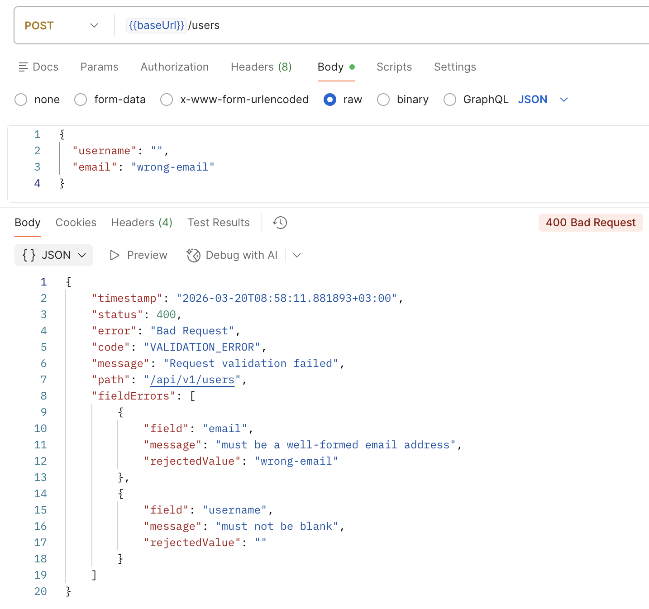

Рисунок 4.1 – Демонстрация единого формата ошибок (400 Bad Request)

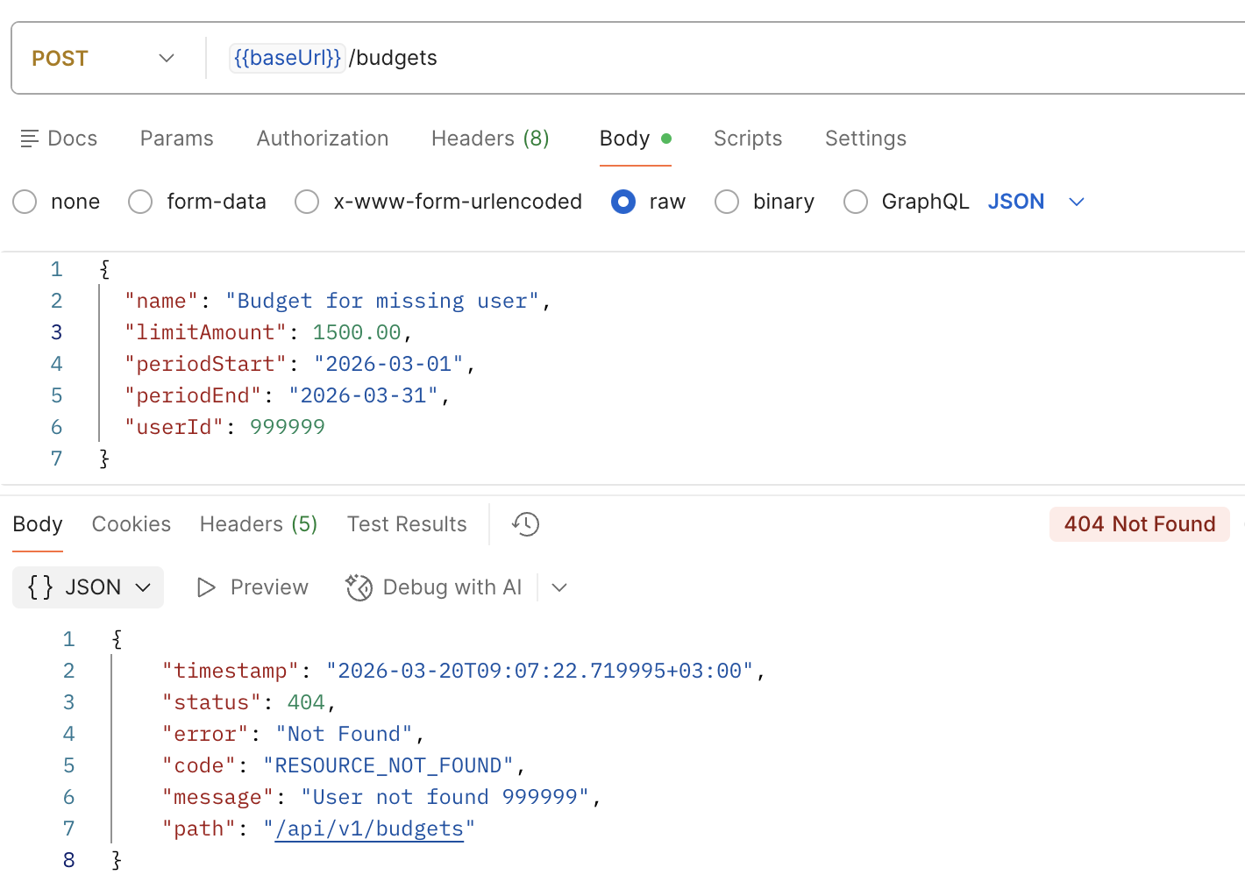

Рисунок 4.2 – Демонстрация единого формата ошибок (404 Not Found)

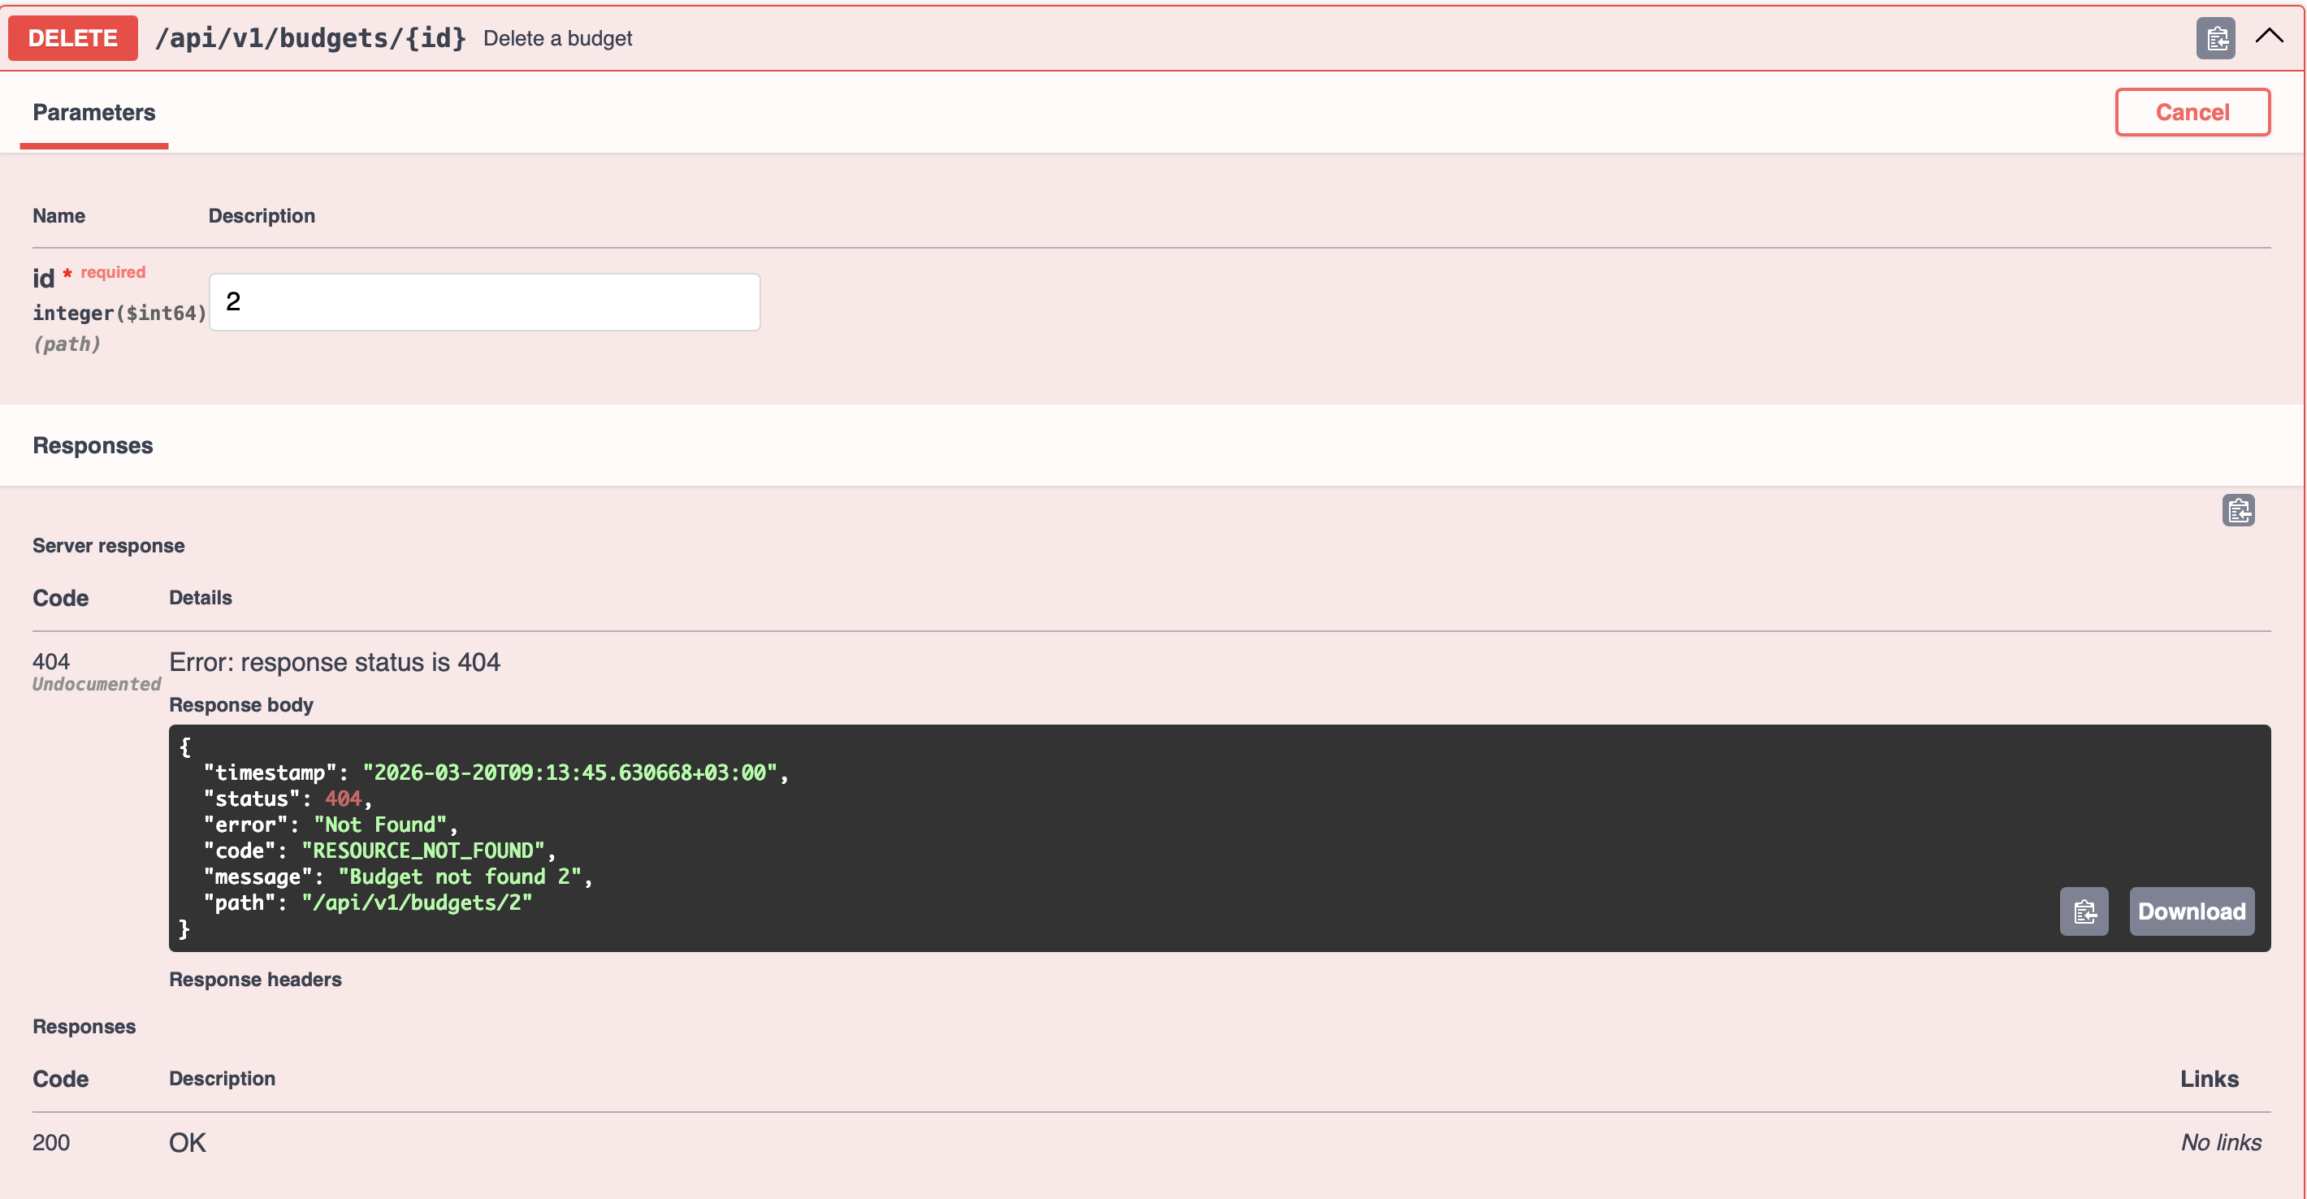

Рисунок 4.3 – Пример описания endpoint (delete budget)

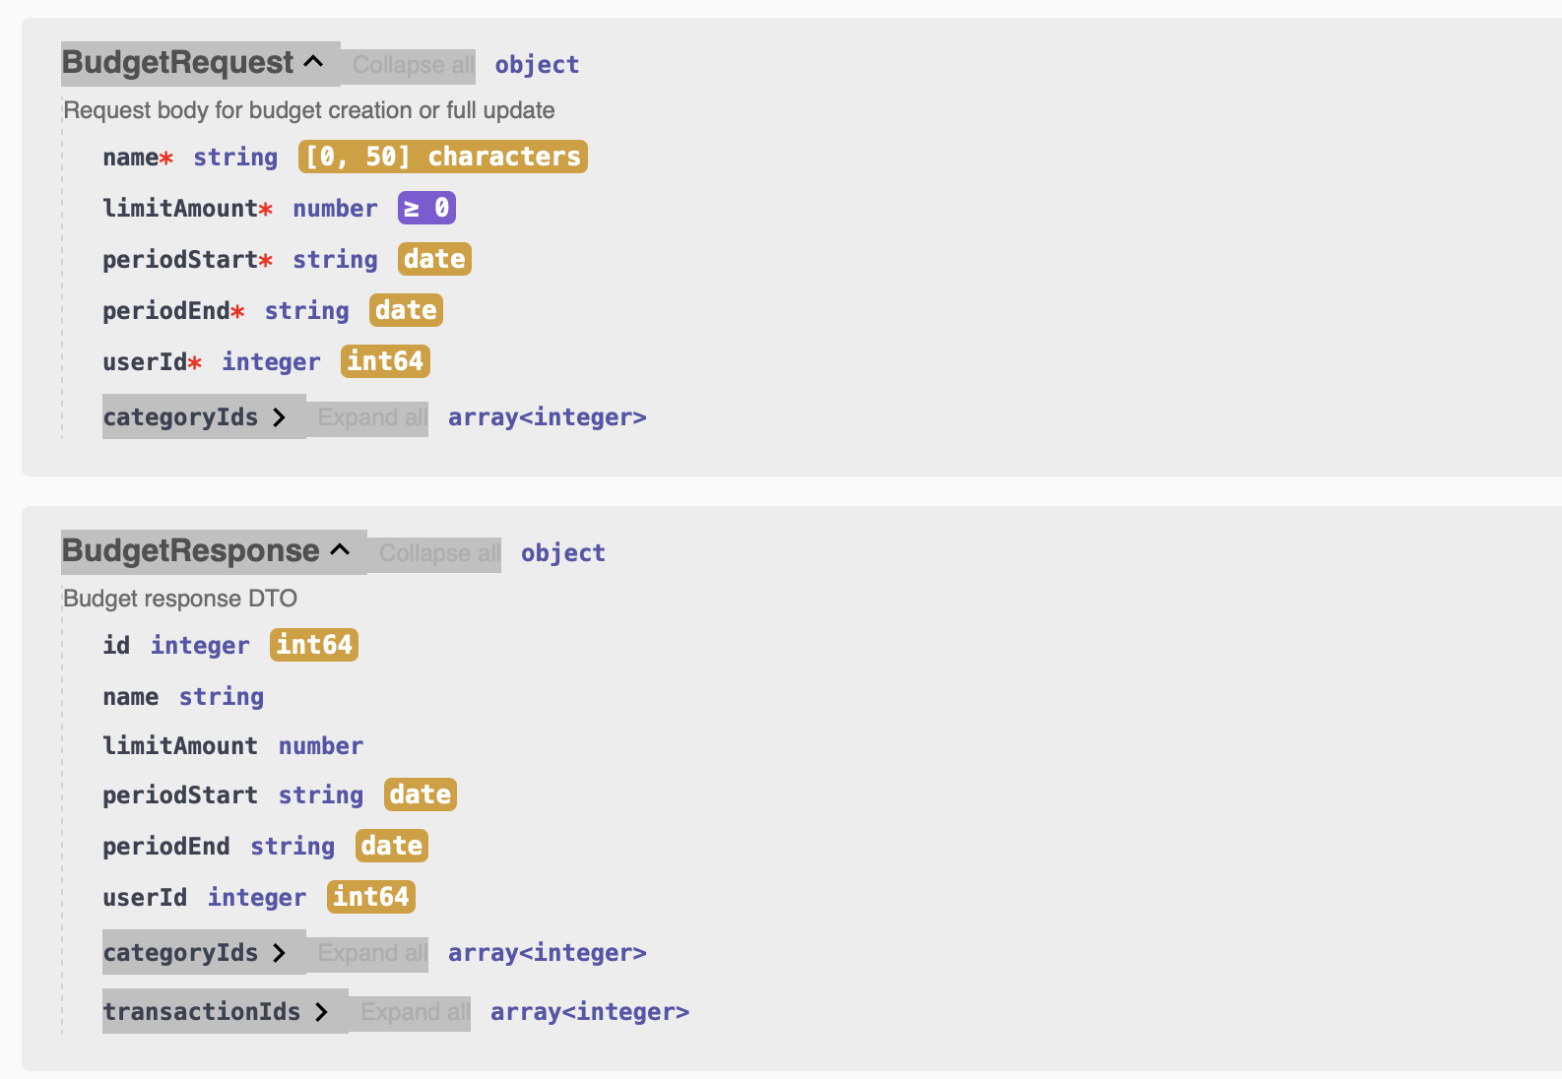

Рисунок 4.4 – Пример описания DTO (BudgetRequest и BudgetResponse)

5 ЗАКЛЮЧЕНИЕ

В ходе лабораторной работы реализована глобальная обработка ошибок через @ControllerAdvice, добавлена валидация входных данных с помощью @Valid и введен единый формат error-response для всех endpoint. Настроено логирование через logback, включая уровни логирования и ротацию логов. Также реализован AOP-аспект для логирования времени выполнения сервисных методов и подключен Swagger/OpenAPI для документирования endpoint и DTO.

