Министерство образования Республики Беларусь
Учреждение образования
«БЕЛОРУССКИЙ ГОСУДАРСТВЕННЫЙ УНИВЕРСИТЕТ
ИНФОРМАТИКИ И РАДИОЭЛЕКТРОНИКИ»
Кафедра электронных вычислительных машин

ОТЧЕТ
О ЛАБОРАТОРНОЙ РАБОТЕ № 5
Batch data processing & Testing
по дисциплине «Программирование на языках высокого уровня»

Выполнил ст. гр. 450502 Е.Ю. Новицкий

Проверил асс. каф. ЭВМ И.Г. Скиба

Минск 2026

1 ПОСТАНОВКА ЗАДАЧИ

1 Реализовать bulk-операцию (POST со списком объектов), имеющую бизнес-смысл в рамках проекта.
2 Использовать Stream API и Optional в сервисном слое.
3 Обеспечить транзакционность bulk-операции. Продемонстрировать работу с/без @Transactional и показать разницу в состоянии БД.
4 Написать:
- unit-тесты для сервисов (Mockito)
2 СТРУКТУРА ПРОЕКТА

finance-tracker
├── .gitattributes
├── .gitignore
├── .mvn
│ └── wrapper
│ └── maven-wrapper.properties
├── README.md
├── config
│ └── checkstyle
│ └── checkstyle.xml
├── logs
│ ├── application.log
│ ├── error.log
│ └── archive
├── mvnw
├── mvnw.cmd
├── pom.xml
└── src
├── main
│ ├── java
│ │ └── com
│ │ └── finance
│ │ └── tracker
│ │ ├── FinanceTrackerApplication.java
│ │ ├── aop
│ │ │ └── ServiceLoggingAspect.java
│ │ ├── cache
│ │ │ ├── TransactionSearchCacheKey.java
│ │ │ ├── TransactionSearchIndex.java
│ │ │ └── TransactionSearchIndexInvalidator.java
│ │ ├── config
│ │ │ └── OpenApiConfig.java
│ │ ├── controller
│ │ │ ├── AccountController.java
│ │ │ ├── BudgetController.java
│ │ │ ├── CategoryController.java
│ │ │ ├── TransactionController.java
│ │ │ ├── UserController.java
│ │ │ └── api
│ │ │ ├── AccountControllerApi.java
│ │ │ ├── BudgetControllerApi.java
│ │ │ ├── CategoryControllerApi.java
│ │ │ ├── TransactionControllerApi.java
│ │ │ └── UserControllerApi.java
│ │ ├── domain
│ │ │ ├── Account.java
│ │ │ ├── AccountType.java
│ │ │ ├── Budget.java
│ │ │ ├── Category.java
│ │ │ ├── Transaction.java
│ │ │ ├── TransactionType.java
│ │ │ └── User.java
│ │ ├── dto
│ │ │ ├── request
│ │ │ │ ├── AccountRequest.java
│ │ │ │ ├── AccountUpdateRequest.java
│ │ │ │ ├── BudgetRequest.java
│ │ │ │ ├── BudgetUpdateRequest.java
│ │ │ │ ├── CategoryRequest.java
│ │ │ │ ├── CategoryUpdateRequest.java
│ │ │ │ ├── TransactionRequest.java
│ │ │ │ ├── TransactionSearchQueryMode.java
│ │ │ │ ├── TransactionSearchRequest.java
│ │ │ │ ├── TransactionUpdateRequest.java
│ │ │ │ ├── TransferDemoRequest.java
│ │ │ │ ├── UserRequest.java
│ │ │ │ ├── UserUpdateRequest.java
│ │ │ │ └── UserWithAccountsAndBudgetsCreateRequest.java
│ │ │ └── response
│ │ │ ├── AccountResponse.java
│ │ │ ├── BudgetResponse.java
│ │ │ ├── CategoryResponse.java
│ │ │ ├── PageMetadataResponse.java
│ │ │ ├── TransactionResponse.java
│ │ │ ├── TransactionSearchPageResponse.java
│ │ │ ├── TransactionSearchResult.java
│ │ │ ├── TransactionSearchSource.java
│ │ │ ├── TransferDemoResponse.java
│ │ │ └── UserResponse.java
│ │ ├── exception
│ │ │ ├── ApiErrorField.java
│ │ │ ├── ApiErrorResponse.java
│ │ │ ├── ApiException.java
│ │ │ ├── BadRequestException.java
│ │ │ ├── ConflictException.java
│ │ │ ├── DuplicateResourceException.java
│ │ │ ├── GlobalExceptionHandler.java
│ │ │ ├── LoggingException.java
│ │ │ └── ResourceNotFoundException.java
│ │ ├── mapper
│ │ │ ├── AccountMapper.java
│ │ │ ├── BudgetMapper.java
│ │ │ ├── CategoryMapper.java
│ │ │ ├── TransactionMapper.java
│ │ │ └── UserMapper.java
│ │ ├── repository
│ │ │ ├── AccountRepository.java
│ │ │ ├── BudgetRepository.java
│ │ │ ├── CategoryRepository.java
│ │ │ ├── TransactionRepository.java
│ │ │ └── UserRepository.java
│ │ └── service
│ │ ├── AccountService.java
│ │ ├── BudgetService.java
│ │ ├── CategoryService.java
│ │ ├── TransactionService.java
│ │ ├── UserService.java
│ │ └── impl
│ │ ├── AccountServiceImpl.java
│ │ ├── BudgetServiceImpl.java
│ │ ├── CategoryServiceImpl.java
│ │ ├── TransactionServiceImpl.java
│ │ └── UserServiceImpl.java
│ └── resources
│ ├── application.properties
│ ├── logback-spring.xml
│ └── db
│ ├── db.changelog-master.yaml
│ └── migrations
└── test
├── java
│ └── com
│ └── finance
│ └── tracker
│ ├── controller
│ │ └── UserControllerValidationTest.java
│ └── service
│ └── impl
│ └── TransactionServiceImplTest.java
└── resources
├── application.properties
├── logback-test.xml
└── mockito-extensions
└── org.mockito.plugins.MockMaker
3 ЛИСТИНГ КОДА

Файл TransactionControllerApi.java

package com.finance.tracker.controller.api;

import com.finance.tracker.dto.request.TransactionRequest;
import com.finance.tracker.dto.request.TransactionSearchRequest;
import com.finance.tracker.dto.request.TransactionUpdateRequest;
import com.finance.tracker.dto.response.TransactionResponse;
import com.finance.tracker.dto.response.TransactionSearchPageResponse;
import io.swagger.v3.oas.annotations.Operation;
import io.swagger.v3.oas.annotations.tags.Tag;
import jakarta.validation.Valid;
import jakarta.validation.constraints.Positive;
import java.time.LocalDateTime;
import java.util.List;
import org.springframework.http.ResponseEntity;

@Tag(name = "Transactions", description = "Operations with transactions and search")
public interface TransactionControllerApi {

@Operation(summary = "Get transaction by id")
ResponseEntity<TransactionResponse> getById(@Positive Long id);

@Operation(summary = "Get all transactions or filter them by date range")
ResponseEntity<List<TransactionResponse>> getAll(
LocalDateTime startDateTime,
LocalDateTime endDateTime,
boolean withEntityGraph);

@Operation(summary = "Search transactions with filters, pagination and sorting")
ResponseEntity<TransactionSearchPageResponse> search(@Valid TransactionSearchRequest request);

@Operation(summary = "Create a transaction")
ResponseEntity<TransactionResponse> create(@Valid TransactionRequest request);

@Operation(summary = "Create transactions in bulk")
ResponseEntity<List<TransactionResponse>> createBulk(
@Valid List<@Valid TransactionRequest> requests,
boolean transactional);

@Operation(summary = "Update a transaction")
ResponseEntity<TransactionResponse> update(@Positive Long id, @Valid TransactionRequest request);

@Operation(summary = "Patch a transaction")
ResponseEntity<TransactionResponse> patch(@Positive Long id, @Valid TransactionUpdateRequest request);

@Operation(summary = "Delete a transaction")
ResponseEntity<Void> delete(@Positive Long id);
}

Файл TransactionController.java

package com.finance.tracker.controller;

import com.finance.tracker.controller.api.TransactionControllerApi;
import com.finance.tracker.dto.request.TransactionSearchRequest;
import com.finance.tracker.dto.request.TransactionRequest;
import com.finance.tracker.dto.request.TransactionUpdateRequest;
import com.finance.tracker.dto.response.TransactionSearchPageResponse;
import com.finance.tracker.dto.response.TransactionResponse;
import com.finance.tracker.dto.response.TransactionSearchResult;
import com.finance.tracker.service.TransactionService;

import lombok.RequiredArgsConstructor;

import java.time.LocalDateTime;
import java.util.List;

import org.springframework.data.domain.PageRequest;
import org.springframework.data.domain.Sort;
import org.springframework.http.HttpStatus;
import org.springframework.http.ResponseEntity;
import org.springframework.format.annotation.DateTimeFormat;
import org.springframework.validation.annotation.Validated;
import org.springframework.web.bind.annotation.DeleteMapping;
import org.springframework.web.bind.annotation.GetMapping;
import org.springframework.web.bind.annotation.ModelAttribute;
import org.springframework.web.bind.annotation.PathVariable;
import org.springframework.web.bind.annotation.PatchMapping;
import org.springframework.web.bind.annotation.PostMapping;
import org.springframework.web.bind.annotation.PutMapping;
import org.springframework.web.bind.annotation.RequestBody;
import org.springframework.web.bind.annotation.RequestMapping;
import org.springframework.web.bind.annotation.RequestParam;
import org.springframework.web.bind.annotation.RestController;

@RestController
@Validated
@RequiredArgsConstructor
@RequestMapping("/api/v1/transactions")
public class TransactionController implements TransactionControllerApi {

private final TransactionService transactionService;

@GetMapping("/{id}")
@Override
public ResponseEntity<TransactionResponse> getById(@PathVariable("id") Long id) {
return ResponseEntity.ok(transactionService.findById(id));
}

@GetMapping
@Override
public ResponseEntity<List<TransactionResponse>> getAll(
@RequestParam(required = false)
@DateTimeFormat(iso = DateTimeFormat.ISO.DATE_TIME) final LocalDateTime startDateTime,
@RequestParam(required = false)
@DateTimeFormat(iso = DateTimeFormat.ISO.DATE_TIME) final LocalDateTime endDateTime,
@RequestParam(required = false, defaultValue = "false") final boolean withEntityGraph) {
if (startDateTime == null && endDateTime == null) {
return ResponseEntity.ok(transactionService.findAll(withEntityGraph));
}
return ResponseEntity.ok(transactionService.findByDateRange(startDateTime, endDateTime));
}

@GetMapping("/search")
@Override
public ResponseEntity<TransactionSearchPageResponse> search(
@ModelAttribute TransactionSearchRequest request) {
PageRequest pageable = PageRequest.of(
request.getPage(),
request.getSize(),
Sort.by(
request.isAscending() ? Sort.Direction.ASC : Sort.Direction.DESC,
request.getSortBy().trim()));
TransactionSearchResult result = transactionService.search(
request.getQueryMode(),
request.getBudgetName(),
request.getAccountName(),
request.getMinAmount(),
request.getMaxAmount(),
request.getStartDateTime(),
request.getEndDateTime(),
pageable);
return ResponseEntity.ok()
.header("X-Transaction-Search-Source", result.getSource().name())
.body(TransactionSearchPageResponse.from(result.getPage()));
}

@PostMapping
@Override
public ResponseEntity<TransactionResponse> create(@RequestBody TransactionRequest request) {
TransactionResponse response = transactionService.create(request);
return ResponseEntity.status(HttpStatus.CREATED).body(response);
}

@PostMapping("/bulk")
@Override
public ResponseEntity<List<TransactionResponse>> createBulk(
@RequestBody List<TransactionRequest> requests,
@RequestParam(defaultValue = "true") boolean transactional) {
List<TransactionResponse> response = transactional
? transactionService.createBulkTx(requests)
: transactionService.createBulkNoTx(requests);
return ResponseEntity.status(HttpStatus.CREATED).body(response);
}

@PutMapping("/{id}")
@Override
public ResponseEntity<TransactionResponse> update(
@PathVariable("id") Long id,
@RequestBody TransactionRequest request) {
return ResponseEntity.ok(transactionService.update(id, request));
}

@PatchMapping("/{id}")
@Override
public ResponseEntity<TransactionResponse> patch(
@PathVariable("id") Long id,
@RequestBody TransactionUpdateRequest request) {
return ResponseEntity.ok(transactionService.patch(id, request));
}

@DeleteMapping("/{id}")
@Override
public ResponseEntity<Void> delete(@PathVariable("id") Long id) {
transactionService.delete(id);
return ResponseEntity.noContent().build();
}
}

Файл TransactionServiceImpl.java

package com.finance.tracker.service.impl;

import java.math.BigDecimal;
import com.finance.tracker.domain.Account;
import com.finance.tracker.domain.Budget;
import com.finance.tracker.domain.Transaction;
import com.finance.tracker.cache.TransactionSearchCacheKey;
import com.finance.tracker.cache.TransactionSearchIndex;
import com.finance.tracker.cache.TransactionSearchIndexInvalidator;
import com.finance.tracker.dto.request.TransactionSearchQueryMode;
import com.finance.tracker.dto.request.TransactionRequest;
import com.finance.tracker.dto.request.TransactionUpdateRequest;
import com.finance.tracker.dto.response.TransactionResponse;
import com.finance.tracker.dto.response.TransactionSearchResult;
import com.finance.tracker.dto.response.TransactionSearchSource;
import com.finance.tracker.exception.BadRequestException;
import com.finance.tracker.exception.ConflictException;
import com.finance.tracker.exception.ResourceNotFoundException;
import com.finance.tracker.mapper.TransactionMapper;
import com.finance.tracker.repository.AccountRepository;
import com.finance.tracker.repository.BudgetRepository;
import com.finance.tracker.repository.TransactionRepository;
import com.finance.tracker.service.TransactionService;

import java.time.LocalDateTime;
import java.util.List;
import java.util.Optional;

import org.springframework.data.domain.Page;
import org.springframework.data.domain.PageImpl;
import org.springframework.data.domain.PageRequest;
import org.springframework.data.domain.Pageable;
import org.springframework.data.domain.Sort;
import org.springframework.stereotype.Service;
import org.springframework.transaction.annotation.Propagation;
import org.springframework.transaction.annotation.Transactional;

import lombok.RequiredArgsConstructor;
import lombok.extern.slf4j.Slf4j;

@Service
@Slf4j
@Transactional(readOnly = true)
@RequiredArgsConstructor
public class TransactionServiceImpl implements TransactionService {

private static final String TRANSACTION_NOT_FOUND_MESSAGE_PREFIX = "Transaction not found ";
private static final BigDecimal SEARCH_MIN_AMOUNT = new BigDecimal("-999999999999.99");
private static final BigDecimal SEARCH_MAX_AMOUNT = new BigDecimal("999999999999.99");
private static final LocalDateTime SEARCH_START_DATE_TIME = LocalDateTime.of(1, 1, 1, 0, 0);
private static final LocalDateTime SEARCH_END_DATE_TIME = LocalDateTime.of(9999, 12, 31, 23, 59, 59);
private static final String BULK_REQUEST_EMPTY_MESSAGE =
"Bulk transaction request must contain at least one item";

private final TransactionRepository transactionRepository;
private final BudgetRepository budgetRepository;
private final AccountRepository accountRepository;
private final TransactionMapper transactionMapper;
private final TransactionSearchIndex transactionSearchIndex;
private final TransactionSearchIndexInvalidator transactionSearchIndexInvalidator;

@Override
public TransactionResponse findById(Long id) {
return transactionMapper.toResponse(getTransaction(id), true, true);
}

@Override
public List<TransactionResponse> findAll(boolean withEntityGraph) {
List<Transaction> transactions = withEntityGraph
? transactionRepository.findAllTransactionsWithEntityGraph()
: transactionRepository.findAllTransactions();
return toResponses(transactions);
}

@Override
public List<TransactionResponse> findByDateRange(LocalDateTime startDateTime,
LocalDateTime endDateTime) {
if (startDateTime == null || endDateTime == null) {
throw new BadRequestException("Both startDateTime and endDateTime are required for date range filtering");
}

if (endDateTime.isBefore(startDateTime)) {
throw new BadRequestException("endDateTime must be greater than or equal to startDateTime");
}

List<Transaction> transactions = transactionRepository.findByOccurredAtBetween(startDateTime, endDateTime);
return toResponses(transactions);
}

@Override
public TransactionSearchResult search(
TransactionSearchQueryMode queryMode,
String budgetName,
String accountName,
BigDecimal minAmount,
BigDecimal maxAmount,
LocalDateTime startDateTime,
LocalDateTime endDateTime,
Pageable pageable) {
validateSearchFilters(minAmount, maxAmount, startDateTime, endDateTime);

TransactionSearchQueryMode normalizedQueryMode = queryMode == null
? TransactionSearchQueryMode.JPQL
: queryMode;
Pageable repositoryPageable = normalizePageableForQuery(normalizedQueryMode, pageable);
String normalizedBudgetName = normalizeTextFilterForCache(budgetName);
String normalizedAccountName = normalizeTextFilterForCache(accountName);
String repositoryBudgetName = normalizeTextFilterForRepository(budgetName);
String repositoryAccountName = normalizeTextFilterForRepository(accountName);
BigDecimal repositoryMinAmount = minAmount == null ? SEARCH_MIN_AMOUNT : minAmount;
BigDecimal repositoryMaxAmount = maxAmount == null ? SEARCH_MAX_AMOUNT : maxAmount;
LocalDateTime repositoryStartDateTime = startDateTime == null ? SEARCH_START_DATE_TIME : startDateTime;
LocalDateTime repositoryEndDateTime = endDateTime == null ? SEARCH_END_DATE_TIME : endDateTime;

TransactionSearchCacheKey cacheKey = new TransactionSearchCacheKey(
normalizedQueryMode,
normalizedBudgetName,
normalizedAccountName,
minAmount,
maxAmount,
startDateTime,
endDateTime,
repositoryPageable.getPageNumber(),
repositoryPageable.getPageSize(),
repositoryPageable.getSort().toString());
String searchLogContext = buildSearchLogContext(
normalizedQueryMode,
normalizedBudgetName,
normalizedAccountName,
minAmount,
maxAmount,
startDateTime,
endDateTime,
repositoryPageable);

return transactionSearchIndex.find(cacheKey)
.map(page -> {
log.info("Transaction search cache HIT [{}]", searchLogContext);
return new TransactionSearchResult(page, TransactionSearchSource.CACHE);
})
.orElseGet(() -> loadAndIndexSearchResult(
cacheKey,
normalizedQueryMode,
repositoryBudgetName,
repositoryAccountName,
repositoryMinAmount,
repositoryMaxAmount,
repositoryStartDateTime,
repositoryEndDateTime,
repositoryPageable,
pageable,
searchLogContext));
}

@Override
@Transactional
public TransactionResponse create(TransactionRequest request) {
return transactionMapper.toResponse(createTransactionEntity(request));
}

@Override
@Transactional
public List<TransactionResponse> createBulkTx(List<TransactionRequest> requests) {
return createBulkInternal(requests);
}

@Override
@Transactional(propagation = Propagation.NOT_SUPPORTED)
public List<TransactionResponse> createBulkNoTx(List<TransactionRequest> requests) {
return createBulkInternal(requests);
}

@Override
@Transactional
public TransactionResponse update(Long id, TransactionRequest request) {
Transaction transaction = getTransaction(id);

Budget budget = getBudgetIfPresent(request.getBudgetId());
Account account = getAccount(request.getAccountId());

ensureSameOwner(budget, account);

transaction.setOccurredAt(request.getOccurredAt());
transaction.setAmount(request.getAmount());
transaction.setDescription(normalizeDescription(request.getDescription()));
transaction.setType(request.getType());
transaction.setBudget(budget);
transaction.setAccount(account);

Transaction saved = transactionRepository.save(transaction);
transactionSearchIndexInvalidator.invalidateAfterCommitOrNow();
return transactionMapper.toResponse(saved);
}

@Override
@Transactional
public TransactionResponse patch(Long id, TransactionUpdateRequest request) {
Transaction transaction = getTransaction(id);

Budget budget = request.getBudgetId() != null
? getBudget(request.getBudgetId())
: transaction.getBudget();
Account account = request.getAccountId() != null
? getAccount(request.getAccountId())
: transaction.getAccount();

ensureSameOwner(budget, account);

if (request.getOccurredAt() != null) {
transaction.setOccurredAt(request.getOccurredAt());
}
if (request.getAmount() != null) {
transaction.setAmount(request.getAmount());
}
if (request.getDescription() != null) {
transaction.setDescription(normalizeDescription(request.getDescription()));
}
if (request.getType() != null) {
transaction.setType(request.getType());
}
if (request.getBudgetId() != null) {
transaction.setBudget(budget);
}
if (request.getAccountId() != null) {
transaction.setAccount(account);
}

Transaction saved = transactionRepository.save(transaction);
transactionSearchIndexInvalidator.invalidateAfterCommitOrNow();
return transactionMapper.toResponse(saved);
}

@Override
@Transactional
public void delete(Long id) {
if (!transactionRepository.existsById(id)) {
throw new ResourceNotFoundException(TRANSACTION_NOT_FOUND_MESSAGE_PREFIX + id);
}
transactionRepository.deleteById(id);
transactionSearchIndexInvalidator.invalidateAfterCommitOrNow();
}

private TransactionSearchResult loadAndIndexSearchResult(
TransactionSearchCacheKey cacheKey,
TransactionSearchQueryMode queryMode,
String budgetName,
String accountName,
BigDecimal minAmount,
BigDecimal maxAmount,
LocalDateTime startDateTime,
LocalDateTime endDateTime,
Pageable repositoryPageable,
Pageable responsePageable,
String searchLogContext) {
log.info("Transaction search cache MISS [{}]", searchLogContext);
log.info("Transaction search loading from DATABASE [{}]", searchLogContext);
Page<Transaction> transactions = switch (queryMode) {
case NATIVE -> transactionRepository.searchByNestedFiltersNative(
budgetName,
accountName,
minAmount,
maxAmount,
startDateTime,
endDateTime,
repositoryPageable);
case JPQL -> transactionRepository.searchByNestedFiltersJpql(
budgetName,
accountName,
minAmount,
maxAmount,
startDateTime,
endDateTime,
repositoryPageable);
};

Page<TransactionResponse> responsePage = new PageImpl<>(
transactions.getContent().stream()
.map(transaction -> transactionMapper.toResponse(transaction, true, true))
.toList(),
responsePageable,
transactions.getTotalElements());
transactionSearchIndex.put(cacheKey, responsePage);
log.info("Transaction search result cached [{}]", searchLogContext);
return new TransactionSearchResult(responsePage, TransactionSearchSource.DATABASE);
}

private void validateSearchFilters(
BigDecimal minAmount,
BigDecimal maxAmount,
LocalDateTime startDateTime,
LocalDateTime endDateTime) {
if (minAmount != null && maxAmount != null && maxAmount.compareTo(minAmount) < 0) {
throw new BadRequestException("maxAmount must be greater than or equal to minAmount");
}

if (startDateTime != null && endDateTime != null && endDateTime.isBefore(startDateTime)) {
throw new BadRequestException("endDateTime must be greater than or equal to startDateTime");
}
}

private String normalizeTextFilterForCache(String value) {
if (value == null) {
return null;
}

String normalized = value.trim();
return normalized.isBlank() ? null : normalized;
}

private String normalizeTextFilterForRepository(String value) {
if (value == null) {
return "";
}

String normalized = value.trim();
return normalized.isBlank() ? "" : normalized;
}

private Pageable normalizePageableForQuery(TransactionSearchQueryMode queryMode, Pageable pageable) {
Sort normalizedSort = pageable.getSort().isSorted()
? normalizeSort(queryMode, pageable.getSort())
: defaultSort(queryMode);
return PageRequest.of(pageable.getPageNumber(), pageable.getPageSize(), normalizedSort);
}

private Sort normalizeSort(TransactionSearchQueryMode queryMode, Sort sort) {
List<Sort.Order> normalizedOrders = sort.stream()
.map(order -> normalizeSortOrder(queryMode, order))
.toList();
return Sort.by(normalizedOrders);
}

private Sort defaultSort(TransactionSearchQueryMode queryMode) {
return queryMode == TransactionSearchQueryMode.NATIVE
? Sort.by(Sort.Direction.DESC, "occurred_at")
: Sort.by(Sort.Direction.DESC, "occurredAt");
}

private Sort.Order normalizeSortOrder(TransactionSearchQueryMode queryMode, Sort.Order order) {
String normalizedProperty = queryMode == TransactionSearchQueryMode.NATIVE
? mapNativeSortProperty(order.getProperty())
: mapJpqlSortProperty(order.getProperty());
Sort.Order normalizedOrder = new Sort.Order(order.getDirection(), normalizedProperty);
return order.isIgnoreCase() ? normalizedOrder.ignoreCase() : normalizedOrder;
}

private String mapJpqlSortProperty(String property) {
return switch (property) {
case "id" -> "id";
case "occurredAt", "occurred_at" -> "occurredAt";
case "amount" -> "amount";
case "description" -> "description";
case "type" -> "type";
default -> throw new BadRequestException("Unsupported sort property for JPQL query: " + property);
};
}

private String mapNativeSortProperty(String property) {
return switch (property) {
case "id" -> "id";
case "occurredAt", "occurred_at" -> "occurred_at";
case "amount" -> "amount";
case "description" -> "description";
case "type" -> "type";
case "budgetId", "budget_id" -> "budget_id";
case "accountId", "account_id" -> "account_id";
default -> throw new BadRequestException("Unsupported sort property for native query: " + property);
};
}

private String buildSearchLogContext(
TransactionSearchQueryMode queryMode,
String budgetName,
String accountName,
BigDecimal minAmount,
BigDecimal maxAmount,
LocalDateTime startDateTime,
LocalDateTime endDateTime,
Pageable pageable) {
return "queryMode=" + queryMode
+ ", budgetName=" + valueOrDash(budgetName)
+ ", accountName=" + valueOrDash(accountName)
+ ", minAmount=" + valueOrDash(minAmount)
+ ", maxAmount=" + valueOrDash(maxAmount)
+ ", startDateTime=" + valueOrDash(startDateTime)
+ ", endDateTime=" + valueOrDash(endDateTime)
+ ", page=" + pageable.getPageNumber()
+ ", size=" + pageable.getPageSize()
+ ", sort=" + pageable.getSort();
}

private String valueOrDash(Object value) {
return value == null ? "-" : value.toString();
}

private Transaction createTransactionEntity(TransactionRequest request) {
Budget budget = Optional.ofNullable(request.getBudgetId())
.map(this::getBudget)
.orElse(null);
Account account = getAccount(request.getAccountId());

ensureSameOwner(budget, account);

Transaction transaction = transactionMapper.fromRequest(request, budget, account);
transaction.setDescription(normalizeDescription(request.getDescription()));
Transaction saved = transactionRepository.save(transaction);
transactionSearchIndexInvalidator.invalidateAfterCommitOrNow();
return saved;
}

private List<TransactionResponse> createBulkInternal(List<TransactionRequest> requests) {
List<TransactionRequest> bulkRequests = Optional.ofNullable(requests)
.filter(items -> !items.isEmpty())
.orElseThrow(() -> new BadRequestException(BULK_REQUEST_EMPTY_MESSAGE));

return bulkRequests.stream()
.map(this::createTransactionEntity)
.map(transaction -> transactionMapper.toResponse(transaction, true, true))
.toList();
}

private Budget getBudget(Long budgetId) {
return budgetRepository.findById(budgetId)
.orElseThrow(() -> new ResourceNotFoundException("Budget not found: " + budgetId));
}

private Budget getBudgetIfPresent(Long budgetId) {
if (budgetId == null) {
return null;
}
return getBudget(budgetId);
}

private Account getAccount(Long accountId) {
return accountRepository.findById(accountId)
.orElseThrow(() -> new ResourceNotFoundException("Account not found: " + accountId));
}

private void ensureSameOwner(Budget budget, Account account) {
if (account.getUser() == null) {
throw new ConflictException("Account must be owned by a user");
}

if (budget == null) {
return;
}

if (budget.getUser() == null) {
throw new ConflictException("Budget must be owned by a user");
}

if (!budget.getUser().getId().equals(account.getUser().getId())) {
throw new ConflictException("Budget owner and account owner must match");
}
}

private List<TransactionResponse> toResponses(List<Transaction> transactions) {
return transactions.stream()
.map(transaction -> transactionMapper.toResponse(transaction, true, true))
.toList();
}

private Transaction getTransaction(Long id) {
return transactionRepository.findById(id)
.orElseThrow(() -> new ResourceNotFoundException(TRANSACTION_NOT_FOUND_MESSAGE_PREFIX + id));
}

private String normalizeDescription(String value) {
String normalized = value == null ? null : value.trim();
if (normalized == null || normalized.isBlank()) {
throw new BadRequestException("Description must not be blank");
}
return normalized;
}
}

Файл TransactionService.java

package com.finance.tracker.service;

import java.math.BigDecimal;
import com.finance.tracker.dto.request.TransactionSearchQueryMode;
import com.finance.tracker.dto.request.TransactionRequest;
import com.finance.tracker.dto.request.TransactionUpdateRequest;
import com.finance.tracker.dto.response.TransactionResponse;
import com.finance.tracker.dto.response.TransactionSearchResult;

import java.time.LocalDateTime;
import java.util.List;

import org.springframework.data.domain.Pageable;

public interface TransactionService {

TransactionResponse findById(Long id);

List<TransactionResponse> findAll(boolean withEntityGraph);

List<TransactionResponse> findByDateRange(LocalDateTime startDateTime, LocalDateTime endDateTime);

TransactionSearchResult search(
TransactionSearchQueryMode queryMode,
String budgetName,
String accountName,
BigDecimal minAmount,
BigDecimal maxAmount,
LocalDateTime startDateTime,
LocalDateTime endDateTime,
Pageable pageable);

TransactionResponse create(TransactionRequest request);

List<TransactionResponse> createBulkTx(List<TransactionRequest> requests);

List<TransactionResponse> createBulkNoTx(List<TransactionRequest> requests);

TransactionResponse update(Long id, TransactionRequest request);
TransactionResponse patch(Long id, TransactionUpdateRequest request);

void delete(Long id);
}

Файл TransactionServiceImplTest.java

package com.finance.tracker.service.impl;

import static org.junit.jupiter.api.Assertions.assertEquals;
import static org.junit.jupiter.api.Assertions.assertThrows;
import static org.junit.jupiter.api.Assertions.assertTrue;
import static org.mockito.ArgumentMatchers.any;
import static org.mockito.Mockito.never;
import static org.mockito.Mockito.times;
import static org.mockito.Mockito.verify;
import static org.mockito.Mockito.verifyNoInteractions;
import static org.mockito.Mockito.when;

import com.finance.tracker.cache.TransactionSearchIndex;
import com.finance.tracker.cache.TransactionSearchIndexInvalidator;
import com.finance.tracker.domain.Account;
import com.finance.tracker.domain.Budget;
import com.finance.tracker.domain.Transaction;
import com.finance.tracker.domain.TransactionType;
import com.finance.tracker.domain.User;
import com.finance.tracker.dto.request.TransactionRequest;
import com.finance.tracker.dto.request.TransactionUpdateRequest;
import com.finance.tracker.dto.response.TransactionResponse;
import com.finance.tracker.exception.BadRequestException;
import com.finance.tracker.exception.ConflictException;
import com.finance.tracker.mapper.TransactionMapper;
import com.finance.tracker.repository.AccountRepository;
import com.finance.tracker.repository.BudgetRepository;
import com.finance.tracker.repository.TransactionRepository;
import java.math.BigDecimal;
import java.time.LocalDateTime;
import java.util.List;
import java.util.Optional;
import java.util.concurrent.atomic.AtomicLong;
import org.junit.jupiter.api.BeforeEach;
import org.junit.jupiter.api.Test;
import org.junit.jupiter.api.extension.ExtendWith;
import org.mockito.Mock;
import org.mockito.junit.jupiter.MockitoExtension;

@ExtendWith(MockitoExtension.class)
class TransactionServiceImplTest {

@Mock
private TransactionRepository transactionRepository;

@Mock
private BudgetRepository budgetRepository;

@Mock
private AccountRepository accountRepository;

@Mock
private TransactionSearchIndex transactionSearchIndex;

@Mock
private TransactionSearchIndexInvalidator transactionSearchIndexInvalidator;

private TransactionServiceImpl service;

@BeforeEach
void setUp() {
service = new TransactionServiceImpl(
transactionRepository,
budgetRepository,
accountRepository,
new TransactionMapper(),
transactionSearchIndex,
transactionSearchIndexInvalidator);
}

@Test
void createBulkTxShouldCreateAllTransactions() {
User user = user(1L);
Account account = account(1L, "Main card", user);
Budget budget = budget(2L, "Groceries", user);
TransactionRequest salary = request("Salary", TransactionType.INCOME, "50.00", 1L, null);
TransactionRequest lunch = request("Lunch", TransactionType.EXPENSE, "20.00", 1L, 2L);

when(accountRepository.findById(1L)).thenReturn(Optional.of(account));
when(budgetRepository.findById(2L)).thenReturn(Optional.of(budget));

AtomicLong ids = new AtomicLong(10L);
when(transactionRepository.save(any(Transaction.class))).thenAnswer(invocation -> {
Transaction transaction = invocation.getArgument(0);
transaction.setId(ids.getAndIncrement());
return transaction;
});

List<TransactionResponse> responses = service.createBulkTx(List.of(salary, lunch));

assertEquals(2, responses.size());
assertEquals(10L, responses.get(0).getId());
assertEquals(11L, responses.get(1).getId());
assertEquals(1L, responses.get(0).getAccountId());
assertEquals("Main card", responses.get(0).getAccountName());
assertEquals(2L, responses.get(1).getBudgetId());
assertEquals("Groceries", responses.get(1).getBudgetName());
verify(transactionRepository, times(2)).save(any(Transaction.class));
verify(transactionSearchIndexInvalidator, times(2)).invalidateAfterCommitOrNow();
}

@Test
void createBulkTxShouldRejectEmptyRequest() {
BadRequestException exception = assertThrows(
BadRequestException.class,
() -> service.createBulkTx(List.of()));

assertTrue(exception.getMessage().contains("at least one item"));
verifyNoInteractions(transactionRepository, budgetRepository, accountRepository, transactionSearchIndexInvalidator);
}

@Test
void createShouldFailWhenBudgetOwnerAndAccountOwnerDoNotMatch() {
Account account = account(1L, "Main card", user(1L));
Budget budget = budget(2L, "Groceries", user(2L));
TransactionRequest request = request("Lunch", TransactionType.EXPENSE, "20.00", 1L, 2L);

when(accountRepository.findById(1L)).thenReturn(Optional.of(account));
when(budgetRepository.findById(2L)).thenReturn(Optional.of(budget));

assertThrows(ConflictException.class, () -> service.create(request));

verify(transactionRepository, never()).save(any(Transaction.class));
verify(transactionSearchIndexInvalidator, never()).invalidateAfterCommitOrNow();
}

@Test
void patchShouldKeepCurrentValuesWhenOptionalFieldsAreMissing() {
User user = user(1L);
Account account = account(1L, "Main card", user);
Budget budget = budget(2L, "Groceries", user);
Transaction transaction = transaction(5L, account, budget);
TransactionUpdateRequest request = new TransactionUpdateRequest();
request.setAmount(new BigDecimal("10.00"));

when(transactionRepository.findById(5L)).thenReturn(Optional.of(transaction));
when(transactionRepository.save(any(Transaction.class))).thenAnswer(invocation -> invocation.getArgument(0));

TransactionResponse response = service.patch(5L, request);

assertEquals("Lunch", response.getDescription());
assertEquals(TransactionType.EXPENSE, response.getType());
assertAmount("10.00", response.getAmount());
assertEquals(1L, response.getAccountId());
assertEquals(2L, response.getBudgetId());
verify(accountRepository, never()).findById(any());
verify(budgetRepository, never()).findById(any());
verify(transactionSearchIndexInvalidator).invalidateAfterCommitOrNow();
}

private static User user(Long id) {
User user = new User();
user.setId(id);
return user;
}

private static Account account(Long id, String name, User user) {
Account account = new Account();
account.setId(id);
account.setName(name);
account.setUser(user);
return account;
}

private static Budget budget(Long id, String name, User user) {
Budget budget = new Budget();
budget.setId(id);
budget.setName(name);
budget.setUser(user);
return budget;
}

private static TransactionRequest request(
String description,
TransactionType type,
String amount,
Long accountId,
Long budgetId) {
TransactionRequest request = new TransactionRequest();
request.setOccurredAt(LocalDateTime.of(2026, 3, 17, 10, 0));
request.setAmount(new BigDecimal(amount));
request.setDescription(description);
request.setType(type);
request.setAccountId(accountId);
request.setBudgetId(budgetId);
return request;
}

private static Transaction transaction(Long id, Account account, Budget budget) {
Transaction transaction = new Transaction();
transaction.setId(id);
transaction.setOccurredAt(LocalDateTime.of(2026, 3, 17, 12, 0));
transaction.setAmount(new BigDecimal("30.00"));
transaction.setDescription("Lunch");
transaction.setType(TransactionType.EXPENSE);
transaction.setAccount(account);
transaction.setBudget(budget);
return transaction;
}

private static void assertAmount(String expected, BigDecimal actual) {
assertEquals(0, new BigDecimal(expected).compareTo(actual));
}
}
4 ТЕСТИРОВАНИЕ ПРОГРАММЫ

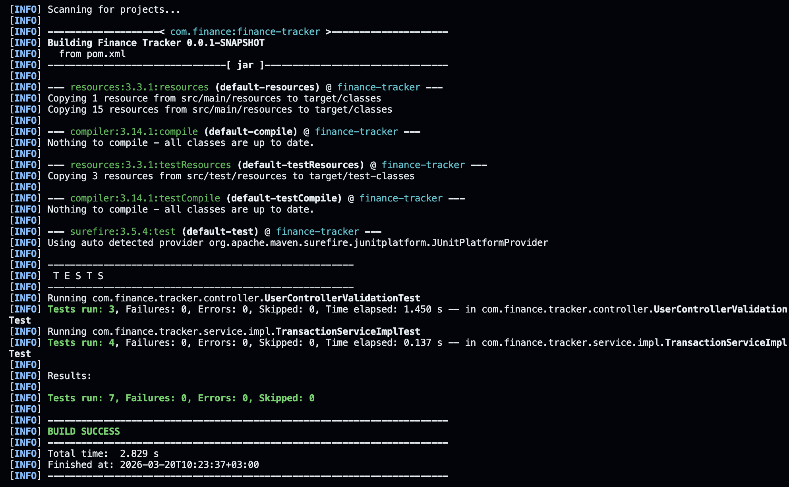

Рисунок 4.1 – Результат выполнения тестов

5 РЕЗУЛЬТАТ РАБОТЫ ПРОГРАММЫ

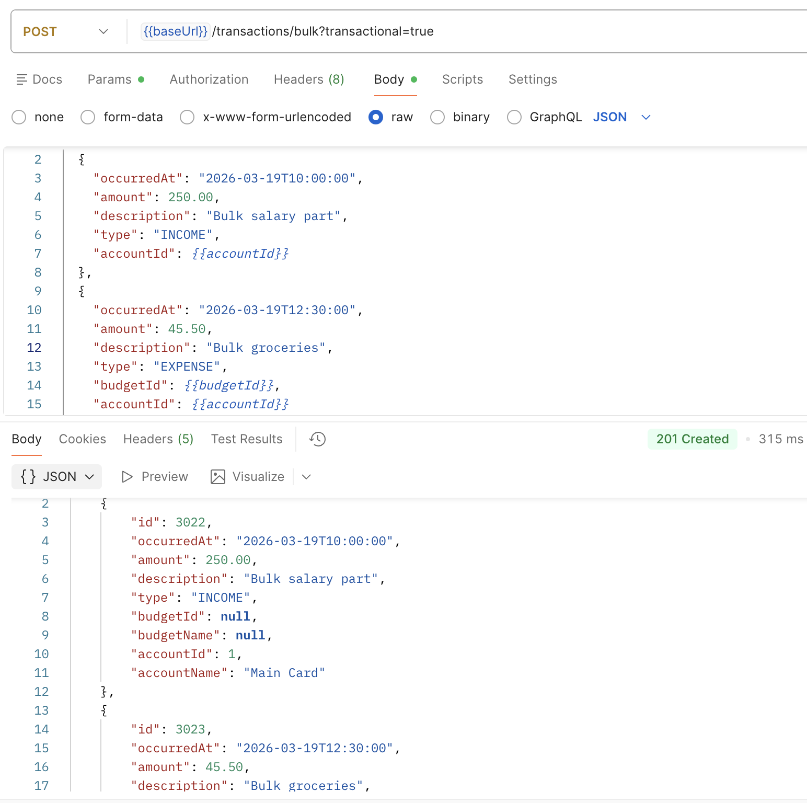

Рисунок 5.1 – Демонстрация bulk запроса

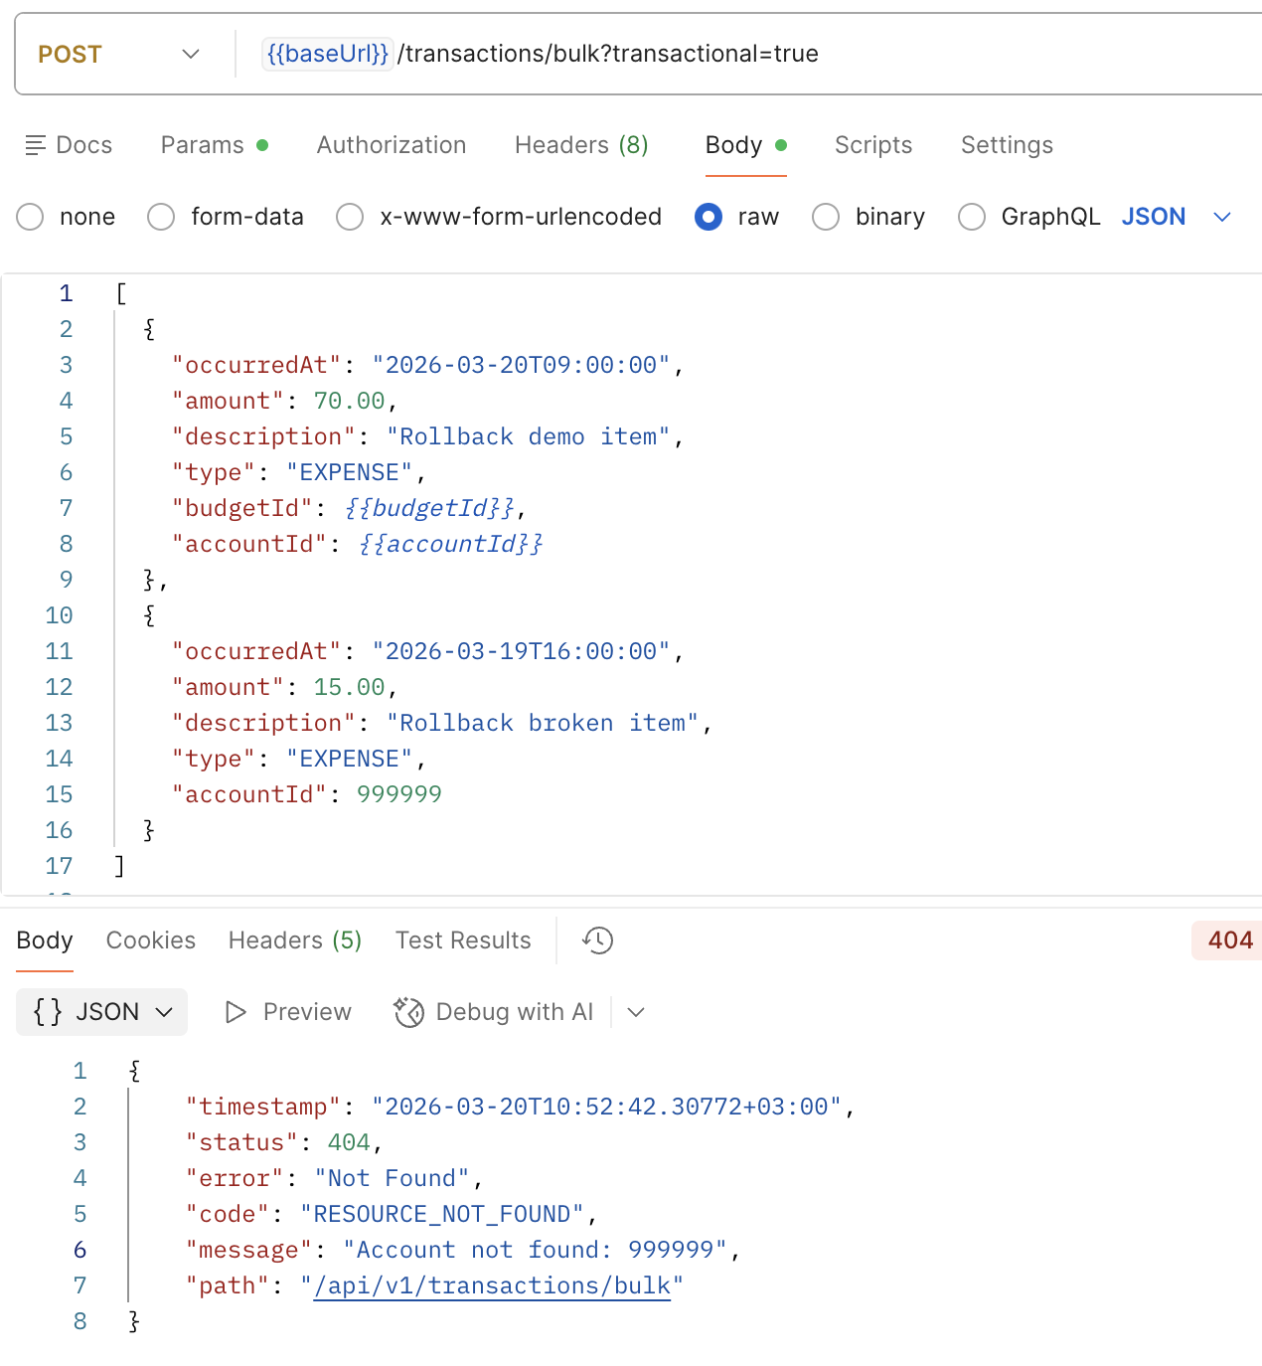

Рисунок 5.2 – Демонстрация bulk запроса с инициированной ошибкой

6 ЗАКЛЮЧЕНИЕ

В ходе работы реализована bulk-операция для массовой обработки сущностей с использованием Stream API (filter, map) и Optional для защиты от null. Операция аннотирована @Transactional для обеспечения атомарности: продемонстрирован откат всех изменений при возникновении исключения, тогда как без транзакции часть данных сохраняется частично.

