Министерство образования Республики Беларусь Учреждение образования
«БЕЛОРУССКИЙ ГОСУДАРСТВЕННЫЙ УНИВЕРСИТЕТ ИНФОРМАТИКИ И РАДИОЭЛЕКТРОНИКИ»

Кафедра электронных вычислительных машин

ОТЧЕТ
О ЛАБОРАТОРНОЙ РАБОТЕ № 7
Client
по дисциплине «Программирование на языках высокого уровня»

Выполнил ст. гр. 450502 Новицкий Е.Ю.

Проверил асс. каф. ЭВМ Скиба И.Г.

Минск, 2026

1 ПОСТАНОВКА ЗАДАЧИ

1. Реализовать SPA-клиент (React/Angular/Vue и т.д.).
2. Клиент должен работать с API, реализованным в лабораторных работах.
3. Отобразить связи OneToMany и ManyToMany.
4. Реализовать CRUD операции и фильтрацию.

2 СТРУКТУРА ПРОЕКТА

frontend
├── Dockerfile
├── index.html
├── nginx.conf
├── package.json
├── public
├── src
│ ├── App.vue
│ ├── assets
│ │ └── ambient-fintech-bg.png
│ ├── components
│ │ ├── BaseDrawer.vue
│ │ ├── BaseModal.vue
│ │ └── ConfirmDialogHost.vue
│ ├── composables
│ │ ├── useConfirmDialog.ts
│ │ ├── useFinanceTracker.ts
│ │ └── useRouteQueryState.ts
│ ├── layouts
│ │ └── DashboardLayout.vue
│ ├── main.ts
│ ├── pages
│ │ ├── AccountsPage.vue
│ │ ├── BudgetsPage.vue
│ ├── router
│ │ └── index.ts
│ ├── services
│ │ └── api.ts
│ ├── style.css
│ ├── types
│ │ └── api.ts
│ ├── utils
│ │ ├── finance.ts
│ │ ├── format.ts
│ │ └── query.ts
│ └── widgets
│ ├── FiltersToolbar.vue
│ ├── SidebarNav.vue
├── tsconfig.app.json
├── tsconfig.json
├── vite-env.d.ts
└── vite.config.ts

3 ЛИСТИНГ КОДА

Файл frontend/main.ts

const elements = {
authScreen: document.getElementById("authScreen"),
appScreen: document.getElementById("appScreen"),
authNotice: document.getElementById("authNotice"),
notice: document.getElementById("notice"),
showLoginBtn: document.getElementById("showLoginBtn"),
showRegisterBtn: document.getElementById("showRegisterBtn"),
loginForm: document.getElementById("loginForm"),
registerForm: document.getElementById("registerForm"),
logoutBtn: document.getElementById("logoutBtn"),
sectionTabs: Array.from(document.querySelectorAll(".section-tab")),
sections: Array.from(document.querySelectorAll(".section")),
categoryForm: document.getElementById("categoryForm"),
categoriesList: document.getElementById("categoriesList"),
exerciseForm: document.getElementById("exerciseForm"),
exerciseCategorySelect: document.getElementById("exerciseCategorySelect"),
exerciseFilterForm: document.getElementById("exerciseFilterForm"),
exerciseFilterCategorySelect: document.getElementById("exerciseFilterCategorySelect"),
clearExerciseFilterBtn: document.getElementById("clearExerciseFilterBtn"),
exercisesList: document.getElementById("exercisesList"),
prevExercisesBtn: document.getElementById("prevExercisesBtn"),
nextExercisesBtn: document.getElementById("nextExercisesBtn"),
exercisesPageInfo: document.getElementById("exercisesPageInfo"),
workoutForm: document.getElementById("workoutForm"),
workoutExerciseChoices: document.getElementById("workoutExerciseChoices"),
workoutsList: document.getElementById("workoutsList"),
dayForm: document.getElementById("dayForm"),
dayWorkoutSelect: document.getElementById("dayWorkoutSelect"),
daysList: document.getElementById("daysList"),
mediaForm: document.getElementById("mediaForm"),
mediaResult: document.getElementById("mediaResult"),
};

function getAccessToken() {
return localStorage.getItem(TOKEN_KEY);
}

function setTokens(tokens) {
localStorage.setItem(TOKEN_KEY, tokens.access);
localStorage.setItem(REFRESH_KEY, tokens.refresh);
}

function clearTokens() {
localStorage.removeItem(TOKEN_KEY);
localStorage.removeItem(REFRESH_KEY);
}

function getDayWorkoutId(day) {
return day.wokroutId ?? day.workoutId ?? null;
}

function formatWeekday(dateValue) {
return new Intl.DateTimeFormat("ru-RU", { weekday: "long" }).format(new Date(dateValue));
}

function formatWeekdayShort(dateValue) {
return new Intl.DateTimeFormat("ru-RU", { weekday: "short" }).format(new Date(dateValue));
}

function pickNoticeTarget(scope = "auto") {
if (scope === "auth") {
return elements.authNotice;
}
if (scope === "app") {
return elements.notice;
}
return elements.appScreen.classList.contains("hidden") ? elements.authNotice : elements.notice;
}

function clearNotice(scope = "all") {
if (state.noticeTimer) {
clearTimeout(state.noticeTimer);
state.noticeTimer = null;
}

const targets = scope === "all" ? [elements.notice, elements.authNotice] : [pickNoticeTarget(scope)];
targets.forEach((target) => {
target.textContent = "";
target.classList.add("hidden");
target.classList.remove("success", "error");
});
}

function showNotice(message, type = "info", scope = "auto", autoHide = true) {
const target = pickNoticeTarget(scope);
target.textContent = message;
target.classList.remove("hidden", "success", "error");
if (type === "success") {
target.classList.add("success");
} else if (type === "error") {
target.classList.add("error");
}

if (scope !== "auth" && autoHide) {
if (state.noticeTimer) {
clearTimeout(state.noticeTimer);
}
state.noticeTimer = setTimeout(() => clearNotice("app"), NOTICE_TIMEOUT_MS);
}
}

function setAuthView(mode) {
const showLogin = mode === "login";
elements.showLoginBtn.classList.toggle("active", showLogin);
elements.showRegisterBtn.classList.toggle("active", !showLogin);
elements.loginForm.classList.toggle("active", showLogin);
elements.registerForm.classList.toggle("active", !showLogin);
}

function setMainSection(sectionName) {
elements.sectionTabs.forEach((tab) => {
tab.classList.toggle("active", tab.dataset.section === sectionName);
});
elements.sections.forEach((section) => {
section.classList.toggle("active", section.id === `section-${sectionName}`);
});
}

function mapHttpError(status) {
if (status === 502 || status === 503 || status === 504) {
return "Сервер временно недоступен. Попробуйте обновить страницу через несколько секунд.";
}
return `Ошибка ${status}`;
}

async function api(path, options = {}, retried = false) {
const headers = { ...(options.headers || {}) };
const token = getAccessToken();
if (token) {
headers.Authorization = `Bearer ${token}`;
}

let response;
try {
response = await fetch(`${API_BASE}${path}`, { ...options, headers });
} catch {
throw new Error("Нет соединения с сервером. Проверьте, что backend запущен.");
}

if (response.status === 401 && !retried) {
const refreshed = await tryRefreshToken();
if (refreshed) {
return api(path, options, true);
}
clearTokens();
applyAuthState(false);
throw new Error("Сессия истекла. Выполните вход снова.");
}

if (!response.ok) {
let message = mapHttpError(response.status);
try {
const contentType = response.headers.get("content-type") || "";
if (contentType.includes("application/json")) {
const body = await response.json();
message = body.message || message;
}
} catch {
// ignore parse errors
}
throw new Error(message);
}

if (response.status === 204) {
return null;
}
return response.json();
}

function resetPrivateDataUI() {
state.categories = [];
state.exercises = [];
state.workouts = [];
state.days = [];
state.exercisesPage = 0;
state.exercisesTotalPages = 1;
state.exerciseFilters = {};
state.details = { categories: null, exercises: null, workouts: null };

elements.categoriesList.innerHTML = "";
elements.exercisesList.innerHTML = "";
elements.workoutsList.innerHTML = "";
elements.daysList.innerHTML = "";
elements.workoutExerciseChoices.innerHTML = "";
elements.exerciseCategorySelect.innerHTML = "";
elements.exerciseFilterCategorySelect.innerHTML = "<option value=\"\">Все категории</option>";
elements.dayWorkoutSelect.innerHTML = "";
elements.mediaResult.textContent = "Файл еще не загружен.";
elements.exercisesPageInfo.textContent = "Страница 1 / 1";
}

function getCategoryById(id) {
return state.categories.find((item) => item.id === id) || null;
}

function getWorkoutById(id) {
return state.workouts.find((item) => item.id === id) || null;
}

function renderSelectOptions() {
const categoryOptions = state.categories
.map((category) => `<option value="${category.id}">${category.name}</option>`)
.join("");
elements.exerciseCategorySelect.innerHTML = categoryOptions || "<option value=\"\">Нет категорий</option>";

const filterOptions = state.categories
.map((category) => `<option value="${category.id}">${category.name}</option>`)
.join("");
elements.exerciseFilterCategorySelect.innerHTML = `<option value="">Все категории</option>${filterOptions}`;

const workoutOptions = state.workouts
.map((workout) => `<option value="${workout.id}">${workout.name}</option>`)
.join("");
elements.dayWorkoutSelect.innerHTML = workoutOptions || "<option value=\"\">Нет тренировок</option>";
}

function renderWorkoutExerciseChoices() {
elements.workoutExerciseChoices.innerHTML = "";
if (!state.exercises.length) {
elements.workoutExerciseChoices.innerHTML = "<p class=\"muted\">Сначала добавьте упражнения.</p>";
return;
}

state.exercises.forEach((exercise) => {
const chip = document.createElement("label");
chip.className = "choice-item";
chip.innerHTML = `
<input type="checkbox" name="exerciseIds" value="${exercise.id}">
<span>${exercise.name}</span>
`;
elements.workoutExerciseChoices.appendChild(chip);
});
}

function createDetailContainer(html, isLoading = false) {
const container = document.createElement("div");
container.className = "inline-detail";
if (isLoading) {
container.innerHTML = "<p class=\"muted\">Загрузка...</p>";
} else {
container.innerHTML = html;
}
return container;
}

function allKnownWeekdays() {
const unique = Array.from(
new Set(
state.days
.map((day) => formatWeekdayShort(day.date))
.filter(Boolean)
)
);
return unique.sort((a, b) => a.localeCompare(b, "ru"));
}

function weekdayListForWorkout(workoutId) {
const weekdays = Array.from(
new Set(
state.days
.filter((day) => getDayWorkoutId(day) === workoutId)
.map((day) => formatWeekdayShort(day.date))
)
);
if (weekdays.length) {
return weekdays.sort((a, b) => a.localeCompare(b, "ru"));
}
return allKnownWeekdays();
}

function formatWorkoutDaysLabel(workoutId) {
const days = weekdayListForWorkout(workoutId);
return days.length ? days.join(", ") : "не указаны";
}

function renderCategories() {
elements.categoriesList.innerHTML = "";
if (!state.categories.length) {
elements.categoriesList.innerHTML = "<p class=\"muted\">Категории пока не созданы.</p>";
return;
}

state.categories.forEach((category) => {
const card = document.createElement("article");
card.className = "card";
card.dataset.entity = "categories";
card.dataset.id = String(category.id);

const header = document.createElement("div");
header.className = "card-head";
header.innerHTML = `<h4>${category.name}</h4>`;

const actions = document.createElement("div");
actions.className = "card-actions";

const detailBtn = document.createElement("button");
detailBtn.type = "button";
detailBtn.className = "secondary";
detailBtn.textContent = state.details.categories === category.id ? "Скрыть" : "Подробнее";
detailBtn.addEventListener("click", async () => {
if (state.details.categories === category.id) {
state.details.categories = null;
renderCategories();
return;
}
state.details.categories = category.id;
renderCategories();
await loadCategoryDetail(category.id);
});

const deleteBtn = document.createElement("button");
deleteBtn.type = "button";
deleteBtn.className = "danger";
deleteBtn.textContent = "Удалить";
deleteBtn.addEventListener("click", async () => {
try {
await api(`/categories/${category.id}`, { method: "DELETE" });
await refreshAllData();
showNotice("Категория удалена.", "success");
} catch (error) {
showNotice(error.message, "error");
}
});

actions.append(detailBtn, deleteBtn);
header.appendChild(actions);
card.appendChild(header);

if (state.details.categories === category.id) {
card.appendChild(createDetailContainer("", true));

elements.categoriesList.appendChild(card);
});
}

function renderExercises() {
elements.exercisesList.innerHTML = "";
if (!state.exercises.length) {
elements.exercisesList.innerHTML = "<p class=\"muted\">Упражнения не найдены.</p>";
return;
}

state.exercises.forEach((exercise) => {
const category = getCategoryById(exercise.categoryId);
const card = document.createElement("article");
card.className = "card";
card.dataset.entity = "exercises";
card.dataset.id = String(exercise.id);
card.innerHTML = `
<div class="card-head">
<h4>${exercise.name}</h4>
<p class="muted">${exercise.durationMinutes} мин</p>
</div>
<p class="meta">Категория: ${category ? category.name : "Без категории"}</p>
`;

const actions = document.createElement("div");
actions.className = "card-actions";

const detailBtn = document.createElement("button");
detailBtn.type = "button";
detailBtn.className = "secondary";
detailBtn.textContent = state.details.exercises === exercise.id ? "Скрыть" : "Подробнее";
detailBtn.addEventListener("click", async () => {
if (state.details.exercises === exercise.id) {
state.details.exercises = null;
renderExercises();
return;
}
state.details.exercises = exercise.id;
renderExercises();
await loadExerciseDetail(exercise.id);
});

const deleteBtn = document.createElement("button");
deleteBtn.type = "button";
deleteBtn.className = "danger";
deleteBtn.textContent = "Удалить";
deleteBtn.addEventListener("click", async () => {
try {
await api(`/exercises/${exercise.id}`, { method: "DELETE" });
await refreshAllData();
showNotice("Упражнение удалено.", "success");
} catch (error) {
showNotice(error.message, "error");
}
});

actions.append(detailBtn, deleteBtn);
card.appendChild(actions);

if (state.details.exercises === exercise.id) {
card.innerHTML = `
<div class="card-head">
<h4>${workout.name}</h4>
<p class="muted">Проведено: ${relatedDays.length} ${declension(relatedDays.length, ["раз", "раза", "раз"])}</p>
</div>
<p class="meta">Дни: ${formatWorkoutDaysLabel(workout.id)}</p>
`;

const actions = document.createElement("div");
actions.className = "card-actions";

const detailBtn = document.createElement("button");
detailBtn.type = "button";
detailBtn.className = "secondary";
detailBtn.textContent = state.details.workouts === workout.id ? "Скрыть" : "Подробнее";
detailBtn.addEventListener("click", async () => {
if (state.details.workouts === workout.id) {
state.details.workouts = null;
renderWorkouts();
return;
}
state.details.workouts = workout.id;
renderWorkouts();
await loadWorkoutDetail(workout.id);
});

const deleteBtn = document.createElement("button");
deleteBtn.type = "button";
deleteBtn.className = "danger";
deleteBtn.textContent = "Удалить";
deleteBtn.addEventListener("click", async () => {
try {
await api(`/workouts/${workout.id}`, { method: "DELETE" });
await refreshAllData();
showNotice("Тренировка удалена.", "success");
} catch (error) {
showNotice(error.message, "error");
}
});

actions.append(detailBtn, deleteBtn);
card.appendChild(actions);

if (state.details.workouts === workout.id) {
card.appendChild(createDetailContainer("", true));
}

elements.workoutsList.appendChild(card);
});
}

function renderDays() {
elements.daysList.innerHTML = "";
if (!state.days.length) {
elements.daysList.innerHTML = "<p class=\"muted\">История тренировок пока пуста.</p>";
return;
}

const sortedDays = [...state.days].sort((a, b) => b.date.localeCompare(a.date));
sortedDays.forEach((day) => {
const workout = getWorkoutById(getDayWorkoutId(day));
const card = document.createElement("article");
card.className = "card";
card.innerHTML = `
<div class="card-head">
<h4>${workout ? workout.name : "Тренировка"}</h4>
<p class="muted">${day.calories} ккал</p>
</div>
<p class="meta">${day.date}, ${formatWeekday(day.date)}</p>
`;

const actions = document.createElement("div");
actions.className = "card-actions";
const deleteBtn = document.createElement("button");
deleteBtn.type = "button";
deleteBtn.className = "danger";
deleteBtn.textContent = "Удалить запись";
deleteBtn.addEventListener("click", async () => {
try {
await api(`/days/${day.id}`, { method: "DELETE" });
await refreshAllData();
showNotice("Запись дня удалена.", "success");
} catch (error) {
showNotice(error.message, "error");
}
});
actions.appendChild(deleteBtn);
card.appendChild(actions);
elements.daysList.appendChild(card);
});
}

function updateCardDetail(entity, id, html) {
const selector = `.card[data-entity="${entity}"][data-id="${id}"]`;
const card = document.querySelector(selector);
if (!card) {
return;
}

const existing = card.querySelector(".inline-detail");
if (existing) {
existing.innerHTML = html;
} else {
card.appendChild(createDetailContainer(html));
}
}

async function loadCategoryDetail(categoryId) {
try {
const response = await api(`/exercises?categoryId=${categoryId}&page=0&size=100`);
const exercises = Array.isArray(response) ? response : response.content || [];
const exerciseNames = exercises.length
? exercises.map((item) => `<li>${item.name} (${item.durationMinutes} мин)</li>`).join("")

updateCardDetail("categories", categoryId, `
<ul class="detail-list">${exerciseNames}</ul>
`);
} catch (error) {
updateCardDetail("categories", categoryId, `<p class="error-inline">${error.message}</p>`);
}
}

4. РЕЗУЛЬТАТ РАБОТЫ ПРОГРАММЫ

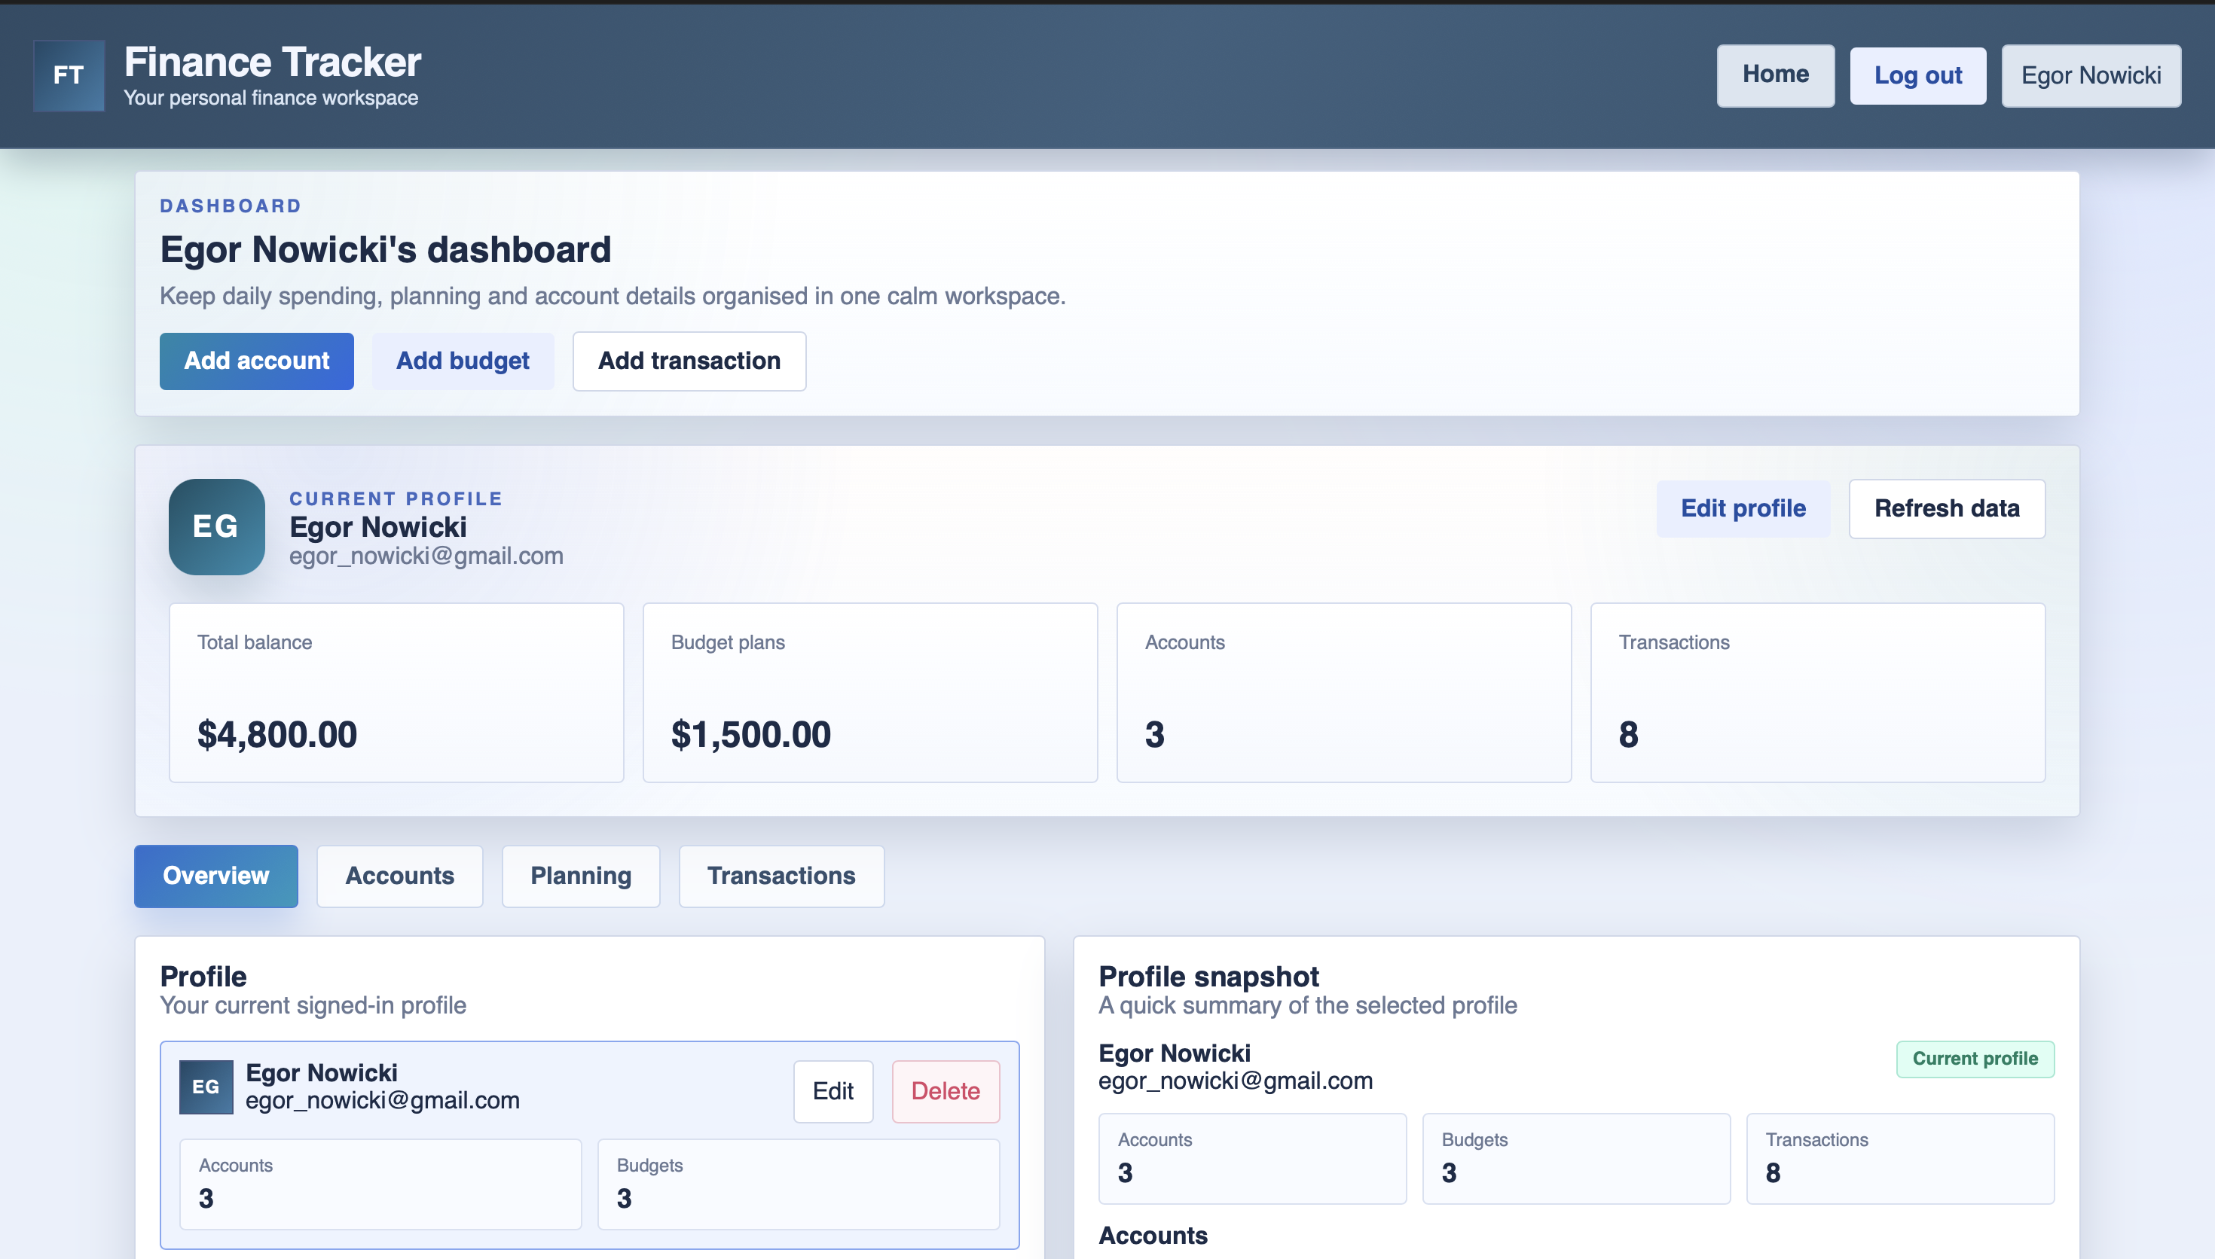

Рисунок 4.1 – Страница входа

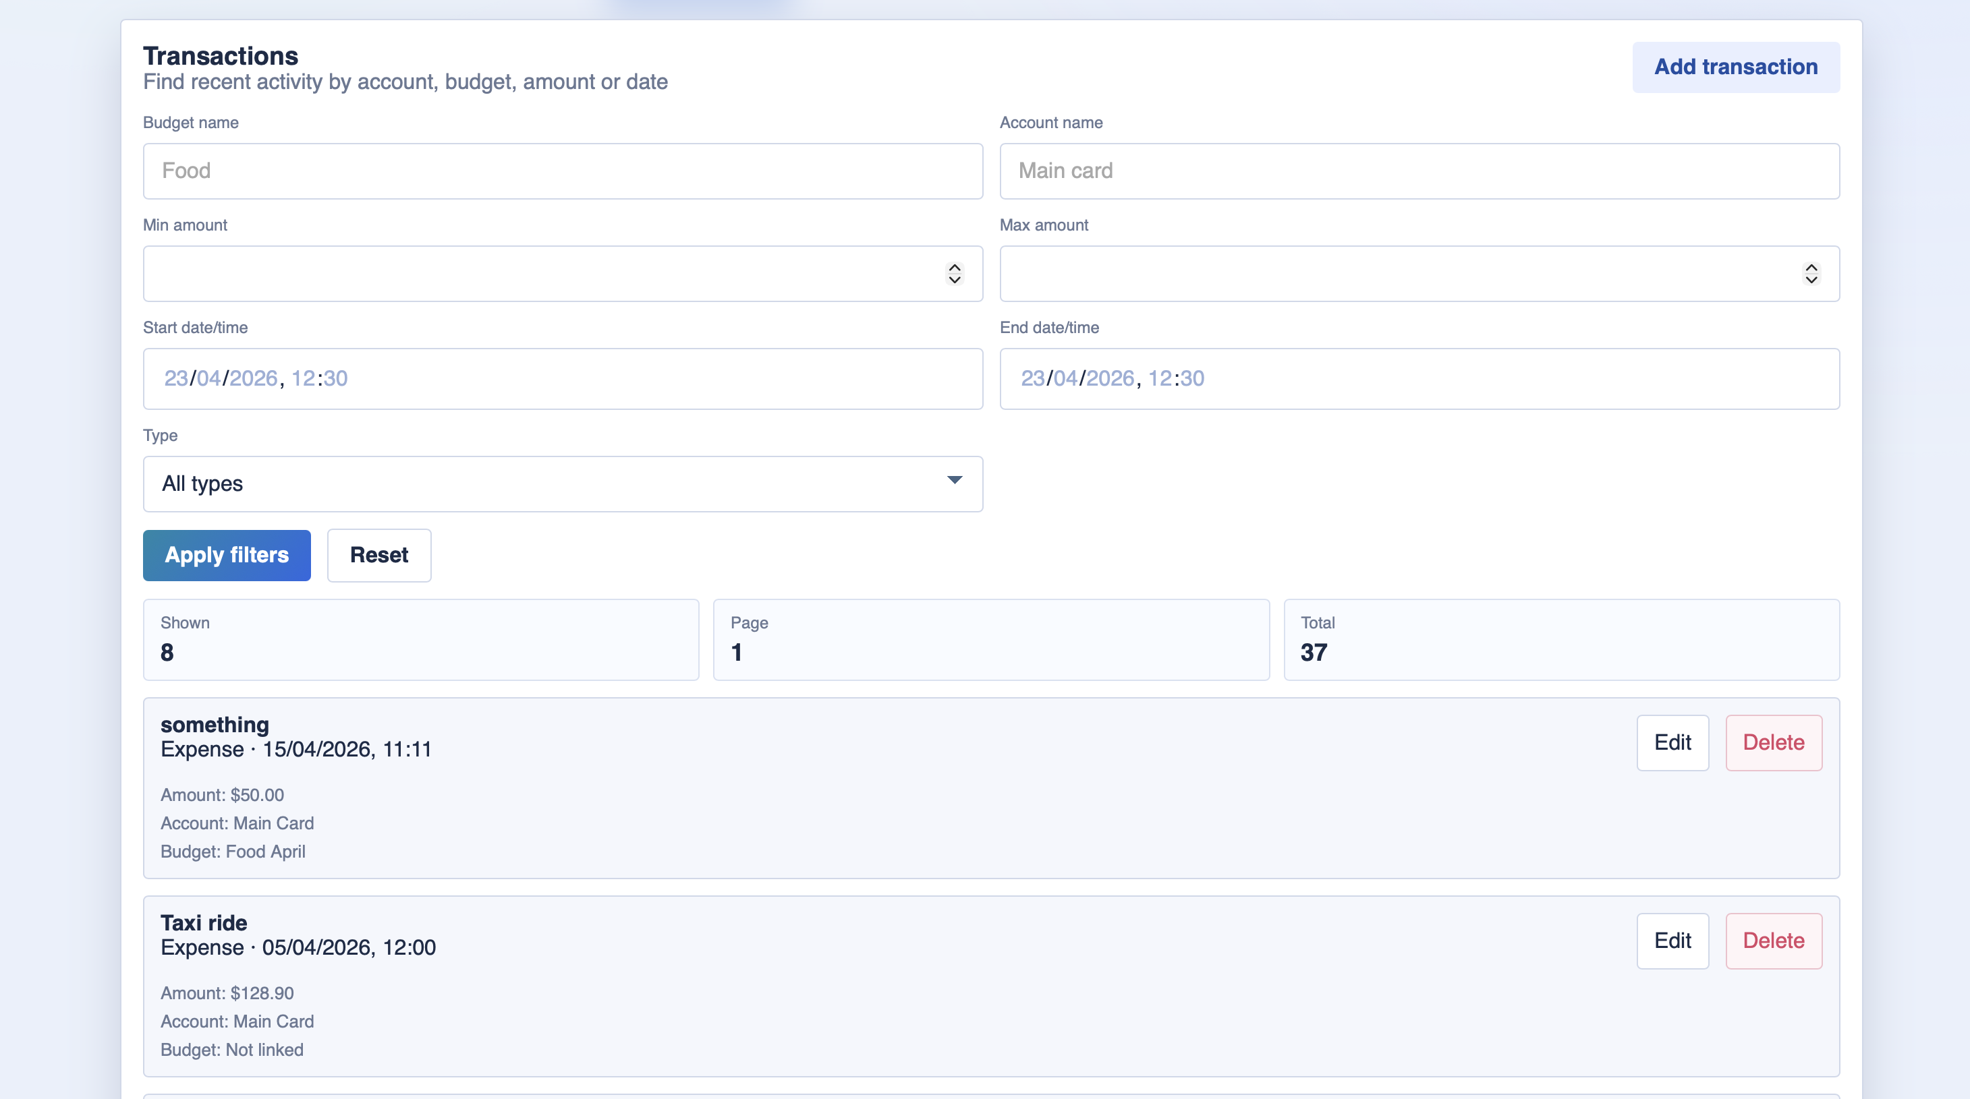

Рисунок 4.2 – Демонстрация просмотра транзакций

5 ЗАКЛЮЧЕНИЕ

В ходе выполнения лабораторной работы реализован SPA-клиент на React, обеспечивающий полноценное взаимодействие с ранее разработанным API. Реализовано отображение связей OneToMany (user – meal) и ManyToMany (meal – product) с визуализацией связанных сущностей. Разработан CRUD-интерфейс для всех основных моделей, позволяющий создавать, просматривать, удалять и обновлять записи через удобную форму. Реализована фильтрация данных по ключевым полям с обновлением списка без перезагрузки страницы. Проведена демонстрация работы клиента: при изменении данных через CRUD-операции связанные сущности корректно обновляются, фильтрация отрабатывает без потери производительности. Выполнено тестирование всех сценариев взаимодействия с API (GET, POST, PUT, DELETE), результаты подтверждают корректную работу клиент-серверной архитектуры и правильное отображение сложных связей между сущностями.

6 ДЕМОНСТРАЦИЯ ТОНКОГО И ТОЛСТОГО КЛИЕНТА



Рисунок 6.1 – Демонстрация тонкого клиента



Рисунок 6.2 – Демонстрация толстого клиента

