Министерство образования Республики Беларусь Учреждение образования
«БЕЛОРУССКИЙ ГОСУДАРСТВЕННЫЙ УНИВЕРСИТЕТ ИНФОРМАТИКИ И РАДИОЭЛЕКТРОНИКИ»
Кафедра электронных вычислительных машин

ОТЧЕТ
О ЛАБОРАТОРНОЙ РАБОТЕ № 4
Error logging/handling
по дисциплине «Программирование на языках высокого уровня»

Выполнил ст. гр. 450502 Е.Ю. Новицкий
Проверил асс. каф. ЭВМ И.Г. Скиба

Минск 2026

1 ПОСТАНОВКА ЗАДАЧИ

1 Реализовать глобальную обработку ошибок через @ControllerAdvice.
2 Добавить валидацию входных данных через @Valid.
3 Реализовать единый формат ошибки для всех endpoint.
4 Настроить логирование через logback:
- уровни логирования
- ротация логов
5 Реализовать аспект (AOP) для логирования времени выполнения сервисных методов.
6 Подключить Swagger/OpenAPI с описанием endpoint и DTO.
2 СТРУКТУРА ПРОЕКТА

finance-tracker
├── .gitignore
├── Dockerfile
├── README.md
├── docker-compose.yaml
├── logs
│ ├── application.log
│ └── error.log
├── mvnw
├── mvnw.cmd
├── pom.xml
└── src
└── main
├── java
│ └── com
│ └── finance
│ └── tracker
│ ├── FinanceTrackerApplication.java
│ ├── aop
│ │ └── ServiceLoggingAspect.java
│ ├── cache
│ │ ├── CacheKey.java
│ │ └── CacheManager.java
│ ├── controller
│ │ ├── AccountController.java
│ │ ├── BudgetController.java
│ │ ├── TagController.java
│ │ ├── TransactionController.java
│ │ ├── UserController.java
│ │ └── api
│ │ ├── AccountControllerApi.java
│ │ ├── BudgetControllerApi.java
│ │ ├── TagControllerApi.java
│ │ ├── TransactionControllerApi.java
│ │ └── UserControllerApi.java
│ ├── domain
│ │ ├── Account.java
│ │ ├── AccountType.java
│ │ ├── Budget.java
│ │ ├── Tag.java
│ │ ├── Transaction.java
│ │ ├── TransactionType.java
│ │ └── User.java
│ ├── dto
│ │ ├── request
│ │ │ ├── AccountRequest.java
│ │ │ ├── AccountTransferRequest.java
│ │ │ ├── AccountUpdateRequest.java
│ │ │ ├── BudgetRequest.java
│ │ │ ├── BudgetUpdateRequest.java
│ │ │ ├── TagRequest.java
│ │ │ ├── TagUpdateRequest.java
│ │ │ ├── TransactionRequest.java
│ │ │ ├── TransactionUpdateRequest.java
│ │ │ ├── UserRequest.java
│ │ │ └── UserUpdateRequest.java
│ │ └── response
│ │ ├── AccountResponse.java
│ │ ├── BudgetResponse.java
│ │ ├── TagResponse.java
│ │ ├── TransactionResponse.java
│ │ └── UserResponse.java
│ ├── exception
│ │ ├── ApiException.java
│ │ ├── BadRequestException.java
│ │ ├── ConflictException.java
│ │ ├── DuplicateResourceException.java
│ │ ├── GlobalExceptionHandler.java
│ │ ├── LoggingException.java
│ │ ├── ResourceNotFoundException.java
│ │ └── response
│ │ ├── ErrorResponse.java
│ │ └── ValidationErrorResponse.java
│ ├── mapper
│ │ ├── AccountMapper.java
│ │ ├── BudgetMapper.java
│ │ ├── TagMapper.java
│ │ ├── TransactionMapper.java
│ │ └── UserMapper.java
│ ├── repository
│ │ ├── AccountRepository.java
│ │ ├── BudgetRepository.java
│ │ ├── TagRepository.java
│ │ ├── TransactionRepository.java
│ │ └── UserRepository.java
│ └── service
│ ├── AccountService.java
│ ├── BudgetService.java
│ ├── TagService.java
│ ├── TransactionService.java
│ ├── UserService.java
│ └── impl
│ ├── AccountServiceImpl.java
│ ├── BudgetServiceImpl.java
│ ├── TagServiceImpl.java
│ ├── TransactionServiceImpl.java
│ └── UserServiceImpl.java
└── resources
├── application.properties
└── logback-spring.xml
3 ЛИСТИНГ КОДА

Файл ServiceLoggingAspect.java

package com.finance.tracker.aop;

import com.finance.tracker.exception.ApiException;
import com.finance.tracker.exception.LoggingException;
import java.util.Arrays;
import org.aspectj.lang.ProceedingJoinPoint;
import org.aspectj.lang.annotation.Around;
import org.aspectj.lang.annotation.Aspect;
import org.aspectj.lang.annotation.Pointcut;
import org.slf4j.Logger;
import org.slf4j.LoggerFactory;
import org.springframework.stereotype.Component;
import org.springframework.util.StopWatch;

@Aspect
@Component
public class ServiceLoggingAspect {

private static final int SLOW_THRESHOLD_MS = 500;
private static final int VERY_SLOW_THRESHOLD_MS = 1000;
private static final String ERROR_EXECUTING_METHOD = "Error executing method!";

private static final Logger LOGGER = LoggerFactory.getLogger(ServiceLoggingAspect.class);

@Pointcut("within(@org.springframework.stereotype.Service *)")
public void serviceMethods() {
}

@Around("serviceMethods()")
public Object logExecutionTime(ProceedingJoinPoint joinPoint) throws Throwable {
String className = joinPoint.getTarget().getClass().getSimpleName();
String methodName = joinPoint.getSignature().getName();
String fullMethodName = className + "." + methodName;

StopWatch stopWatch = new StopWatch(fullMethodName);

try {
stopWatch.start(fullMethodName);
LOGGER.debug("Executing method: {} with arguments: {}",
fullMethodName,
Arrays.toString(joinPoint.getArgs()));

Object result = joinPoint.proceed();

stopWatch.stop();
long executionTime = stopWatch.getTotalTimeMillis();

if (executionTime > VERY_SLOW_THRESHOLD_MS) {
LOGGER.warn("Method {} finished in {} ms (exceeds {} ms threshold)",
fullMethodName,
executionTime,
VERY_SLOW_THRESHOLD_MS);
} else if (executionTime > SLOW_THRESHOLD_MS) {
LOGGER.info("Method {} finished in {} ms", fullMethodName, executionTime);
} else {
LOGGER.debug("Method {} finished in {} ms", fullMethodName, executionTime);
}

return result;
} catch (ApiException exception) {
LOGGER.warn("Business exception in method {}: {}", fullMethodName, exception.getMessage());
throw exception;
} catch (Exception exception) {
LOGGER.error("Unexpected error while executing method {}: {}",
fullMethodName,
exception.getMessage(),
exception);
throw new LoggingException(ERROR_EXECUTING_METHOD);
}
}
}

Файл AccountControllerApi.java

package com.finance.tracker.controller.api;

import com.finance.tracker.dto.request.AccountRequest;
import com.finance.tracker.dto.request.AccountTransferRequest;
import com.finance.tracker.dto.request.AccountUpdateRequest;
import com.finance.tracker.dto.response.AccountResponse;
import com.finance.tracker.exception.response.ErrorResponse;
import com.finance.tracker.exception.response.ValidationErrorResponse;
import io.swagger.v3.oas.annotations.Operation;
import io.swagger.v3.oas.annotations.Parameter;
import io.swagger.v3.oas.annotations.media.ArraySchema;
import io.swagger.v3.oas.annotations.media.Content;
import io.swagger.v3.oas.annotations.media.Schema;
import io.swagger.v3.oas.annotations.responses.ApiResponse;
import io.swagger.v3.oas.annotations.responses.ApiResponses;
import io.swagger.v3.oas.annotations.tags.Tag;
import jakarta.validation.Valid;
import java.util.List;
import org.springframework.http.ResponseEntity;
import org.springframework.web.bind.annotation.DeleteMapping;
import org.springframework.web.bind.annotation.GetMapping;
import org.springframework.web.bind.annotation.PatchMapping;
import org.springframework.web.bind.annotation.PathVariable;
import org.springframework.web.bind.annotation.PostMapping;
import org.springframework.web.bind.annotation.RequestBody;
import org.springframework.web.bind.annotation.RequestParam;

@Tag(name = "Account Controller", description = "Account management endpoints")
public interface AccountControllerApi {

@Operation(summary = "Get account by ID", description = "Returns account details by identifier.")
@ApiResponses(value = {
@ApiResponse(responseCode = "200", description = "Account found",
content = @Content(schema = @Schema(implementation = AccountResponse.class))),
@ApiResponse(responseCode = "404", description = "Account not found",
content = @Content(schema = @Schema(implementation = ErrorResponse.class)))
})
@GetMapping("/api/v1/accounts/{id}")
ResponseEntity<AccountResponse> getAccountById(
@Parameter(description = "Account ID", required = true, example = "1") @PathVariable Long id);

@Operation(summary = "Get all accounts", description = "Returns all accounts.")
@ApiResponses(value = {
@ApiResponse(responseCode = "200", description = "Accounts retrieved successfully",
content = @Content(array = @ArraySchema(schema = @Schema(implementation = AccountResponse.class))))
})
@GetMapping("/api/v1/accounts")
ResponseEntity<List<AccountResponse>> getAllAccounts();

@Operation(summary = "Create account", description = "Creates a new account.")
@ApiResponses(value = {
@ApiResponse(responseCode = "201", description = "Account created successfully",
content = @Content(schema = @Schema(implementation = AccountResponse.class))),
@ApiResponse(responseCode = "400", description = "Invalid request body",
content = @Content(schema = @Schema(implementation = ValidationErrorResponse.class))),
@ApiResponse(responseCode = "404", description = "User not found",
content = @Content(schema = @Schema(implementation = ErrorResponse.class)))
})
@PostMapping("/api/v1/accounts")
ResponseEntity<AccountResponse> createAccount(
@Parameter(description = "Account payload", required = true) @Valid @RequestBody AccountRequest request);

@Operation(summary = "Create transfer", description = "Transfers money between two accounts.")
@ApiResponses(value = {
@ApiResponse(responseCode = "204", description = "Transfer completed successfully"),
@ApiResponse(responseCode = "400", description = "Invalid request body",
content = @Content(schema = @Schema(implementation = ErrorResponse.class))),
@ApiResponse(responseCode = "404", description = "Account not found",
content = @Content(schema = @Schema(implementation = ErrorResponse.class))),
@ApiResponse(responseCode = "409", description = "Transfer conflict",
content = @Content(schema = @Schema(implementation = ErrorResponse.class))),
@ApiResponse(responseCode = "500", description = "Unexpected transfer error",
content = @Content(schema = @Schema(implementation = ValidationErrorResponse.class)))
})
@PostMapping("/api/v1/account/transfer")
ResponseEntity<Void> createTransfer(
@Parameter(description = "Transfer payload", required = true)
@Valid @RequestBody AccountTransferRequest request,
@Parameter(description = "Run transfer inside a transaction", example = "true")
@RequestParam(defaultValue = "true") boolean transactional,
@Parameter(description = "Force an error after debit for demo purposes", example = "false")
@RequestParam(defaultValue = "false") boolean failAfterDebit);

@Operation(summary = "Patch account", description = "Partially updates an account.")
@ApiResponses(value = {
@ApiResponse(responseCode = "200", description = "Account updated successfully",
content = @Content(schema = @Schema(implementation = AccountResponse.class))),
@ApiResponse(responseCode = "400", description = "Invalid request body",
content = @Content(schema = @Schema(implementation = ErrorResponse.class))),
@ApiResponse(responseCode = "404", description = "Account or user not found",
content = @Content(schema = @Schema(implementation = ErrorResponse.class))),
@ApiResponse(responseCode = "409", description = "Account update conflict",
content = @Content(schema = @Schema(implementation = ErrorResponse.class)))
})
@PatchMapping("/api/v1/accounts/{id}")
ResponseEntity<AccountResponse> updateAccount(
@Parameter(description = "Account ID", required = true, example = "1")
@PathVariable Long id,
@Parameter(description = "Partial account payload", required = true)
@Valid @RequestBody AccountUpdateRequest request);

@Operation(summary = "Delete account", description = "Deletes an account by ID.")
@ApiResponses(value = {
@ApiResponse(responseCode = "204", description = "Account deleted successfully"),
@ApiResponse(responseCode = "404", description = "Account not found",
content = @Content(schema = @Schema(implementation = ErrorResponse.class)))
})
@DeleteMapping("/api/v1/accounts/{id}")
ResponseEntity<Void> deleteAccount(
@Parameter(description = "Account ID", required = true, example = "1") @PathVariable Long id);
}

Файл BudgetControllerApi.java

package com.finance.tracker.controller.api;

import com.finance.tracker.dto.request.BudgetRequest;
import com.finance.tracker.dto.request.BudgetUpdateRequest;
import com.finance.tracker.dto.response.BudgetResponse;
import com.finance.tracker.exception.response.ErrorResponse;
import com.finance.tracker.exception.response.ValidationErrorResponse;
import io.swagger.v3.oas.annotations.Operation;
import io.swagger.v3.oas.annotations.Parameter;
import io.swagger.v3.oas.annotations.media.Content;
import io.swagger.v3.oas.annotations.media.Schema;
import io.swagger.v3.oas.annotations.responses.ApiResponse;
import io.swagger.v3.oas.annotations.responses.ApiResponses;
import io.swagger.v3.oas.annotations.tags.Tag;
import jakarta.validation.Valid;
import org.springframework.data.domain.Page;
import org.springframework.http.ResponseEntity;
import org.springframework.web.bind.annotation.DeleteMapping;
import org.springframework.web.bind.annotation.GetMapping;
import org.springframework.web.bind.annotation.PatchMapping;
import org.springframework.web.bind.annotation.PathVariable;
import org.springframework.web.bind.annotation.PostMapping;
import org.springframework.web.bind.annotation.RequestBody;
import org.springframework.web.bind.annotation.RequestParam;

@Tag(name = "Budget Controller", description = "Budget management endpoints")
public interface BudgetControllerApi {

@Operation(summary = "Get budget by ID", description = "Returns budget details by identifier.")
@ApiResponses(value = {
@ApiResponse(
responseCode = "200",
description = "Budget found",
content = @Content(schema = @Schema(implementation = BudgetResponse.class))),
@ApiResponse(
responseCode = "404",
description = "Budget not found",
content = @Content(schema = @Schema(implementation = ErrorResponse.class)))
})
@GetMapping("/api/v1/budgets/{id}")
ResponseEntity<BudgetResponse> getBudgetById(
@Parameter(description = "Budget ID", required = true, example = "1")
@PathVariable Long id
);

@Operation(summary = "Get budgets", description = "Returns budgets with pagination and sorting.")
@ApiResponses(value = {
@ApiResponse(
responseCode = "200",
description = "Budgets retrieved successfully",
content = @Content(schema = @Schema(implementation = Page.class)))
})
@GetMapping("/api/v1/budgets")
ResponseEntity<Page<BudgetResponse>> getAllBudgets(
@Parameter(description = "Page index", example = "0")
@RequestParam(defaultValue = "0") int page,
@Parameter(description = "Page size", example = "3")
@RequestParam(defaultValue = "3") int size,
@Parameter(description = "Sort field", example = "id")
@RequestParam(defaultValue = "id") String sortBy,
@Parameter(description = "Sort direction flag", example = "true")
@RequestParam(defaultValue = "true") boolean ascending
);

@Operation(summary = "Create budget", description = "Creates a new budget.")
@ApiResponses(value = {
@ApiResponse(
responseCode = "201",
description = "Budget created successfully",
content = @Content(schema = @Schema(implementation = BudgetResponse.class))),
@ApiResponse(
responseCode = "400",
description = "Invalid request body",
content = @Content(schema = @Schema(implementation = ValidationErrorResponse.class))),
@ApiResponse(
responseCode = "404",
description = "User not found",
content = @Content(schema = @Schema(implementation = ErrorResponse.class)))
})
@PostMapping("/api/v1/budgets")
ResponseEntity<BudgetResponse> createBudget(
@Parameter(description = "Budget payload", required = true)
@Valid @RequestBody BudgetRequest request
);

@Operation(summary = "Patch budget", description = "Partially updates a budget.")
@ApiResponses(value = {
@ApiResponse(
responseCode = "200",
description = "Budget updated successfully",
content = @Content(schema = @Schema(implementation = BudgetResponse.class))),
@ApiResponse(
responseCode = "400",
description = "Invalid request body",
content = @Content(schema = @Schema(implementation = ValidationErrorResponse.class))),
@ApiResponse(
responseCode = "404",
description = "Budget or user not found",
content = @Content(schema = @Schema(implementation = ErrorResponse.class)))
})
@PatchMapping("/api/v1/budgets/{id}")
ResponseEntity<BudgetResponse> updateBudget(
@Parameter(description = "Budget ID", required = true, example = "1")
@PathVariable Long id,
@Parameter(description = "Partial budget payload", required = true)
@Valid @RequestBody BudgetUpdateRequest request
);

@Operation(summary = "Delete budget", description = "Deletes a budget by ID.")
@ApiResponses(value = {
@ApiResponse(responseCode = "204", description = "Budget deleted successfully"),
@ApiResponse(
responseCode = "404",
description = "Budget not found",
content = @Content(schema = @Schema(implementation = ErrorResponse.class)))
})
@DeleteMapping("/api/v1/budgets/{id}")
ResponseEntity<Void> deleteBudget(
@Parameter(description = "Budget ID", required = true, example = "1")
@PathVariable Long id
);
}

Файл TagControllerApi.java

package com.finance.tracker.controller.api;

import com.finance.tracker.dto.request.TagRequest;
import com.finance.tracker.dto.request.TagUpdateRequest;
import com.finance.tracker.dto.response.TagResponse;
import com.finance.tracker.exception.response.ErrorResponse;
import com.finance.tracker.exception.response.ValidationErrorResponse;
import io.swagger.v3.oas.annotations.Operation;
import io.swagger.v3.oas.annotations.Parameter;
import io.swagger.v3.oas.annotations.media.ArraySchema;
import io.swagger.v3.oas.annotations.media.Content;
import io.swagger.v3.oas.annotations.media.Schema;
import io.swagger.v3.oas.annotations.responses.ApiResponse;
import io.swagger.v3.oas.annotations.responses.ApiResponses;
import io.swagger.v3.oas.annotations.tags.Tag;
import jakarta.validation.Valid;
import java.util.List;
import org.springframework.http.ResponseEntity;
import org.springframework.web.bind.annotation.DeleteMapping;
import org.springframework.web.bind.annotation.GetMapping;
import org.springframework.web.bind.annotation.PatchMapping;
import org.springframework.web.bind.annotation.PathVariable;
import org.springframework.web.bind.annotation.PostMapping;
import org.springframework.web.bind.annotation.RequestBody;

@Tag(name = "Tag Controller", description = "Tag management endpoints")
public interface TagControllerApi {

@Operation(summary = "Get tag by ID", description = "Returns tag details by identifier.")
@ApiResponses(value = {
@ApiResponse(
responseCode = "200",
description = "Tag found",
content = @Content(schema = @Schema(implementation = TagResponse.class))),
@ApiResponse(
responseCode = "404",
description = "Tag not found",
content = @Content(schema = @Schema(implementation = ErrorResponse.class)))
})
@GetMapping("/api/v1/tags/{id}")
ResponseEntity<TagResponse> getTagById(
@Parameter(description = "Tag ID", required = true, example = "1")
@PathVariable Long id
);

@Operation(summary = "Get all tags", description = "Returns all tags.")
@ApiResponses(value = {
@ApiResponse(
responseCode = "200",
description = "Tags retrieved successfully",
content = @Content(array = @ArraySchema(schema = @Schema(implementation = TagResponse.class))))
})
@GetMapping("/api/v1/tags")
ResponseEntity<List<TagResponse>> getAllTags();

@Operation(summary = "Create tag", description = "Creates a new tag.")
@ApiResponses(value = {
@ApiResponse(
responseCode = "201",
description = "Tag created successfully",
content = @Content(schema = @Schema(implementation = TagResponse.class))),
@ApiResponse(
responseCode = "400",
description = "Invalid request body",
content = @Content(schema = @Schema(implementation = ValidationErrorResponse.class))),
@ApiResponse(
responseCode = "409",
description = "Duplicate tag name",
content = @Content(schema = @Schema(implementation = ErrorResponse.class)))
})
@PostMapping("/api/v1/tags")
ResponseEntity<TagResponse> createTag(
@Parameter(description = "Tag payload", required = true)
@Valid @RequestBody TagRequest request
);

@Operation(summary = "Patch tag", description = "Partially updates a tag.")
@ApiResponses(value = {
@ApiResponse(
responseCode = "200",
description = "Tag updated successfully",
content = @Content(schema = @Schema(implementation = TagResponse.class))),
@ApiResponse(
responseCode = "400",
description = "Invalid request body",
content = @Content(schema = @Schema(implementation = ValidationErrorResponse.class))),
@ApiResponse(
responseCode = "404",
description = "Tag not found",
content = @Content(schema = @Schema(implementation = ErrorResponse.class))),
@ApiResponse(
responseCode = "409",
description = "Duplicate tag name",
content = @Content(schema = @Schema(implementation = ErrorResponse.class)))
})
@PatchMapping("/api/v1/tags/{id}")
ResponseEntity<TagResponse> updateTag(
@Parameter(description = "Tag ID", required = true, example = "1")
@PathVariable Long id,
@Parameter(description = "Partial tag payload", required = true)
@Valid @RequestBody TagUpdateRequest request
);

@Operation(summary = "Delete tag", description = "Deletes a tag by ID.")
@ApiResponses(value = {
@ApiResponse(responseCode = "204", description = "Tag deleted successfully"),
@ApiResponse(
responseCode = "404",
description = "Tag not found",
content = @Content(schema = @Schema(implementation = ErrorResponse.class)))
})
@DeleteMapping("/api/v1/tags/{id}")
ResponseEntity<Void> deleteTag(
@Parameter(description = "Tag ID", required = true, example = "1")
@PathVariable Long id
);
}

Файл TransactionControllerApi.java

package com.finance.tracker.controller.api;

import com.finance.tracker.dto.request.TransactionRequest;
import com.finance.tracker.dto.request.TransactionUpdateRequest;
import com.finance.tracker.dto.response.TransactionResponse;
import com.finance.tracker.exception.response.ErrorResponse;
import com.finance.tracker.exception.response.ValidationErrorResponse;
import io.swagger.v3.oas.annotations.Operation;
import io.swagger.v3.oas.annotations.Parameter;
import io.swagger.v3.oas.annotations.media.ArraySchema;
import io.swagger.v3.oas.annotations.media.Content;
import io.swagger.v3.oas.annotations.media.Schema;
import io.swagger.v3.oas.annotations.responses.ApiResponse;
import io.swagger.v3.oas.annotations.responses.ApiResponses;
import io.swagger.v3.oas.annotations.tags.Tag;
import jakarta.validation.Valid;
import java.time.LocalDate;
import java.util.List;
import org.springframework.http.ResponseEntity;
import org.springframework.web.bind.annotation.DeleteMapping;
import org.springframework.web.bind.annotation.GetMapping;
import org.springframework.web.bind.annotation.PatchMapping;
import org.springframework.web.bind.annotation.PathVariable;
import org.springframework.web.bind.annotation.PostMapping;
import org.springframework.web.bind.annotation.RequestBody;
import org.springframework.web.bind.annotation.RequestParam;

@Tag(name = "Transaction Controller", description = "Transaction management endpoints")
public interface TransactionControllerApi {

@Operation(summary = "Get transaction by ID", description = "Returns transaction details by identifier.")
@ApiResponses(value = {
@ApiResponse(
responseCode = "200",
description = "Transaction found",
content = @Content(schema = @Schema(implementation = TransactionResponse.class))),
@ApiResponse(
responseCode = "404",
description = "Transaction not found",
content = @Content(schema = @Schema(implementation = ErrorResponse.class)))
})
@GetMapping("/api/v1/transactions/{id}")
ResponseEntity<TransactionResponse> getById(
@Parameter(description = "Transaction ID", required = true, example = "1")
@PathVariable Long id
);

@Operation(
summary = "Get transactions",
description = "Returns all transactions or filters them by date range."
)
@ApiResponses(value = {
@ApiResponse(
responseCode = "200",
description = "Transactions retrieved successfully",
content = @Content(
array = @ArraySchema(schema = @Schema(implementation = TransactionResponse.class))
)),
@ApiResponse(
responseCode = "400",
description = "Invalid query parameters",
content = @Content(schema = @Schema(implementation = ErrorResponse.class)))
})
@GetMapping("/api/v1/transactions")
ResponseEntity<List<TransactionResponse>> getByDateRange(
@Parameter(description = "Start date filter", example = "2026-03-01")
@RequestParam(required = false) LocalDate startDate,
@Parameter(description = "End date filter", example = "2026-03-31")
@RequestParam(required = false) LocalDate endDate,
@Parameter(description = "Whether to fetch transactions with EntityGraph", example = "false")
@RequestParam(required = false, defaultValue = "false") boolean withEntityGraph
);

@Operation(summary = "Create transaction", description = "Creates a new transaction.")
@ApiResponses(value = {
@ApiResponse(
responseCode = "201",
description = "Transaction created successfully",
content = @Content(schema = @Schema(implementation = TransactionResponse.class))),
@ApiResponse(
responseCode = "400",
description = "Invalid request body",
content = @Content(schema = @Schema(implementation = ValidationErrorResponse.class))),
@ApiResponse(
responseCode = "404",
description = "Account or tags not found",
content = @Content(schema = @Schema(implementation = ErrorResponse.class)))
})
@PostMapping("/api/v1/transactions")
ResponseEntity<TransactionResponse> createTransaction(
@Parameter(description = "Transaction payload", required = true)
@Valid @RequestBody TransactionRequest request
);

@Operation(summary = "Patch transaction", description = "Partially updates a transaction.")
@ApiResponses(value = {
@ApiResponse(
responseCode = "200",
description = "Transaction updated successfully",
content = @Content(schema = @Schema(implementation = TransactionResponse.class))),
@ApiResponse(
responseCode = "400",
description = "Invalid request body",
content = @Content(schema = @Schema(implementation = ValidationErrorResponse.class))),
@ApiResponse(
responseCode = "404",
description = "Transaction, account, or tags not found",
content = @Content(schema = @Schema(implementation = ErrorResponse.class)))
})
@PatchMapping("/api/v1/transactions/{id}")
ResponseEntity<TransactionResponse> updateTransaction(
@Parameter(description = "Transaction ID", required = true, example = "1")
@PathVariable Long id,
@Parameter(description = "Partial transaction payload", required = true)
@Valid @RequestBody TransactionUpdateRequest request
);

@Operation(summary = "Delete transaction", description = "Deletes a transaction by ID.")
@ApiResponses(value = {
@ApiResponse(responseCode = "204", description = "Transaction deleted successfully"),
@ApiResponse(
responseCode = "404",
description = "Transaction not found",
content = @Content(schema = @Schema(implementation = ErrorResponse.class)))
})
@DeleteMapping("/api/v1/transactions/{id}")
ResponseEntity<Void> deleteTransaction(
@Parameter(description = "Transaction ID", required = true, example = "1")
@PathVariable Long id
);
}

Файл UserControllerApi.java

package com.finance.tracker.controller.api;

import com.finance.tracker.domain.AccountType;
import com.finance.tracker.dto.request.UserRequest;
import com.finance.tracker.dto.request.UserUpdateRequest;
import com.finance.tracker.dto.response.UserResponse;
import com.finance.tracker.exception.response.ErrorResponse;
import com.finance.tracker.exception.response.ValidationErrorResponse;
import io.swagger.v3.oas.annotations.Operation;
import io.swagger.v3.oas.annotations.Parameter;
import io.swagger.v3.oas.annotations.media.ArraySchema;
import io.swagger.v3.oas.annotations.media.Content;
import io.swagger.v3.oas.annotations.media.Schema;
import io.swagger.v3.oas.annotations.responses.ApiResponse;
import io.swagger.v3.oas.annotations.responses.ApiResponses;
import io.swagger.v3.oas.annotations.tags.Tag;
import jakarta.validation.Valid;
import java.math.BigDecimal;
import java.util.List;
import org.springframework.http.ResponseEntity;
import org.springframework.web.bind.annotation.DeleteMapping;
import org.springframework.web.bind.annotation.GetMapping;
import org.springframework.web.bind.annotation.PatchMapping;
import org.springframework.web.bind.annotation.PathVariable;
import org.springframework.web.bind.annotation.PostMapping;
import org.springframework.web.bind.annotation.RequestBody;
import org.springframework.web.bind.annotation.RequestParam;

@Tag(name = "User Controller", description = "User management endpoints")
public interface UserControllerApi {

@Operation(summary = "Get user by ID", description = "Returns user details by identifier.")
@ApiResponses(value = {
@ApiResponse(
responseCode = "200",
description = "User found",
content = @Content(schema = @Schema(implementation = UserResponse.class))),
@ApiResponse(
responseCode = "404",
description = "User not found",
content = @Content(schema = @Schema(implementation = ErrorResponse.class)))
})
@GetMapping("/api/v1/users/{id}")
ResponseEntity<UserResponse> getUserById(
@Parameter(description = "User ID", required = true, example = "1")
@PathVariable Long id
);

@Operation(summary = "Get all users", description = "Returns all users.")
@ApiResponses(value = {
@ApiResponse(
responseCode = "200",
description = "Users retrieved successfully",
content = @Content(array = @ArraySchema(schema = @Schema(implementation = UserResponse.class))))
})
@GetMapping("/api/v1/users")
ResponseEntity<List<UserResponse>> getAllUsers();

@Operation(
summary = "Search users with JPQL",
description = "Finds users by account type and budget limit range using JPQL."
)
@ApiResponses(value = {
@ApiResponse(
responseCode = "200",
description = "Users retrieved successfully",
content = @Content(array = @ArraySchema(schema = @Schema(implementation = UserResponse.class)))),
@ApiResponse(
responseCode = "400",
description = "Invalid search parameters",
content = @Content(schema = @Schema(implementation = ErrorResponse.class)))
})
@GetMapping("/api/v1/users/search/account-type/jpql")
ResponseEntity<List<UserResponse>> searchUsersWithJpql(
@Parameter(description = "Account type filter", required = true, example = "CHECKING")
@RequestParam("accountType") AccountType accountType,
@Parameter(description = "Minimum budget limit", required = true, example = "100.00")
@RequestParam("minBudgetLimit") BigDecimal minBudgetLimit,
@Parameter(description = "Maximum budget limit", required = true, example = "1000.00")
@RequestParam("maxBudgetLimit") BigDecimal maxBudgetLimit
);

@Operation(
summary = "Search users with native SQL",
description = "Finds users by account type and budget limit range using a native query."
)
@ApiResponses(value = {
@ApiResponse(
responseCode = "200",
description = "Users retrieved successfully",
content = @Content(array = @ArraySchema(schema = @Schema(implementation = UserResponse.class)))),
@ApiResponse(
responseCode = "400",
description = "Invalid search parameters",
content = @Content(schema = @Schema(implementation = ErrorResponse.class)))
})
@GetMapping("/api/v1/users/search/account-type/native")
ResponseEntity<List<UserResponse>> searchUsersWithNative(
@Parameter(description = "Account type filter", required = true, example = "CHECKING")
@RequestParam("accountType") AccountType accountType,
@Parameter(description = "Minimum budget limit", required = true, example = "100.00")
@RequestParam("minBudgetLimit") BigDecimal minBudgetLimit,
@Parameter(description = "Maximum budget limit", required = true, example = "1000.00")
@RequestParam("maxBudgetLimit") BigDecimal maxBudgetLimit
);

@Operation(summary = "Create user", description = "Creates a new user.")
@ApiResponses(value = {
@ApiResponse(
responseCode = "201",
description = "User created successfully",
content = @Content(schema = @Schema(implementation = UserResponse.class))),
@ApiResponse(
responseCode = "400",
description = "Invalid request body",
content = @Content(schema = @Schema(implementation = ErrorResponse.class))),
@ApiResponse(
responseCode = "404",
description = "Related accounts or budgets not found",
content = @Content(schema = @Schema(implementation = ValidationErrorResponse.class))),
@ApiResponse(
responseCode = "409",
description = "User relation conflict",
content = @Content(schema = @Schema(implementation = ErrorResponse.class)))
})
@PostMapping("/api/v1/users")
ResponseEntity<UserResponse> createUser(
@Parameter(description = "User payload", required = true)
@Valid @RequestBody UserRequest request
);

@Operation(summary = "Patch user", description = "Partially updates a user.")
@ApiResponses(value = {
@ApiResponse(
responseCode = "200",
description = "User updated successfully",
content = @Content(schema = @Schema(implementation = UserResponse.class))),
@ApiResponse(
responseCode = "400",
description = "Invalid request body",
content = @Content(schema = @Schema(implementation = ErrorResponse.class))),
@ApiResponse(
responseCode = "404",
description = "User or related entities not found",
content = @Content(schema = @Schema(implementation = ValidationErrorResponse.class))),
@ApiResponse(
responseCode = "409",
description = "User relation conflict",
content = @Content(schema = @Schema(implementation = ErrorResponse.class)))
})
@PatchMapping("/api/v1/users/{id}")
ResponseEntity<UserResponse> updateUser(
@Parameter(description = "User ID", required = true, example = "1")
@PathVariable Long id,
@Parameter(description = "Partial user payload", required = true)
@Valid @RequestBody UserUpdateRequest request
);

@Operation(summary = "Delete user", description = "Deletes a user by ID.")
@ApiResponses(value = {
@ApiResponse(responseCode = "204", description = "User deleted successfully"),
@ApiResponse(
responseCode = "404",
description = "User not found",
content = @Content(schema = @Schema(implementation = ErrorResponse.class)))
})
@DeleteMapping("/api/v1/users/{id}")
ResponseEntity<Void> deleteUser(
@Parameter(description = "User ID", required = true, example = "1")
@PathVariable Long id
);
}

Файл AccountUpdateRequest.java

package com.finance.tracker.dto.request;

import com.finance.tracker.domain.AccountType;
import io.swagger.v3.oas.annotations.media.Schema;
import jakarta.validation.constraints.DecimalMin;
import jakarta.validation.constraints.Min;
import jakarta.validation.constraints.Size;
import jakarta.validation.constraints.NotBlank;
import java.math.BigDecimal;
import lombok.AllArgsConstructor;
import lombok.Getter;
import lombok.NoArgsConstructor;
import lombok.Setter;

@Getter
@Setter
@NoArgsConstructor
@AllArgsConstructor
@Schema(description = "Request body for partially updating an account.")
public class AccountUpdateRequest {

@NotBlank(message = "must not be blank")
@Size(min = 3, max = 50)
private String name;

private AccountType type;

@DecimalMin(value = "0.00")
private BigDecimal balance;

@Min(1)
private Long userId;
}

Файл BudgetUpdateRequest.java

package com.finance.tracker.dto.request;

import io.swagger.v3.oas.annotations.media.Schema;
import jakarta.validation.constraints.Min;
import jakarta.validation.constraints.NotBlank;
import jakarta.validation.constraints.Positive;
import jakarta.validation.constraints.Size;
import java.math.BigDecimal;
import java.time.LocalDate;
import lombok.AllArgsConstructor;
import lombok.Getter;
import lombok.NoArgsConstructor;
import lombok.Setter;

@Getter
@Setter
@NoArgsConstructor
@AllArgsConstructor
@Schema(description = "Request body for partially updating a budget.")
public class BudgetUpdateRequest {

@NotBlank(message = "must not be blank")
@Size(min = 3, max = 50)
private String name;

@Positive
private BigDecimal limitAmount;

private LocalDate startDate;

private LocalDate endDate;

@Min(1)
private Long userId;
}

Файл TagUpdateRequest.java

package com.finance.tracker.dto.request;

import io.swagger.v3.oas.annotations.media.Schema;
import jakarta.validation.constraints.NotBlank;
import jakarta.validation.constraints.Size;
import lombok.AllArgsConstructor;
import lombok.Getter;
import lombok.NoArgsConstructor;
import lombok.Setter;

@Getter
@Setter
@NoArgsConstructor
@AllArgsConstructor
@Schema(description = "Request body for partially updating a tag.")
public class TagUpdateRequest {

@NotBlank(message = "must not be blank")
@Size(min = 1, max = 50)
private String name;
}

Файл TransactionUpdateRequest.java

package com.finance.tracker.dto.request;

import com.finance.tracker.domain.TransactionType;
import io.swagger.v3.oas.annotations.media.Schema;
import jakarta.validation.constraints.DecimalMin;
import jakarta.validation.constraints.NotBlank;
import jakarta.validation.constraints.Positive;
import jakarta.validation.constraints.Size;
import java.math.BigDecimal;
import java.time.LocalDateTime;
import java.util.List;
import lombok.AllArgsConstructor;
import lombok.Getter;
import lombok.NoArgsConstructor;
import lombok.Setter;

@Getter
@Setter
@NoArgsConstructor
@AllArgsConstructor
@Schema(description = "Request body for partially updating a transaction.")
public class TransactionUpdateRequest {

private LocalDateTime occurredAt;

@DecimalMin(value = "0.01")
private BigDecimal amount;

@NotBlank(message = "must not be blank")
@Size(min = 3, max = 255)
private String description;

private TransactionType type;

@Positive
private Long accountId;

private List<Long> tagIds;
}

Файл UserUpdateRequest.java

package com.finance.tracker.dto.request;

import io.swagger.v3.oas.annotations.media.Schema;
import jakarta.validation.constraints.Email;
import jakarta.validation.constraints.NotBlank;
import jakarta.validation.constraints.Size;
import java.util.List;
import lombok.AllArgsConstructor;
import lombok.Getter;
import lombok.NoArgsConstructor;
import lombok.Setter;

@Getter
@Setter
@AllArgsConstructor
@NoArgsConstructor
@Schema(description = "Request body for partially updating a user.")
public class UserUpdateRequest {

@NotBlank(message = "must not be blank")
@Size(min = 3, max = 50)
private String username;

@Email
private String email;

private List<Long> accountIds;

private List<Long> budgetIds;
}

Файл ApiException.java

package com.finance.tracker.exception;

import org.springframework.http.HttpStatus;

public abstract class ApiException extends RuntimeException {

private final HttpStatus status;

protected ApiException(HttpStatus status, String message) {
super(message);
this.status = status;
}

public HttpStatus getStatus() {
return status;
}
}

Файл BadRequestException.java

package com.finance.tracker.exception;

import org.springframework.http.HttpStatus;

public class BadRequestException extends ApiException {

public BadRequestException(String message) {
super(HttpStatus.BAD_REQUEST, message);
}
}

Файл ConflictException.java

package com.finance.tracker.exception;

import org.springframework.http.HttpStatus;

public class ConflictException extends ApiException {

public ConflictException(String message) {
super(HttpStatus.CONFLICT, message);
}
}

Файл DuplicateResourceException.java

package com.finance.tracker.exception;

public class DuplicateResourceException extends ConflictException {

public DuplicateResourceException(String message) {
super(message);
}
}

Файл GlobalExceptionHandler.java

package com.finance.tracker.exception;

import com.fasterxml.jackson.databind.exc.InvalidFormatException;
import com.finance.tracker.exception.response.ErrorResponse;
import com.finance.tracker.exception.response.ValidationErrorResponse;
import java.time.LocalDateTime;
import java.util.LinkedHashMap;
import java.util.Map;
import lombok.extern.slf4j.Slf4j;
import org.springframework.http.HttpStatus;
import org.springframework.http.ResponseEntity;
import org.springframework.http.converter.HttpMessageNotReadableException;
import org.springframework.validation.FieldError;
import org.springframework.web.bind.MethodArgumentNotValidException;
import org.springframework.web.bind.annotation.ExceptionHandler;
import org.springframework.web.bind.annotation.RestControllerAdvice;
import org.springframework.web.method.annotation.MethodArgumentTypeMismatchException;

@Slf4j
@RestControllerAdvice
public class GlobalExceptionHandler {

private static final String VALIDATION_FAILED = "Validation failed";
private static final String MALFORMED_JSON_REQUEST = "Malformed JSON request";
private static final String UNEXPECTED_ERROR = "An unexpected error occurred";

@ExceptionHandler(ApiException.class)
public ResponseEntity<ErrorResponse> handleApiException(ApiException exception) {
HttpStatus status = exception.getStatus();
return ResponseEntity.status(status)
.body(buildErrorResponse(status, exception.getMessage()));
}

@ExceptionHandler(MethodArgumentNotValidException.class)
public ResponseEntity<ValidationErrorResponse> handleMethodArgumentNotValidException(
MethodArgumentNotValidException exception) {
Map<String, String> errors = new LinkedHashMap<>();
for (FieldError fieldError : exception.getBindingResult().getFieldErrors()) {
errors.put(fieldError.getField(), fieldError.getDefaultMessage());
}

return ResponseEntity.badRequest()
.body(buildValidationErrorResponse(HttpStatus.BAD_REQUEST, VALIDATION_FAILED, errors));
}

@ExceptionHandler(MethodArgumentTypeMismatchException.class)
public ResponseEntity<ErrorResponse> handleMethodArgumentTypeMismatchException(
MethodArgumentTypeMismatchException exception) {
String message = "Invalid value '%s' for parameter '%s'"
.formatted(exception.getValue(), exception.getName());
return ResponseEntity.badRequest()
.body(buildErrorResponse(HttpStatus.BAD_REQUEST, message));
}

@ExceptionHandler(HttpMessageNotReadableException.class)
public ResponseEntity<ErrorResponse> handleHttpMessageNotReadableException(
HttpMessageNotReadableException exception) {
Throwable cause = exception.getMostSpecificCause();
String message = MALFORMED_JSON_REQUEST;
if (cause instanceof InvalidFormatException invalidFormatException
&& invalidFormatException.getPath() != null
&& !invalidFormatException.getPath().isEmpty()) {
String fieldName = invalidFormatException.getPath().getFirst().getFieldName();
message = "Invalid value for field '%s'".formatted(fieldName);
}
return ResponseEntity.badRequest()
.body(buildErrorResponse(HttpStatus.BAD_REQUEST, message));
}

@ExceptionHandler(Exception.class)
public ResponseEntity<ErrorResponse> handleException(Exception exception) {
log.error("Unhandled exception", exception);
return ResponseEntity.status(HttpStatus.INTERNAL_SERVER_ERROR)
.body(buildErrorResponse(HttpStatus.INTERNAL_SERVER_ERROR, UNEXPECTED_ERROR));
}

private ErrorResponse buildErrorResponse(HttpStatus status, String message) {
return new ErrorResponse(status.value(), message, LocalDateTime.now());
}

private ValidationErrorResponse buildValidationErrorResponse(
HttpStatus status,
String message,
Map<String, String> errors) {
return new ValidationErrorResponse(status.value(), message, LocalDateTime.now(), errors);
}
}

Файл LoggingException.java

package com.finance.tracker.exception;

import org.springframework.http.HttpStatus;

public class LoggingException extends ApiException {

public LoggingException(String message) {
super(HttpStatus.INTERNAL_SERVER_ERROR, message);
}
}

Файл ResourceNotFoundException.java

package com.finance.tracker.exception;

import org.springframework.http.HttpStatus;

public class ResourceNotFoundException extends ApiException {

public ResourceNotFoundException(String message) {
super(HttpStatus.NOT_FOUND, message);
}
}

Файл ErrorResponse.java

package com.finance.tracker.exception.response;

import java.time.LocalDateTime;

public record ErrorResponse(
int status,
String message,
LocalDateTime timestamp
) {
}

Файл ValidationErrorResponse.java

package com.finance.tracker.exception.response;

import java.time.LocalDateTime;
import java.util.Map;

public record ValidationErrorResponse(
int status,
String message,
LocalDateTime timestamp,
Map<String, String> errors
) {
}

4 РЕЗУЛЬТАТ РАБОТЫ ПРОГРАММЫ

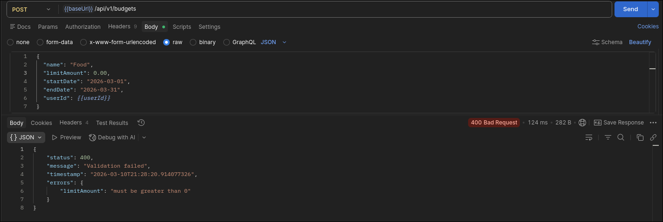

Рисунок 5.1 – Демонстрация единого формата ошибок (400 Bad Request)

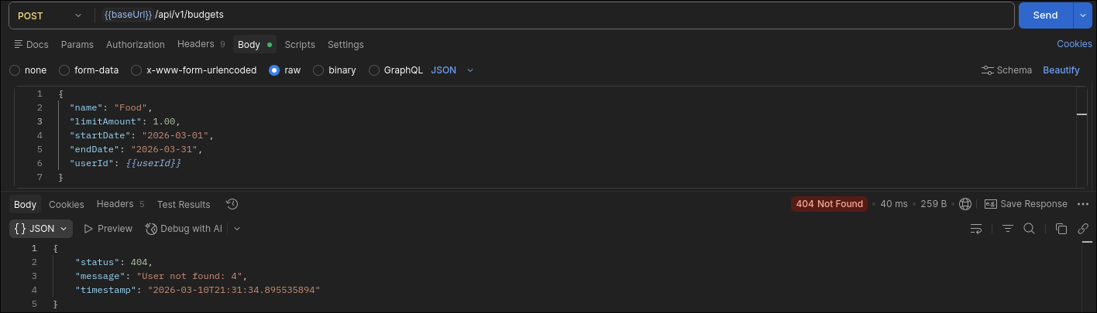

Рисунок 5.2 – Демонстрация единого формата ошибок(404 Not Found)

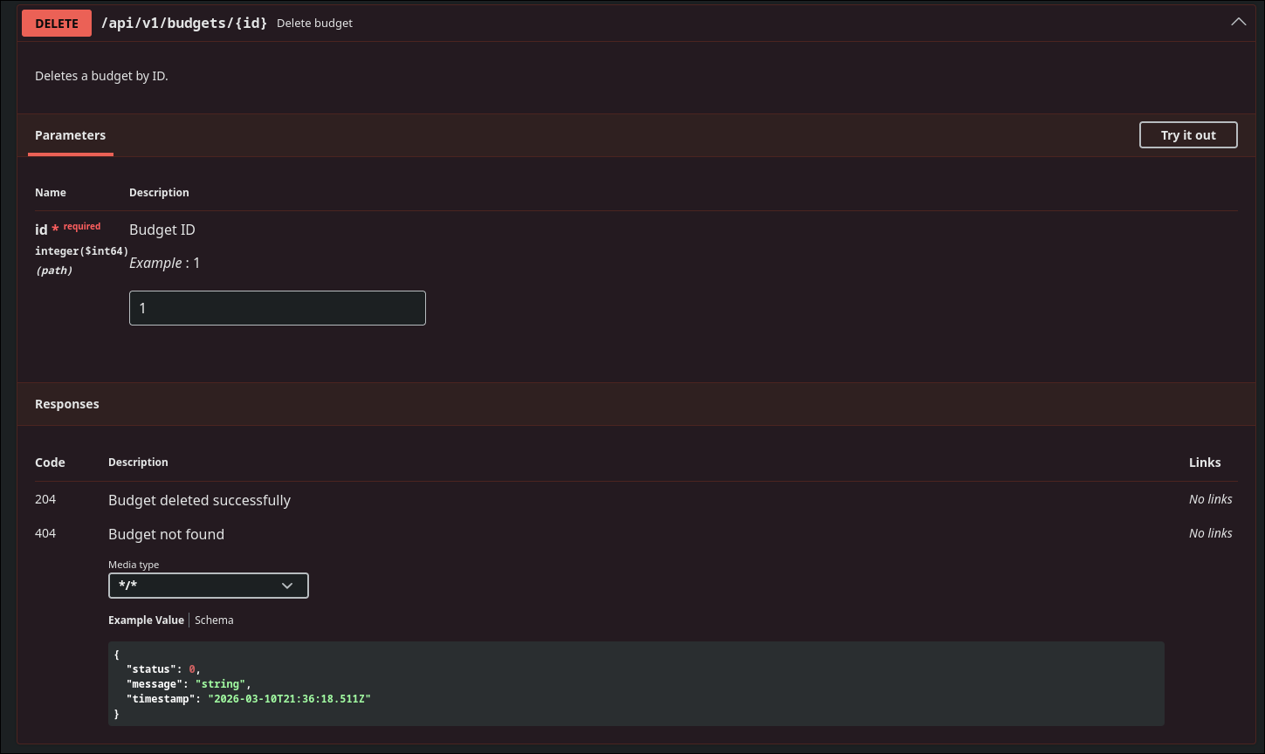

Рисунок 5.3 – Пример описания endpoint (delete budget)

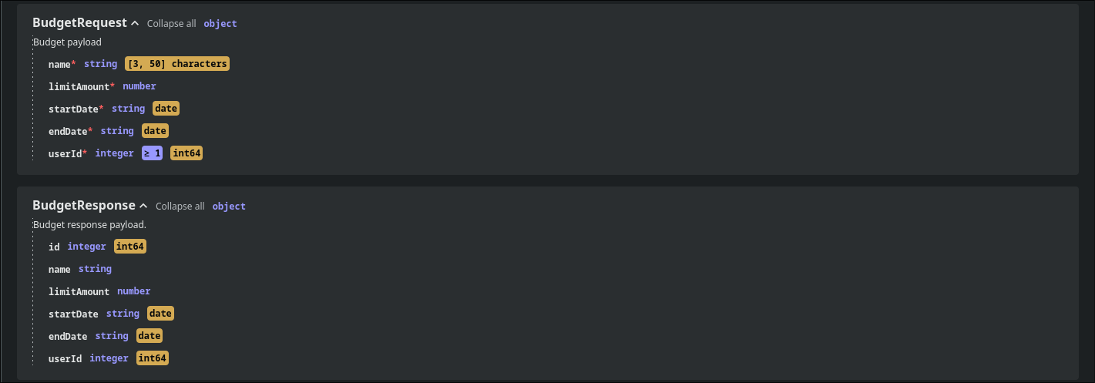

Рисунок 5.4 – Пример описания DTO (BudgetRequest и BudgetResponse)

5 ЗАКЛЮЧЕНИЕ

В ходе лабораторной работы реализована глобальная обработка ошибок через @ControllerAdvice, добавлена валидация входных данных с помощью @Valid и введен единый формат error-response для всех endpoint. Настроено логирование через logback, включая уровни логирования и ротацию логов. Также реализован AOP-аспект для логирования времени выполнения сервисных методов и подключен Swagger/OpenAPI для документирования endpoint и DTO.

