“We Rate Dogs” A Twitter Sensation

In 2015, a twitter user with by the screen name @dog_rates, started a twitter account called WeRateDogs that ended up going viral and resulting in a published book. The premise behind the account is for individuals to upload pictures of their dogs doing interesting or humorous things and the public gets to rate the dogs. What set it apart from other internet based dog photosharing, was two fold; the dog rating system and the defined dog “stages”. All ratings are a fraction with a denominator of ten, a common rating scale, except that almost all dogs are exclusively rated at above ten (ex. 13/10, 11/10, 99/10), a system that isn’t just funny but also affirms the love people have for dogs. The account also came up with its own set of vocabulary including; doggo, pupper, puppo, and floof. These were powerful, particularly words like floof, because although they are made up they immediately conjure a precise description of a dog that is almost innate, as if the word was in your mind the whole time.

I was able to access archived data of the twitter account to do some investigation. I wanted to explore how dog breed and dog stage categories would impact overall popularity. In the data I was able to use two metrics to gauge overall popularity, the ratings each tweet got and the number of retweets. The first categories I measured were dog breeds. There were 113 recognized dog breeds, and the top four breeds contained about 100-150 dogs each. I chose to examine the Labrador Retriever, Pembroke, and Chihuahua since they not only had large sample sizes, but also very similar sample sizes close to 100. I felt this made them more statistically comparable. In an investigation of three dog breeds; labradors, pembrokes, and chihuahuas had similar rating averages with 1.1198113207547167, 1.1425531914893614, 1.0492929292929294 respectively. Investigating the popularity if the same three dog breeds by measure of retweets puts labradors in a clear first place with 405,404, 291,771, and 250,722 respectively.

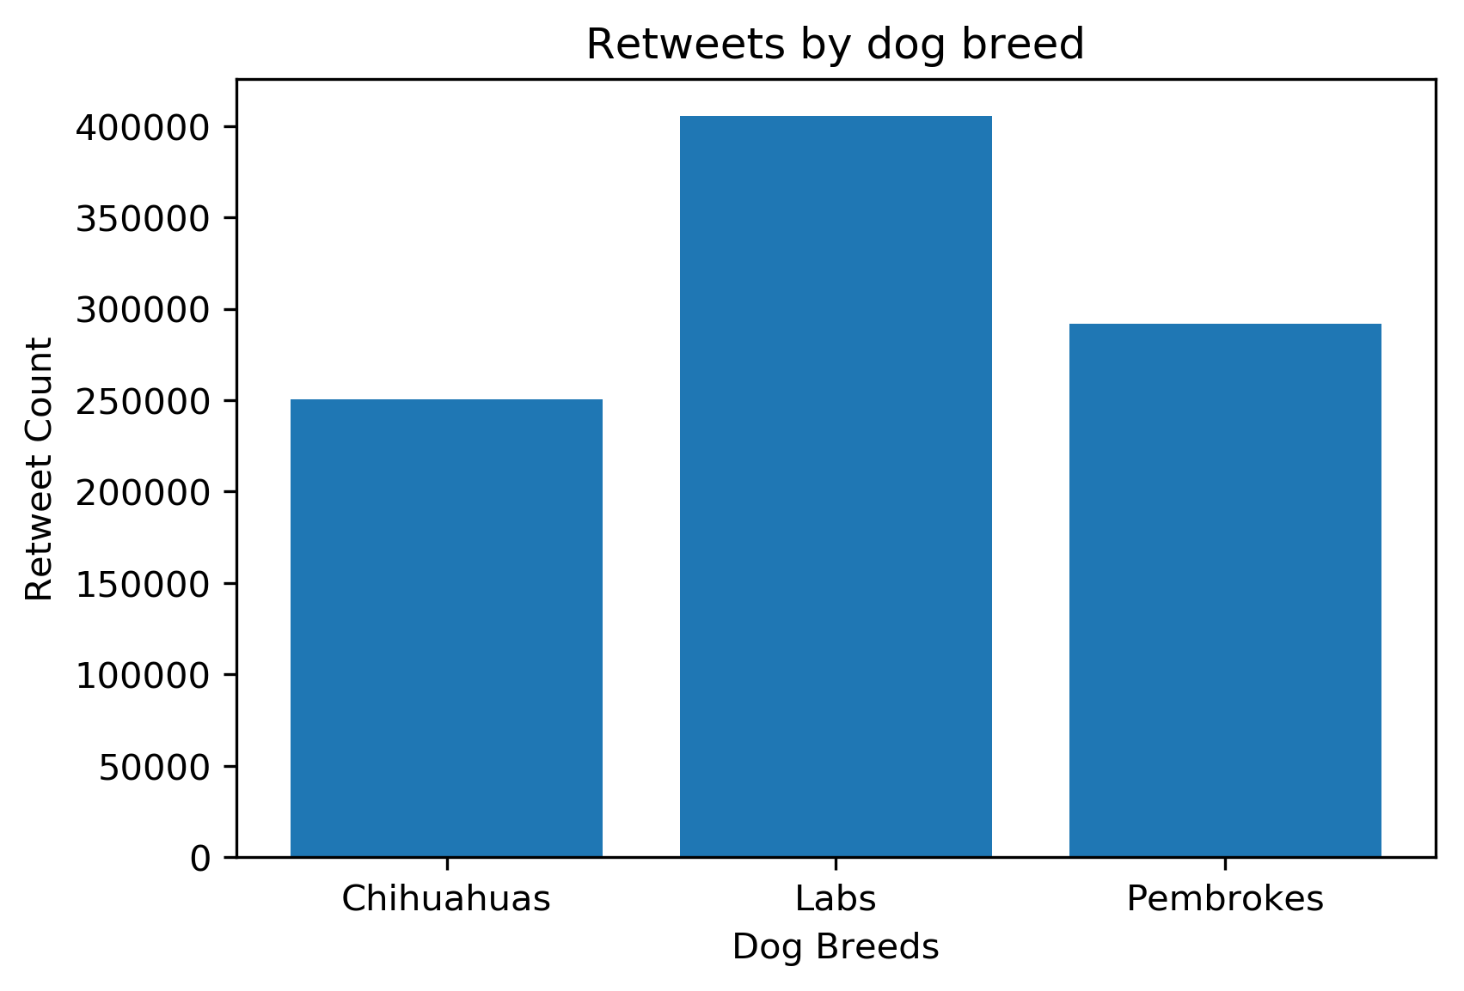

I also examined dog stages and their average ratings. Investigating the top three occurrences of dog stages; pupper, doggo and puppo by measure of average ratings yielded 1.07, 1.88, and 1.2 respectively. Puppos having the best average as well as the lowest standard deviation implying that most dogs in that category are closer to the average.