CISCO

Ray Lance C. Gregorio

Jane A. Barrameda

ROUTER LAB TOPOLOGY

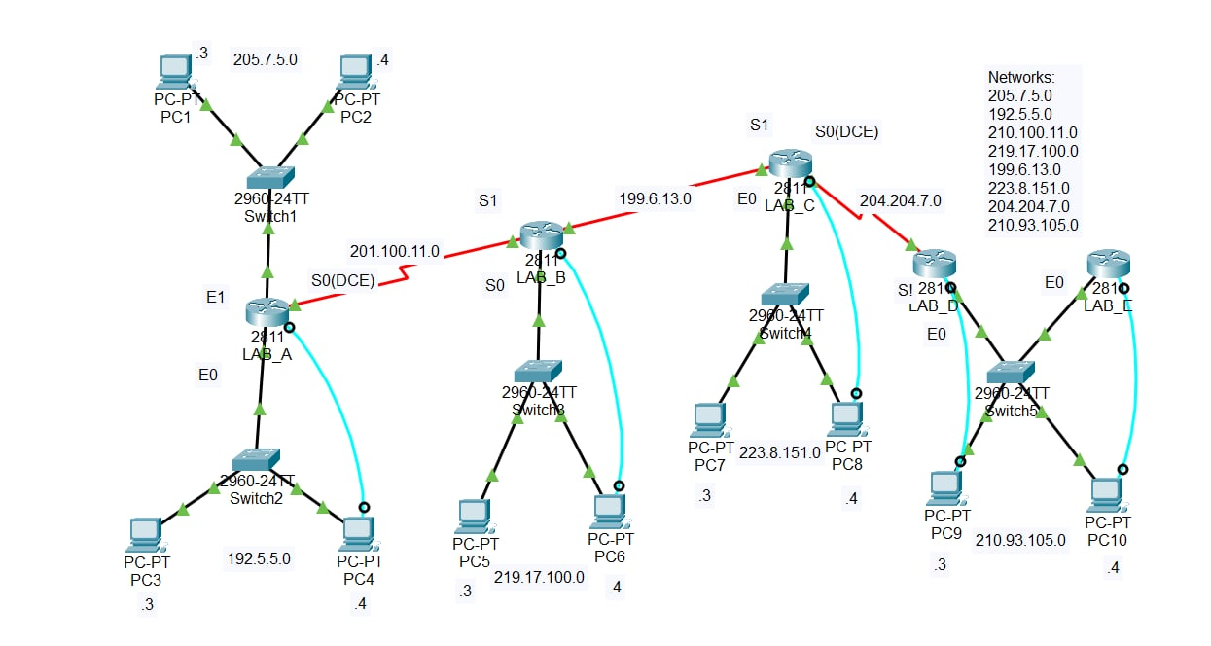

|  |  |  |  |  |  |  |  |  |
| --- | --- | --- | --- | --- | --- | --- | --- | --- |
| ROUTER  NAME | ROUTER  TYPE | E0 | E1 | S0 | S1 | SUBNET  MASK | ENABLE  PASSWORD | VTY  PASSWORD |
| LAB_A | 1841 | 192.5.5.1 | 205.7.5.1 | 201.100.11.1 | - | 255.255.255.0 | class | cisco |
| LAB_B | 1841 | 219.17.100.1 | 205.7.5.1 | 199.6.13.1 | 201.100.11.2 | 255.255.255.0 | class | cisco |
| LAB_C | 1841 | 223.8.151.1 | 205.7.5.1 | 204.204.7.1 | 199.6.13.2 | 255.255.255.0 | class | cisco |
| LAB_D | 1841 | 210.93.105.1 | 205.7.5.1 | - | 204.204.7.2 | 255.255.255.0 | class | cisco |
| LAB_E | 1841 | 210.93.105.2 | 205.7.5.1 | - | - | 255.255.255.0 | class | cisco |

LAB_A ROUTER

Hostname configuration:

Router> enable

Router# configure terminal

Router(config)# hostname LAB_A

LAB_A(config)# exit

Router interface configuration:

LAB_A# configure terminal

LAB_A(config)# interface fa0/0

LAB_A(config-if)# ip address 205.7.5.1 255.255.255.0

LAB_A(config-if)# no shutdown

LAB_A(config-if)# exit

LAB_A(config)# interface fa0/1

LAB_A(config-if)# ip address 192.5.5.1 255.255.255.0

LAB_A(config-if)# no shutdown

LAB_A(config-if)# exit

LAB_A(config)# interface se0/1/0

LAB_A(config-if)# ip address 201.100.11.1 255.255.255.0

LAB_A(config-if)# no shutdown

LAB_A(config-if)# exit

Line configuration mode:

LAB_A# configure terminal

LAB_A(config)# line con 0

LAB_A(config-line)# password cisco

LAB_A(config-line)# login

LAB_A(config-line)# exit

LAB_A(config)# line vty 0 4

LAB_A(config-line)# password cisco

LAB_A(config-line)# login

LAB_A(config-line)# exit

LAB_A(config)# enable password cisco

LAB_A(config)# enable secret class

LAB_A(config)# exit

Router RIP:

LAB_A# configure terminal

LAB_A(config)# router rip

LAB_A(config-router)# network 205.7.5.0

LAB_A(config-router)# network 192.5.5.0

LAB_A(config-router)# network 201.100.11.0

LAB_A(config-router)# network 219.17.100.0

LAB_A(config-router)# network 199.6.13.0

LAB_A(config-router)# network 223.8.151.0

LAB_A(config-router)# network 204.204.7.0

LAB_A(config-router)# network 210.93.105.0

LAB_A(config-router)# end

LAB_B ROUTER

Hostname configuration:

Router> enable

Router# configure terminal

Router(config)# hostname LAB_B

LAB_B(config)# exit

Router interface configuration:

LAB_B# configure terminal

LAB_B(config)# interface fa0/0

LAB_B(config-if)# ip address 219.17.100.1 255.255.255.0

LAB_B(config-if)# no shutdown

LAB_B(config-if)# exit

LAB_B(config)# interface se0/1/0

LAB_B(config-if)# ip address 201.100.11.2 255.255.255.0

LAB_B(config-if)# no shutdown

LAB_B(config-if)# exit

LAB_B(config)# interface se0/1/1

LAB_B(config-if)# ip address 199.6.13.1 255.255.255.0

LAB_B(config-if)# no shutdown

LAB_B(config-if)# exit

Line configuration mode:

LAB_B# configure terminal

LAB_B(config)# line con 0

LAB_B(config-line)# password cisco

LAB_B(config-line)# login

LAB_B(config-line)# exit

LAB_B(config)# line vty 0 4

LAB_B(config-line)# password cisco

LAB_B(config-line)# login

LAB_B(config-line)# exit

LAB_B(config)# enable password cisco

LAB_B(config)# enable secret class

LAB_B(config)# exit

Router RIP:

LAB_B# configure terminal

LAB_B(config)# router rip

LAB_B(config-router)# network 205.7.5.0

LAB_B(config-router)# network 192.5.5.0

LAB_B(config-router)# network 201.100.11.0

LAB_B(config-router)# network 219.17.100.0

LAB_B(config-router)# network 199.6.13.0

LAB_B(config-router)# network 223.8.151.0

LAB_B(config-router)# network 204.204.7.0

LAB_B(config-router)# network 210.93.105.0

LAB_B(config-router)# end

LAB_C ROUTER

Hostname configuration:

Router> enable

Router# configure terminal

Router(config)# hostname LAB_C

LAB_C(config)# exit

Router interface configuration:

LAB_C# configure terminal

LAB_C(config)# interface fa0/0

LAB_C(config-if)# ip address 223.8.151.1 255.255.255.0

LAB_C(config-if)# no shutdown

LAB_C(config-if)# exit

LAB_C(config)# interface se0/1/0

LAB_C(config)# ip address 199.6.13.2 255.255.255.0

LAB_C(config-if)# no shutdown

LAB_C(config-if)# exit

LAB_C(config)# interface se0/1/1

LAB_C(config)# ip address 204.204.7.1 255.255.255.0

LAB_C(config-if)# no shutdown

LAB_C(config-if)# exit

Line configuration mode:

LAB_C# configure terminal

LAB_C(config)# line con 0

LAB_C(config-line)# password cisco

LAB_C(config-line)# login

LAB_C(config-line)# exit

LAB_C(config)# line vty 0 4

LAB_C(config-line)# password cisco

LAB_C(config-line)# login

LAB_C(config-line)# exit

LAB_C(config)# enable password cisco

LAB_C(config)# enable secret class

LAB_C(config)# exit

Router RIP:

LAB_C# configure terminal

LAB_C(config)# router rip

LAB_C(config-router)# network 205.7.5.0

LAB_C(config-router)# network 192.5.5.0

LAB_C(config-router)# network 201.100.11.0

LAB_C(config-router)# network 219.17.100.0

LAB_C(config-router)# network 199.6.13.0

LAB_C(config-router)# network 223.8.151.0

LAB_C(config-router)# network 204.204.7.0

LAB_C(config-router)# network 210.93.105.0

LAB_C(config-router)# end

LAB_D ROUTER

Hostname configuration:

Router> enable

Router# configure terminal

Router(config)# hostname LAB_D

LAB_D(config)# exit

Router interface configuration:

LAB_D# configure terminal

LAB_D(config)# interface se0/1/0

LAB_D(config-if)# ip address 204.204.7.2 255.255.255.0

LAB_D(config-if)# no shutdown

LAB_D(config-if)# exit

LAB_D(config)# interface fa0/0

LAB_D(config-if)# ip address 210.93.105.1 255.255.255.0

LAB_D(config-if)# no shutdown

LAB_D(config-if)# exit

Line configuration mode:

LAB_D# configure terminal

LAB_D(config)# line con 0

LAB_D(config-line)# password cisco

LAB_D(config-line)# login

LAB_D(config-line)# exit

LAB_D(config)# line vty 0 4

LAB_D(config-line)# password cisco

LAB_D(config-line)# login

LAB_D(config-line)# exit

LAB_D(config)# enable password cisco

LAB_D(config)# enable secret class

LAB_D(config)# exit

Router RIP:

LAB_D# configure terminal

LAB_D(config)# router rip

LAB_D(config-router)# network 205.7.5.0

LAB_D(config-router)# network 192.5.5.0

LAB_D(config-router)# network 201.100.11.0

LAB_D(config-router)# network 219.17.100.0

LAB_D(config-router)# network 199.6.13.0

LAB_D(config-router)# network 223.8.151.0

LAB_D(config-router)# network 204.204.7.0

LAB_D(config-router)# network 210.93.105.0

LAB_D(config-router)# end

LAB_E ROUTER

Hostname configuration:

Router> enable

Router# configure terminal

Router(config)# hostname LAB_E

LAB_E(config)# exit

Router interface configuration:

LAB_E# configure terminal

LAB_E(config)# interface fa0/0

LAB_E(config-if)# ip address 210.93.105.2 255.255.255.0

LAB_E(config-if)# no shutdown

LAB_E(config-if)# exit

Line configuration mode:

LAB_E# configure terminal

LAB_E(config)# line con 0

LAB_E(config-line)# password cisco

LAB_E(config-line)# login

LAB_E(config-line)# exit

LAB_E(config)# line vty 0 4

LAB_E(config-line)# password cisco

LAB_E(config-line)# login

LAB_E(config-line)# exit

LAB_E(config)# enable password cisco

LAB_E(config)# enable secret class

LAB_E(config)# exit

Router RIP:

LAB_E# configure terminal

LAB_E(config)# router rip

LAB_E(config-router)# network 205.7.5.0

LAB_E(config-router)# network 192.5.5.0

LAB_E(config-router)# network 201.100.11.0

LAB_E(config-router)# network 219.17.100.0

LAB_E(config-router)# network 199.6.13.0

LAB_E(config-router)# network 223.8.151.0

LAB_E(config-router)# network 204.204.7.0

LAB_E(config-router)# network 210.93.105.0

LAB_E(config-router)# end

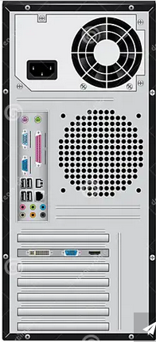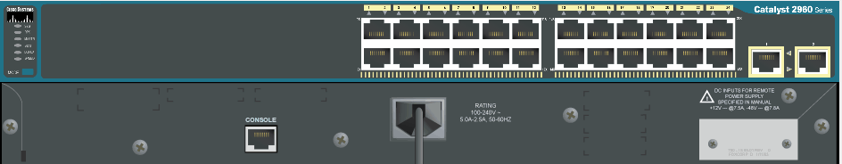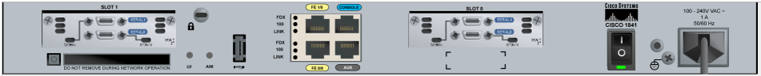

To console

IP: 205.7.5.3

Subnet Mask: 255.255.255.0

Gateway: 205.7.5.1

**220V**

**220V**

**220V**

**220V**

**220V**

**220V**

192.5.5.1

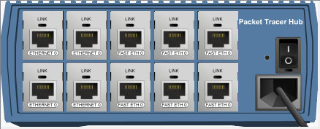

IP: 192.5.5.2

Subnet Mask: 255.255.255.0

Gateway: 192.5.5.1

To console

205.7.5.1

**LAB_A**

201.100.11.1

**220V**



IP: 219.17.100.3

Subnet Mask: 255.255.255.0

Gateway: 219.17.100.1

To console

219.17.100.1

201.100.11.2

**LAB_B**

199.6.13.1



IP: 223.8.151.3

Subnet Mask: 255.255.255.0

Gateway: 223.8.151.1

To console

**220V**



223.8.151.1

199.6.13.2

**LAB_C**

204.204.7.1

IP: 210.93.105.3

Subnet Mask: 255.255.255.0

Gateway: 210.93.105.1



**220V**

To console

210.93.105.1

204.204.7.2



**LAB_D**

IP: 210.93.105.4

Subnet Mask: 255.255.255.0

Gateway: 210.93.105.1

To console

210.93.105.2



**LAB_E**

UTP Straight Cable

Serial Cable

Console Cable

**220V**

PING COMMAND

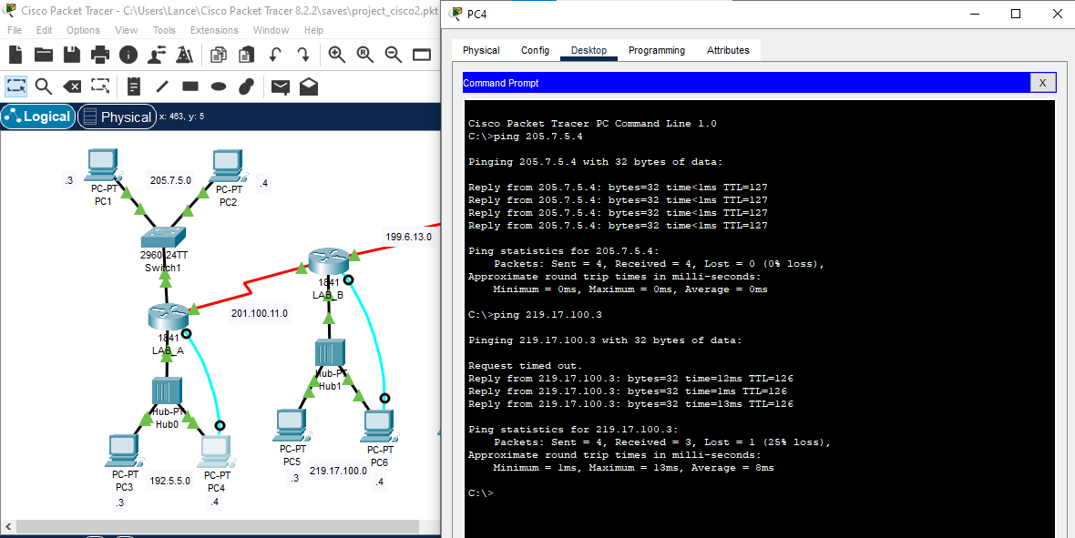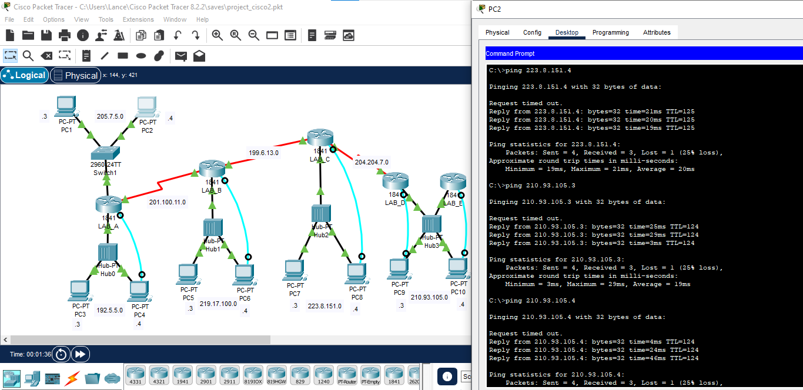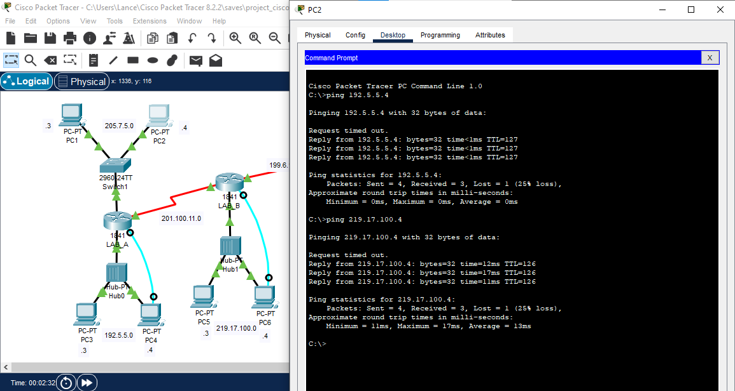

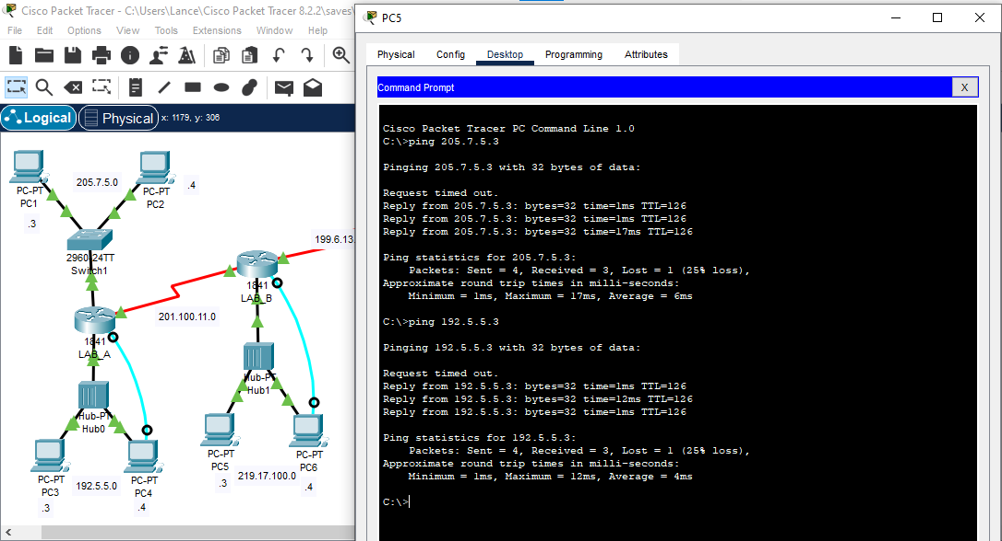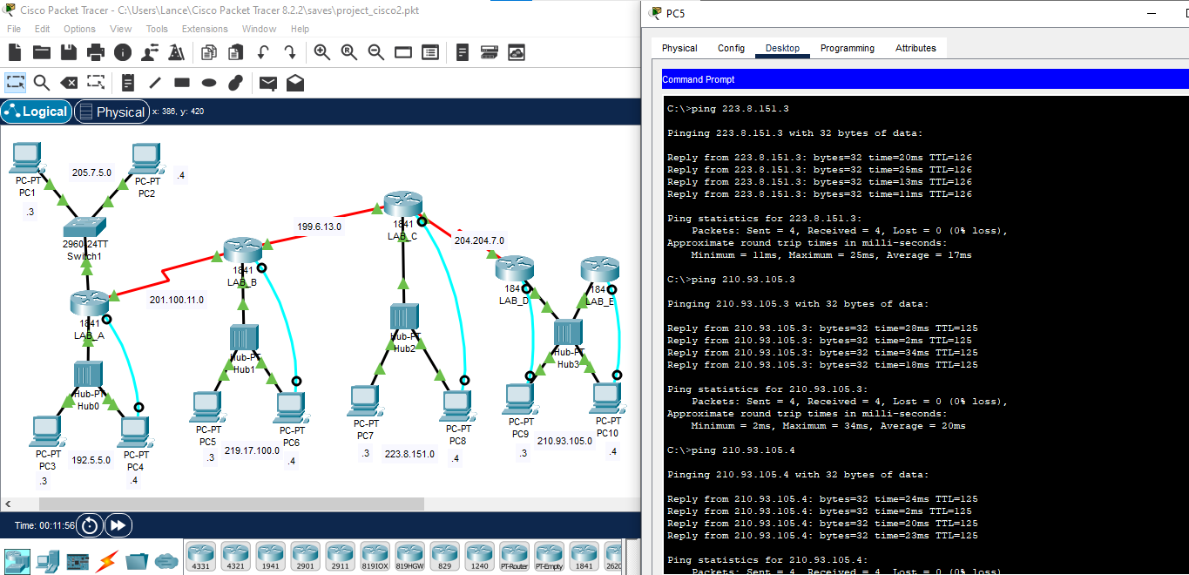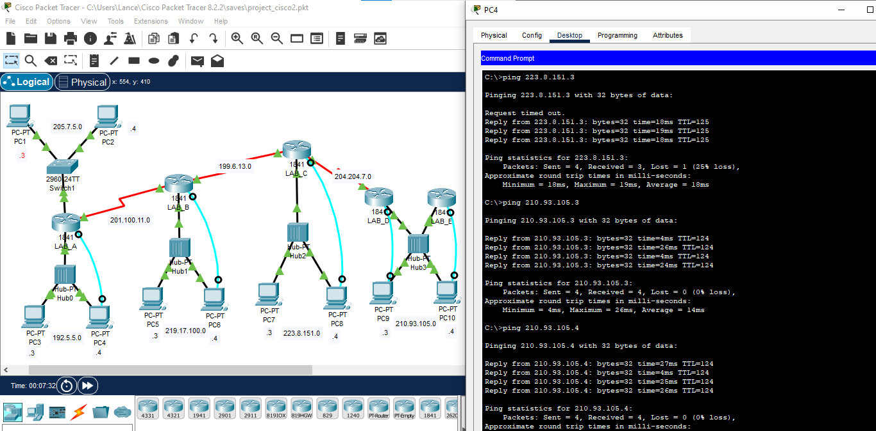

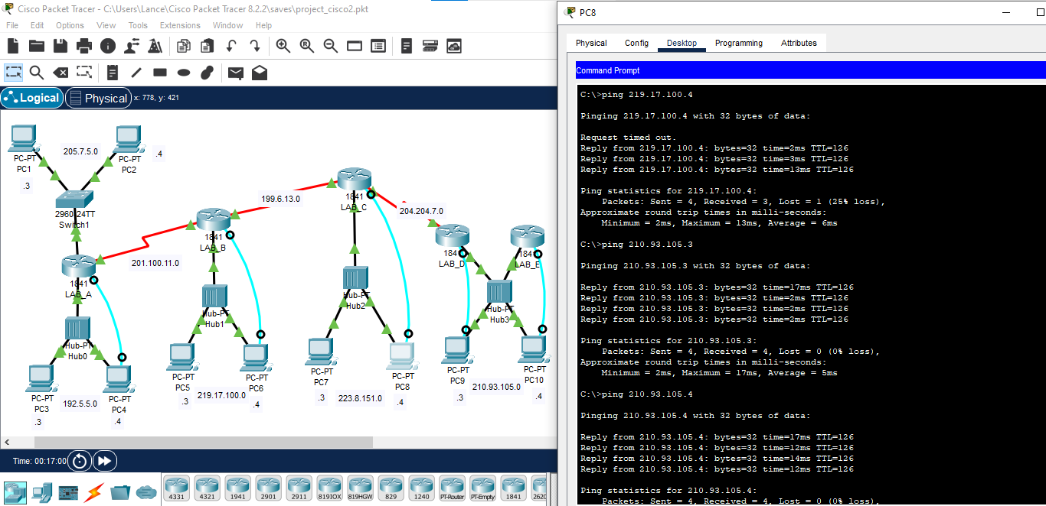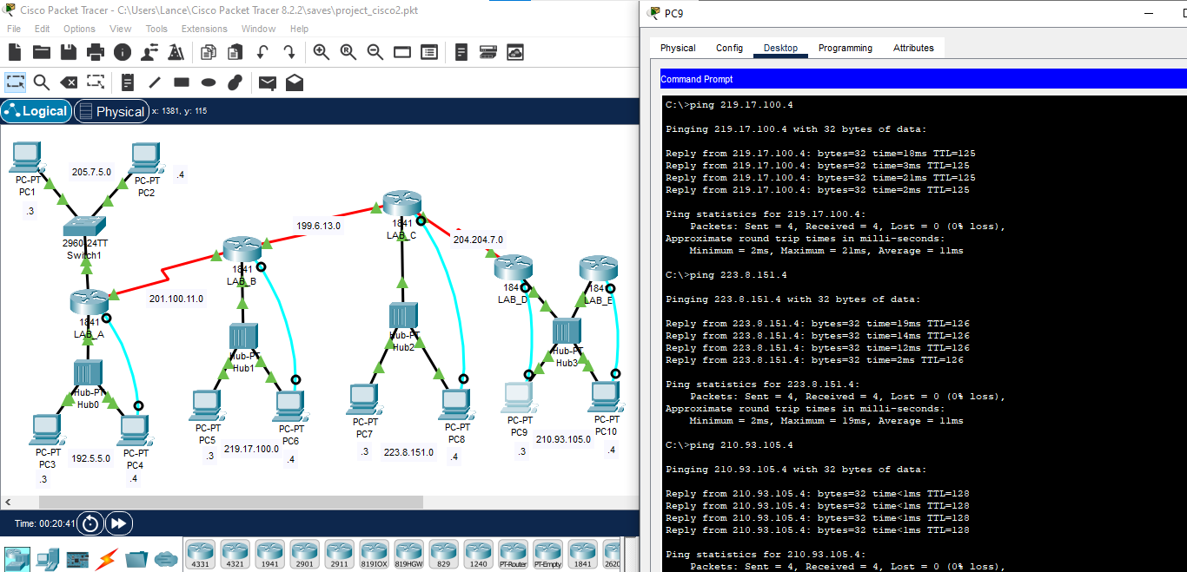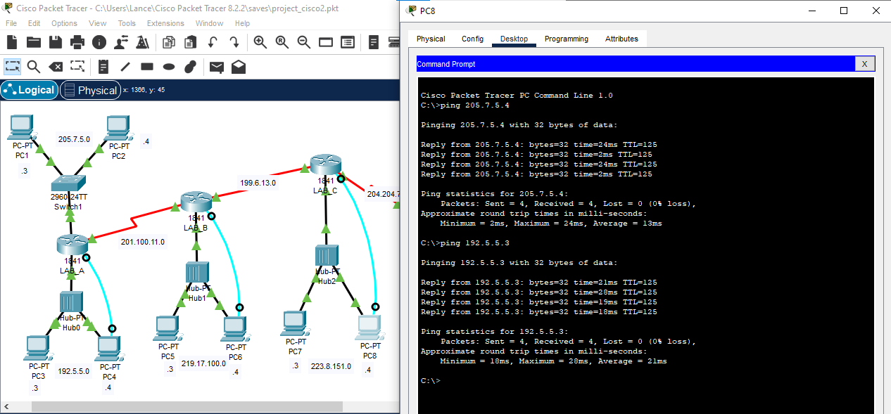

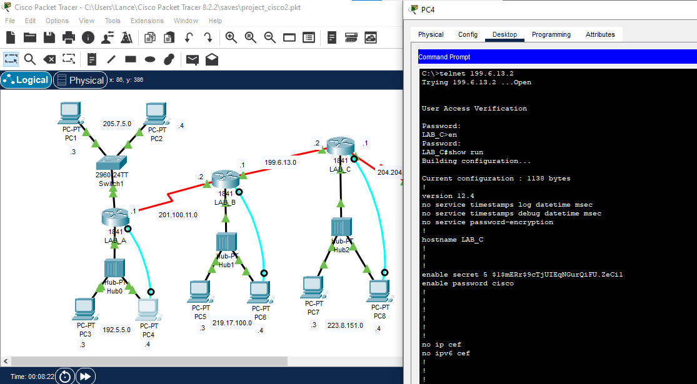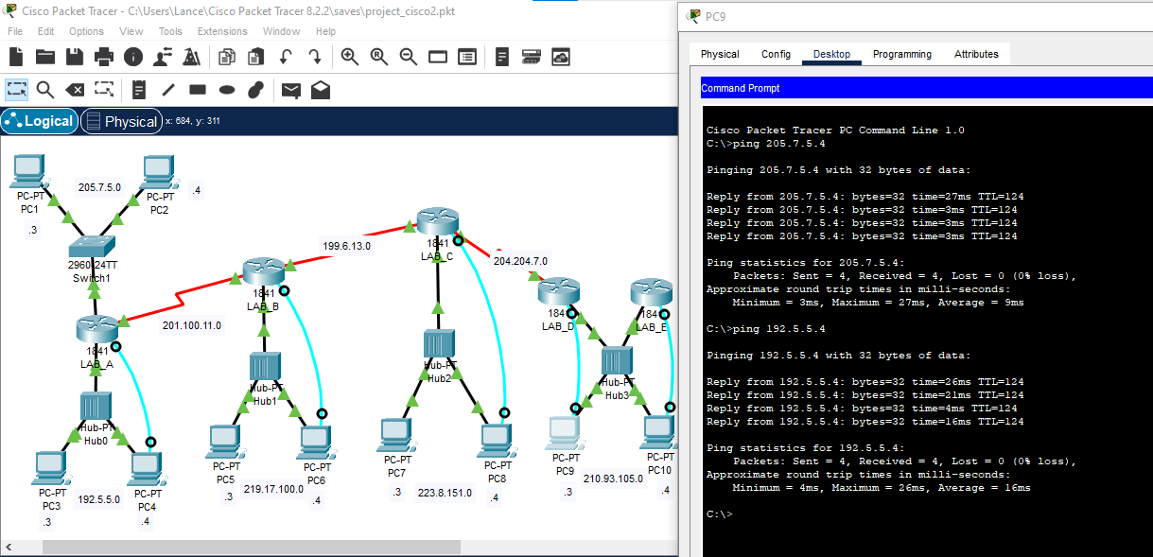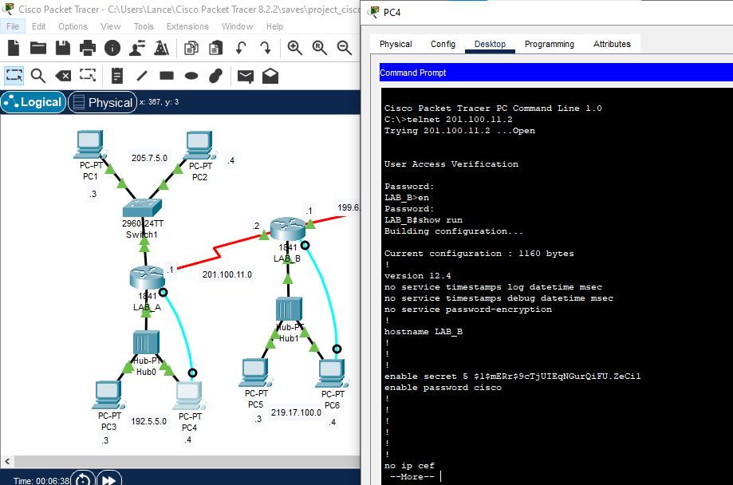Telnet – LAB A

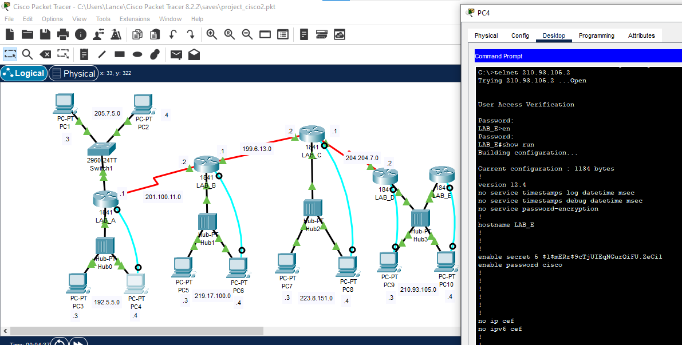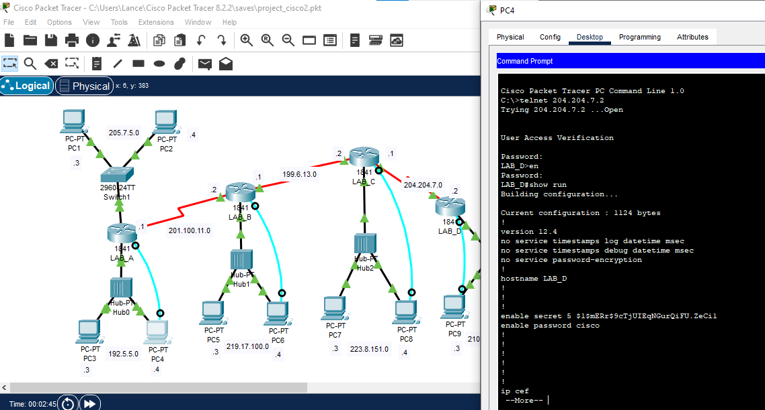

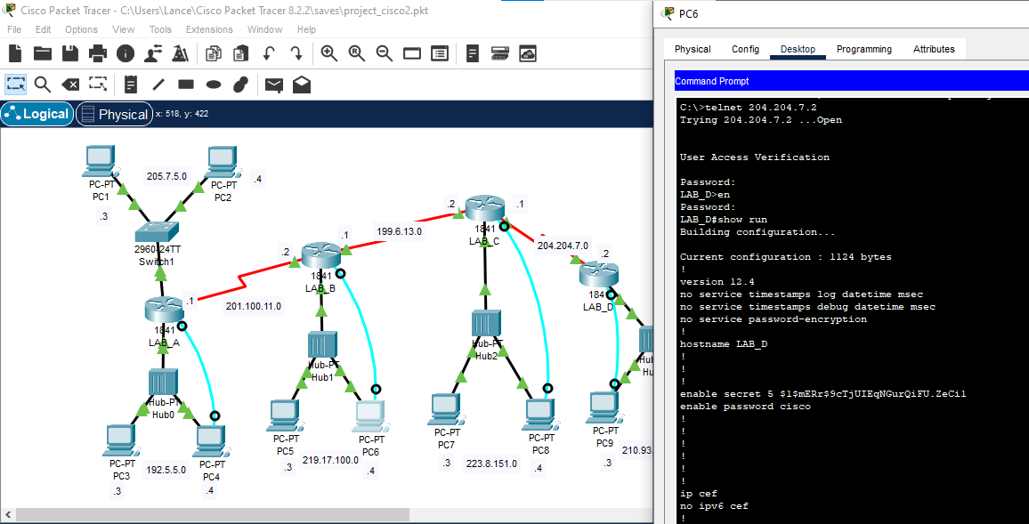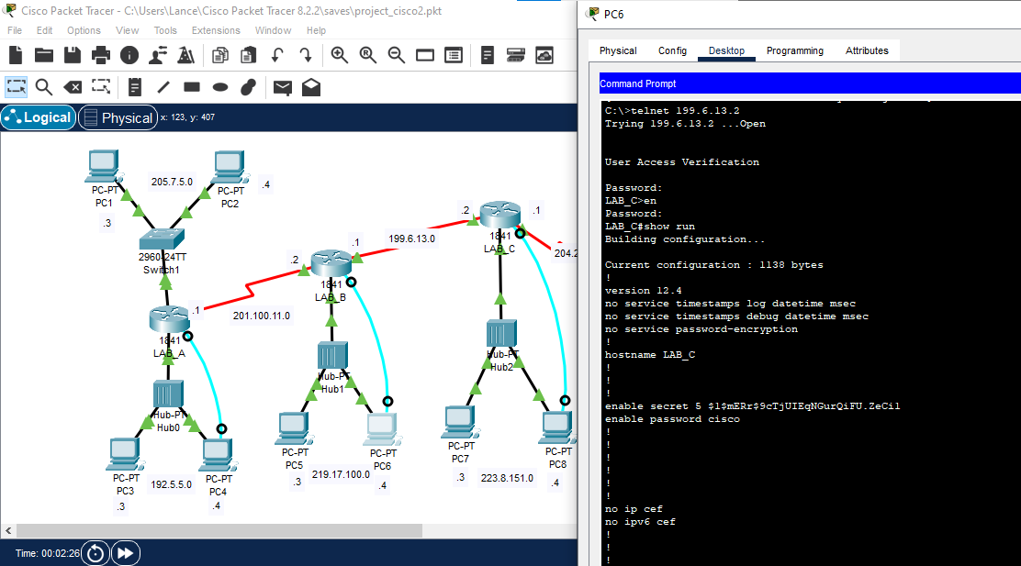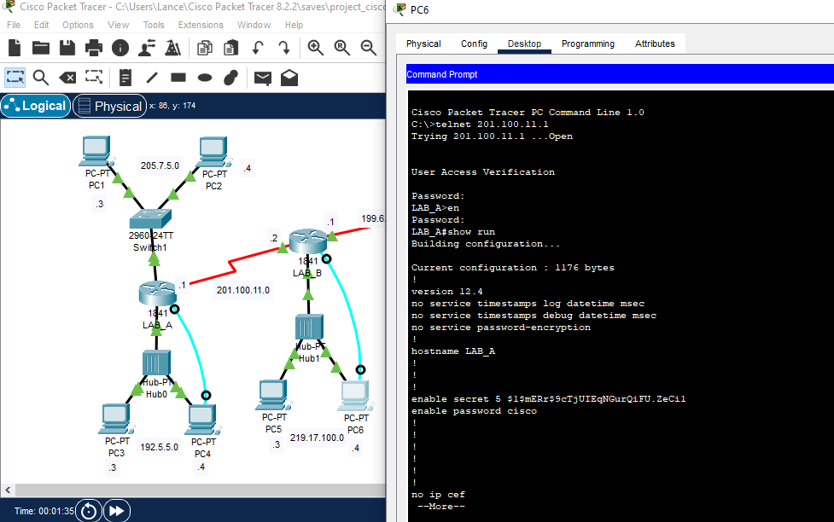Telnet – LAB B

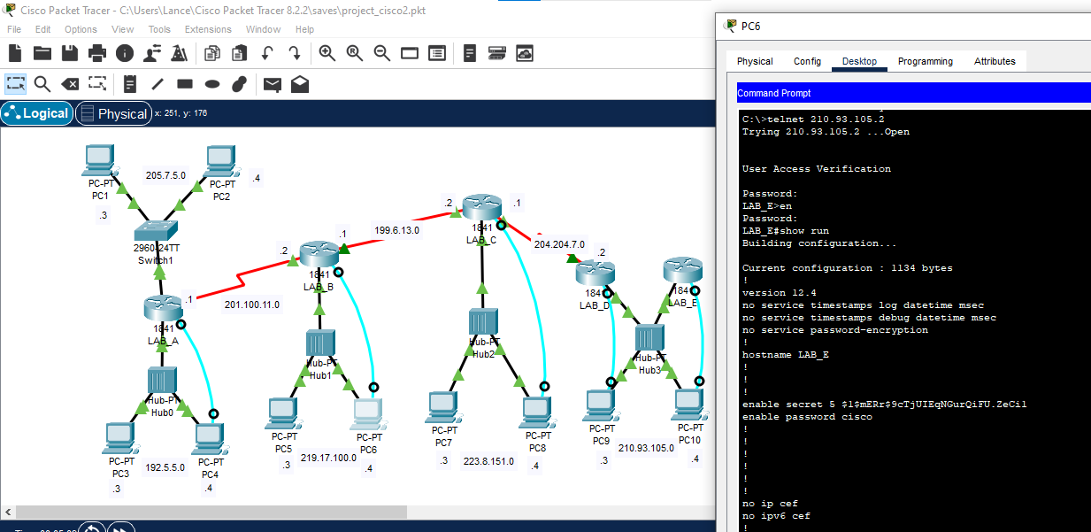

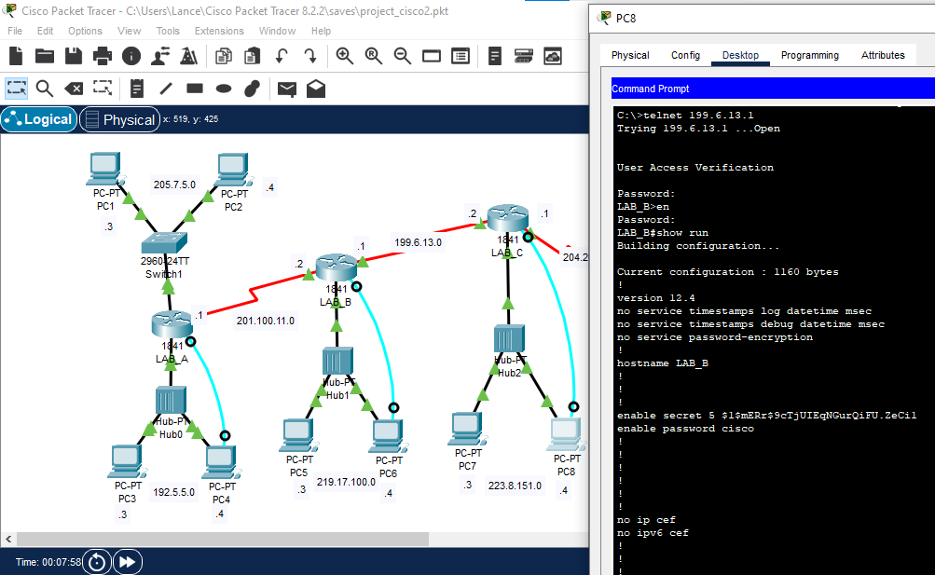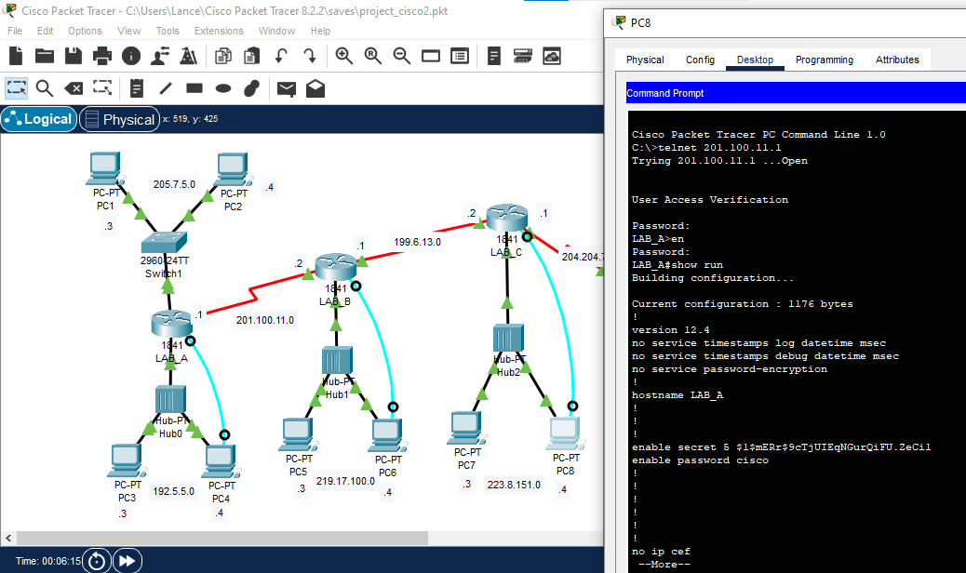Telnet – LAB C

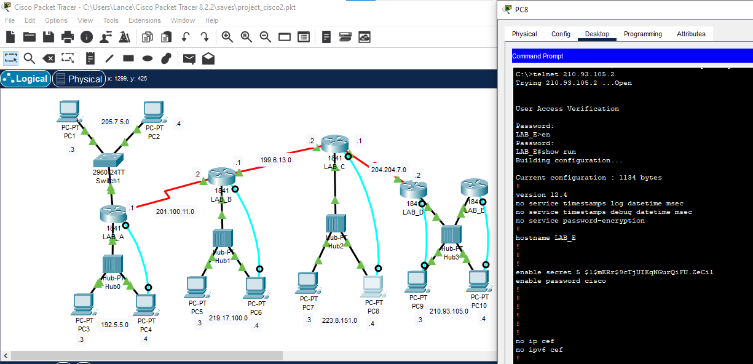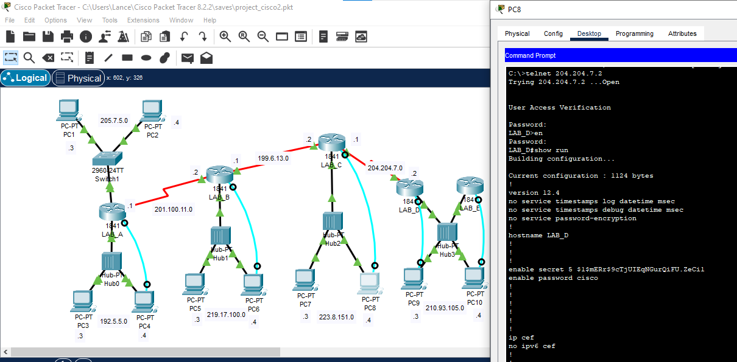

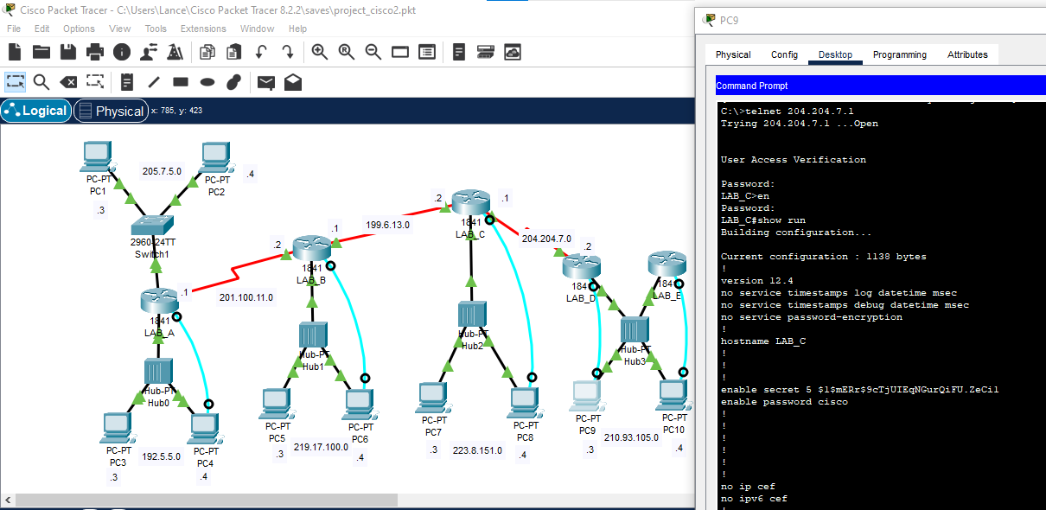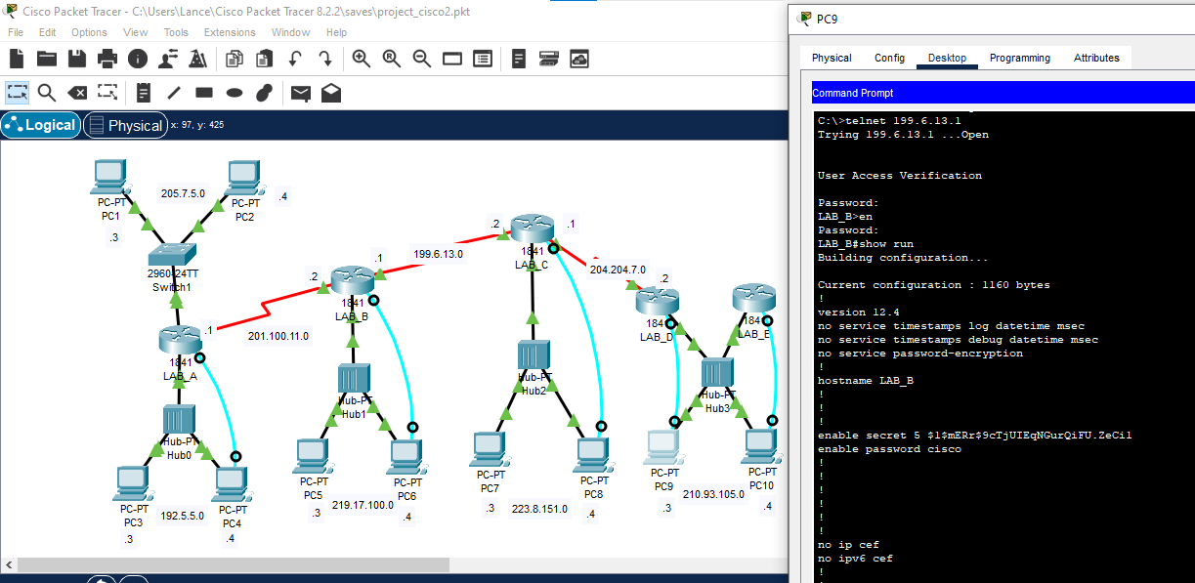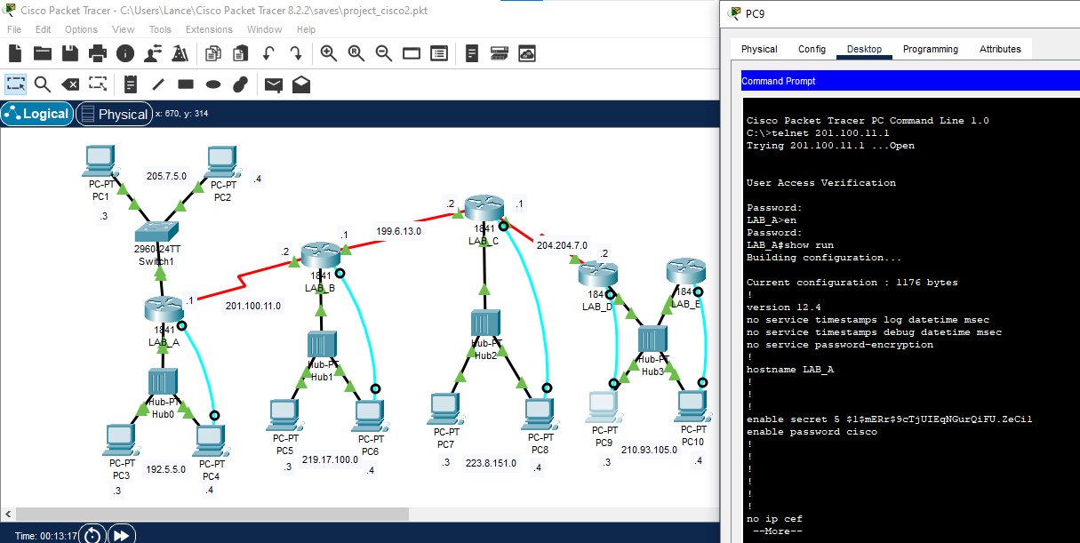Telnet – LAB D

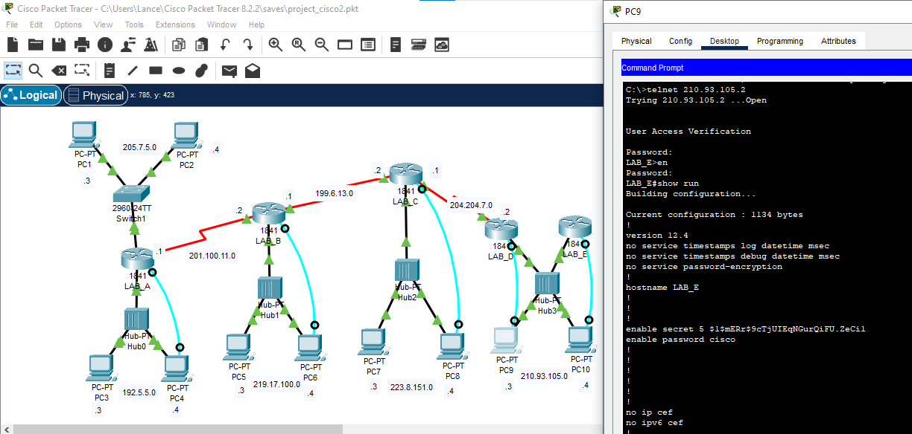

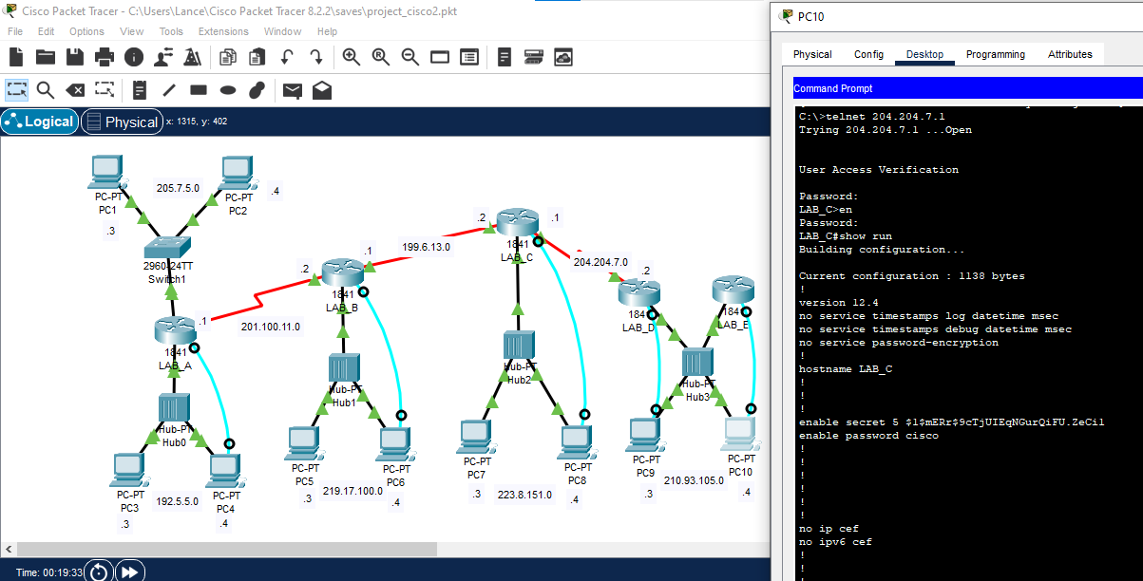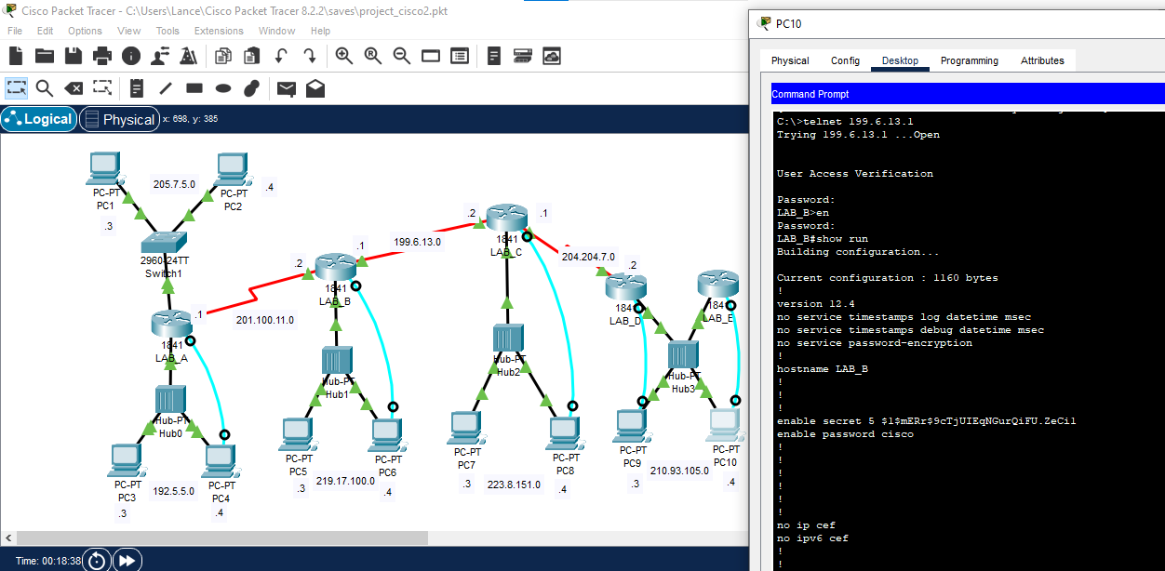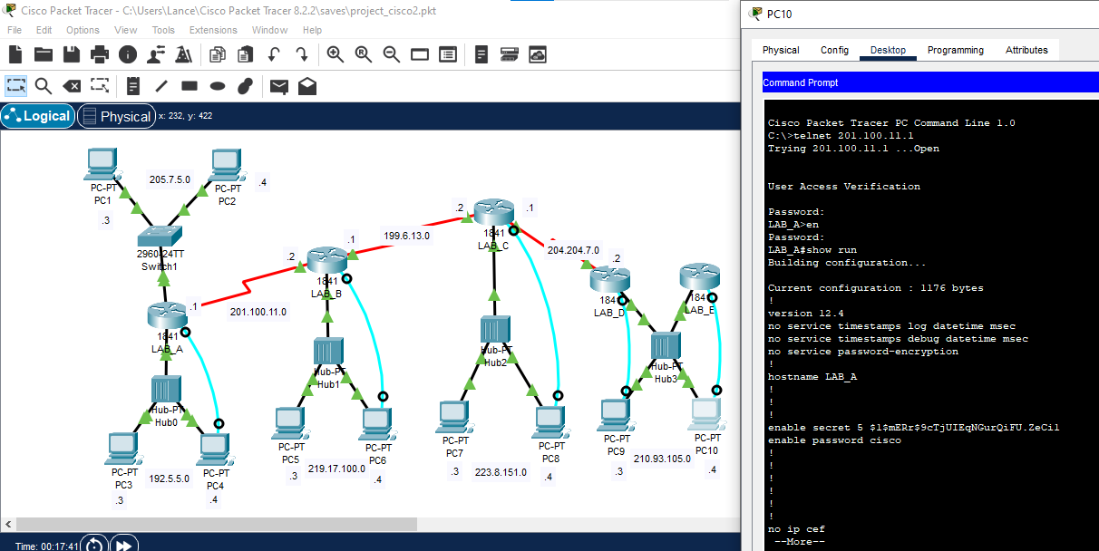Telnet – LAB E

