

Lecture with Computer Exercises:
Modelling and Simulating Social Systems with MATLAB

Project Report

Sequential Investment Game

Michael Bernasconi, Jens Hauser & Samuel Käser

Zürich
17.12.2017



Agreement for free-download

We hereby agree to make our source code of this project freely available for download from the web pages of the SOMS chair. Furthermore, we assure that all source code is written by ourselves and is not violating any copyright restrictions.

Michael Bernasconi Jens Hauser Samuel Käser

Abstract/Introduction
This project is based on Ryan Murphy’s paper “A Sequential Investment Game” (see References). His paper describes the problem of a decision maker, who has a specific amount of money that he can invest in every stage of a game. The outcome of every stage can either be positive or negative for the decision maker. If it’s positive, his investment is doubled and returned, if it’s negative the investment is gone. The problem concerning which strategy the decision maker should take to maximize his expected payoff is solved. Therefore we extended the game to the following:
We have N players with the same amount of money at the beginning, on every stage the players can invest any percentage of their current holdings.
The probability for a positive outcome is between 50% and 100% and stays constant during the whole game. At the end of a given number of stages the player with the highest amount of money wins the round and gets one point, all the other players don’t get anything, independent of their amount of money left. If more than one player has the highest amount of money a tie decides about the winner.
The players do not know what happens to other players during a game. Known and the same for everyone are just the win probability and the number of stages. Murphy’s paper suggests as a start solving the problem of finding a Nash equilibrium to a game of two players, number of stages at 20 and a win probability of 60%. We did so considering constant and time linear strategies discretized to a level that we can work with, since we cannot simulate an infinite amount of strategies.
We then enlarged the problem to population sizes (number of players) greater than two. Since Nash equilibria are hard to compute and even harder to plot for more than 3 players we focused on evolutionary stable strategies and tried to find out where they occur depending on our parameters number of stages, population size and win probability.

Individual contributions/Work-development
Our group consists of 2 electrical engineering students in the third semester (Jens and Samuel) and one computer science student in the seventh semester (Michael). Since Michael had the best coding skills in the group, he was responsible for the implementation in Java. The requirements for our simulation were discussed in plenum. As soon as the code was ready, the simulation tasks were distributed and the calculation processes could begin, which lasted sometimes up to a few days. As the results came in form of matrices with zeros and ones, we had to figure out a nice way of visualizing them. MATLAB’s Heatmap was the solution. The plotting and the analysis of the results were mainly done by Jens and Samuel, in order to balance the individual efforts.

Description of the Model
Evolutionary stability
A strategy x is evolutionary stable if for all strategies y ≠ x at least one of the following conditions is true:
- f(x,x) > f(y,x)
- f(x,x) = f(y,x) and f(x,y) > f(y,y)
where f(x,y) is the payoff of strategy x in an environment where all others have strategy y.

The first condition tells you that if we are in a situation where everyone plays strategy x there is an incentive to keep playing strategy x (because every other strategy would be worse). So a pure x-environment is stable.
The second condition tells you that if a player, in a pure x-environment, is indifferent between strategy x and y then he should still keep playing strategy x because in case everyone else switches to y he will do better.

We might imagine that a number of people play the sequential investment game over multiple rounds. After each round every player can see which player won and what strategy was played by each player. Naturally players will start to copy strategies that did well. This process very closely resembles how evolution works in nature in the sense that strategies that do well will inspire more players to play this strategy (have more offspring).
Considering this it makes sense to find evolutionary stable strategies for the sequential investment game.

Nash equilibrium
A Nash equilibrium is a strategy profile where no individual player can increase their payoff by altering their strategy. This means that, under the assumption that players are rational, a Nash equilibrium is a strategy profile that is stable.

Implementation
For the implementation we used Java.
To calculate the expected payoff for each player in a given game we ran 10000 iterations of the same game and calculated the number of times each player won (resolving ties randomly). So the expected payoff for a given player is the number of times this player won divided by the number of iterations (10000). To compensate for the remaining variance we considered expected payoffs to be equal if they differed by less than 1% (epsilon = 0.01).
Since players are completely independent from each other during the stages it is clear that the win probability of a player with strategy x in a pure x environment is one divided by the number of players. Therefore we did not simulate such games.
To determine whether or not a strategy x was evolutionary stable given the strategy space S we used a brute-force approach. We did the same for the Nash equilibrium.

Simulation Results and Discussion
Evolutionary stable with constant strategies
In the following plots we are looking for evolutionary stable strategies by varying the number of stages, the population size and the win probability. All strategies are constant, meaning a player invests a certain percentage of his holdings in every stage.

Two player game
Murphy’s paper suggests starting with a game of two players, a win probability of 60% and 20 stages. Our first goal was therefore to see whether or not we can find an evolutionary stable strategy in this environment.
For constant strategies we could indeed find a solution, investing 20% in every stage is an evolutionary stable strategy. In fact, for every win probability from 50% to 100% in 5%-steps we could find an evolutionary stable strategy as can be seen in the following plots.

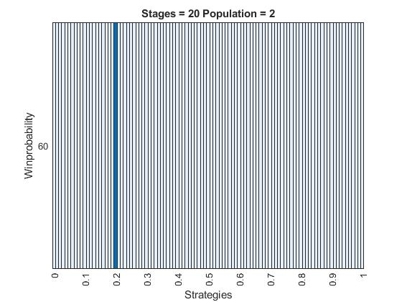

It’s interesting to see that for 20 stages evolutionary stable strategies occur in steps of 10%, giving us a very nice and symmetric plot. Increasing the number of stages to 50 gives us less evolutionary stable strategies, but doesn’t really change their pattern.
If we decrease the number of stages to 5 we would expect that our evolutionary stable strategies shift to the right. In particular for win probabilities greater than 0.88 we expect that 100% is the strategy to go for, since 0.88^5 = 0.528 > 0.5. Looking at the following a little more detailed plot with win probabilities in steps of 0.01 on the y-axis we find that this is indeed what happens. Interesting to see is that the 40% and 60% strategies and a little less surprisingly the 100% strategy, which were all evolutionary stable for 50 stages are still evolutionary stable for the same win probability. Further these strategies are also evolutionary stable for many win probabilities nearby.

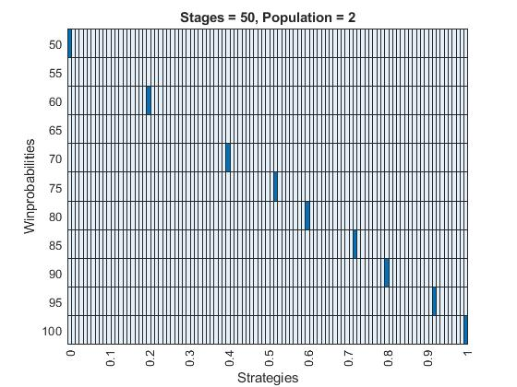
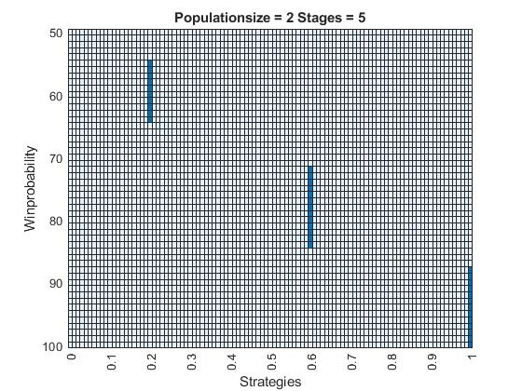

Variable number of stages
What we can see in general when we look at simulations with number of stages varying from 1 to 50 is that it pays to play riskier for a low number of stages, while for a higher number of stages it is smarter to invest only little money.
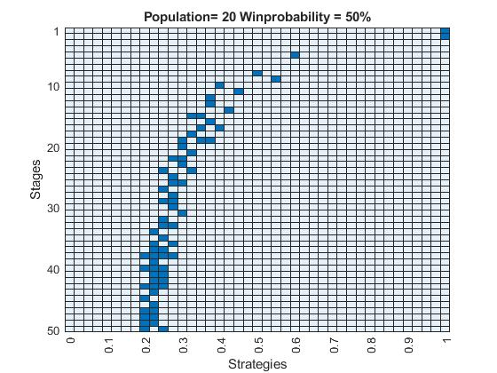
This seems quite logical, since if you only play a few stages there is almost always going to be one lucky player who wins in all stages. Therefore, if you invest less than 100% you are ending up on the losing side no matter how lucky you get!
We can further see that we get quite a lot of evolutionary stable strategies for higher stages. This is because we are simulating with a finite number of iterations and must consider strategies as equal when the difference in their payoff is less than 1%.
In games with higher number of stages the evolutionary stable strategies depend strongly on the population size. For an increasing population sizes our curve shifts to the right, meaning you must play riskier strategies to be successful.

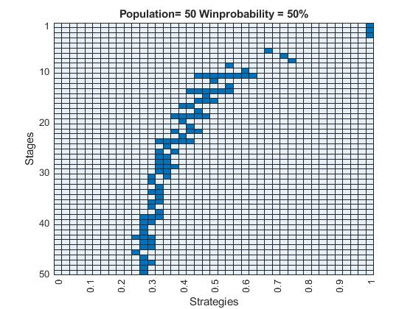

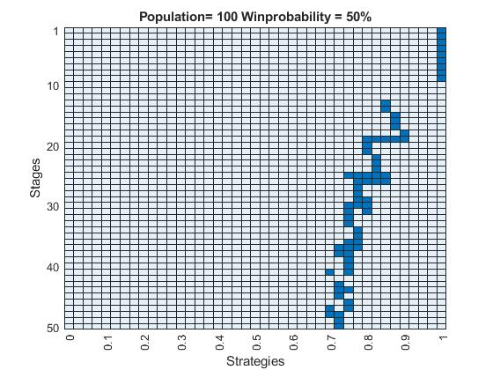
This can again be explained easily because for high population sizes it is more likely that one player gets extremely lucky.
Clear to see is also that if we keep the other parameters fixed and increase the win probability our evolutionary stable strategies move to the right.

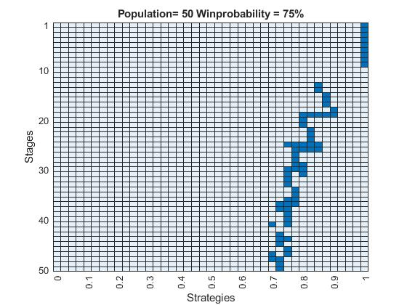

Variable win probability
Plotting the win probability on our y-axis what we can see is basically the same just from a different angle. Besides the obvious fact that for an increasing win probability you should play riskier we can again see that you must invest more playing against a higher number of players. On the other hand, for an increasing number of stages you should generally invest less.
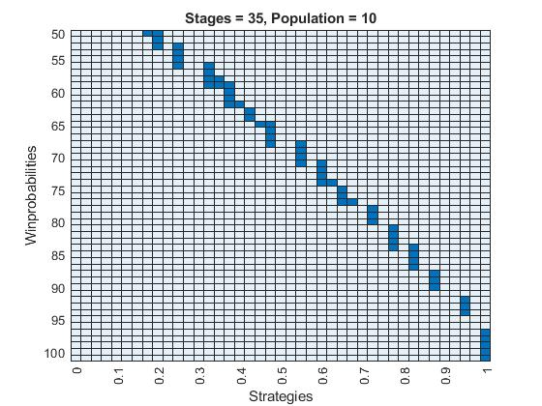

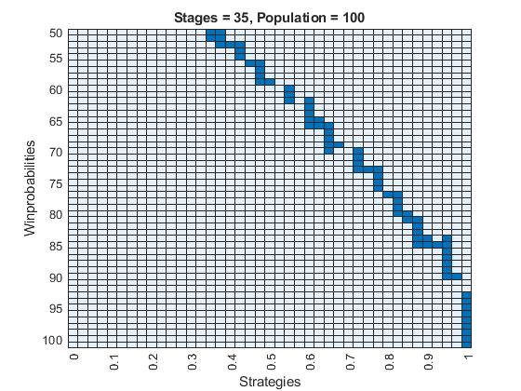
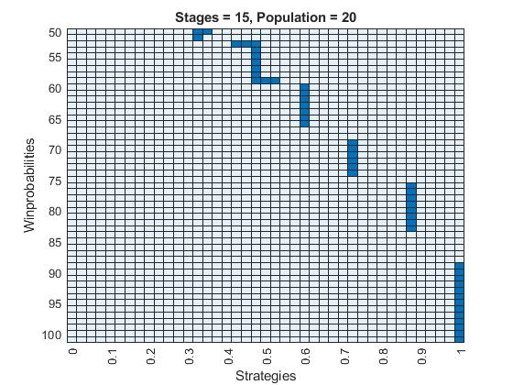

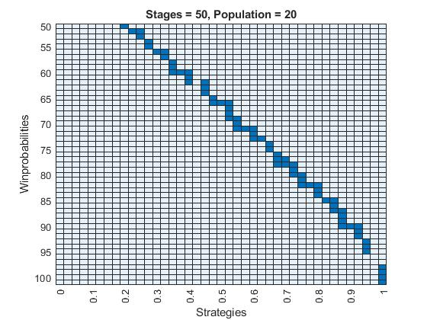

Variable population size
There are several developments one can observe when looking at the results for a growing population, ranging from two players to a hundred players. The most obvious thing is the right-shift when increasing the number of players. This can be explained through the fact that a player only gets a point in a round, if he has the highest amount of money left. If he is second, he gets zero points as well as all the other players. Therefore, it pays to play riskier with a growing population.
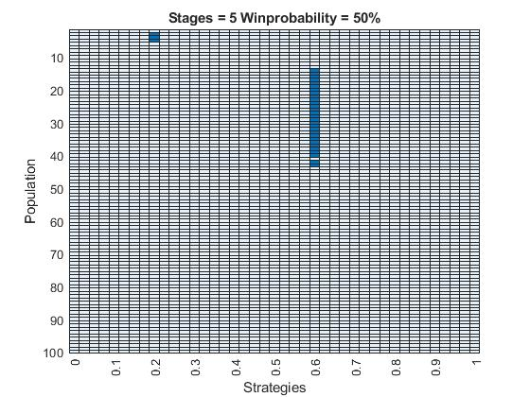

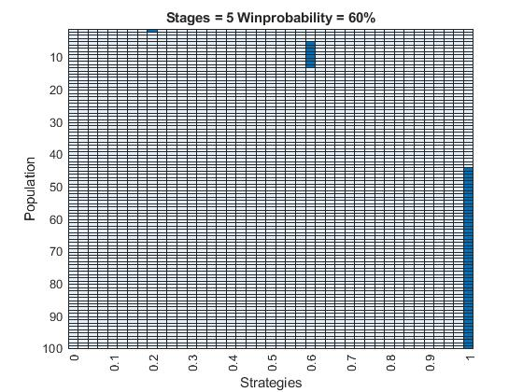

In games with lower stages, if we look at the step from 50% win probability to 60%, we can see that the strategies that are evolutionary stable change from about 20% for just a few players to 60% and from 60% to 100% for more than 20 players. This means a strategy-step of about 40 percent points, if the win probability increases only 10 percentage points.

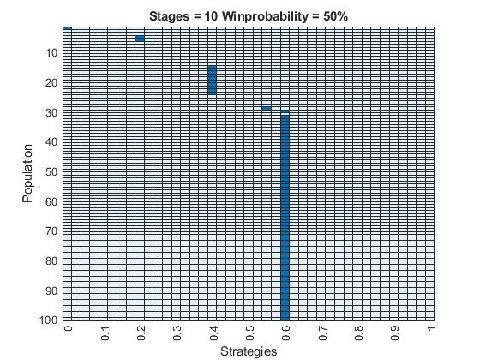

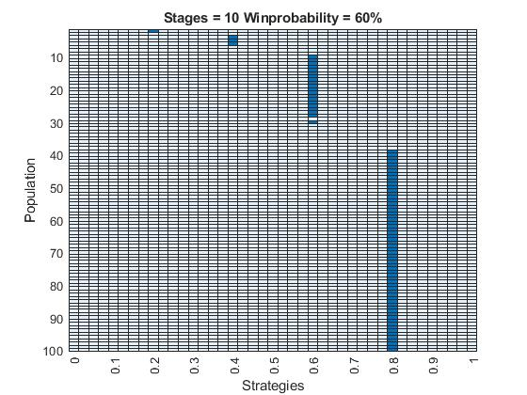

If we double the amount of stages from 5 to 10, the strategy-step is halved to 20 percent points by increasing again the win probability from 50% to 60%.

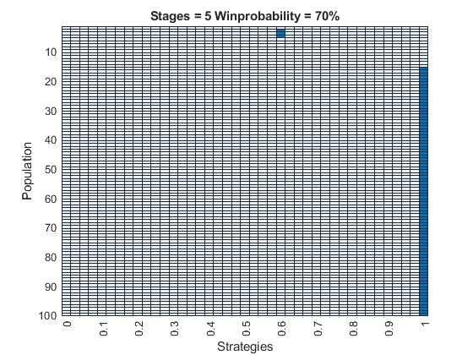
As we can see in the graph above, when playing with a win probability of 70%, as soon as there are more than about 15 players, it pays out best when betting 100% of your money.

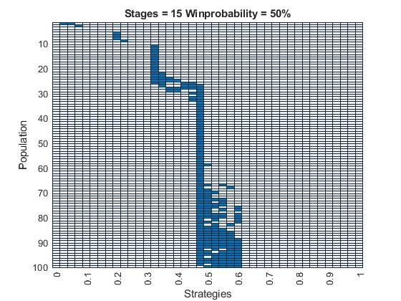
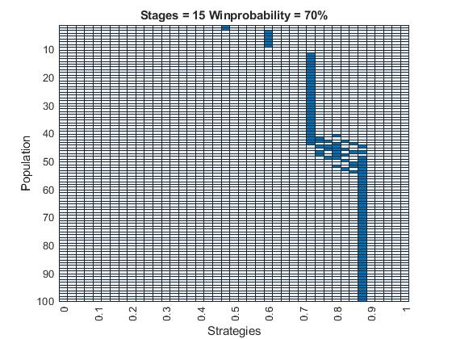
Raising the number of stages from 10 to 15 results in a kind of splattering between 50% and 60% that goes up and to the right in 10%-steps. This means that all these strategies seem to have almost equal payout with a difference below 1%. We tried to minimize this effect by lowering the margin of tolerance epsilon, but as a result, there were almost no evolutionary stable strategies left, so we kept the epsilon unchanged.

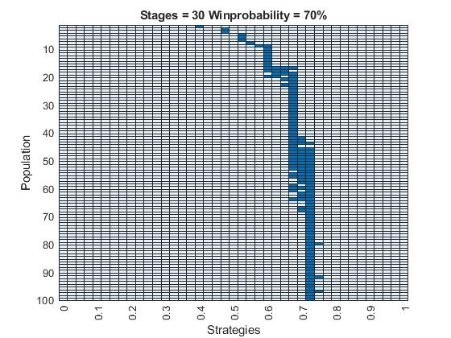
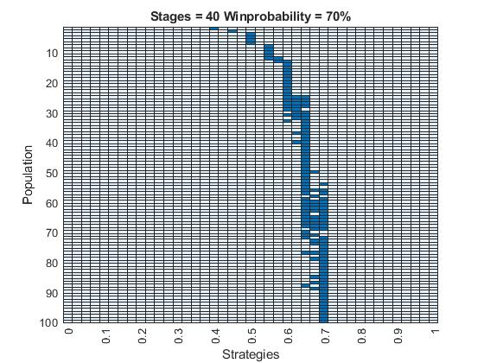

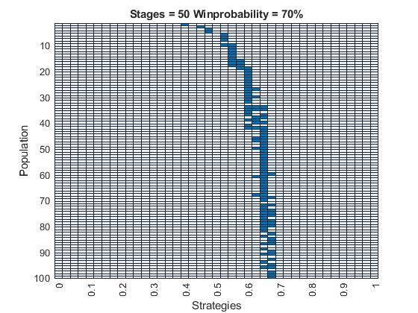
In general, one can say that when playing with win probabilities between 50% and 60%, the higher the population, the steadier the trail of evolutionary stable strategies. The more stages you have to play, the less risky you should play, because if you once lose all your money in a stage, there is no possibility to reenter the game until the end. This is the reason why we can observe a slight left shift with a growing amount of stages.

Evolutionary stable with time linear strategies
After the constant strategies we experimented with time linear strategies. Unfortunately, nonconstant strategies are quite difficult to plot. In the following plots, the y-axis is numbered from 0 to 120. Strategies 0 to 10 are constant, 11 to 120 are all possible “lines” that can be drawn between a certain percentage (from 0% in steps of 10% to 100%) on stage 1 and another percentage on the last stage N. A time linear strategy is therefore given by offset (from 0 to 1) and slope (from -1 to 1 and depending on the offset). Every time you run a simulation with time linear strategies you also get a strategy table which you’ll need to determine the exact properties of the found solutions.
If we first consider again a game of two players we get the following result.
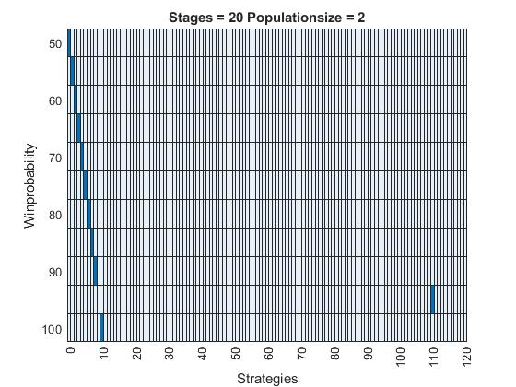
This is exactly the same result as we got for constant strategies except for a win probability of 95%, where strategy number 110 is evolutionary stable. If we look into the strategy table we can see that strategy 110 has an offset of 0.9 and a slope of 0.1.
It gets a lot more interesting if we look at games with more than 2 players as can be seen in the following graphic.
INCLUDEPICTURE "https://lh3.googleusercontent.com/FrF8jtdhvxA9Gx4P8YPEUAy1IaziZaukfEfw5NU-EyXvSYsLzLbTX8Q6U7UvXwslSXMHL2MXJYmifvW-PkzpNuGrAnMn9GSRxA2bpiWDEdF1CzbFRDF-osZkENpwbNnRmD-MII7z" \* MERGEFORMAT 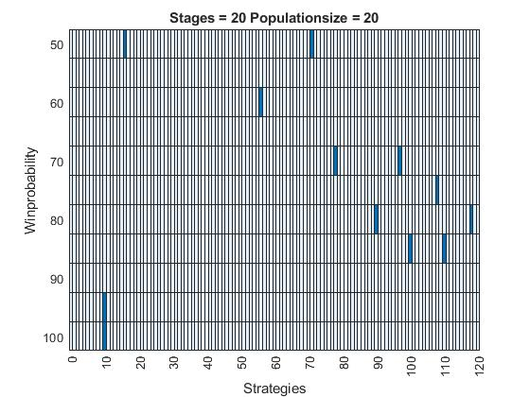
Now this looks really complicated and is indeed hard to read but with a little help from the strategy table we get the following result:

For a win probability of 50%: strategies 16 (offset 0, slope 0.6) and 71 (0.6, -0.6)
For a win probability of 60%: strategy 56 (0.4, 0.2)
For a win probability of 70%: strategies 78 (0.6, 0.2) and 97 (0.8, -0.2)
For a win probability of 75%: strategy 108 (0.9, -0.2)
For a win probability of 80%: strategies 90 (0.7, 0.3) and 118 (1, -0.3)
For a win probability of 85%: strategies 100 (0.8. 0.2) and 110 (0.9, 0.1)
For a win probability of 95%: strategy 10 (1, 0)
For a win probability of 100%: strategy 10 (1, 0)

It’s quite nice to see that we get symmetric pairs of strategies which are evolutionary stable. It can be assumed that in the cases where we didn’t our epsilon was two small (0.5% in this case) or our number of rounds (10000) to low. What we can also clearly see is that linear strategies are often better than constant strategies as soon as we have more than two players. The problem here is that is really hard to find a pattern and it’s definitely less intuitive than constant strategies.

Nash equilibrium
Testing a for a Nash equilibrium in a two player game with number of stages at 20 and considering constant and time linear strategies brought the following results:

For a win probability of 50%: Both players play (offset = 0, slope = 0)
For a win probability of 55%: Both players play (0.1, 0)
For a win probability of 60%: Both players play (0.2, 0)
For a win probability of 65%: Both players play (0.3, 0)
For a win probability of 70%: Both players play (0.4, 0)
For a win probability of 75%: Both players play (0.5, 0)
For a win probability of 80%: Both players play (0.6, 0)
For a win probability of 85%: Both players play (0.7, 0.1)
For a win probability of 90%: Both players play (0.8, 0.1)
For a win probability of 95%: Both players play (0.9, 0.1)
For a win probability of 100%: Both players play (1, 0)

If we compare these results to the evolutionary stable strategies we found in the last chapter we see that they are the same except for 85% and 90% where we have a Nash equilibrium for a slope of 0.1 compared to the evolutionary stable strategies which are constant.

Considering only constant strategies we were further able to find Nash equilibria in games of more than two players. Since it is not possible to plot them properly we will stick to one more example. Let’s consider a game of 5 players with the number of stages again at 20. We found the following Nash equilibria: (In brackets the constant strategies for all 5 players)

For a win probability of 50%: (0.1),(0.1),(0.1),(0.2),(0.2)
For a win probability of 70%: (0.5),(0.5),(0.5),(0.5),(0.6) and (0.5),(0.5),(0.6),(0.6),(0.6) and (0.5),(0.6),(0.6),(0.6),(0.6)
For a win probability of 80%: (0.7),(0.7),(0.7),(0.7),(0.7) and (0.7),(0.7),(0.7),(0.7),(0.8)
For a win probability of 90%: (0.9),(0.9),(0.9),(0.9),(0.9)
For a win probability of 100%: (1.0),(1.0),(1.0),(1.0),(1.0)

Summary and Outlook
Looking back, we can say that for a two player game we could find an evolutionary stable strategy, which turned out to be also a Nash equilibrium, for the given problem in Murphy’s paper considering constant and time linear strategies. We could further find more evolutionary stable strategies for different configurations of the two player game and found out that in most cases constant strategies are better than linear ones. We could also find Nash equilibria for all win probabilities from 50% to 100% in steps of 5%, still of course only assuming constant and time linear strategies.
For games of more than two players we can say that in the constant case evolutionary stable strategies depend in the following way on our parameters:
The higher the population size, the more risk you should take.
The more stages you have to get through, the lower should be your investment in each stage.
Higher win probability of course leads again to riskier strategies.
We could further find Nash equilibria if we considered only constant strategies. We also found out that evolutionary stable strategies often appear among linear strategies if we consider them as well, but it was not possible to detect a pattern about when they occur.

Further Investigation possibilities
What could be further investigated is the, as we call it, discretization phenomenon. When increasing the win probability, evolutionary stable strategies only occur at 0.x0-points. It is nicely observable in the plot below:
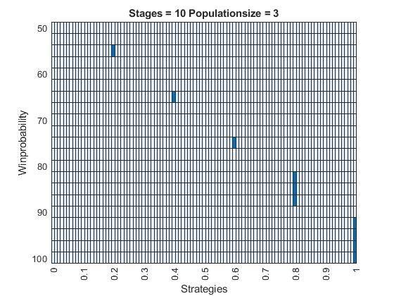

Another interesting point one could further develop, is the observation that these steady “strategy-lines” can suddenly vanish and come back again, as shown below:

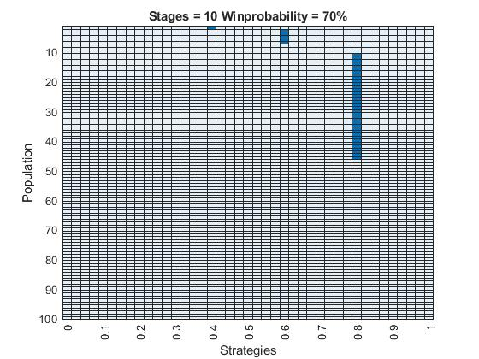

References
A Sequential Investment Game, 2011
Ryan O. Murphy (rmurphy@ethz.ch) Assistant Professor and Chair, Decision Theory and Behavioural Game Theory

