**LTE CELL SEARCH HARDWARE DETAILS**

**RF SoC:**

Xilinx’s Radio Frequency System-on-Chip (RFSoC) device combine high-accuracy ADCs and DACs operating at Giga samples per second (Gsps), with programmable heterogeneous compute engines. RFSoC 2x2 board with 2 RF DAC and 2 RF ADC channels. The RFSoC 2x2 has a Zynq Ultrascale+ XCZU28DR-FFVG1517-2-E with an Quad-core ARM Cortex A53 Processing System (PS) and Xilinx Ultrascale+ Programmable Logic (PL). There are BALUNs between the SMA connectors and the Zynq RFSoC on the board, which means that antenna and external signal sources can be connected directly to the board.

**RFSoC Board:**

[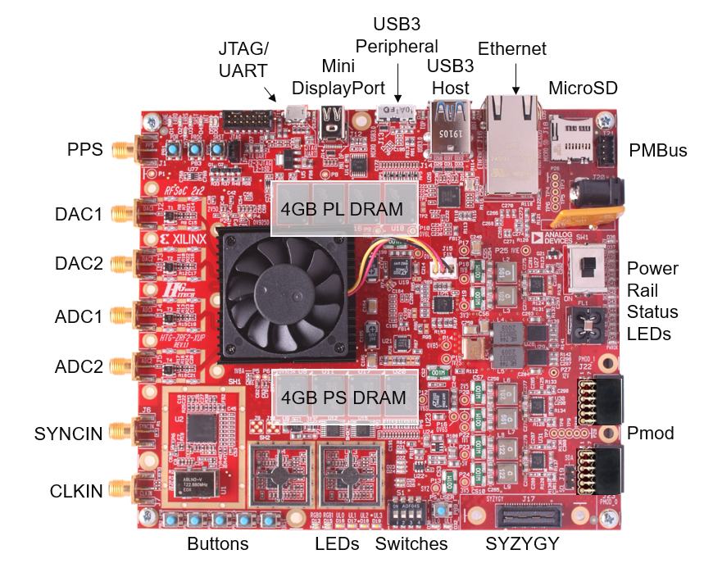](https://user-images.githubusercontent.com/77175120/168524070-e34712db-e864-4dd9-b182-6a35b00d5852.png)

**RFSoC Block Diagram:**

[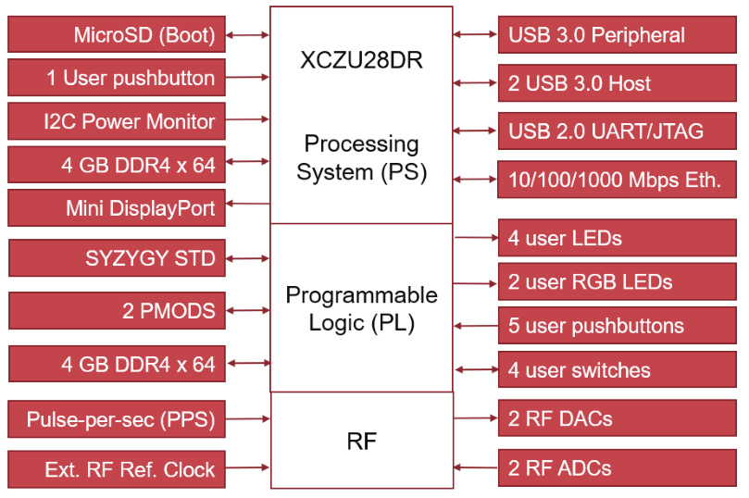](https://user-images.githubusercontent.com/77175120/168524116-8beba6e0-f300-4990-b298-17b5d1e52188.png)

([back to top](https://github.com/jehigh-sd/LTE_Cell_Search#top))

**RF SoC LMX Configuration:**

* [LMX2596 Configuration files](https://github.com/jehigh-sd/LTE_Cell_Search/tree/main/Hardware/LMX_Settings)
* Configured ADC Clock for LTE OTA RF input
* Live Signal Target = 30.72 MHz
* ADC Sample Rate = 3932.16MHz
* IP Decimates from 3932.16MHz to 1.92MHz. 2048 decimation.   
  RF SoC supports Fs in range of 1024 MHz - 4096 MHz.
* Our LTE Cell search IP needs Fs of 1.92MHz.
* ADC Fs is configured to 3932.16MHz as it is a multiple of 30.72MHz (LTE Rate).
* Reference ADC clock needed 491.52MHz.
* Our System needs decimation of 2048.
* 8x decimation in RF Soc. From 3932.16MHz to 491.52MHz.
* 256x decimation in our custom IP to achieve Fs of 1.92MHz at LTE Cell search IP.
* NCO configured to down convert carrier frequency to DC.
* 48-bit NCO per RF-ADC.
* Mixer is programmed to fine mode

There are three main components of the platform configuration.

1. ADC Sampling: The sampling rate of the on-board ADC is configured to 3932.16MHz because it is multiple of LTE standard sampling rate.

2. Decimation: The hardware IP requires a sampling frequency of 1.92MHz. As a result, the system requires several stages of decimation.

3. Numerically Controlled Oscillator: The NCO is runtime configured to down convert the carrier frequency to DC.

**RF SoC PLL configuration path using LMX:** [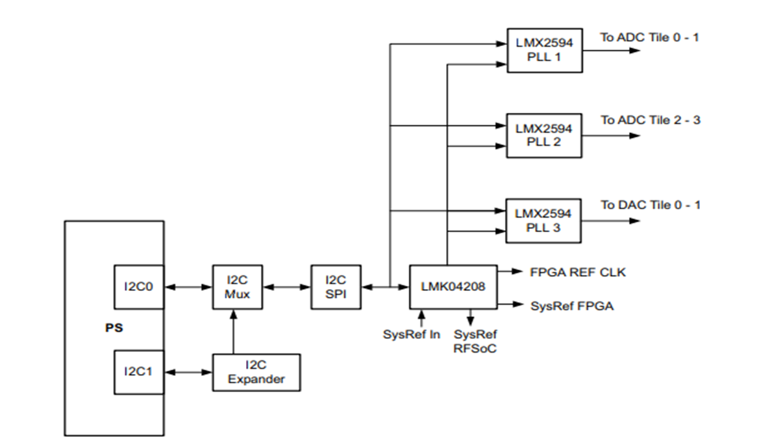](https://user-images.githubusercontent.com/77175120/169735159-47492021-819d-4613-988b-c1a3b37e5604.png)

**LMX Configuration to configure to 245.76MHz:** [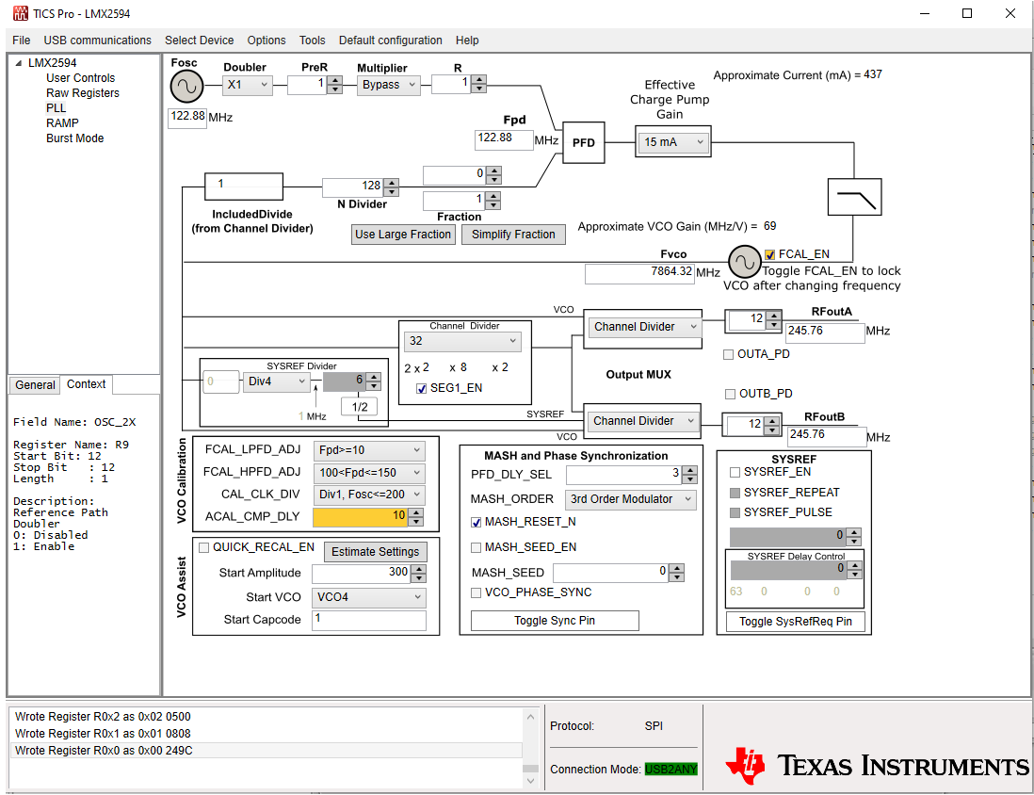](https://user-images.githubusercontent.com/77175120/168522940-0c458bac-967c-44a3-8043-116fa8b4533c.png)

**245.76MHz Tone measured in the Spectrum Analyzer after configuring LMX 2596:** [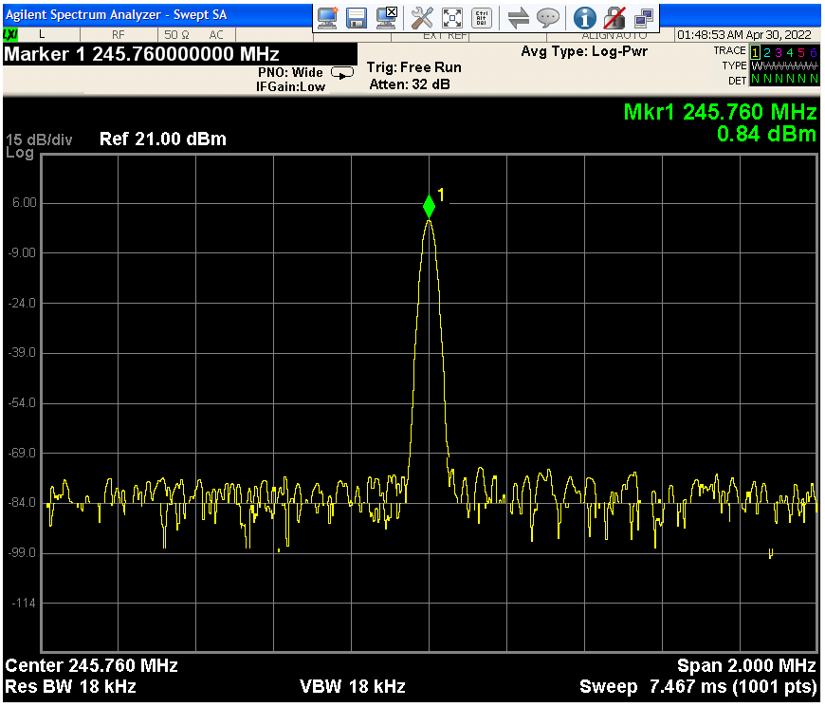](https://user-images.githubusercontent.com/77175120/168523024-419aa3f3-1ba4-4538-be6c-b5d92e9d7672.png)

**Low Noise Amplifier:**

* Used Vega Barebones - Ultra Low-Noise Variable Gain Amplifier (VGA) Module for RF & Software Defined Radio (SDR) from Nooelec.
* Highly Linear & Wideband 30MHz-4000MHz Frequency Capability w/Bias Tee & USB Power Options.
* Characterized Nooelec LNA for its Gain modes and return loss performance using KeySight E5071C vector network Analyzer
* Measured Gain (S21) for different Analog gain modes.
* Conclusion: ~40 dB of gain around ~1GHz and ~34 dB of gain around ~2GHz
* Return loss (S11) performance is reasonable in the entire bandwidth

Gain across frequency with 5 Gain modes [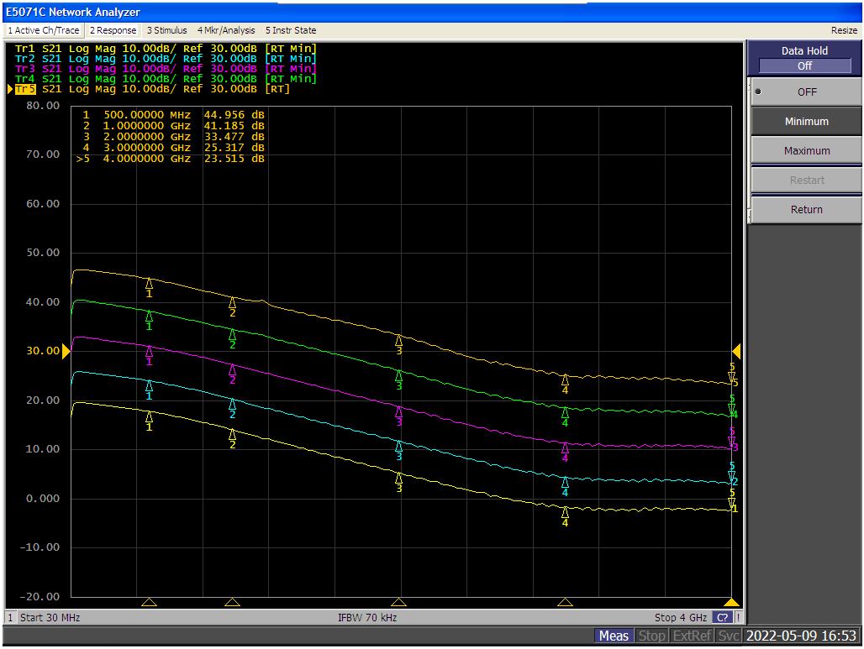](https://user-images.githubusercontent.com/77175120/168521348-b243b478-aff8-4194-b9dc-a5173fda35cb.png)

Gain (S21) and Return Loss (S11) performing at Max Gain mode

[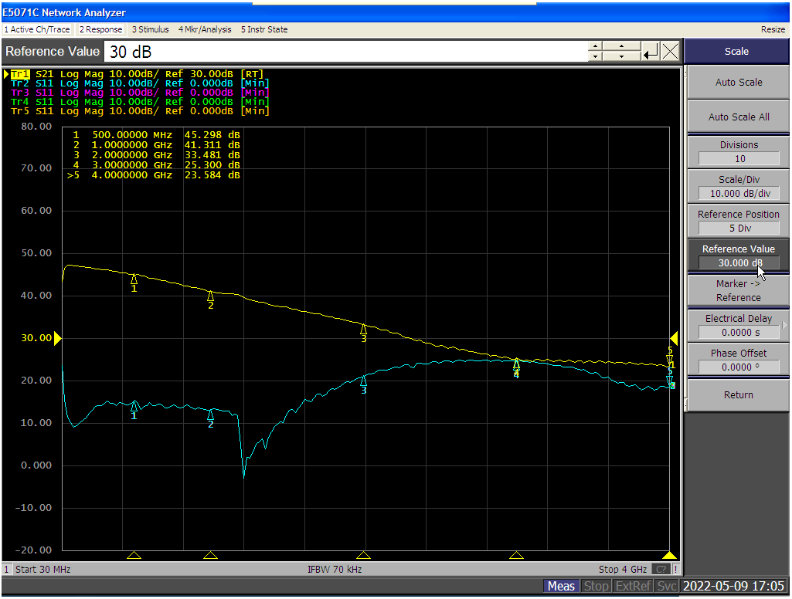](https://user-images.githubusercontent.com/77175120/168521435-544ce17e-8b10-4732-b39c-dec93d782e19.png)

Image of nooelec LNA:

[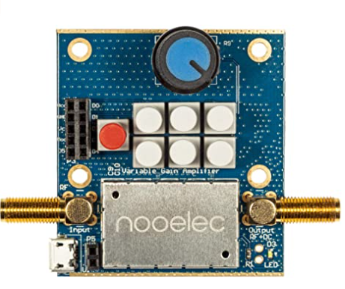](https://user-images.githubusercontent.com/77175120/168521577-a6aacffe-198c-483e-a1d5-c59fa8132f9a.png)

[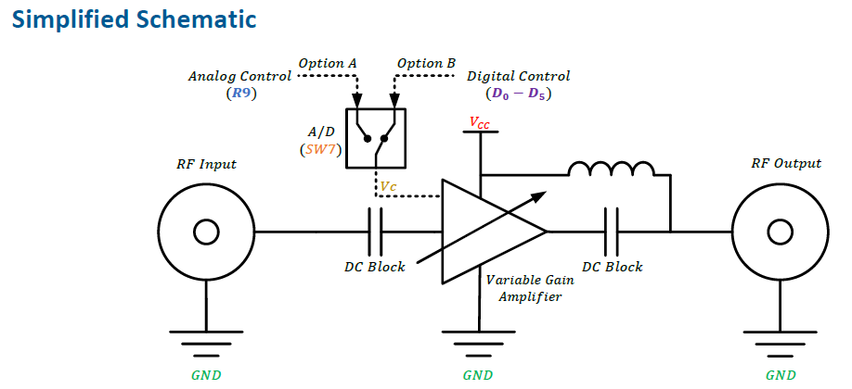](https://user-images.githubusercontent.com/77175120/168521692-72d2b6f1-8484-420d-ad5d-51efcae6ebc0.png)

[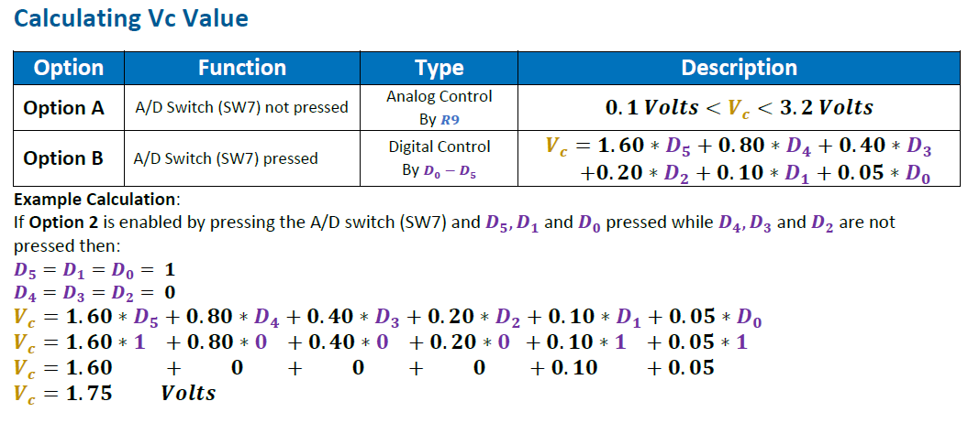](https://user-images.githubusercontent.com/77175120/168521749-ad4f0d0c-f598-40bd-b067-a1a6232aa335.png)

(