LTE CELL SEARCH BOARD-LEVEL HARDWARE

Table of Contents

Equipment List 2

RFSoC 2

RFSoC Board 3

Board File – Parts selection (Vivado Project Setup) 3

RFSoC Block Diagram 4

Accessories 5

Nooelec RaTLSnake M6 v2 5

Nooelec LNA – Variable Gain Amplifier 5

Information from Data Sheet 6

RFSoC LMX Configuration 7

RFSoC PLL configuration path using LMX 8

Debug Test Bench Block Diagram 9

LMX Configuration to configure to 491.52MHz 10

Spectrum Analyzer Plot: Configured LMX 2596 11

Low Noise Amplifier Characterization 12

# Equipment List

1. RFSoC_2x2 (Xilinx ZYNQ Ultra Scale+ RFSoC ZU28DR FPGA device)
   1. Part Number: HTG-ZRF2-XUP
2. 2 Antennas ($30) – Used 1 per setup. https://www.nooelec.com/store/sdr/sdr-addons/antennas/ratlsnake-m6.html
3. LNA ($50) - https://www.nooelec.com/store/vega-barebones.html
4. Terminators for unused ADC/DAC SMA connections
5. *(Optional)* 2 Filters ($64) - https://www.mouser.com/ProductDetail/Mini-Circuits/VLF-1800+?qs=xZ%2FP%252Ba9zWqZiMerIBdUJuQ%3D%3D
6. *(Optional)*Attenuator($40) - https://www.nooelec.com/store/sdr/sdr-addons/attenuators/attenuator-bundle.html
7. *(Optional)* (Intermediate debugging, using MATLAB and Pluto SDR Plug-in) https://www.analog.com/en/design-center/evaluation-hardware-and-software/evaluation-boards-kits/adalm-pluto.html
   1. https://github.com/jehigh-sd/LTE_Cell_Search/tree/main/TEST_BENCH
8. *(Optional)* (Intermediate debugging, scan LTE signal, evaluate Pluto transmit) PYNQ-Z2 Development Board – LTE Cell Scanner
   1. http://www.pynq.io/board.html
   2. https://www.mathworks.com/help/wireless-hdl/ug/lte-hdl-cell-search.html

# RFSoC

[https://www.rfsoc-pynq.io/overview.html]

Xilinx’s Radio Frequency System-on-Chip (RFSoC) device combine high-accuracy ADCs and DACs operating at Giga samples per second (Gsps), with programmable heterogeneous compute engines. RFSoC 2x2 board with 2 RF DAC and 2 RF ADC channels. The RFSoC 2x2 has a Zynq Ultrascale+ XCZU28DR-FFVG1517-2-E with a Quad-core ARM Cortex A53 Processing System (PS) and Xilinx Ultrascale+ Programmable Logic (PL). There are BALUNs between the SMA connectors and the Zynq RFSoC on the board, which means that antenna and external signal sources can be connected directly to the board.

# RFSoC Board

[https://www.rfsoc-pynq.io/overview.html]

[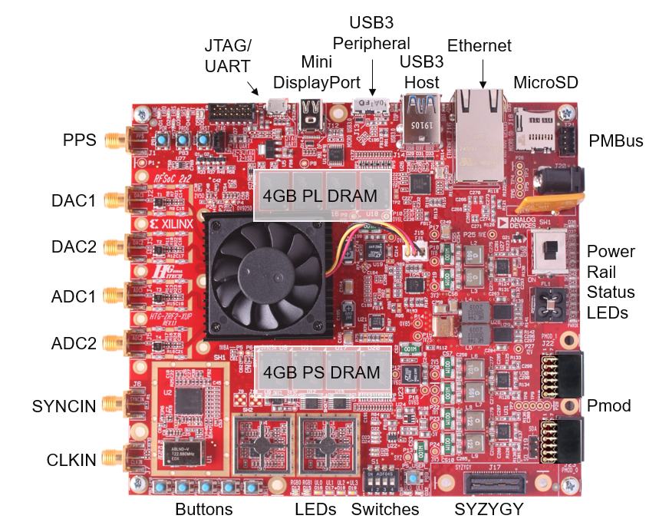](https://user-images.githubusercontent.com/77175120/168524070-e34712db-e864-4dd9-b182-6a35b00d5852.png)

# Board File – Parts selection (Vivado Project Setup)

1. Board File Installation Instructions: https://www.rfsoc-pynq.io/board_files.html
2. Steps used in this project (instructions/script out of date based on Vivado version)
   1. Download: https://github.com/Xilinx/XilinxBoardStore/tree/2020.1/boards/Xilinx/rfsoc2x2/
   2. Linux path to place files prior to starting/running Vivado: /tools/Xilinx/Vivado/2020.2/data/boards/board_files/rfsoc2x2/1.1
3. New Project: Browse Board tab menu (not Parts) to locate the board file configuration.

# RFSoC Block Diagram

[https://www.rfsoc-pynq.io/overview.html]

[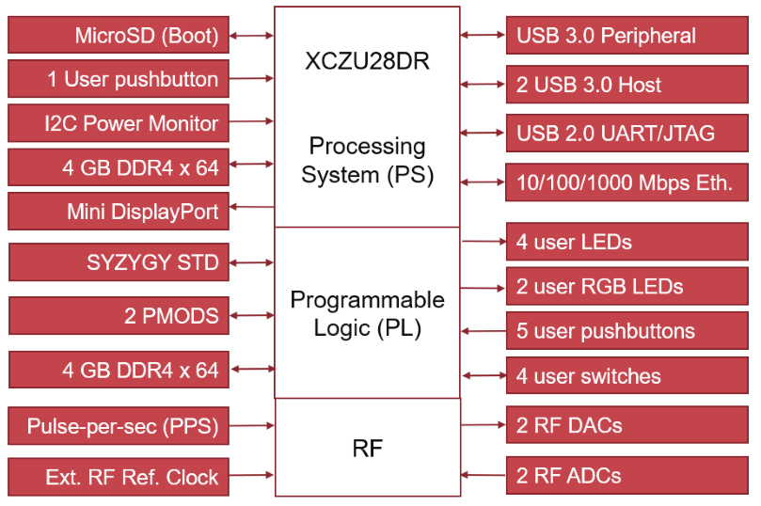](https://user-images.githubusercontent.com/77175120/168524116-8beba6e0-f300-4990-b298-17b5d1e52188.png)

# Accessories

## Nooelec RaTLSnake M6 v2

Connect antenna to ADC0 for Over-The-Air testing with Jupyter Notebook.

https://github.com/jehigh-sd/LTE_Cell_Search/tree/main/NOTEBOOKS

## Nooelec LNA – Variable Gain Amplifier

[https://www.nooelec.com/store/vega-barebones.html]

[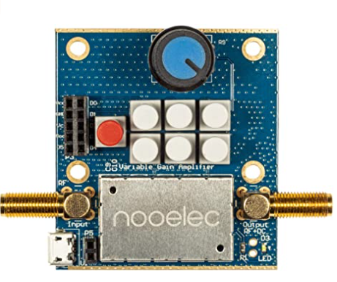](https://user-images.githubusercontent.com/77175120/168521577-a6aacffe-198c-483e-a1d5-c59fa8132f9a.png)

### Information from Data Sheet

[https://www.nooelec.com/store/downloads/dl/file/id/103/product/334/vega_datasheet_revision_1.pdf]

[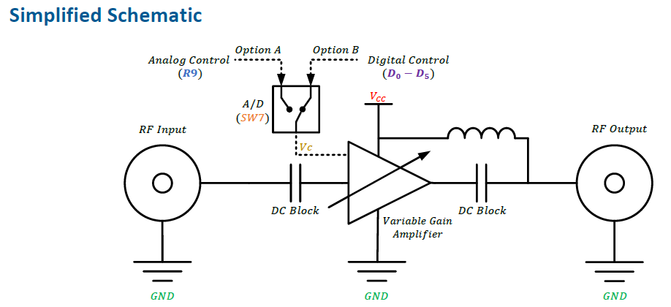](https://user-images.githubusercontent.com/77175120/168521692-72d2b6f1-8484-420d-ad5d-51efcae6ebc0.png)

[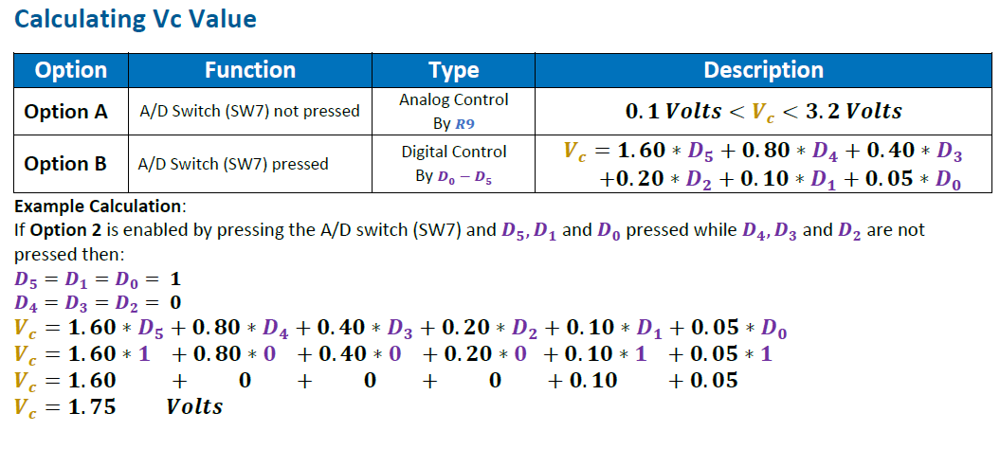](https://user-images.githubusercontent.com/77175120/168521749-ad4f0d0c-f598-40bd-b067-a1a6232aa335.png)

### RFSoC LMX Configuration

* [LMX2596 Configuration files](https://github.com/jehigh-sd/LTE_Cell_Search/tree/main/Hardware/LMX_Settings)
* Configured ADC Clock for LTE OTA RF input
* Live Signal Target = 30.72 MHz
* ADC Sample Rate = 3932.16MHz
* IP Decimates from 3932.16MHz to 1.92MHz. 2048 decimation.   
  RF SoC supports Fs in range of 1024 MHz - 4096 MHz.
* Our LTE Cell search IP needs Fs of 1.92MHz.
* ADC Fs is configured to 3932.16MHz as it is a multiple of 30.72MHz (LTE Rate).
* Reference ADC clock needed 491.52MHz.
* Our System needs decimation of 2048.
* 8x decimation in RFSoC. From 3932.16MHz to 491.52MHz.
* 256x decimation in our custom IP to achieve Fs of 1.92MHz at LTE Cell search IP.
* NCO configured to down convert carrier frequency to DC.
* 48-bit NCO per RF-ADC.
* Mixer is programmed to fine mode

There are three main components of the platform configuration.

* ADC Sampling: The sampling rate of the on-board ADC is configured to 3932.16MHz because it is multiple of LTE standard sampling rate.
* Decimation: The hardware IP requires a sampling frequency of 1.92MHz. As a result, the system requires several stages of decimation.
* Numerically Controlled Oscillator: The NCO is runtime configured to down convert the carrier frequency to DC.

### RFSoC PLL configuration path using LMX

[RFSoC Data Converter Evaluation Tool User Guide UG1287 (v2021.2) October 28, 2021

Chapter 4: Clocking, Figure 4-1 ZCU111 AMS Clocking Structure:

https://www.xilinx.com/content/dam/xilinx/support/documents/boards_and_kits/zcu111/2021_2/ug1287-zcu111-rfsoc-eval-tool.pdf]

[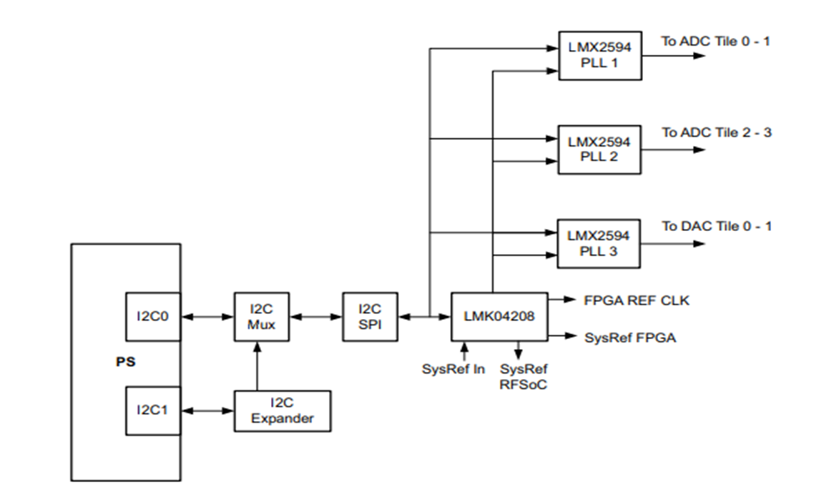](https://user-images.githubusercontent.com/77175120/169735159-47492021-819d-4613-988b-c1a3b37e5604.png)

Debug Test Bench Block Diagram

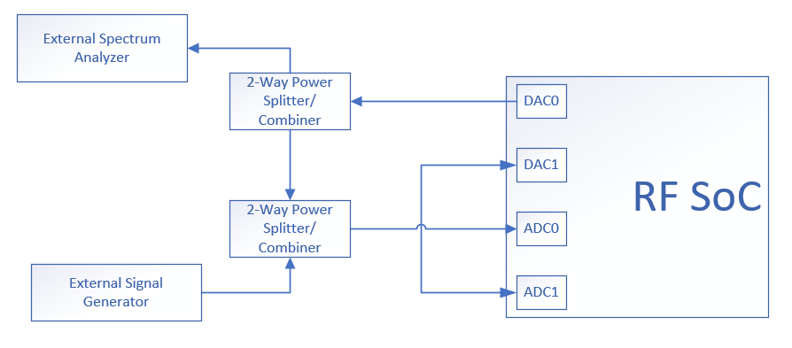

LMX Configuration to configure to 491.52MHz

Example screenshot: 245.76MHz (originally used this number to decimate by 8, but MATLAB reference IP required 61.44 MHz and decimates internally by 2 to get 30.72MHz. Needed to start with 2x)[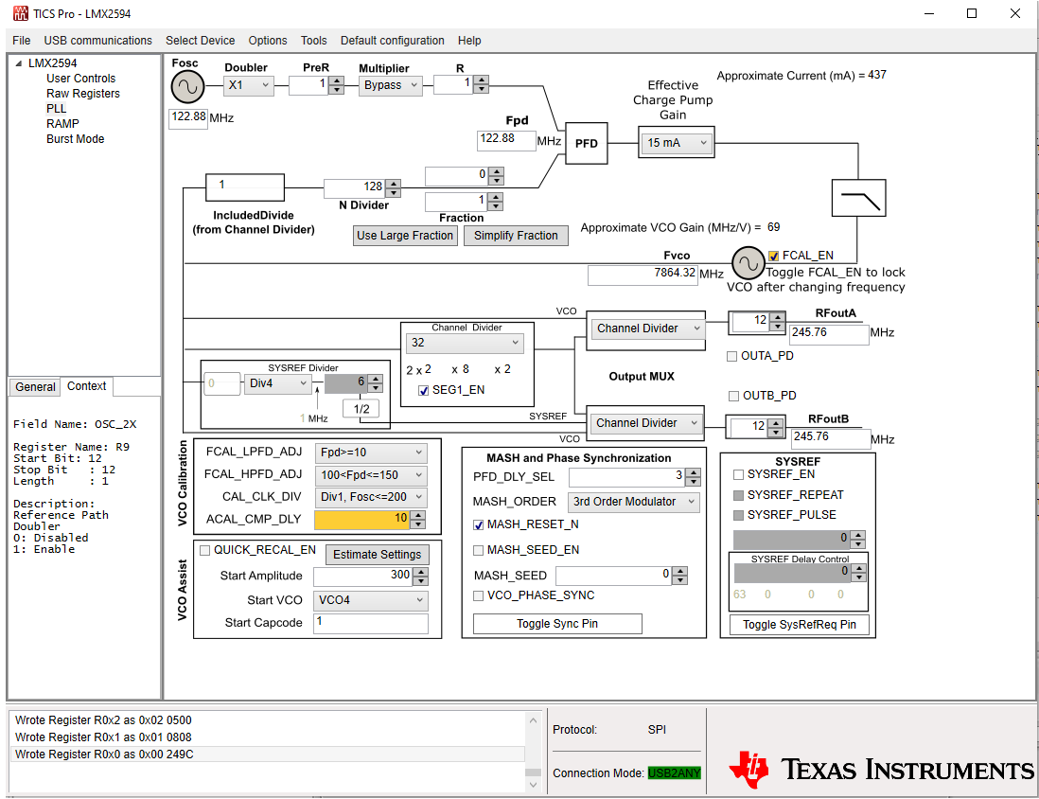](https://user-images.githubusercontent.com/77175120/168522940-0c458bac-967c-44a3-8043-116fa8b4533c.png)

Spectrum Analyzer Plot: Configured LMX 2596

Example screenshot: 245.76MHz Tone measured in the Spectrum Analyzer after configuring LMX 2596[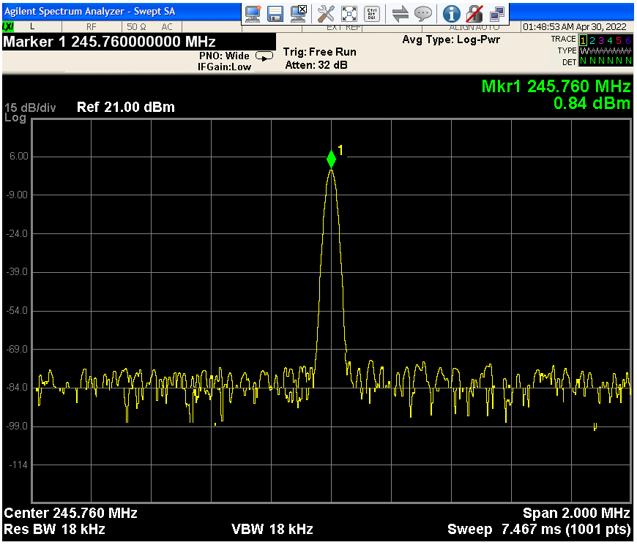](https://user-images.githubusercontent.com/77175120/168523024-419aa3f3-1ba4-4538-be6c-b5d92e9d7672.png)

Note: Configured ADC Clock for LTE OTA RF input

* RFSoC Range = 1024 MHz to 4096 MHz
  + Max decimation supported RF data converter (x8)
* Live Signal Target = 30.72 MHz
* ADC Sample Rate = 1.96608 GHz
* Need IP Block: Decimate 491.52 MHz to 61.44 MHz

# Low Noise Amplifier Characterization

* Used Vega Barebones - Ultra Low-Noise Variable Gain Amplifier (VGA) Module for RF & Software Defined Radio (SDR) from Nooelec.
* Highly Linear & Wideband 30MHz-4000MHz Frequency Capability w/Bias Tee & USB Power Options.
* Characterized Nooelec LNA for its Gain modes and return loss performance using KeySight E5071C vector network Analyzer (prepare front end)
* Measured Gain (S21) for different Analog gain modes.
* Conclusion: ~40 dB of gain around ~1GHz and ~34 dB of gain around ~2GHz
* Return loss (S11) performance is reasonable in the entire bandwidth

Gain across frequency with 5 Gain modes[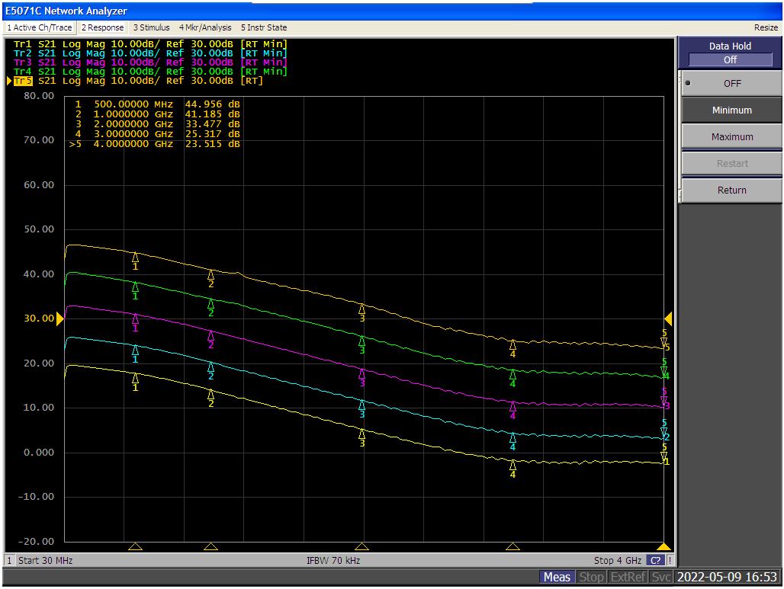](https://user-images.githubusercontent.com/77175120/168521348-b243b478-aff8-4194-b9dc-a5173fda35cb.png)

Gain (S21) and Return Loss (S11) performing at Max Gain mode

[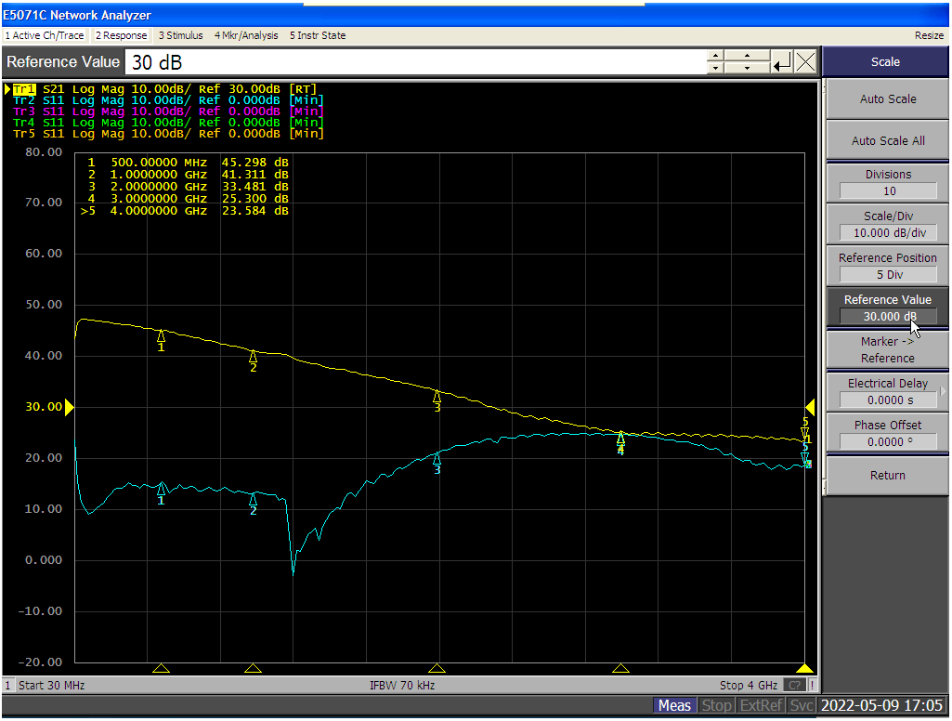](https://user-images.githubusercontent.com/77175120/168521435-544ce17e-8b10-4732-b39c-dec93d782e19.png)