LTE Cell Search Theory

Table of Contents

**Cyclic Prefix Correlation** 2

**LTE Synchronization Signals (PSS and SSS)** 3

**PSS Peak Correlation** 4

PSS Correlation Peak Detection 5

PSS Process 5

**SSS Sequence Calculations and Correlation** 6

SSS Process 7

PSD of LTE Signal Received 8

Cell ID Detected from MATLAB IP 9

Frequency Estimation from Custom IP 9

Detected Cell ID 10

**Table of Figures**

**Figure 1: CP Correlation, FFT Window, OFDM Symbol, OFDM Block 2**

**Figure 2: LTE Frame Details: Relative Symbol Position of SSS and PSS in Frame | Sub-frame | Slots.** 3

**Figure 3: Calculations for Primary Synchronization Signal (PSS) Detection at Receiver.** 4

**Figure 4: PSS Peak Detection: 50 ms Capture: 5 LTE Frames – 10 PSS Correlation Peaks** 5

**Figure 5: SSS Sequences: SSS Correlation.** 6

**Figure 6: Received Power Spectral Density (PSD) of Recorded LTE Signal Transmitted from the Pluto.** 8

**Figure 7: Jupyter Notebook Output from Loopback Configuration** 9

**Figure 8: Jupyter Notebook Output from Over-the-Air Data (LNA + Antenna)** 10

**Cyclic Prefix Correlation**

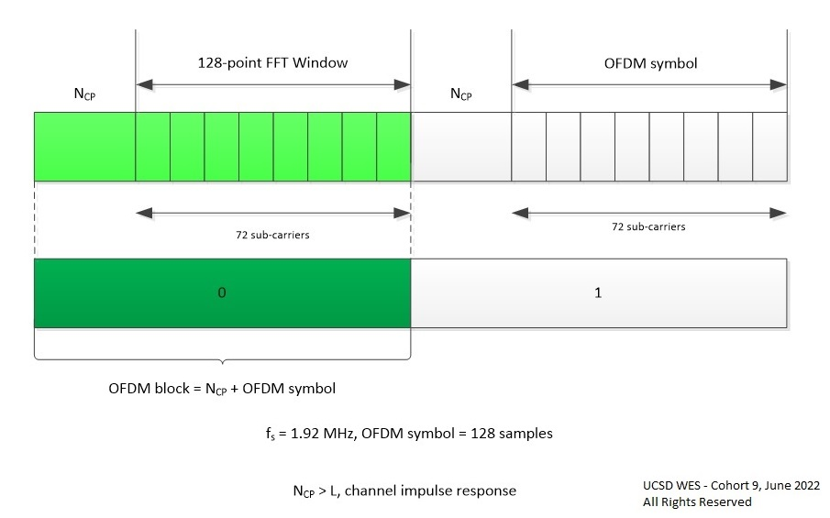

Figure 1: CP Correlation, FFT Window, OFDM Symbol, OFDM Block

**LTE Synchronization Signals (PSS and SSS)**

There are two downlink synchronization signals used by the User Equipment to obtain the cell identity and frame timing.

* Primary synchronization signal (PSS)
* Secondary synchronization signal (SSS)

The division into two signals is aimed to reduce the complexity of the cell search process.

<https://www.mathworks.com/help/lte/ug/synchronization-signals-pss-and-sss.html>

<https://www.mathworks.com/help/wireless-hdl/ug/lte-hdl-cell-search.html>

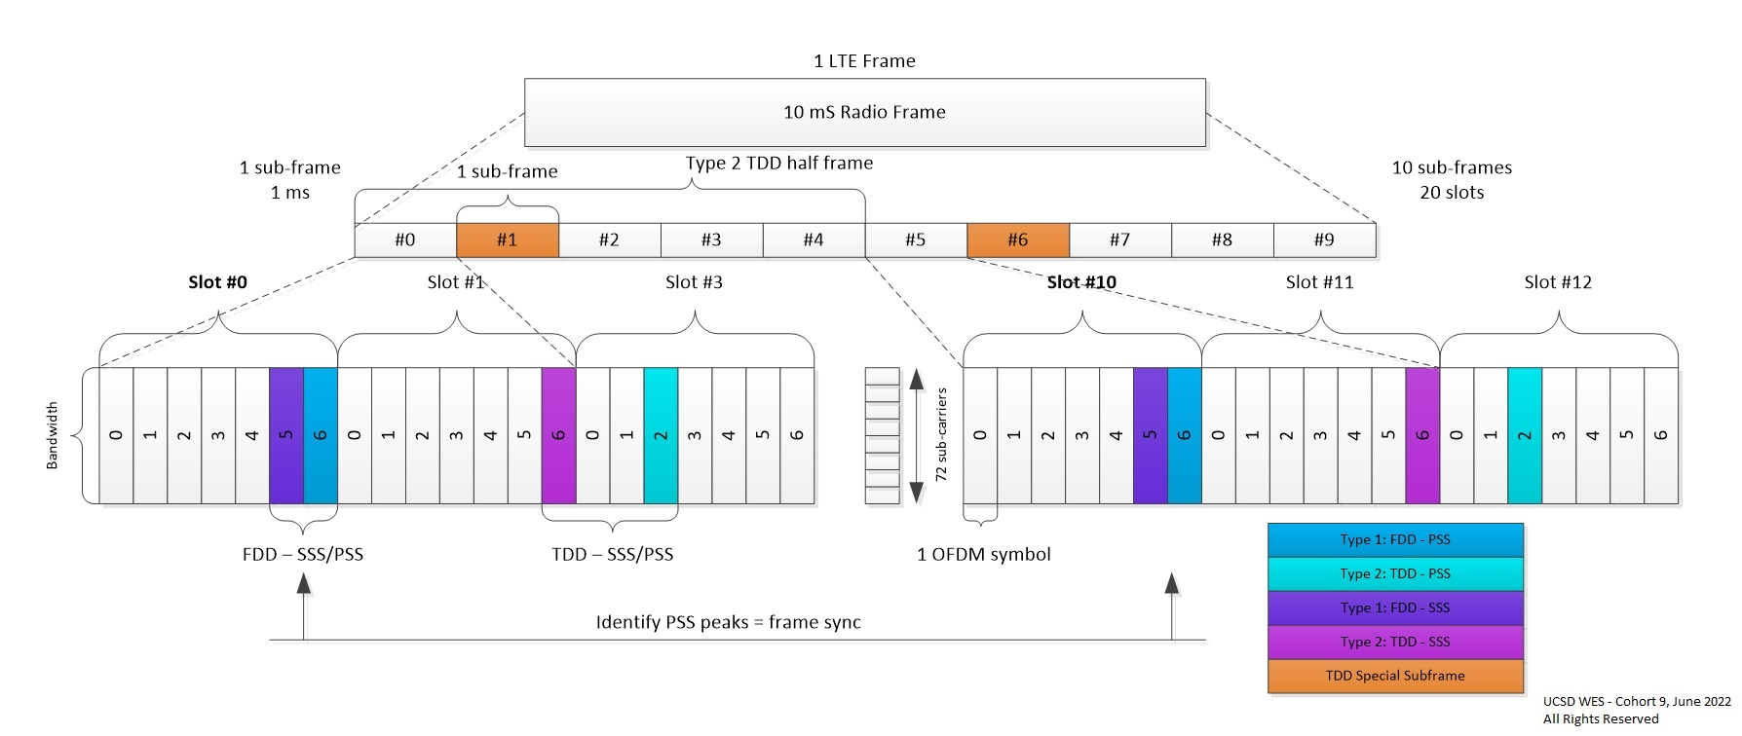

**Figure 2: LTE Frame Details: Relative Symbol Position of SSS and PSS in Frame | Sub-frame | Slots.**

**PSS Peak Correlation**

https://www.mathworks.com/help/lte/ug/synchronization-signals-pss-and-sss.html#bt0y_j2-1

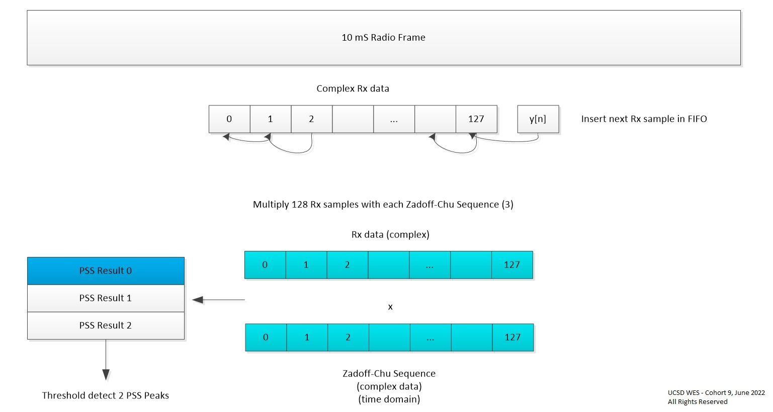

**Figure 3: Calculations for Primary Synchronization Signal (PSS) Detection at Receiver.**

## PSS Correlation Peak Detection

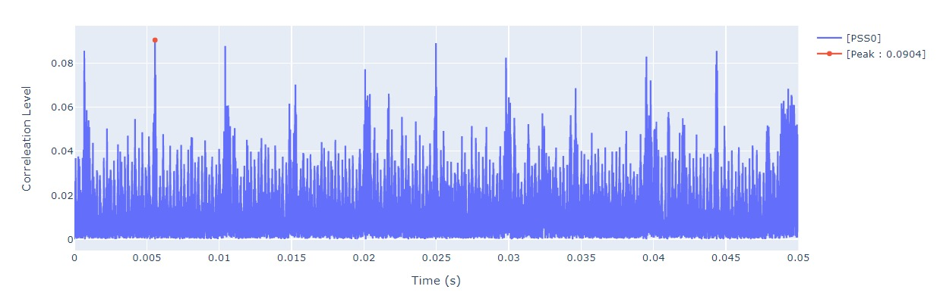

**Figure 4: PSS Peak Detection: 50 ms Capture: 5 LTE Frames – 10 PSS Correlation Peaks**

## PSS Process

LTE data carried in frames (10 ms) and sub-frames (10) divided into 20 slots - structured for synchronization

Goal: Identify PSS and demodulate (extract info for Cell ID)

Don’t know which type of frame. Need to correlate input with known Zadoff-Chu sequences - identify peaks (2 symbol locations within frame)

Programmable Logic (PL) Implementation:

* Complex Multiply: Rx input sequence * PSS (time domain)
* Identify 2 peaks over 10 slots (1 frame)
* Identify known sequence in Rx data - 1 of 3 Zadoff-Chu sequences
* Keep searching for pair of peaks to maintain sync using threshold detect - maintain sync
* Part 1 of getting Physical Cell ID (504 Unique IDs)

Primary synchronization signal (PSS): linked to the cell identity within the group.

**SSS Sequence Calculations and Correlation**

https://www.mathworks.com/help/lte/ug/synchronization-signals-pss-and-sss.html#bt03428-1

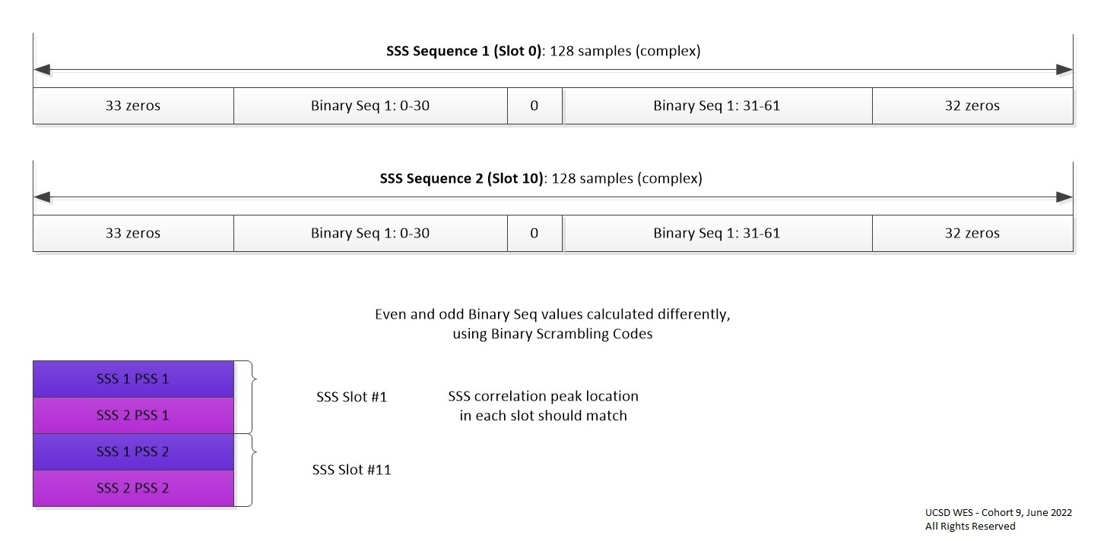

**Figure 5: SSS Sequences: SSS Correlation.**

## SSS Process

LTE data carried in frames (10 ms) and sub-frames (10) divided into 20 slots - structured for synchronization

Goal: Identify SSS and demodulate (extract info for Cell ID)

Know location of PSS in frame. 2 frame types determine relative location of SSS sequences.

Programmable Logic (PL) Implementation:

* Start with 2 locations of PSS and take 128 point fft (and fft shift to put samples in order for analysis)
* Analyze PSS locations @ **slot 0 and slot 10**
* Generate 3 binary sequences: s[31],c[31],z[31] - polynomial based on Galois field
* Iterate over the set of 168 cell identity groups, NID(1).
  + Create binary sequences with binary scrambling codes - depend on NID(2)
* Generate 2 sequences length 62 from binary sequence: even and odd indices calculations different
* Insert 2 length 62 sequences in 128 samples centered around 0 at middle (DC) (See Figure 5 above)
* Iterate over 128 samples @ PSS locations: Multiply and accumulate input samples with generated sequences (separate real and imaginary components): 2 complex inputs from 2 PSS locations
* Fill 4 complex data buffers, length 168, with accumulated values:
  + 2 sequences for **slot 0** and 2 sequences for **slot 10**
  + 2 sequences since SSS interleave improve sync performance
* Analyze the 4 complex data buffers (only need 2 since redundant)
  + Identify peaks and determine physical layer identity group (location of peak is group -> Cell ID

Secondary Synchronization Signal (SSS): linked to the cell identity within the group + physical layer cell identity group.

## PSD of LTE Signal Received

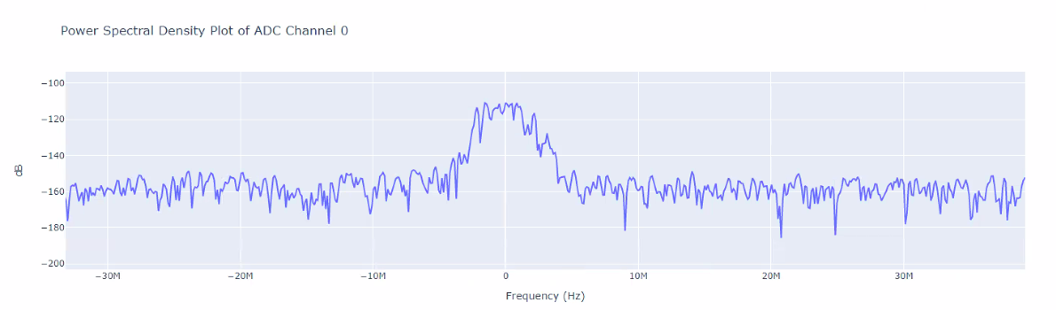

**Figure 6: Received Power Spectral Density (PSD) of Recorded LTE Signal Transmitted from the Pluto.**

|  |  |
| --- | --- |
| Cell ID Detected from MATLAB IP | Frequency Estimation from Custom IP |
| https://lh5.googleusercontent.com/O7cUpSMZIcp-uNAKlWRzUjGkm0mkMl1ll3m38VSPmZuvelnmP-pH-o4nGPK31WZqFQzt7T6w5rtsjMZsN_TfnG2fZXCATngUbRZai4NdD2eV9TkwknkPDlJlBd5jRd8Udh1mgLUoK44 | https://lh4.googleusercontent.com/H8bRAIMYksGFLu__2R37kpyuEow5qWuN7ilBwvLkLDPO5mT2LQP50svTDwQOKLPna_RjYdhkbZvhYRFFEplDTem7_paKK9BU1XsVTe8na5y9zXOzEo-a-gs3CR092bfOw3l1az4mUJo |

**Figure 7: Jupyter Notebook Output from Loopback Configuration**

## Detected Cell ID

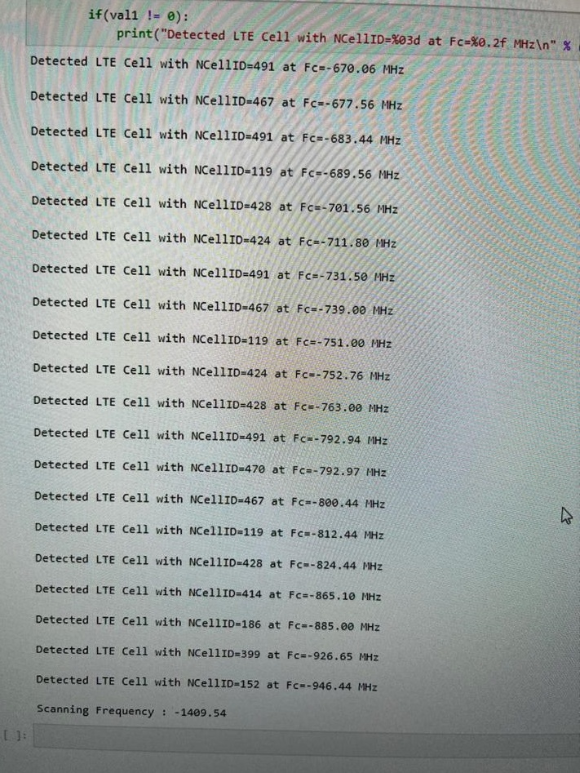

**Figure 8: Jupyter Notebook Output from Over-the-Air Data (LNA + Antenna)**