**LTE Cell Search Test Bench:**

For Test Bench, brought up 3 different types of test setups

1. First one is loopback, where you can generate LTE waveform from DAC is fed back into ADC via SMA cables

2. Initially results with loopback mode were not as expected so we had to use external signal generator to isolate issues with platform level settings. That’s second setup.

3. Pluto SDR setup is used for wireless testing with LTE waveform

**To Run Test bench:**

* Install Matlab Pluto SDR driver from below link: [Pluto SDR driver](https://www.mathworks.com/help/supportpkg/plutoradio/ug/install-support-package-for-pluto-radio.html)
* Open “LTETx_eNodeB_Transmit.m” in the Test_Bench folder
* Connect the Pluto SDR with antenna connected to TX port
* Run this matlab file
* 800MHz Carrier frequency with eNodeBWaveform file with sampling frequency of 7.86MHz will be started from Pluto SDR
* Run ‘release(tx)’ command to stop the transmission
* You can change the Carrier frequency of your interest.

**LTE Test Bench with Open-source Software:**

* Need PYNQ board, Pluto SDR and RTL digitizer to build this test bench.
* Install Matlab Pluto SDR driver from below link: [Pluto SDR driver](https://www.mathworks.com/help/supportpkg/plutoradio/ug/install-support-package-for-pluto-radio.html)
* To create test bench for this project, used LTE Cell scanner open-source software from GitHub and compiled on the PYNQ board. [LTE Cell Scanner](https://github.com/Evrytania/LTE-Cell-Scanner)
* Verified test bench with NAR bands – 900MHz, able to detect different MIB’s from different Cells
* Picked non-NAR region band – 860MHz to generate LTE Test signal
* Used Matlab "Wireless waveform Generator" application and Generated LTE Test signal using Matlab– 5MHz, 25 RB, 64QAM, Cell ID: 11 with PSS, SSS, PBCH.
* Exported this signal to MatLab to play from Pluto SDR
* Play LTE test signal continuously from Pluto SDR and run cell search algorithm in PYNQ to capture the transmitted LTE test signal.

**"Wireless Waveform Generator" Application in MATLAB**[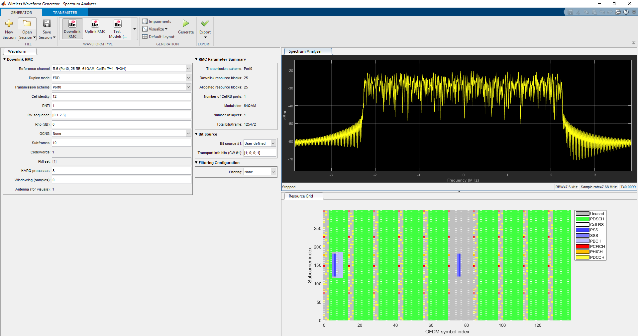](https://user-images.githubusercontent.com/77175120/168521307-bde56b3c-8cd0-4a36-a6ca-82908db87317.png)

**Block diagram of Test Bench with Pluto SDR**[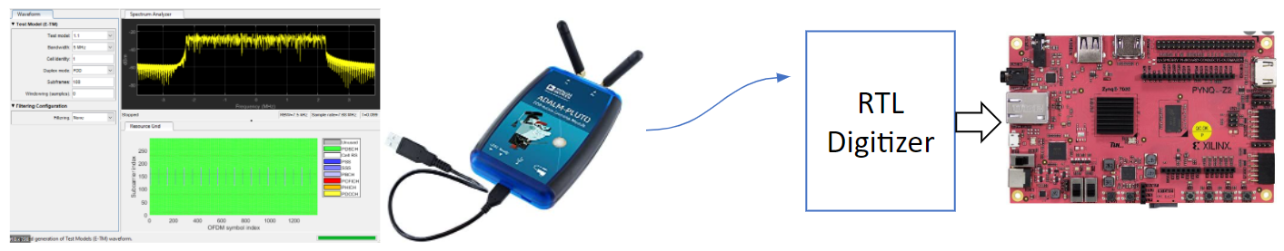](https://user-images.githubusercontent.com/77175120/168525137-b0576fe0-edb7-48d5-be1a-041e3c41d492.png)

**LTE Cell Search Result from PYNQ Board**[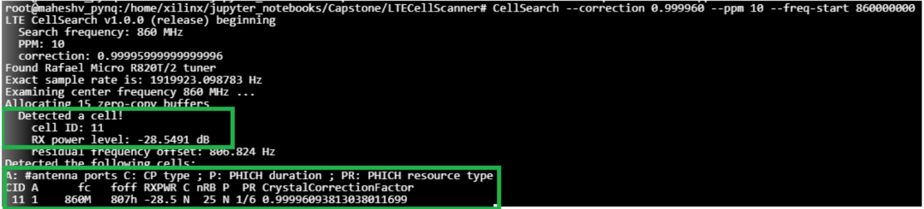](https://user-images.githubusercontent.com/77175120/168525256-2f4d184c-fb22-4da8-9ad1-91684b45fcd7.png)

**Block diagram of Test Bench**

External Spectrum Analyzer and Modulated Signal Generator (for accurate testing)[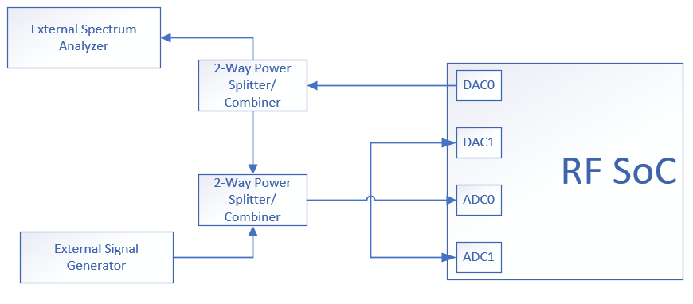](https://user-images.githubusercontent.com/77175120/169672119-b5f330b6-6a6d-44b9-899f-981caf7f155d.png)