Tracking via Colour Indexing, using Back Projection and Mean Shift
This is an implementation of object matching using colour indexing. The first part is just using colour indexing to find a target in a collage. The second part is using the colour index matching to track a target in video. The third part is tracking the target in the video, but using mean shift on the back projection instead of just the maximum of the back projection.
The Algorithms
Part I: Object Matching
First the target object image is preprocessed to remove all the background. Since the set of images use black as the background, this is as simple as setting all the black values to not a number. Then the target image is converted from 8-bit colour to 3-bit colour before a colour histogram is taken of the image, resulting in 512 bins. The collage image is then loaded in and the same process is done on it, to end up with a different colour histogram of 512 bins that represents the whole collage image. Then the ratio histogram is calculated by taking the result of target object colour histogram over the collage colour histogram. This ratio histogram is then back projected on to the original collage image, meaning each pixel is replaced with the value in the ratio histogram for the corresponding colour. The resulting back projected image shows concentrations where the target object might be. To find where the highest concentration is, the back projected image is convolved with a uniform disk mask. The maximum value in the resulting image is the location of the target object.
Part II: Object Tracking
The object tracking is done using the exact same method from part one. First the ginput is taken of the first frame of the video, this represents the centroid of object to track. Then a certain radius around the centroid is used to take a sample and converted into the colour histogram to match. Then for each frame of the video, the whole frame is converted to a colour histogram, the ratio histogram computed, then back projected and convolved with the uniform disk to find the maximum value. This lengthy back projection process is repeated for each frame of the video to find the target sample in each frame.
Part III: Mean Shift
This part is much the same as the method in part two. However, instead of just taking the maximum of the convolved back projected image to be the centroid of the target, the centroid is found using the mean shift algorithm. The starting position for the mean shift is the same ginput that is inputted on the first frame. Then for each successive frame, the average of all the values within a certain radius of the previous mean is calculated to find the “center of gravity” of the region, which becomes the centroid for the next frame. This process continues for each frame, the mean shifting each time to its new location.

The Results
Part I
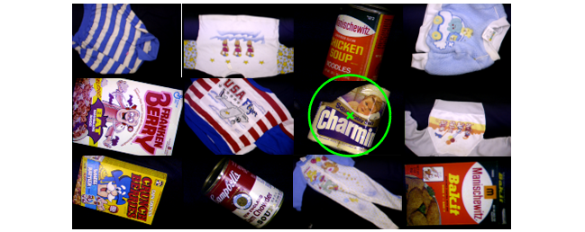
The algorithm is able to find the toilet paper rolls very well. It is able to detect every object, although some objects detect the centroid to be off centre, like the can of Campbell’s.
Part II
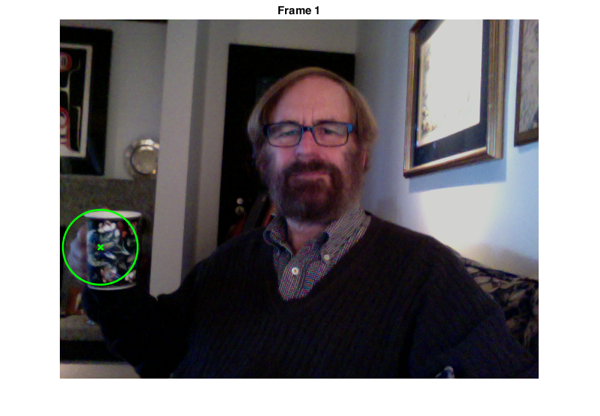
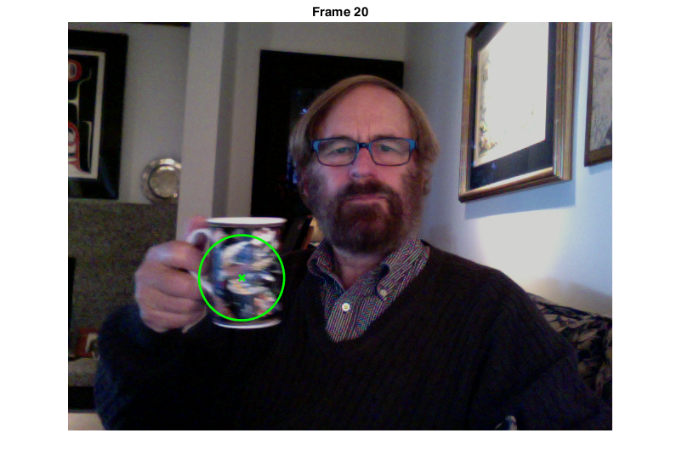
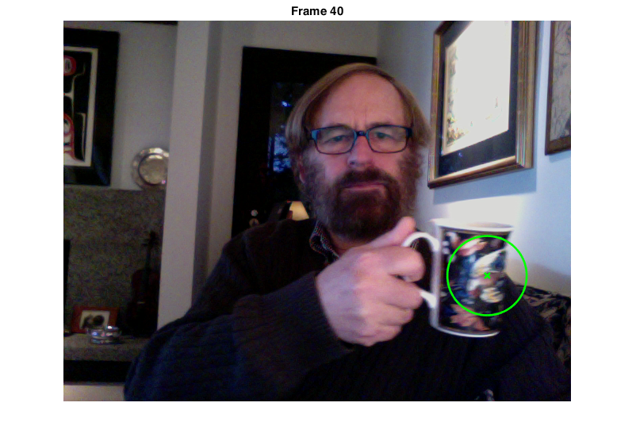
The algorithm tracks both cups very well. However the center is a bit off at both ends.
Part III
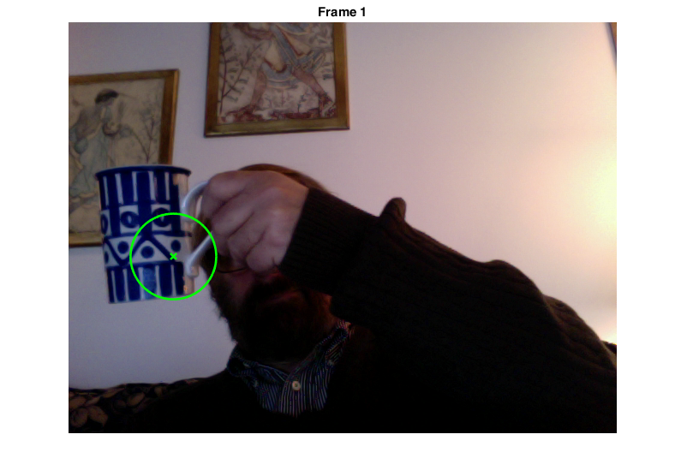
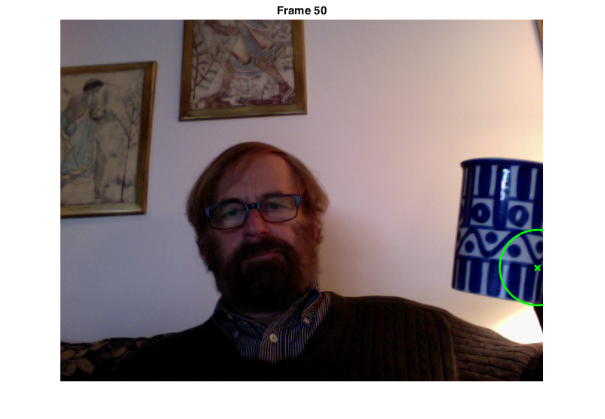
The mean tracking still works pretty well, but a peculiar side effect is that the mean seems to always shift towards the bottom right of the cup.
The Code
%% Part I
clear all, close all

% Load in mask image
target8b = imread('swain_database/charmin.sqr.128.bmp');
% Preprocess to eliminate background
for i = 1:size(target8b,1)
for j = 1:size(target8b,2)
if target8b(i,j,1) == 0 & target8b(i,j,2) == 0 & target8b(i,j,3) == 0
target8b(i,j,1) = NaN;
target8b(i,j,2) = NaN;
target8b(i,j,3) = NaN;
end
end
end
% Convert each channel from 8-bit to 3-bit integers
target3b = fix(double(target8b)/(2^8/2^3))+1;

% Initialize colour histogram
M = zeros(8,8,8);
% Count occurance of each
for i = 1:size(target3b,1)
for j = 1:size(target3b,2)
currpixel = target3b(i,j,:);
M(currpixel(1), currpixel(2), currpixel(3)) = M(currpixel(1), currpixel(2), currpixel(3)) + 1;
end
end

% Load in image test
frame8b = imread('SwainCollageForBackprojectionTesting.bmp');
% Preprocess to eliminate background
for i = 1:size(frame8b,1)
for j = 1:size(frame8b,2)
if frame8b(i,j,1) == 0 & frame8b(i,j,2) == 0 & frame8b(i,j,3) == 0
frame8b(i,j,1) = NaN;
frame8b(i,j,2) = NaN;
frame8b(i,j,3) = NaN;
end
end
end
% Convert each channel from 8-bit to 3-bit integers
frame3b = fix(double(frame8b)/(2^8/2^3))+1;

% Initialize colour histogram
I = zeros(8,8,8);
% Count occurance of each
for i = 1:size(frame3b,1)
for j = 1:size(frame3b,2)
currpixel = frame3b(i,j,:);
I(currpixel(1), currpixel(2), currpixel(3)) = I(currpixel(1), currpixel(2), currpixel(3)) + 1;
end
end

% Initialize colour histogram
R = zeros(8,8,8);
% Count occurance of each
for i = 1:size(frame3b,1)
for j = 1:size(frame3b,2)
currpixel = frame3b(i,j,:);
R(currpixel(1), currpixel(2), currpixel(3)) = min(M(currpixel(1), currpixel(2), currpixel(3))/I(currpixel(1), currpixel(2), currpixel(3)),1);
end
end

% Backproject ratio values onto image
for i = 1:size(frame3b,1)
for j = 1:size(frame3b,2)
currpixel = frame3b(i,j,:);
backprojection(i,j,:) = R(currpixel(1),currpixel(2),currpixel(3));
end
end

% Create disk mask
r = min(size(target3b,1),size(target3b,2))/2;
D = zeros(r*2);
for i = 1:size(D,1)
for j = 1:size(D,2)
if sqrt((size(D,1)/2 - i)^2 + (size(D,2)/2 - j)^2) < r
D(i,j) = 1;
end
end
end

% Convolve disk mask with ratio image
backprojection = conv2(D, backprojection);

% Locate peak
[max_val, index] = max(backprojection(:));
backprojection = backprojection./max_val;

x = index/size(backprojection,1)-r;
y = mod(index,size(backprojection,1))-r;

% Show image with centroid
figure, imshow(frame8b), hold;
plot(x,y,'x','LineWidth',2,'Color','g'); % Highlight centroid
ang=0:0.01:2*pi;
xp=r*cos(ang);
yp=r*sin(ang);
plot(x+xp,y+yp,'LineWidth',2,'Color','g');

% % Test intersection
% intersection = 0;
% normalizer = 0;
% for i = 1:8
% for j = 1:8
% for k = 1:8
% intersection = intersection + min( I(i,j,k), M(i,j,k) );
% normalizer = normalizer + M(i,j,k);
% end
% end
% end
% intersection/normalizer

%% Part II
clear all, close all

% Load in video file get input for first frame
video = load('CMPT412_blackcup.mat');
video = video.blackcup;
imshow(video(:,:,:,1));
[x_input,y_input] = ginput(1);
r = 50;

% Load in mask image
target8b = imcrop(video(:,:,:,1),[x_input-r y_input-r 2*r 2*r]);
% Preprocess to eliminate background
for i = 1:size(target8b,1)
for j = 1:size(target8b,2)
if target8b(i,j,1) == 0 & target8b(i,j,2) == 0 & target8b(i,j,3) == 0
target8b(i,j,1) = NaN;
target8b(i,j,2) = NaN;
target8b(i,j,3) = NaN;
end
end
end
% Convert each channel from 8-bit to 3-bit integers
target3b = fix(double(target8b)/(2^8/2^3))+1;

% Initialize colour histogram
M = zeros(8,8,8);
% Count occurance of each
for i = 1:size(target3b,1)
for j = 1:size(target3b,2)
currpixel = target3b(i,j,:);
M(currpixel(1), currpixel(2), currpixel(3)) = M(currpixel(1), currpixel(2), currpixel(3)) + 1;
end
end

% Create disk mask
D = zeros(r*2);
for i = 1:size(D,1)
for j = 1:size(D,2)
if sqrt((size(D,1)/2 - i)^2 + (size(D,2)/2 - j)^2) < r
D(i,j) = 1;
end
end
end

for frame = 1:size(video,4);
% Close last open window
close;
% Load in image test
frame8b = video(:,:,:,frame);
% Convert each channel from 8-bit to 3-bit integers
frame3b = fix(double(frame8b)/(2^8/2^3))+1;

% Initialize colour histogram
I = zeros(8,8,8);
% Count occurance of each
for i = 1:size(frame3b,1)
for j = 1:size(frame3b,2)
currpixel = frame3b(i,j,:);
I(currpixel(1), currpixel(2), currpixel(3)) = I(currpixel(1), currpixel(2), currpixel(3)) + 1;
end
end

% Initialize colour histogram
R = zeros(8,8,8);
% Count occurance of each
for i = 1:size(frame3b,1)
for j = 1:size(frame3b,2)
currpixel = frame3b(i,j,:);
R(currpixel(1), currpixel(2), currpixel(3)) = min(M(currpixel(1), currpixel(2), currpixel(3))/I(currpixel(1), currpixel(2), currpixel(3)),1);
end
end

% Backproject ratio values onto image
for i = 1:size(frame3b,1)
for j = 1:size(frame3b,2)
currpixel = frame3b(i,j,:);
backprojection(i,j,:) = R(currpixel(1),currpixel(2),currpixel(3));
end
end

% Convolve disk mask with ratio image
backprojection = conv2(D, backprojection);

% Locate peak
[max_val, index] = max(backprojection(:));
backprojection = backprojection./max_val;

x_coord = index/size(backprojection,1)-r;
y_coord = mod(index,size(backprojection,1))-r;

% Show image with centroid
figure, imshow(frame8b), hold;
title(['Frame ' num2str(frame)]),
plot(x_coord,y_coord,'x','LineWidth',2,'Color','g'); % Highlight centroid
plot(x_coord+r*cos(0:0.01:2*pi),y_coord+r*sin(0:0.01:2*pi),'LineWidth',2,'Color','g');

filename = fullfile('tracking.gif');
drawnow
gifframe = getframe(1);
im = frame2im(gifframe);
[imind,cm] = rgb2ind(im,256);
if frame == 1;
imwrite(imind,cm,filename,'gif', 'Loopcount',inf);
else
imwrite(imind,cm,filename,'gif','WriteMode','append');
end

clear backprojection;
clear index;
clear x_coord;
clear y_coord;
end

%% Part III
clear all, close all

% Load in video file get input for first frame
video = load('CMPT412_bluecup.mat');
video = video.bluecup;
imshow(video(:,:,:,1));
[x_input,y_input] = ginput(1);
r = 50;

% Load in mask image
target8b = imcrop(video(:,:,:,1),[x_input-r y_input-r 2*r 2*r]);
% Preprocess to eliminate background
for i = 1:size(target8b,1)
for j = 1:size(target8b,2)
if target8b(i,j,1) == 0 & target8b(i,j,2) == 0 & target8b(i,j,3) == 0
target8b(i,j,1) = NaN;
target8b(i,j,2) = NaN;
target8b(i,j,3) = NaN;
end
end
end
% Convert each channel from 8-bit to 3-bit integers
target3b = fix(double(target8b)/(2^8/2^3))+1;

% Initialize colour histogram
M = zeros(8,8,8);
% Count occurance of each
for i = 1:size(target3b,1)
for j = 1:size(target3b,2)
currpixel = target3b(i,j,:);
M(currpixel(1), currpixel(2), currpixel(3)) = M(currpixel(1), currpixel(2), currpixel(3)) + 1;
end
end

% Create disk mask
D = zeros(r*2);
for i = 1:size(D,1)
for j = 1:size(D,2)
if sqrt((size(D,1)/2 - i)^2 + (size(D,2)/2 - j)^2) < r
D(i,j) = 1;
end
end
end

% Initialize mean as input
mean = [x_input y_input];

for frame = 1:size(video,4);
% Close last open window
close;
% Load in image test
frame8b = video(:,:,:,frame);
% Convert each channel from 8-bit to 3-bit integers
frame3b = fix(double(frame8b)/(2^8/2^3))+1;

% Initialize colour histogram
I = zeros(8,8,8);
% Count occurance of each
for i = 1:size(frame3b,1)
for j = 1:size(frame3b,2)
currpixel = frame3b(i,j,:);
I(currpixel(1), currpixel(2), currpixel(3)) = I(currpixel(1), currpixel(2), currpixel(3)) + 1;
end
end

% Initialize colour histogram
R = zeros(8,8,8);
% Count occurance of each
for i = 1:size(frame3b,1)
for j = 1:size(frame3b,2)
currpixel = frame3b(i,j,:);
R(currpixel(1), currpixel(2), currpixel(3)) = min(M(currpixel(1), currpixel(2), currpixel(3))/I(currpixel(1), currpixel(2), currpixel(3)),1);
end
end

% Backproject ratio values onto image
for i = 1:size(frame3b,1)
for j = 1:size(frame3b,2)
currpixel = frame3b(i,j,:);
backprojection(i,j,:) = R(currpixel(1),currpixel(2),currpixel(3));
end
end

% Convolve disk mask with ratio image
backprojection = conv2(D, backprojection);

% Calculate new mean
total = 0;
x_total = 0;
y_total = 0;
for i = 1:size(backprojection,1)
for j = 1:size(backprojection,2)
if sqrt((j-mean(1))^2 + (i-mean(2))^2) < 2*r
total = total + backprojection(i,j);
x_total = x_total + j*backprojection(i,j);
y_total = y_total + i*backprojection(i,j);
end
end
end
mean(1) = x_total/total;
mean(2) = y_total/total;

% Show image with centroid
figure, imshow(frame8b), hold;
title(['Frame ' num2str(frame)]),
plot(mean(1),mean(2),'x','LineWidth',2,'Color','g'); % Highlight centroid
plot(mean(1)+r*cos(0:0.01:2*pi),mean(2)+r*sin(0:0.01:2*pi),'LineWidth',2,'Color','g');

filename = fullfile('trackingmean.gif');
drawnow
gifframe = getframe(1);
im = frame2im(gifframe);
[imind,cm] = rgb2ind(im,256);
if frame == 1;
imwrite(imind,cm,filename,'gif', 'Loopcount',inf);
else
imwrite(imind,cm,filename,'gif','WriteMode','append');
end

clear backprojection;
clear index;
clear x_coord;
clear y_coord;
end

