CMPT 414 – D100
Prof: Ze-Nian Li

Term Project
Curvature Scale Space for Melanoma Detection

Jon Holmes
301123551
This is an implementation of the Curvature Scale Space algorithm with the intended use of classifying malignant skin lesions for the detection of melanoma, a form of skin cancer. The border of a skin lesion border can be irregular in two different ways. Texture irregularities are what produce the finer ridged edges of a lesion. Structure irregularities are large deformations in the shape of the border. A significant presence of structure irregularities in a lesion means that it is more likely a case of melanoma.

The Algorithm
The first step of the curvature scale space algorithm is to extract the edges of the lesion from a sample image. Many different edge detection algorithms were tried, but of course Canny edge detection proved to be the most useful. Because the sample images are taken so close to the skin, features such as crevices or hair caused artifacts in the canny edge detection, resulting in many broken up edge pieces that aren’t part of the lesion border. It was thus necessary to apply a base Gaussian filter (of 4 times the default sigma value of the square root of 2) to the Canny edge detection to ensure that it would extract only the border of the lesion. The Gaussian filter is then further applied to stronger degrees to produce multiple edge images that are progressively smoother. There were still a few gaps in the resulting edges, so I managed to find a function online that automatically fills in these small gaps.

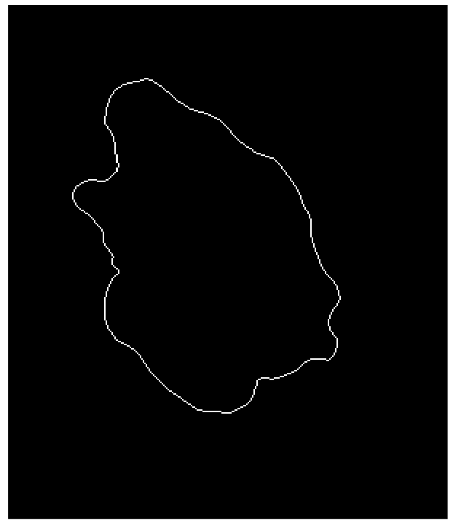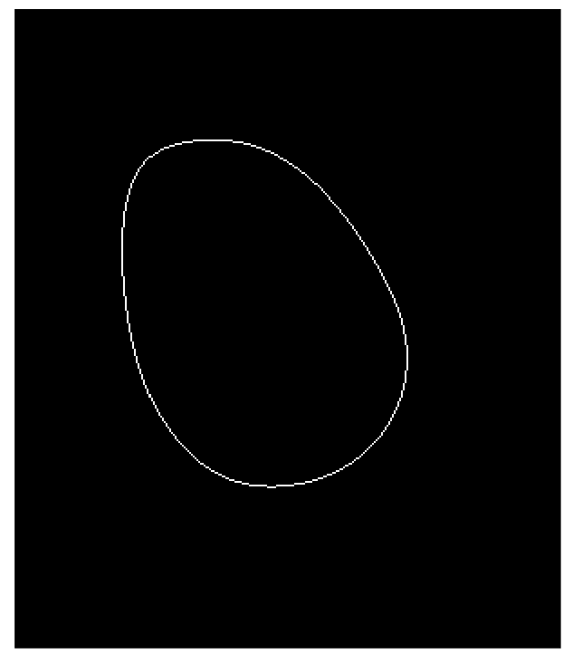
Figure 1: Edge images of the first sample at sigma levels 0 and 29.

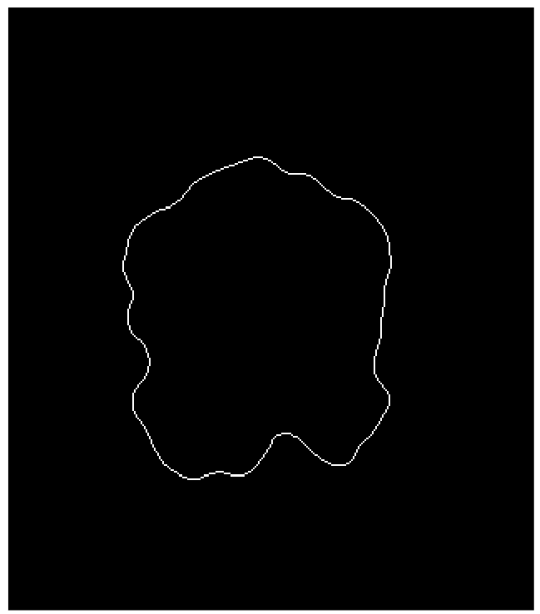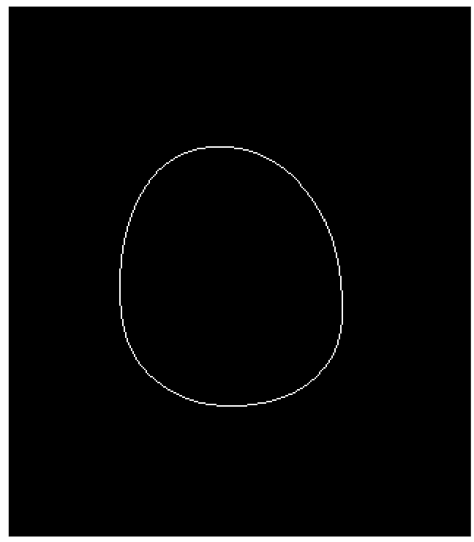
Figure 2: Edge images of the second sample at sigma levels 0 and 29.

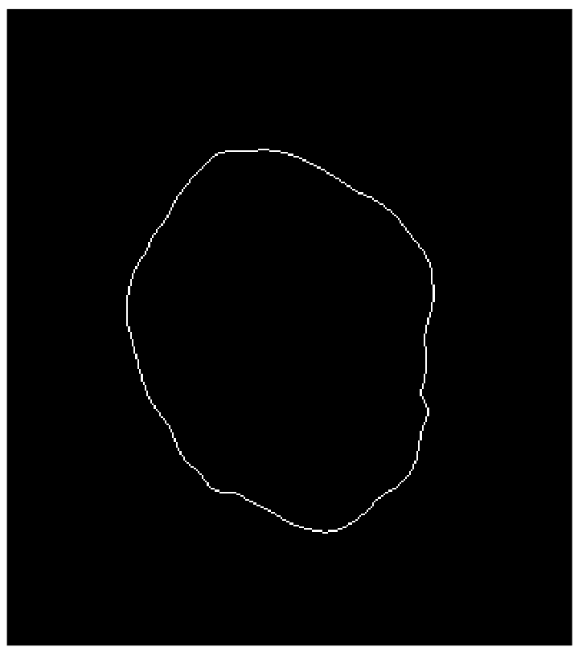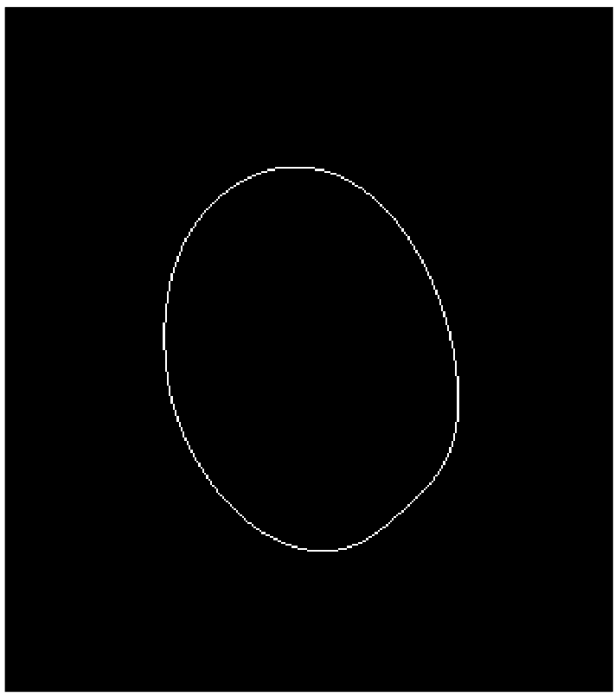
Figure 3: Edge images of the third sample at sigma levels 0 and 29.

The next step was to format all the points of the edge into a consecutive list, such that each next coordinate in the list is the next point along the edge. I managed to find another function for this from the same place I got the function to fill in the gaps from. The function takes in the binary image of the edge and outputs a list of consecutive points. To make the start and end points consistent, a 1 pixel wide gap is made in the top centre (12 o’clock position) of the edge. Then for each sigma level, the discrete curvature is computed for each list of edge points, using the formula from the notes.

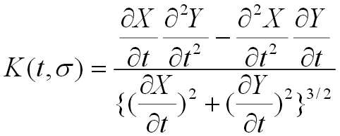
Figure 4: The formula to calculate the discrete curvature.

At first, I calculated the curvature for any given point to be based off the points directly before and after the point. However, since a neighbouring pixel can only be in one of 8 directions, the resulting curvature is very coarse and doesn’t really give an idea of the general curvature. So instead of basing the calculations off the direct neighbours, I use points a certain distance along the edge to calculate the curvature. So for each point, I would compare it to the point at a distance of 20 before and after on the edge. Then with the list of points converted to a list of usable curvatures, we can go on to detect the changes in curvature.

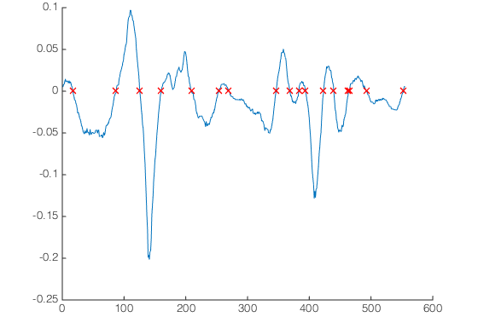
Figure 5: A plot of the curvature of the first sample at sigma level 0, with zero crossings marked by red crosses.

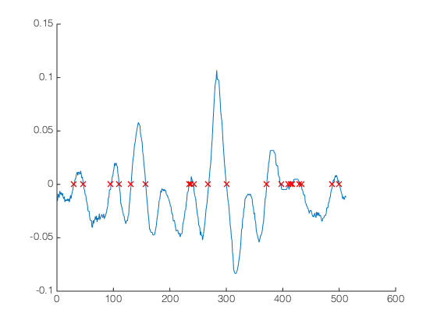
Figure 6: A plot of the curvature of the second sample at sigma level 0, with zero crossings marked by red crosses.
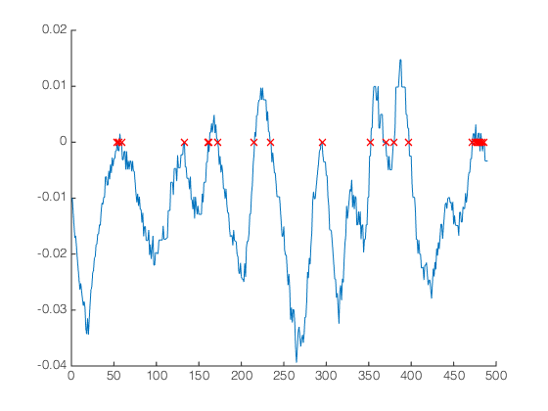
Figure 7: A plot of the curvature of the third sample at sigma level 0, with zero crossings marked by red crosses.

The change in curvature is what is needed to plot the curvature scale space. A change in curvature happens whenever the curvature value switches signs, or crosses the zero line. Thus every zero crossing for each set of curvatures is saved as a one dimensional array for each sigma level. Each of the extracted zero crossings for each sigma level is then plotted vertically to build the curvature scale space image. At first, there was an issue of the zero crossings “tilting” as they go up higher sigma levels. The reason for this is that each successively further Gaussian filtered edge results in an edge that uses fewer pixels, meaning the edge lists get shorter as the sigma levels go higher. To alleviate this issue, I merely multiplied each index of the curvature zero crossings by a a fraction of the maximum edge length (at simgma 0) over the current sigma level’s edge length. Another issue that became apparent is that the algorithm has troubles with flat spots. If the edge has a flat spot, the Gaussian filter has troubles trying to round it out, and it typically remains flat. However these flat spots aren’t perfectly flat, rather they fluctuate over the zero line at very small amplitudes. This results in many false zero crossings being registered at high sigma values. To alleviate this issue a bit, I put an extra check in the zero crossing detection to make sure that the change of curvature is large enough to be a true zero crossing. The result is far from perfect, but the resulting curvature scale space images are readable.

The Results
For the final results, I defined a lesion to have sufficient structure irregularities if curvature changes are still present at sigma level 20 and above. For each sample, the image is shown along with the respective curvature scale space image, along with a brief description of the result.

Sample 1:
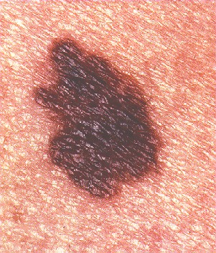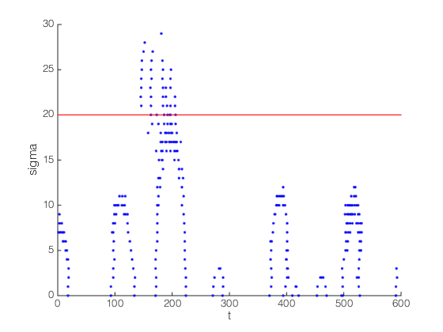
The structure irregularities on the left side of the lesion are very prominent. This correlates to the large peak around the t = 200 point in the curvature scale space. You can also see the false points start to show at the top of the peaks, this is when the area of the shape is flat and has troubles rounding it out. The true peak of the irregularity is still present after sigma = 20, thus the lesion is malignant.

Sample 2:
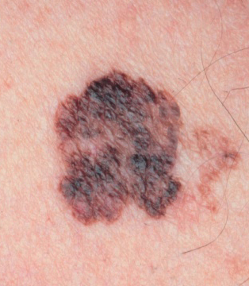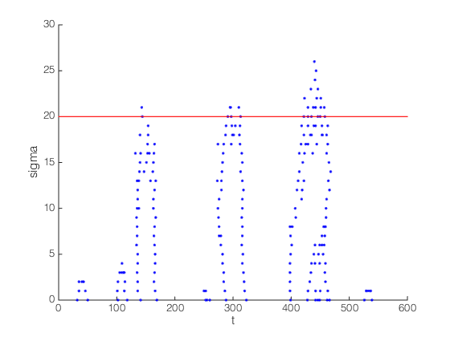
There are a few structure irregularities in different areas of this lesion border. These correlate to the multiple large peaks in the curvature scale space. These irregularities are still present after sigma = 20, although just barely, thus the lesion is malignant.

Sample 3:
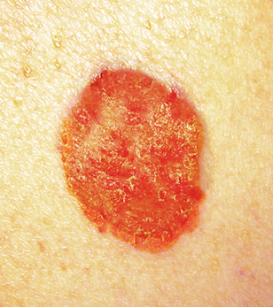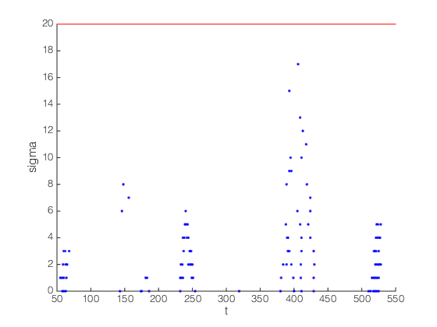
This lesion is mostly round, with no apparent structure irregularities. The resulting curvature scale space ends up being very sparse and shallow. The curvature zero crossings disappear before sigma = 20, thus the lesion is not malignant.

Comparison and Potential Improvements
The biggest shortcoming of my algorithm in comparison to other implementations of is how it handles flat spots. Most published implementations of curvature scale space are able to deal with these flat spots no problem, making their peaks in the curvature scale space image clear, consistent and uncluttered. There are two reasons why my algorithm does not handle these flat spots so well. These reasons are the unideal implementations of the Gaussian filtering and curvature calculation. In the class notes, the Gaussian filter is applied to the series of edge points, however in my implementation the Gaussian filter is merely amplified during the Canny edge detection. These methods of applying Gaussian filter differ greatly, the notes apply it to the extracted curve where as I applied it to the original image. However because of how the list of edge points is generated, I was not able to figure out how to apply this Gaussian filtering properly. The result is that the Gaussian filtering on the images means that flat spots are more likely to stay, instead of being rounded out as they would in the curve. The fact that my implementation of the curvature calculation uses a window of 41 points for each point doesn’t help either. If the window used to calculate the curvature is smaller, then the accuracy of the curvature is too coarse to use. If the window is larger, then it takes in too much data and results in a more muted curvature. The values I used for the window are a sweetspot, but it still not ideal. So while my implementation can still get the general profile of the curvature scale space, flat areas are its downfall.

External Resources Used
Peter Kovesi’s MATLAB Functions [http://www.csse.uwa.edu.au/~pk/Research/MatlabFns/]
- This algorithm uses both the filledgegaps and edgelink functions, along with their required support functions.

Reference
Tim Lee, Stella Atkins, Ze-Nian Li. “Indentation and Protrusion Detection and Its Applications” Available online at: http://www.cs.sfu.ca/~stella/papers/2001/scale.pdf

Journal
These are the raw notes taken during the development of this project:
First step is to get the edges of the image, I used canny with a fine tuned threshold and baseline sigma that gives a mostly complete contour of the lesion. I found a function that fills in the small holes. I then found a function that translates the binary edge image to a vector of successive edge points. I then found another function which calculates the curvature over the series of points. However the curvature function uses a polygon interpolation method that seems to result in too many zero crossings.
I instead made my own curvature function based off the formula given in the lecture notes. I used the discrete definitions of the first and second derivatives to use in the formula. At first I would take the derivative to be 1 pixel along t, but this resulted in a very noisy curvature with not many values. Since the derivatives were only looking 1 pixel away, that pixel could either be right below, right beside, or diagonal, only 3 possible derivatives. So I updated the derivative calculations to look at points 20 pixels away instead. What resulted was a much smoother curvature with zero crossings that made sense. There is still a fair amount of noise, which shows up particularly if the curvature is flat, i.e. it fluctuates from minimal negative, to 0, to minimal positive values, but the overall profile is what is expected. The only issue is that the edgelist is shorter when a higher Gaussian filter is applied, resulting in a shorter list of curvatures, which makes the curvature scale space graph “tilt” to the left as you go higher sigma.
To fix the tilt was trivial, if a bit incorrect. I merely stretched the indexing of the zero-crossing points based on the fraction of the longest length (at sigma 0) over the length of the edge of the current sigma level. But the issue of flat spots was still apparent. As the Gaussian filter gets stronger, flat spots have a tendency to get “stuck”. These flat spots aren’t perfectly flat, so the curvature for these areas tends to fluctuate very close to zero, resulting in many false zero crossings in the curvature. To alleviate this, I applied another check on the zero crossing to make sure that the change in curvature is big enough to be a real zero crossing. The result isn’t ideal, but is much cleaner than before.

