**Density, Growth and Decay of North Pacific Garbage Patch**

**Jenny Hung**

**Fanli Si**

**Entrance of new sources of plastic garbage, together with local area wave dynamics such as diffusion and upwelling, affects surface concentration of the micro plastic waste on time scales from days to years. In this paper, we propose a model which is capable of producing time series of surface density of micro plastic. We also propose a monitoring plan that will measure the diffusion coefficient which calibrates our model to provide us with updated simulations of long-run surface density of micro plastic particles.**

**______________________________________________________________________**

1. **Introduction**

The Great Pacific Garbage Patch is a phenomenon that garnered media attention[1]. Important properties of the gyres such as being the basins of attraction, and the dynamical decomposition of global waters into weakly interacting classes are established[2] (see Related Work).

In this paper, we built upon this earlier work that gyre’s location as basin of attraction, and that different regions of global surface water can be decomposed into weakly interacting classes. We are thus interested in the following problem: given the established properties and the current quantity of foreign matters in the gyre, can we obtain an estimation of the density micro plastic particles in the pacific gyre? The answer to this problem provides important benchmarking tool in global atmospheric, marine health and biological food chain protection, and can help answer important marine life protection, food chain integrity, and environmental protection questions. Furthermore, given the established properties, can we exhibit the most likely scenario for the surface density after a long time – after taking into considerations factors such as entry of new sources of garbage, decay process and mixing of ocean waves? We call them micro plastic concentration problem and growth and decay prediction problem, respectively.

Based on our finding, we propose a monitoring plan that can be easily administered by the existing NOAA observation teams, by adding one test item in each observation location. The advantage of our monitoring plan is that we can leverage upon the existing collection and observation infrastructure, therefore saving setup time and overhead costs.

A. Main Results

The main results of this paper are summarized as follows:

* The concentration problem can be formulated as a combination of both a diffusion process and a wave propagation process. The plastic waste breaks down into smaller pieces faster than we previously thought[3]. Once broken down to smaller chunks, diffusive process in continuous time can take place, with the granularity of the plastic waste allowing for further mixing due to the vertical movement of the current. In particular, the diffusion process can be model by a two dimensional deterministic partial diffusion equation, and the vertical mixing can be modeled by the two-dimensional deterministic wave equation.
* While the break-down process takes place, the diffusion process takes place. The concentration level of the plastic garbage starts to “flow away” from high density surface area to low density area in the ocean. Our simulation based on this deterministic diffusion process behaves in an expected way as described. However, this expected result only holds without considering the upwelling phenomenon observed in the North Pacific. After adding the upwelling effect, simulations from our model show vertical movements facilitate the diffusion process. This is unwelcomed news indeed.
* The concentration problem only deals with the question of how the micro plastic particles at the ocean surface in the gyre will change according the space coordinate of the location. It does not deal with how the concentration level (density) will change over time coordinate. The growth and decay problem answers this.

The growth and decay problem can be formulated as a Brownian motion (random walk) model with stochastic drift. We run $10,000$ simulations, and this Brownian motion model indicates that over time, the surface density of micro plastic density at the gyre is likely to increase. This simulated result can be understood as a culminating effect of decreased density as matters flow away from high to low density areas, increased density as matters were brought in by the vertical mixings from the waves, as well as increased density from introduction of new sources of plastics. Over the long run, our model suggests that the plastic garbage situation in the Gyre will likely not improve in the long run.

B. Related Work

Froyland et al had extensively studied the shape and extent of the basin of attraction in order to understand the connectivity of different regions of the ocean. Important properties of the gyres such as being the basins of attraction in an open dynamical system have been established in this work, where Markov chain was used to analyze the trajectories based on Ulam’s method. Also they have identified left and right eigenvector of the Markov chain transition matrix as almost-invariant sets and basin of attraction, respectively. Using the eigenvector techniques, Froyland et al were able to identify garbage patch locations and mapping their basin of attraction. This allowed dynamical decomposition of global ocean surface into weakly interacting parts in both forward and backward time.

1. **Data Source**

We use the time-dependent zonal and meridional velocity vector fields taken from the Ocean General Circulation Model for the Earth Simulator (OFES model)[4]. OFES is a global high-resolution ocean-only model, with horizontal resolution of $0.1$ degree and 54 vertical levels. The domain of OFES system is from $75°$ S to $75°$ N excluding the arctic regions. The OFES climatological simulation was spun-up for 50 years from the observation data without motion. Our data had incorporated observed winds from the NCEP reanalysis, with velocity data available at three-day temporal resolution.

1. **Problem Formulation**
2. Diffusion process modeled by diffusion equation

The concentration problem can be formulated as a combination of both a diffusion process and a wave propagation process. The plastic waste breaks down into smaller pieces faster than we previously thought [3]. Once broken down to smaller chunks, diffusive process in continuous time can take place, with the granularity of the plastic waste allowing for further mixing due to the vertical movement of the current. In particular, we model the diffusion process with a two-dimensional deterministic partial differential equation

$$\frac{δu}{δt}=d\left(\frac{δ^{2}u}{δx^{2}}+ \frac{δ^{2}u}{δy^{2}}\right).$$

Or more compactly, as $u_{tt}=d\left(u_{xx}+u_{yy}\right)$ on a domain of a $200 ×200$ square meters, centered at $(0,0)$, where $d$ denotes the diffusion coefficient.

The choice of domain is to give a sufficiently broad coverage, while remain a local one, of a small area in the North Pacific gyre, which ranges from $135°$ W to $155° W$, and $35°$ N to $42°$ N. The estimated geographic area where the Gyre is located at is approximately $3.48 ×{10}^{6}$ sq. km. We give the initial condition where we have a source of foreign matter at the center of the computational domain, and given an initial density (concentration) level, the foreign matter will diffuse as expected.

To compute the diffusion coefficient, we first solve the diffusion equation by treating as if $u(x,y,t)$ were a function of position alone and take its Fourier transform as a function of $x$ and $y.$ The result is a function $\hat{u}(s,t)$ which depends on the wave number $s$ and time $t$ alone. This transforms the equation to a differential equation that models exponential growth or decay, whose solution’s Fourier transform is a product of two functions, one of which is given by

$$G_{t}(x,y)=\frac{1}{√\left(2 πσ^{2}\right)} e^{-\left(\frac{{x^{2}+ y}^{2}}{2 σ^{2}}\right)} ,$$

with $σ= \sqrt{2dt}$. Subsequently, we assume that diffusion of each particle occurs independently and at equal rates. The diffusion coefficient, $d$, is computed using random walk Monte Carlo, by relying on the fact that the behavior of a sample collection of particles in the random walk simulation is akin to the movement of average particles in the localized ocean. Then by considering just the $x$-direction alone, we let the

$$x\left(t+Δt\right)=x\left(t\right)+ηΔl,$$

Where $η$ represents the random factor generated from $uniform(-Δl, Δl)$, $Δt$ represents each time step in the computation, and $Δl$ represents the average length that a particle can travel in a time interval $(0, Δt)$, by using the speed of wave. The computation of speed of wave is covered in Part B.

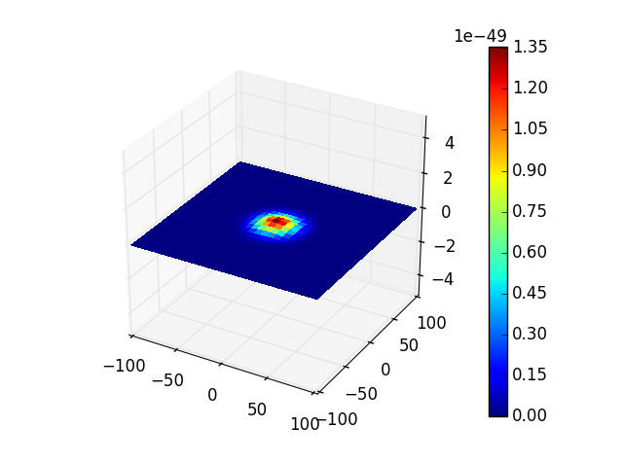

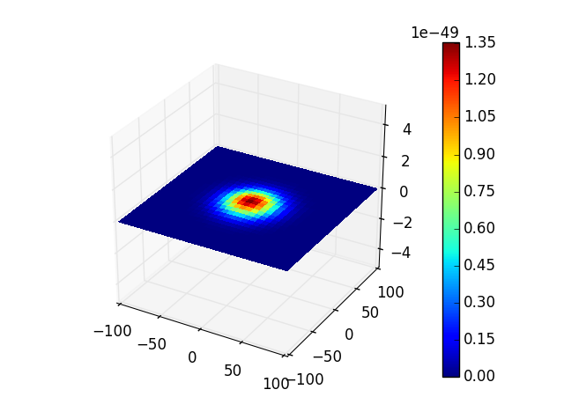

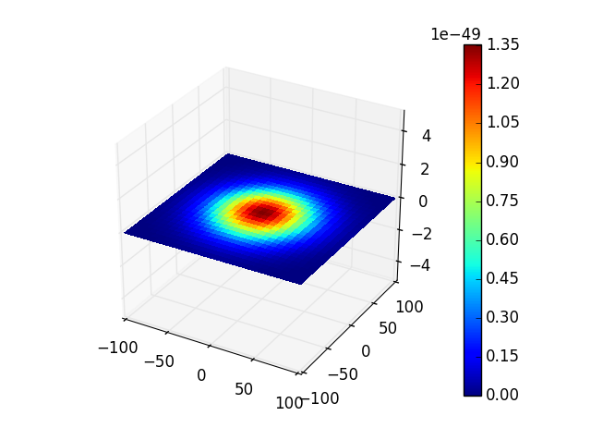

1. Upwelling process modeled by wave equation

While the diffusive process in continuous time takes place, the granularity of the plastic waste further allows mixings due to the vertical movement of the current, also empirically observed as upwelling and downwelling. Thus the concentration problem is not complete without considering this mixing effect. Thus a two-dimensional deterministic wave equation can be used to model the wave propagation process, given by

$$\frac{δ^{2}z }{δ^{2}t}=v\left(\frac{δ^{2}z}{δx^{2}}+ \frac{δ^{2}z}{δy^{2}}\right),$$

on a similar rectangular computational domain as the previous, where $z(x,y,t)$ denotes the vertical displacement of a point $(x,y)$ and time $t$, and $v$ denotes the speed of the waves. We give the initial condition $z\left(x,y,0\right)=\frac{δz}{δt }\left(x,y,0\right)=0$.

The wave speed is obtained from the OFES data on ocean zonal velocity at the Gyre location. Monthly mean across observational points in the Gyre is computed, and this zonal velocity is treated as surrogate for the wave speed.

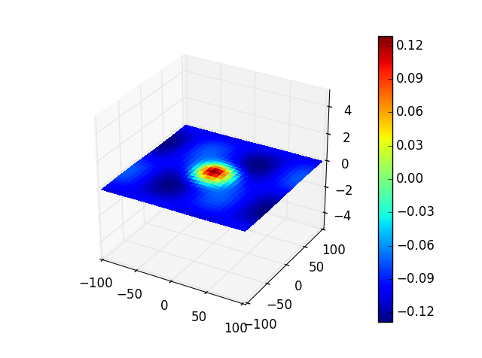

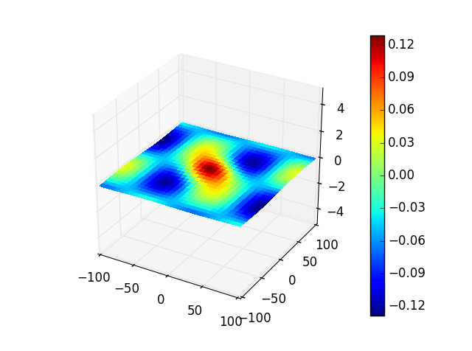

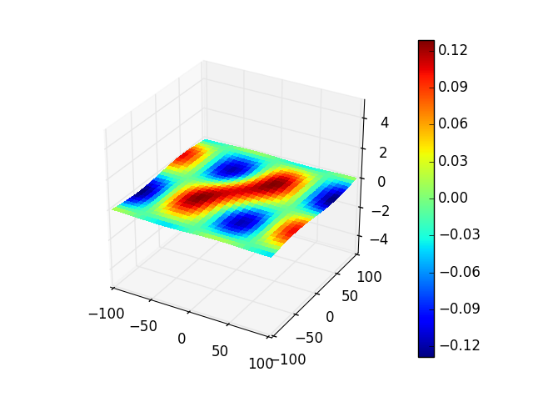

1. Growth and decay modeled by random walk with stochastic drift

The concentration problem only deals with the question of how the micro plastic particles at the ocean surface in the gyre will change according the space coordinate of the location. It does not deal with how the concentration level (density) will change over time coordinate. The growth and decay problem answers this.

The growth and decay problem can be formulated as a Brownian motion (random walk) model, given by

$$D_{t}={δ+D}_{t-1}{+W}_{t},$$

Where $D_{t}$ represents the surface density of micro plastic particles at time $t$, $δ$ denotes the random drift where $δ \sim uniform(-0.05, 0.05)$, and $W_{t}$ denotes identical and independently distributed white noise $W_{t}\sim N(0,1)$. Motivated by the inflation index CPI, we set the current garbage concentration level at 10. $10,000$ simulations were run. Endpoints of random walk, in terms of concentration level of micro plastic particles, are reported in Figure xxx.

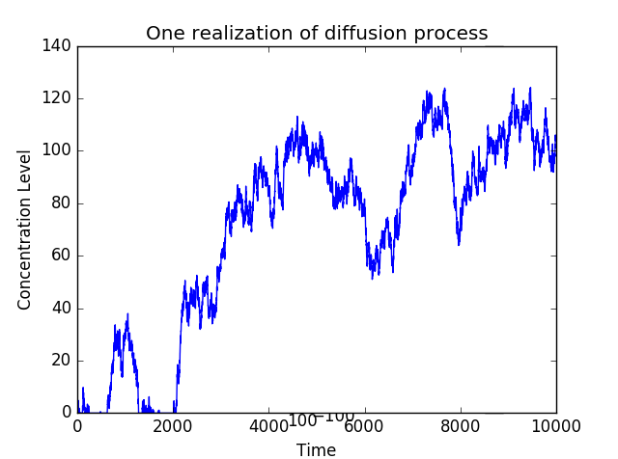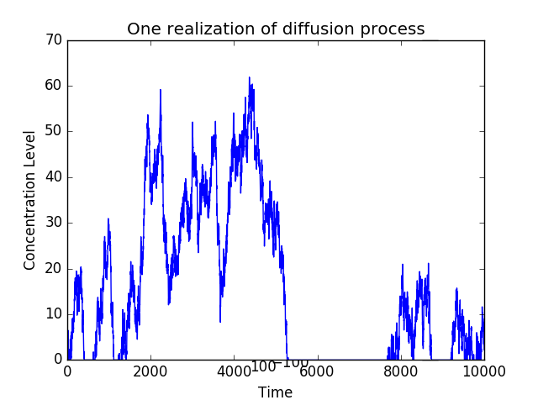

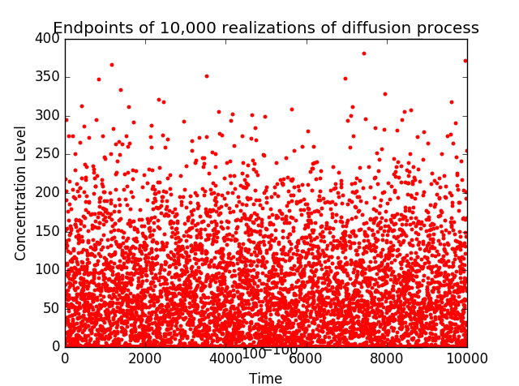

1. **Monitoring Plan**

In existing observation points, we propose a monitoring plant that collects a sample of sea water at various depths (up to 50 meters below surface). The collected ocean water is to be analyzed at NOAA lab, and measurements of diffusion coefficients at each ocean depth and each observation location be extracted. The actual diffusion coefficients will then be used to calibrate our model. New concentration level can then be computed, and time series of generated surface concentration level can then be generated from our calibrated model. Armed with this diffusion coefficient(s), conditional least squares regression can be performed to approximate the stochastic drift $δ$ in the stochastic random walk model described earlier. This will allow us to provide further calibrated prediction of micro plastic particles concentration in the future, and provide benchmark to the ocean health status in the North Pacific gyre.

Our proposed monitoring plan has the benefit that can be easily administered by the existing NOAA observation teams, by adding one more item in the test. The advantage of our monitoring plan is that we can leverage upon the existing collection and observation infrastructure, therefore saving setup time and overhead costs.

1. **Conclusion**

Diffusion and wave propagation process were used to understand the surface density of micro plastic particles. Random walk with stochastic drift was used to understand the most likely long run scenarios for the surface density. Our model reveals worrisome long-run results. We further proposes monitoring plan that collects ocean sample to empirically calculate the diffusion coefficient, which will facilitate us in making future model calibrations to have updated prediction of long run surface plastic density.

1. "Seas of Garbage | Ecology Global Network." Ecology Global Network. 4 Apr. 2012. Web. 17 Jan. 2016.
2. Gary Froyland, Robyn M. Stuart, and Erik van Sebille“ How Well-connected is the Surface of the Global Ocean.” Chaos 24, 033126 (2014); doi: 10.1063/1.4892530
3. Barry, Carolyn. "Plastic Breaks Down in Ocean, After All -- And Fast." National Geographic. National Geographic Society, 20 Aug. 2009. Web. 17 Jan. 2016.
4. "The Earth Simulator Center." OFES (OGCM for the Earth Simulator). Web. 17 Jan. 2016.