Some Title Here

This area reserved for Abstract – to be written after our analysis

1. **Introduction**

The Great Pacific Garbage Patch is a phenomenon that garnered media attention. We show that the plastic waste in the open waters flows according to the ocean current, and over time is drawn into the basin of attraction, which can be physically identified as gyres. Once in the gyre, the foreign matter then follow a density distribution that can be described as a Markov Chain. We learned that not only the plastic waste breaks down into smaller pieces faster than we previously thought, the granularity of the plastic waste allows the further mixing due to the vertical movement of the current. Fortunately, we also show that due to the up welling in the North Pacific, the mixing effect is limited. The mixing effect can be modeled by the Wiener process (Brownian motion), which can be characterized by a random walk a positive drift. This model showed that, in spite of the up welling, over a long period of time, micro plastic waste can still drift down to the depth where it either accumulates in the sea bed, or it is possible for the waste to catch the deep ocean current, which allows the waste to travel outside the gyre.

We propose a monitoring plan that can be easily administered by the existing NOAA observation teams, by adding an item of sampling micro-plastic density at various ocean depths. The advantage of our monitoring plan is that we can leverage upon the existing collection and observation infrastructure, therefore saving setup time and overhead costs.

1. Main Results
2. **Data Description**

Let be the surface area of the North Pacific gyre. We use the time-dependent zonal and meridional velocity vector fields taken from the Ocean General Circulation Model for the Earth Simulator (OFES model). OFES is a global high-resolution ocean-only model, with horizontal resolution of degree and 54 vertical levels. The domain of OFES system is from S to N excluding the arctic regions. The OFES climatological simulation was spun-up for 50 years from the observation data without motion. Our data had incorporated observed winds from the NCEP reanalysis, with velocity data available at three-day temporal resolution.

Further sources of data: costal upwelling – North Pacific

1. **Analytical Method - North Pacific Gyre as a Spiral Sink**

We focus our investigation in a square area between W to W, and between N to N, which also bounds the observational points of the North Pacific gyre , which is between W to W, and between N to N. By examining the relative local area vector fields of the zonal and meridional velocities, we demonstrate that   appear to have lie in the convergence zone, which is characterized by calm surface currents, and low wind velocity. In vast area of is characterized by small movement in the vector fields (Figure 1). However, we also observed a higher-velocity band. Figure 2 shows the overlay of images of overall zonal and meridional velocities with the velocity vector field. The north-south vectors indicate the meridional flow, whereas the east-west vectors indicate the zonal flow. When considering all of the observational points, we see that can be thought of as one of the spiral sink in the set of differential equations modeling the world’s ocean currents.

Our current work is built upon previous studies by Froyland et all, where they have considered the surface ocean currents as a dynamical system which can be constructed as a Markov Chain (link paper). Using short-run trajectories from the global ocean current flows, they constructed a transition matrix to predict the steady-state probability of foreign matters ending up in certain geographical area of the ocean. This approach had yielded fruitful results as the geographical areas with the highest steady-state probabilities agree with high accuracy the location of the world’s ocean gyres.

The existing ocean current at the large scale can be visualized as a velocity vector field. Previous work by others have established using numerical methods to predict the location of the gyre. We can go one step further and propose that these geographical areas are in fact spiral sinks of the theoretical differential equations that describe the world’s ocean current. This means that, without considering up or down welling, the plastic waste cannot leave the area – indeed, these areas can be conceptually thought of as absorbing states of the Markov Chain.

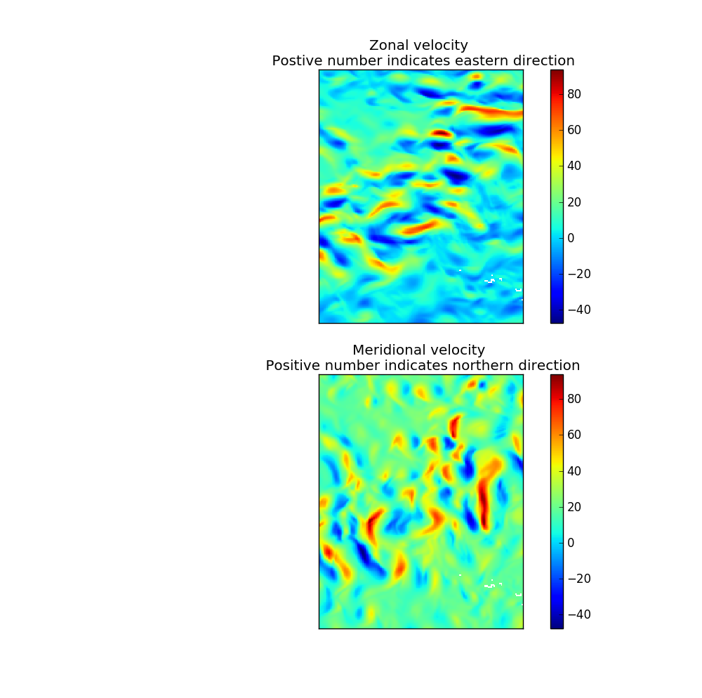

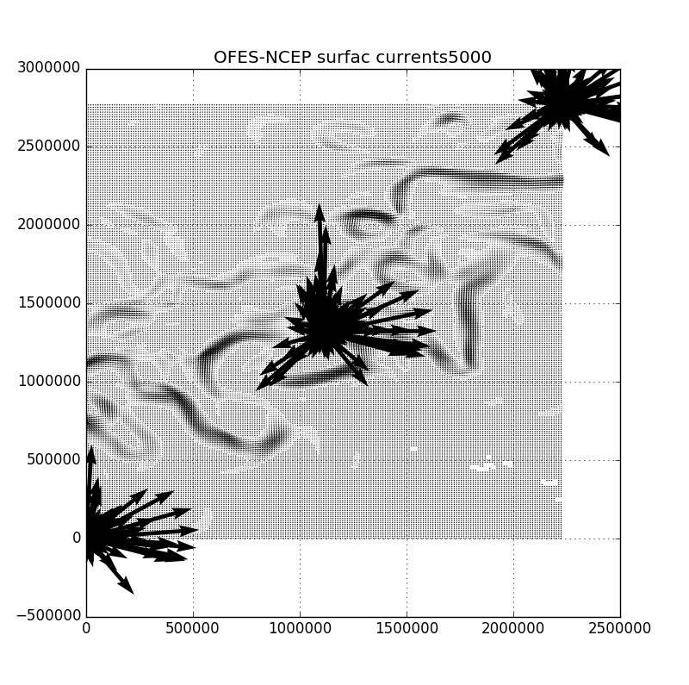

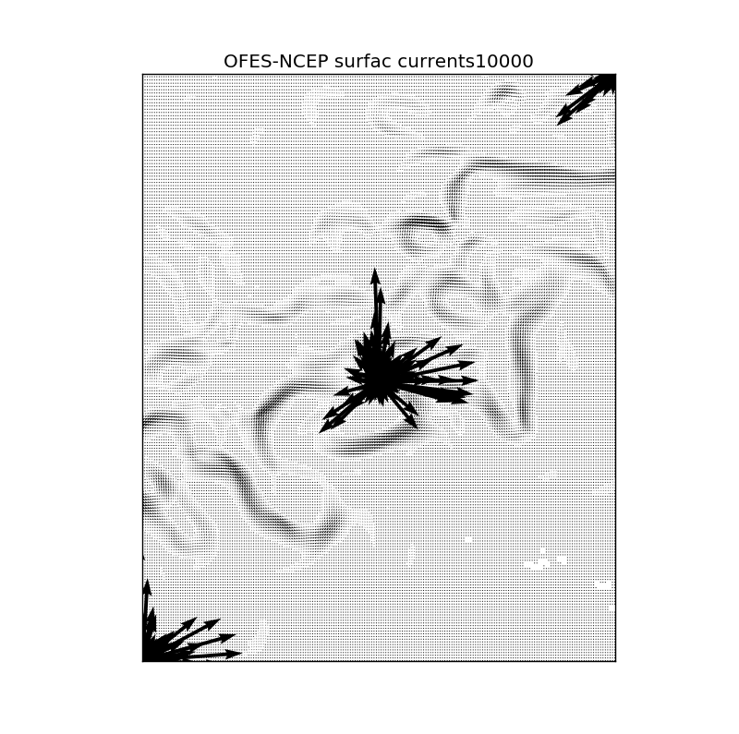

1. **Analytical Method - Forward Evolution of Downward Drift**

However, at the North Pacific gyre, there is indeed pronounced upwelling effect. This can be physically observed as the negative velocity in the vector field. However, actual data at the open sea is hard to come by. Instead, I used the coastal upwelling observed at Northern California / Oregon coastal region by NOAA as an indicator of its presence and its magnitude. By taking a vertical water column at a local point (observational point), I constructed a stochastic process which observe the Weiner Process, also known as the Brownian motion, or random walk, where at each time step, it could take any direction with a uniform distribution between (-0.5, 0.5). This model exhibits that while the upwelling reduces the chance of mixing of plastic, over a long period of time, simply by chance, some plastic will still drift downwards in spite of the upwelling. In fact, I will point out in the paper that other researchers have sampled the deep sea bed of the north Pacific and found concentration of micro plastic matters unsupportable by chance occurrence. I believe this is collaborating evidence that our claim is on the right track.

Since the gyres can be understood as spiral sinks in the set of differential equations that describe the world’s surface ocean current, once foreign matters gets absorbed into the basin of attraction, it cannot leave if we do not consider the down welling phenomenon in the North Pacific gyre. However, by considering the upwelling data collected at observational points off the North Pacific coast, we exhibit a model that uses Wiener process, with to predict the vertical movement of the micro plastic waste, if at all. This is equivalent to a random walk model with positive drift, given by

where represents the vertical distance from the ocean surface at time represents the up welling Ekman coefficient, and represents white noise . The following figures showed

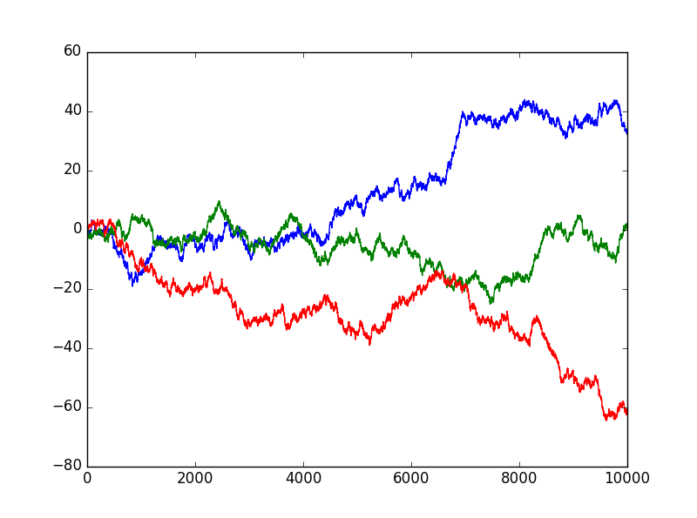 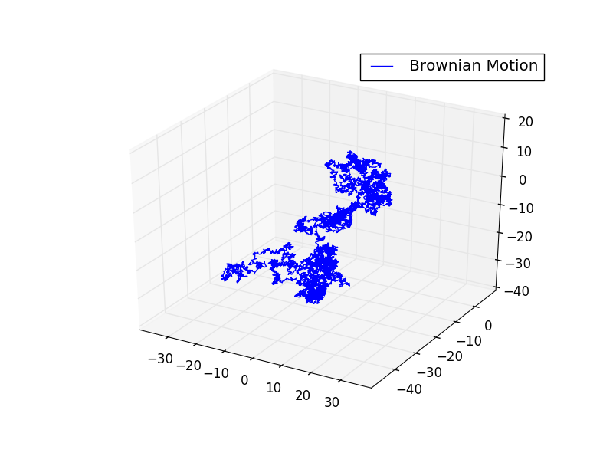

More explanations here

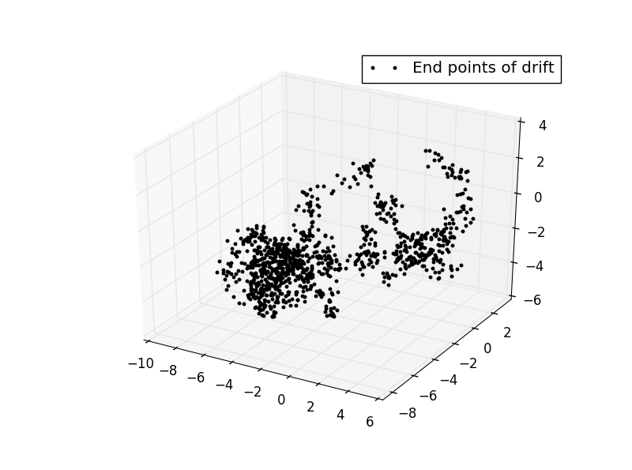

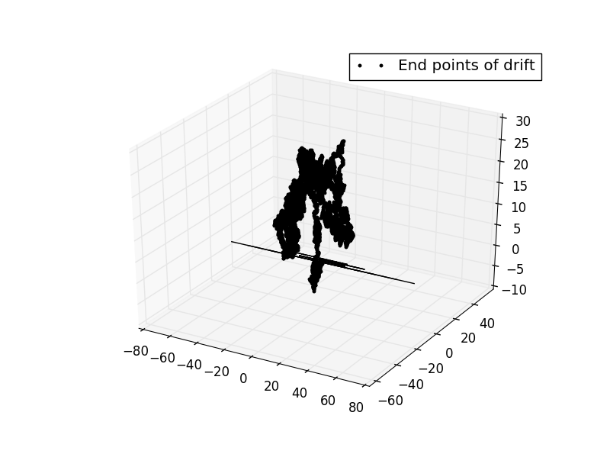

1. **Monitoring Plan**
2. **Conclusion**

* Citation goes here