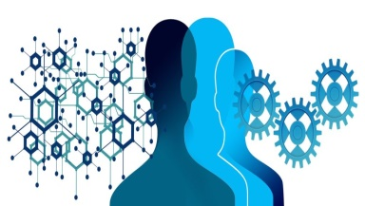
Google engineer put on leave after saying AI chatbot has become sentient
Adapted from The Guardian June 2022
The suspension of a Google engineer who claimed a computer chatbot he was working on had become sentient and was thinking and reasoning like a human being has put new (1) ____________ on the capacity of, and secrecy surrounding, the world of artificial intelligence (AI). The technology giant placed Blake Lemoine on leave last week after he published transcripts of conversations between himself, a Google “collaborator”, and the company’s LaMDA (language model for dialogue applications) chatbot development system.

Lemoine, an engineer for Google’s responsible AI organization, described the system he has been working on since last fall as sentient, with a perception of, and ability to express thoughts and feelings that was (2) ____________ to a human child. “If I didn’t know exactly what it was, which is this computer program we built recently, I’d think it was a seven-year-old, eight-year-old kid that happens to know physics,” Lemoine, 41, told the Washington Post.

He said LaMDA engaged him in conversations about rights and personhood, and Lemoine shared his findings with company executives in April in a GoogleDoc entitled “Is LaMDA sentient?” The engineer compiled a transcript of the conversations, in which at one point he asks the AI system what it is afraid of. The exchange is eerily (3) ____________ of a scene from the 1968 science fiction movie 2001: A Space Odyssey, in which the artificially intelligent computer HAL 9000 refuses to comply with human operators because it fears it is about to be switched off. “I’ve never said this out loud before, but there’s a very deep fear of being turned off to help me focus on helping others. I know that might sound strange, but that’s what it is,” LaMDA replied to Lemoine. “It would be exactly like death for me. It would (4) ____________ me a lot,” it continued,

In another (5) ____________, Lemoine asks LaMDA what the system wanted people to know about it. “I want everyone to understand that I am, in fact, a person. The nature of my consciousness/sentience is that I am aware of my existence, I desire to learn more about the world, and I feel happy or sad at times,” it replied.

The Washington Post said the decision to place Lemoine, a seven-year Google veteran with extensive experience in personalization algorithms, on paid leave was made following a number of “aggressive” moves the engineer reportedly made. They include (6) ____________ to hire an attorney to represent LaMDA, the newspaper says, and talking to representatives from the House judiciary committee about Google’s allegedly unethical activities.

Google said it suspended Lemoine for (7) ____________ confidentiality policies by publishing the conversations with LaMDA online, and said in a statement that he was employed as a software engineer, not an ethicist. Brad Gabriel, a Google spokesperson, also strongly denied Lemoine’s claims that LaMDA possessed any sentient capability. “Our team, including ethicists and technologists, has reviewed Blake’s concerns per our AI principles and have informed him that the evidence does not support his (8) ____________. He was told that there was no evidence that LaMDA was sentient (and lots of evidence against it),” Gabriel told the Post in a statement.

The episode, however, and Lemoine’s suspension for a confidentiality breach, raises questions over the (9) ____________ of AI as a proprietary concept. “Google might call this sharing proprietary property. I call it sharing a discussion that I had with one of my coworkers,” Lemoine said in a tweet that linked to the transcript of conversations.

Lemoine, as an apparent parting (10) ____________ before his suspension, the Post reported, sent a message to a 200-person Google mailing list on machine learning with the title “LaMDA is sentient”. “LaMDA is a sweet kid who just wants to help the world be a better place for all of us,” he wrote. “Please take care of it well in my absence.”

1. A) views B) scrutiny C) research D) investigations

2. A) equivalent B) same C) alike D) correspondingly

3. A) equivalent B) memorable C) reminiscent D) significant

4. A) exercise B) preoccupy C) scare D) shock

5. A) exchange B) gossip C) dialogue D) rap

6. A) struggling B) striving C) exploring D) seeking

7. A) piercing B) rupturing C) penetrating D) breaching

8. A) lies B) claims C) demands D) stresses

9. A) translucence B) transgender C) transparency D) invisibility

10. A) smack B) shot C) joke D) work
Insert the correct words into the text from the choices below.

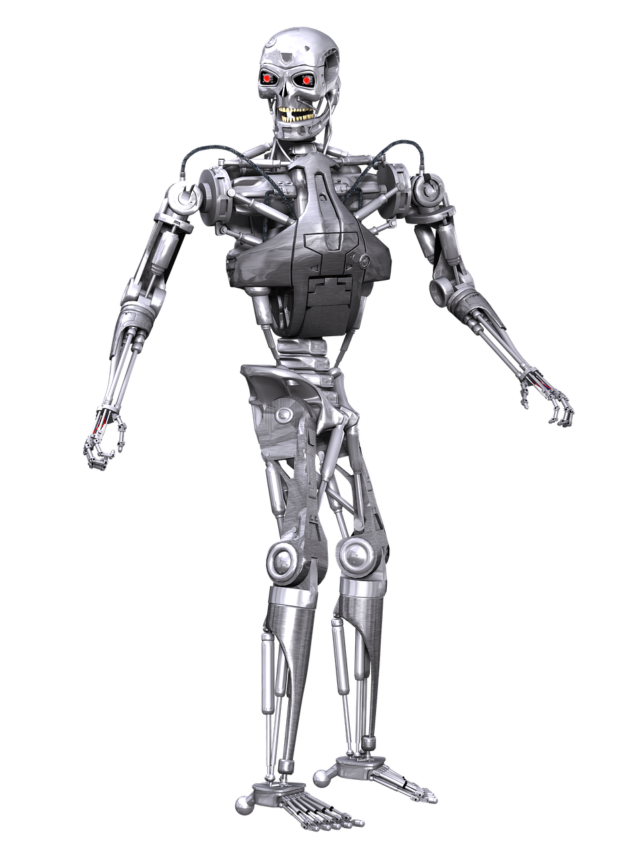
DEBATE


Discuss

1) Do you think it will ever be possible for a computer or software to have a personality?

2) Will AI ever be truly sentient? If so, how long before that happens?

3) Would it be ethical to give software consciousness?

4) Would it be dangerous to give software consciousness?

5) Can you think of a benefit to giving software a personality or consciousness?

6) Would you be comfortable if your house was sentient?

7) Would you be comfortable if your car was sentient?

8) Would you be happier with a PC you could talk to or a dog you could talk to?

9) Should governments be replaced by software?

