IT Helpline
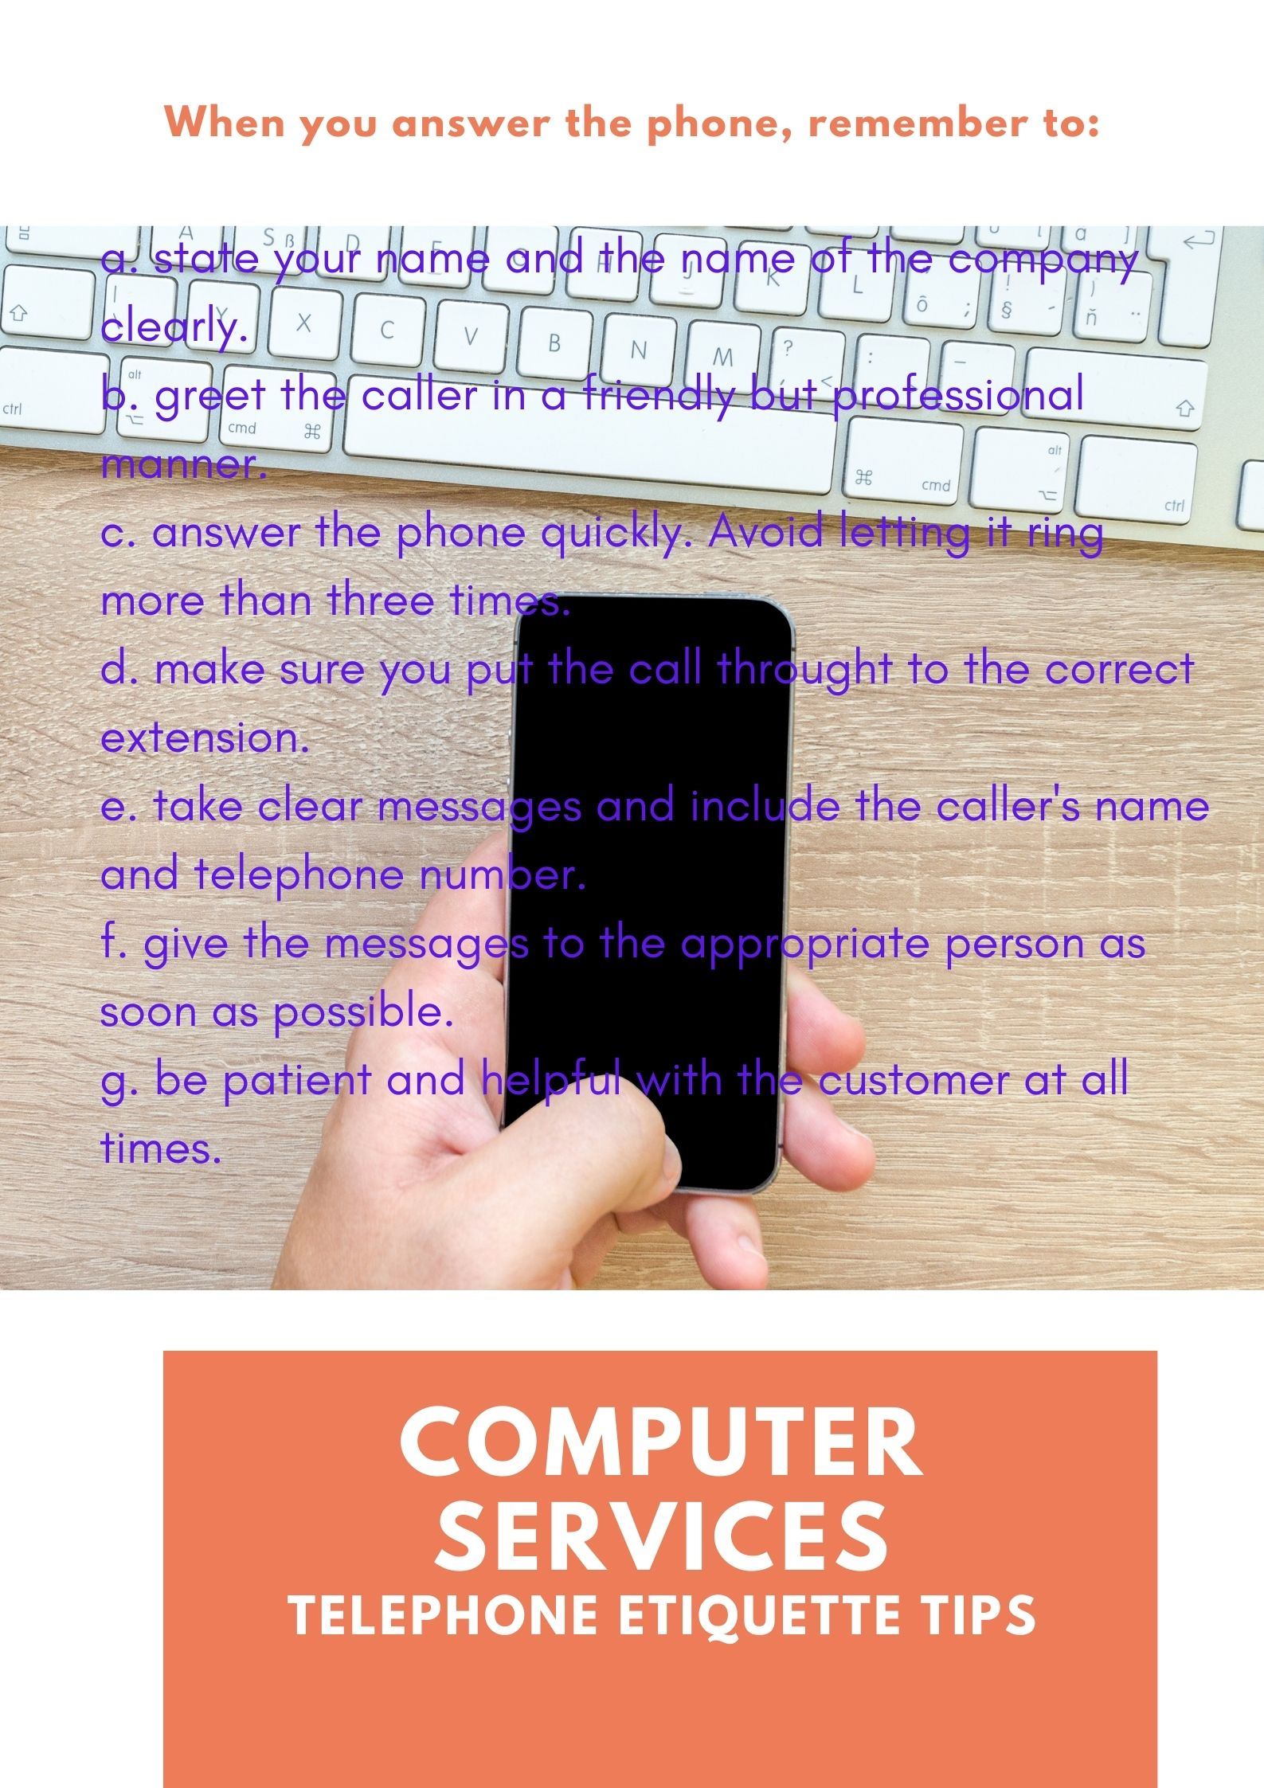
Exercise 1 - Match the sentences below to the correct instructions from the notice.

- The callers shouldn’t wait for a long time.
- The callers should know who they are talking to.
- Write down who is leaving a message and how to contact them.
- Don’t make a mistake when you are putting calls through.
- Deliver messages quickly.
- Be courteous when you speak to callers.

When you introduce yourself on the phone, you can say Melanie speaking. It is not correct to introduce yourself by saying I’m Melanie.

Exercise 2 - Choose the correct answer.

- Her presentation was very professional. She did a bad / good job.
- The shop must be open / closed. There’s no reply.
- I will / won’t be careful when I input the data.
- She must be busy / free. The line is engaged.
- There’s a caller outside / on the phone waiting to speak to you.
- Can you please speak up? I can’t see / hear you very well.

Translate the words underlined in the exercise:

Exercise 3 - Complete these sentences with the following words:
put you through - extension number - repeat - dial a number - state - wrong number - contact

- Sorry, what did you say? Can you _____________ that, please?
- Your mother rang an hour ago - you need to ____________ her immediately.
- One moment, please, I’ll _____________ to Mr Wright now.
- This is not St Ann’s Hospital. You’ve got the ___________________.
- To ___________ abroad, put an 01 before the number.
- From Monday, my new _______________ will be 8015.
- When you answer a phone call, ________________ the name of the company.

Exercise 4 - The words in bold are in the wrong sentences.

- I need to speak to Betty on the line. It’s really important.
- Can you ask Mrs Ford to avoid tomorrow?
- I’ve got a client as soon as possible who wants to speak to the manager.
- Try to remind speaking too loudly on the phone.
- Can you ring back Ms Burns to prepare the invoice for Dell’s Computer Shop?

Exercise 5 - Match A to B

A
- If there’s no reply from his office phone,
- Miss Scott is on the line for you.
- Avoid letting the phone ring a lot.
- They’ve tried to contact you several times,
- Before you dial the number,
- His line is engaged,

B
- he’s probably working off-site.
- so I’ll phone him later.
- so call them as soon as possible.
- press 9 for an outside line.
- She needs to place an order.
- Answer it quickly.
Exercise 6 - Complete the sentences:
spell that - interrupt - return your call - line is busy - out of the office

- When someone is speaking on the phone, it means their _______________.
- How do you _________________ -is it J-U-D-Y or J-U-D-I?
- I’m sorry to _______________ your meeting, but you have a call from your daughter. She says it’s important.
- Mrs Rose isn’t at her desk; she’s ____________________.
- Mr Davies is busy at the moment. shall I ask him to ___________ later today?

Exercise 7 - Put the words with their right definition

- Unavailable: needs immediate attention.
- Transfer: believe that someone or something will arrive soon.
- Deal with: pass a call on to someone else.
- Urgent: take action to do something.
- Expect: can’t be contacted.

Exercise 8 - Choose the correct answer.

MESSAGE FOR MR TRAVIS

Will Samuels called this morning while you were on holiday / in a meeting. He left / took a message saying that he has lost half of his client data and he needs an urgent / unavailable solution. I told him you would hang up / deal with his problem as soon as possible and that you would return / transfer his call after your meeting. I cut off / took down his mobile number in case you haven’t got it. It’s 093-425555.

