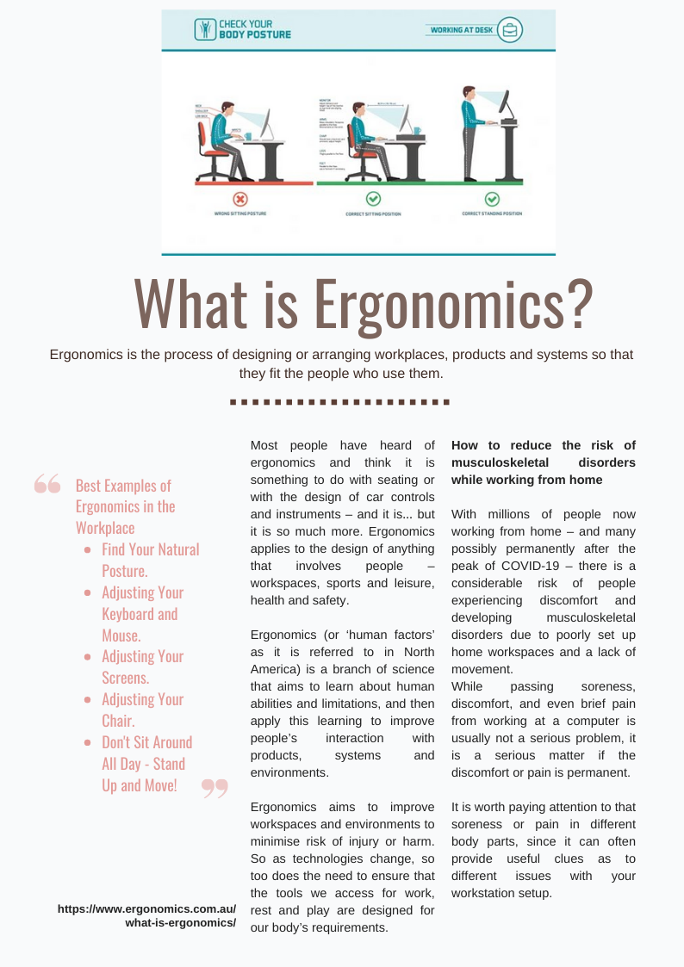
Exercise 1 - Say if the following statements are true or false. Correct the false ones.
- Ergonomics is only something to do with seating or with the design of car controls and instruments.
- Ergonomics applies to the design of anything that involves people – workspaces, sports and leisure, health and safety.
- Brief pain from working at a computer is usually not a serious problem.
- The lack of movement increases the risk of developing musculoskeletal disorders.
- Soreness or pain in different body parts can often provide useless clues to measure discomfort.

Exercise 2 - Give the translation into your language according to the meaning from the text.
arrange:
environment:
aim:
lack of movement:
soreness: ____
brief:
it is worth paying attention to:
difference between injury and harm:

Exercise 3 - Ergonomic tips

Tired of having a sore back, tight shoulders, tension headache and fatigue by the end of the work day? Habits formed in our daily activities like staring at the computer, cradling the phone, slouching in a chair or even just carrying groceries can create painful body conditions. These conditions can be helped or prevented by incorporating good ergonomic techniques into daily routines and work sites.
Ergonomics is helping to fit a job to the person. That job can be a task at work or at home. Here are some suggestions to help improve posture and ergonomics for your daily tasks as a programmer working at home:

 | Suggestion | Picture illustrating the suggestion
1
2
3
4
5
6
7
8
9
10

