Exercise 1 - Read the job advert. Then decide if the sentences below are true or false. Correct the false ones.

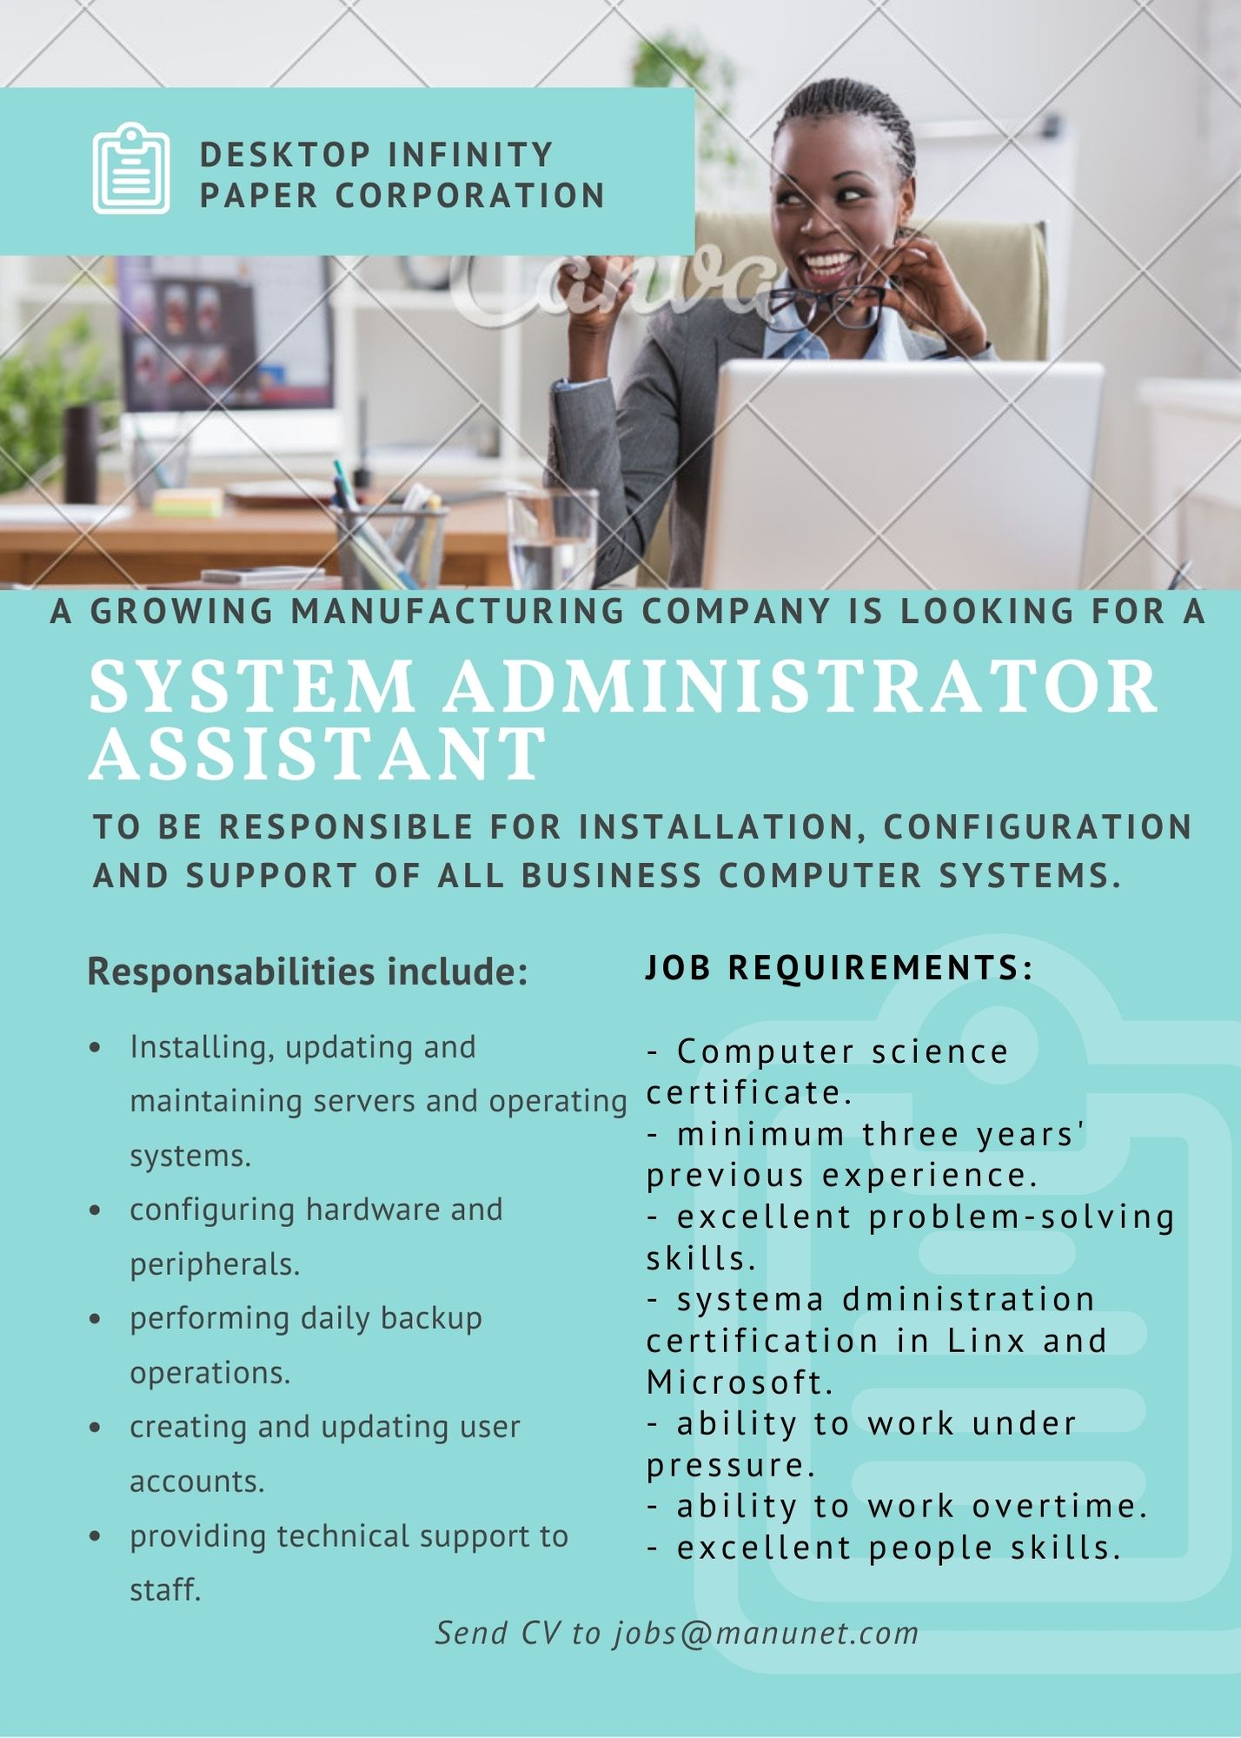

The system administrator assistant…

- will purchase peripherals for the company.
- will make sure all the company data is backed up.
- will be responsible for troubleshooting.
- needs to have a university degree in computer science.
- needs to have training from specific vendors.
- does not need work experience.
- will only work conventional hours.
- will need to interact with colleagues.

Exercise 2 - Complete the sentences with the following words:

vocational training / people skills / certification / secondary school / team / educational background / experience / fast-growing technologies / overtime /
under pressure

- Some people prefer working alone, not in a _________________.
- What is your __________? Did you study at university?
- We gave the job to Patricia Rose because she had a lot of ________________ in handling customer complaints.
- I’m working late. I’ll have to do some___________.
- Mr Ross makes sure to get updates and information on ______________.
- It isn’t easy to work ___________, especially when you’re a new employee.
- You will give technical support to our customers, so you need patience and good ____________.
- I’ve got a ____________ as a Network System Technician from the Electronics Technicians Association.
- I finished ____________ when I was 18. Then I did _________ in electronics.

Exercise 3 - How do you say these words in your language?

employment - employer - employee
interview - interviewer - interviewee

Exercise 4 - Write four pairs of words with opposite meaning.

outgoing / insecure / hard-working / organised / relaxed / lazy / responsible / confident / shy / highly skilled / nervous / knowledgeable

Exercise 5 - Choose the correct answer.

- Amanda is hard-working / confident. She’s at the office from 7 am to 7 pm every day.
- It’s my first day at this job. I’m so lazy / nervous!
- Is Dan responsible / knowledgeable? Does he always finish his projects on time?
- Tim is an excellent software tester. He’s very organised / relaxed.
- Chloe isn’t a good marketing representative. She’s too quiet and outgoing / shy.
- You can’t offer such a low salary to a nervous / highly skilled candidate.
- Lisa is showing me how to search for statistics. She’s very knowledgeable / insecure about the Internet.

Exercise 6 - Use the words to complete the sentences:

temporary - permanent

- I’m looking for a __________ job. I want to work in the same place for a few years.
- This job is probably for three months. It’s only a ________ job.

retirement benefits - starting salary

- The ___________ is €9 per hour.
- What are the _________ at your new job?

hire - retire - fire

- I really want this job. I hope they’ll _______ me.
- Mr Anderson has worked in the IT department for 40 years. He’s going to _______ next week.
- I’m worried the company will _________ me for sleeping at my desk.

shifts - schedule - recruit

- Does your company ______ many students?
- The desktop support technicians provide 24/7 support, so they work in 12-hour _______.
- Every Friday, the staff get their _______ of hours for the following week.

Exercise 7 - Which sentences are true for you?

- I’m very ambitious. I want a good career.
- I’m not very flexible about hours. I can only work for certain hours.
- I’m very industrious. I work hard and get a lot done.
- I’m a fast learner. I don’t need a lot of explanations.
- I’m not very good at multitasking. I can’t do more than one thing at a time.

Exercise 8 - Match the words in A to their definitions in B.

A
- sensitive
- diligent
- easy-going
- creative
- energetic

B
- has got original ideas.
- pleasant and relaxed.
- hard-working.
- active, dynamic.
- is aware of other people’s feelings and behaviour.

Exercise 9 - Read the sentences and choose the correct answer.

- Are you flexible about your hours?
  - No, I don’t want to work shifts.
  - No, I don’t want a temporary job.
- Tom is very ambitious.
  - He’s also a fast learner!
  - He’s not interested in a career.
- Two support technicians were fired.
  - Were they too flexible?
  - Were they temporary workers?
- My starting salary is low.
  - Well, at least there aren’t any retirement benefits.
  - Well, at least the work isn’t hard and the hours are easy.
- It’s great they hired Melanie as a web designer.
  - Yes, she’s really creative.
  - Yes, she’s sensitive.

