Preparing a CV

Exercise 1 - Read the tips for preparing a CV that you have in the pdf document and answer the people’s questions below.

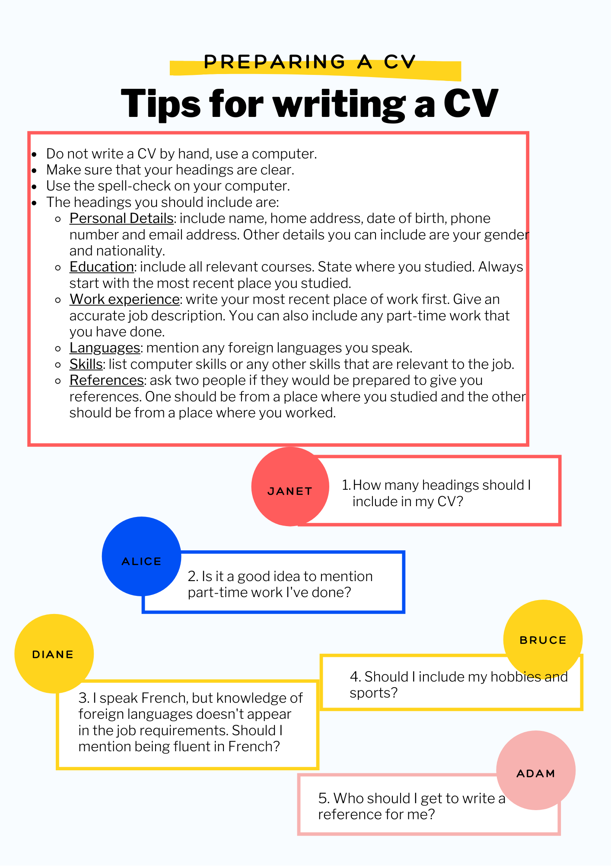

JANET - How many headings should I include in my CV?

ALICE - Is it a good idea to mention part-time work I’ve done?

BRUCE - Should I include my hobbies and sports?

DIANE - I speak French, but knowledge of foreign languages doesn’t appear in the job requirements. Should I mention being fluent in French?

ADAM - Who should I get to write a reference for me?

Exercise 2 - Match the information below to the correct heading on the CV.

- 2012-2013: Network Administrator, Davidson’s Electronics. ___________________
- dana3@gmail.com ________________________________
- Date of birth: 26th August, 1992. __________________________________
- 2010: Certificate in Network Administration - Computer Training School. _____________________
- Installing, configuring and administrating network technologies.

Exercise 3 - Read the sentences and choose the correct answer.

- What are your career objectives?
  - I hope to be a web designer.
  - I hope to finish school next year.
- What is your date of birth?
  - It was last week - 20th May.
  - 20th May, 1993.
- Are you fluent in any other languages?
  - Yes - in German and Russian.
  - I’ve taken a beginner’s course in French.
- What is your current job?
  - I’ve taken a course in information technology.
  - I work as a computer programmer for AAI Computer Games.
- What computer skills have you got?
  - I’ve got a good knowledge of hardware and software applications.
  - I bought a new computer last month.
- Have you got any references?
  - I am very outgoing.
  - Yes, they are listed on my CV.
- What personal details do you need?
  - Include any programming courses you’ve taken.
  - Include your address and phone number.
- What is your job description?
  - I provide technical assistance to customers by phone.
  - I work on Mondays and Fridays.

Exercise 4 - Complete the chart with the words or phrases

graduate - married - single - gender - male - certificate - divorced - Bachelor’s degree - female - formal training - marital status

Personal Details | Education

Exercise 5 - Complete the sentences with words from Exercise 3 or 4.

- Miguel isn’t married. I don’t know if he’s ________ or __________.
- I can perform computer repairs but I have never had any ________________ in computers.
- When I graduated from university, I received a _____________________.
- Your gender, marital status and nationality are __________________________.
- Solving technical problems is my main responsibility in my _________________.
- You must be _____________________ in English in order to apply for a job as a software tester here.

Exercise 6 - Read the covering letter and the CV and then choose the correct answer:

From: Rebecca Webber
To: pgrander@jobs.mizo.net
Subject: IT support
Dear Ms Grander,

I’m writing in reference to the position of IT support as advertised on Job4U.uknet.uk. Please find my CV attached.

If you require further information, please do not hesitate to contact me.

I look forward to hearing from you.

Yours sincerely,

Rebecca Webber

Tip!!!
When writing a covering letter, write To Whom It May Concern when you don’t know the name of the person you are writing to.

CURRICULUM VITAE

Personal details:
Name: Rebecca Webber
Date of birth: 16th June, 1995
Telephone n.: 0173 8367683
e-mail address: ReWeb@ynet.uk

Education:
2013 - 2014: Cyber Security courses, Coursara
2012 - 2013: Business Technology Management courses, Coursara
2010 - 2012: Computer Management Certification, two years, Institute of Technology

Work Experience:
2014 - present: IT Business Support, Preston Trades
Responsibilities: troubleshooting via telephone, e-mail and remote support tools to diagnose technical issues, assisting in maintaining operating systems, applications, networks, servers and peripherals.

Languages: English (native), German (advanced)

Skills: MS Office, HTML, JavaScript

References: Samuel Robins
Head of IT, Preston Trades
23 Centre Ave
Manchester
01748 498633

- What is the purpose of a covering letter?
  - to give basic information about a person.
  - to say what job a person is applying for.
  - to recommend a place of work.
- What is the purpose of a CV?
  - to say why a person wants a job.
  - to give a job description.
  - to give information about a person’s qualifications for a job.
- What is NOT one of Rebecca’s responsibilities at Preston Trades?
  - identifying technical issues.
  - maintaining servers.
  - support for mobile phones.

Exercise 7 - Answer the questions according to the CV and covering letter in Exercise 6.

- Who is Rebecca sending the CV to?
- Where did she see the advert?
- When was Rebecca born?
- Where did she study?
- Is Rebecca working now?
- How many languages does she speak?

Exercise 8 - Look at the CV again. What two things are missing from the CV? Use the tips for writing a CV from exercise 1 to help you.

