Technical English Vocabulary Exercises:
Vocabulary Matching:
1. Vocabulary Matching: Match the technical terms with their definitions:
Technical Terms:
• Algorithm
• Binary
• Debugging
• Encryption
• Firewall
Definitions: a) A process of finding and fixing errors in a computer program. b) A security system that controls the incoming and outgoing network traffic based on an applied rule set. c) A method of converting data into a code to prevent unauthorized access. d) A set of rules or instructions designed to perform a specific task. e) A numbering system consisting of only two digits, 0 and 1.
2. Fill in the Blanks: Fill in the blanks with the appropriate technical terms from the vocabulary list:

Encryption
Debugging
Firewall
Algorithm
Binary
a) The ________ system ensures that only authorized users can access sensitive data.
b) In computer science, an ________ is a step-by-step procedure for solving a problem.
c) ________ is the process of converting plaintext into ciphertext to secure it from unauthorized access.
d) ________ is the process of detecting and removing errors or bugs from a computer program.
e) Computers use the ________ numbering system, which consists of only two digits: 0 and 1.

Extra: What is a ciphertext?
In cryptography, ciphertext or cyphertext is the result of encryption performed on plaintext using an algorithm, called a cipher. Ciphertext is also known as encrypted or encoded information because it contains a form of the original plaintext that is unreadable by a human or computer without the proper cipher to decrypt it. This process prevents the loss of sensitive information via hacking. Decryption, the inverse of encryption, is the process of turning ciphertext into readable plaintext. Ciphertext is not to be confused with codetext because the latter is a result of a code, not a cipher.

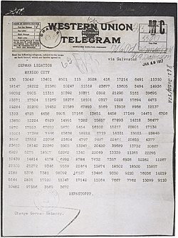

During World War I, the German government sent a secret message called the Zimmermann Telegram to Mexico in 1917. In the message, Germany proposed a military alliance with Mexico against the United States. Germany promised to help Mexico regain territories like Texas, Arizona, and New Mexico if the U.S. entered the war against Germany. The British intercepted the telegram and revealed its contents to the Americans. This revelation angered many Americans, leading to increased support for the U.S. declaring war on Germany in April 1917. The decoding of the telegram was a major success for British intelligence during World War I and showed how intercepted messages could impact global events.

