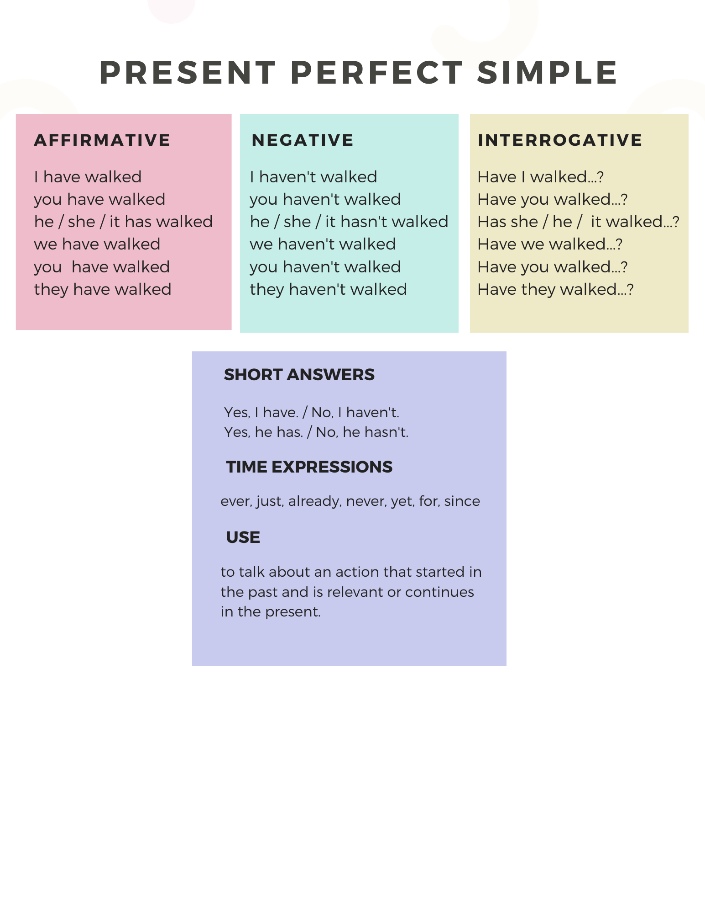

Exercise 1 - Complete the sentences with the verbs below. Use the Present Perfect Simple affirmative

install / return / promise / postpone / resize / allocate

- We ________________ the product. It had a defect.
- The designer __________ the images for the website.
- Brad and Luke _____________ just ___________ the operating system.
- Ms Carlson ___________ already __________ a budget for our project.
- I ______________ my meeting with the manager. It will take place tomorrow.
- The manager ______________ to move me to a different depar.

Exercise 2 - Complete the chart

Base Form | Past Participle
- begin | begun
- buy
- deal
- do
- eat
- fly
- give
- go
- leave
- lose
- read
- take

Exercise 3 - Complete the sentences with verbs from Exercise 2. Use the Present Perfect Simple affirmative.

- I’m sorry. Mrs Kelly __________________ the office. Can I help you?
- I ______________________ the spreadsheet to the sales manager.
- James ___________________ the information about the new software. He understands it better now.
- Please hurry. The meeting _______________ already __________________.
- We _________________________ a good customer because of his mistake.
- Mr Smith ______________________ home for the day. He’ll be in the office tomorrow morning.
- They ________________________ many peripherals from us.

Exercise 4 - Write sentences with the words below. Use the Present Perfect Simple negative.

- Lisa / speak / to the support technician
- IT / customise / that computer / yet
- we / check / today’s orders
- you / ever / be / in that department
- they / modify / the equipment for my requirements
- Mike and Sam / log off / yet

Exercise 5 - Look at the things that Louise wanted to do today. Write six sentences saying what she has and hasn’t done. Use the correct form of the Present Perfect Simple.

Order new credit card for Mr Dench.
Send out all the invoices.
Discuss new logo with sales team.
Talk to Jerry about changing my monitor.
Write a memo about the IT conference.
Ask Callum to repair the printer on the second floor.

1.
2.
3.
4.
5.
6.

Exercise 6 - Circle the correct answer.

- Lucy has worked here _________ five years. since / for
- I have _________ set up the network. ever / already
- Lucas Brothers have been our customers ______ 2005. since / for
- Harry has ______ been a manager. This is the first time. just / never
- Have you ______ bought goods from that company? yet / ever
- The technician has _____ replaced the fan. ever / just
- We haven’t finished _____ yet / already

Exercise 7 - Write questions with the words below. use the Present Perfect Simple. Then match the questions in A to the answers in B.

A
- Mrs Green / send back / the faulty part
- why / John and Max / leave / the office
- where / you / put / yesterday’s invoices
- the visitors / arrive / yet
- which version / he / download
- what / happen / to the barcode scanner

B
- No, but I’m sure they will get here soon.
- Sorry, They’re still on my desk.
- I don’t know. It stopped working yesterday.
- Not yet, but I’m sure she will.
- They’ve got a meeting with the bank.
- The 64-bit.

Exercise 8 - Complete the sentences with the verbs below. Use the correct form of the Present Perfect Simple

cancel / put / give / not come / not subtract / go / open / not send

- _________ Nick __________ to visit a customer?
- Amy _______ to work for three days. She is ill.
- Mr Day __________ the meeting because the client couldn’t be there.
- _______ you _________ us your billing address?
- Mr Ling from Hong Kong is on the line. I __________________ him on hold.
- They ______________ me any emails since last week.
- I _______________ your payment from the total yet.
- Computer-Fix _______________ a shop in the centre of town.

Present Perfect Simple / Past Simple

Uses

Present Perfect Simple
to talk about an action in the past that is related to the present to emphasises the importance of the results of the action, as they affect us now.
Ex: I have already eaten.

Past Simple
to talk about actions that began and ended in the past.
Ex: I ate at 1.00. (Past Simple)

Exercise 9 - Circle the correct answer

- I have never played / never played this game before.
- I didn’t retouch / haven’t retouched it yet.
- We had / have had a lot of customers last night.
- Did you ever use / Have you ever used a virtual projection keyboard?
- Has she prepared / Did she prepare the survey last month?
- We didn’t deal with / haven’t dealt with the technical problems yesterday.

Exercise 10 - Complete the sentences with the time expressions below

last month / ever / already / yet / a few minutes ago / since

- You don’t need to send out the invoices. I’ve ___________ done that.
- She’s worked as a support technician _____________ she finished school.
- Mr Grey sent me an email this morning, so I disposed of those files __________.
- Dan hasn’t listened to the playblack __________________.
- They moved to their new department ___________________.
- Have you _______________ set up a network?

Exercise 11 - Complete the sentences with the verbs in brackets. Use the Present Perfect Simple or Past Simple.

- They ______________ (deliver) the items a few minutes ago.
- Bob __________ (not install) the anti-spyware software yet.
- When __________ you __________ (begin) working here?
- She ___________ never ______ (write) a game review.
- __________ you ever ___________ (design) the topology for a network?

Exercise 12 - Complete the sentences with the verbs below. Use the Present Perfect Simple or Past Simple.

speak / send / not reschedule / not attend / decide

- I ____________ the email a minute ago.
- The programmers ________________ the meeting last week.
- ___________ Mrs Gardner ___________ to buy this software?
- __________ Sally ___________ to the web designer yesterday?
- I don’t know the date of the managers’ meeting because they _________ it yet.

