Zero conditional
The zero conditional works to make sentences where the condition and the result are real facts. The best examples are the ones related to scientists' arguments.
Structure:
Option 1: If + Condition (verb in present simple) + Result (verb in present simple) Example: If you mix red and blue, you get purple
Option 2: Result (verb in present simple) + if + Condition (verb in present simple). Example: An ice cube melts if you put in the sun

FIRST CONDITIONAL

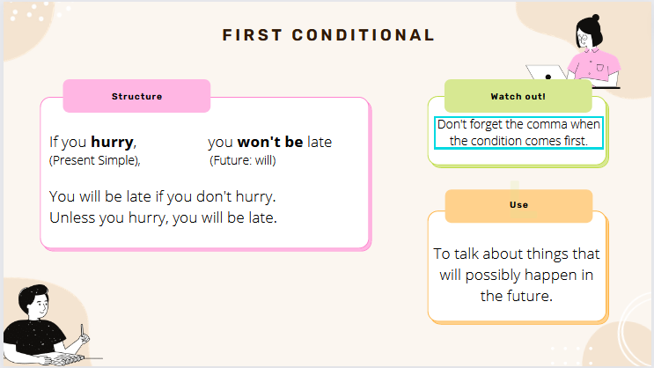

Exercise 1 Match A to B to form sentences in the First conditional.

A
- If you give me the exact address,
- If we move the printer,
- If you don’t sort your files,
- If Linda doesn’t hurry,
- If Jack doesn’t enhance the chart,

B
___ a. there will be more room.
___ b. it won’t be clear enough.
___ c. we will miss the plane
___ d. our technician will be there in an hour.
___ e. you won’t find them.

Exercise 2 Circle the correct answer.

- I don’t come / won’t come to work tomorrow if I’m still ill.
- If we want / will want to try this software, we will get a trial version.
- Our manager won’t be happy if there is / will be malware in the system.
- We let you know / will let you know if you get the job.
- If Emma finds / will find the faulty part, I will tell you.
- If you don’t narrow / won’t narrow your search, you’ll get too many results.

Exercise 3 Complete the sentences with the verbs in brackets. Use the First conditional.

- If you _____________________ (want) to talk, I will be in my office.
- We won’t have the meeting on Tuesday if Mrs Ellis _____________ (not be) back by Monday.
- If they ____________________ (not deliver) the hardware on time, we will write a letter of complaint.
- If Allan calls, I ________________ (tell) him that you phoned.
- If the quality of the product isn’t good enough, it ________________ (not sell).
- We won’t buy these projectors if you ________________ (not give) us a better price.

Exercise 4 Complete the sentences with if or unless.

- The computer won’t cool ____________ the fan is working.
- ___________ there’s no reply, I’ll leave a message.
- ___________ you save this draft, you will lose all your work.
- You won’t make a mistake _____________ you are careful.
- __________ the layout is attractive, our customers won’t buy the product.
- __________ you take the course, you will improve your computer skills.

Exercise 5 Write sentences with the words below. Use the First Conditional. Add commas where necessary.

- Mrs Evans / need / this document / I / send / it / to her

- the programmer / not understand / our problem / he / attend / the meeting

- Mr Davidson / meet / you / at the train station / that / be / convenient

- there / not be / enough webcams / I / order / some more

- Max / call / you / he / not find / the invoce

