Grammar Imperative/Let’s/Present Simple Have got

PART K. IMPERATIVE – Affirmative and Negative

We use the imperative to give a direct order. It is only used in affirmative or negative. It is commonly used with an exclamation mark (!)

Examples:
- Go straight!
- Don’t leave your bag here.

Exercise 1. Complete the sentences with the verbs below. Use the correct form of the imperative.

not assemble – offer – remove – not use – insert – not enter

- ______________ the plug from the power supply.
- ______________ this keyboard. It isn’t working.
- ______________ the visitors a drink.
- ______________ the sound card into its slot.
- ______________ the room right now.
- ______________ the computer until you’ve got all the parts.

PART L. LET’S – Affirmative and Negative

We use the expression “Let’s” to make suggestions. It is only used in affirmative or negative. It is commonly used with an exclamation mark (!).

Examples:

- Let’s go to the cinema tonight!
- I’m tired of watching TV. Let’s do something else.

Exercise 2. Make suggestions for the following situations. Use Let’s.

EXAMPLE
Sentence: You and your Friends are hungry.
Answer: Let’s have lunch in the cafeteria.

- The meeting is on the second floor and there are many people in the lift.

____________________________________________________________

- You and some other employees want to know the same of the programmer.

____________________________________________________________

- Your computers aren’t working well.

____________________________________________________________

- You started work at 8.30 and it’s 6.30 now.

____________________________________________________________

PART M. Present Simple HAVE GOT – Affirmative, Negative and Interrogative

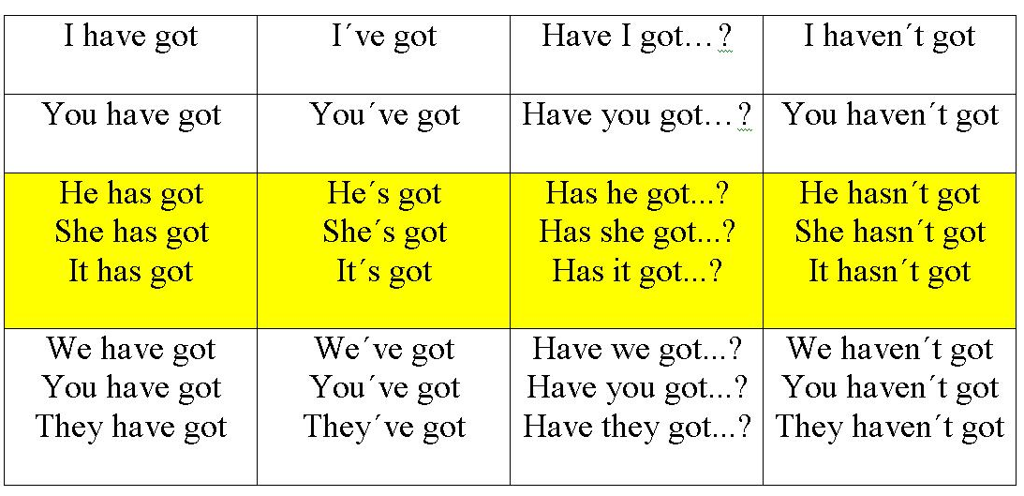
Short answers | Uses
Yes, I have / No, I haven’t | To talk about possession.  To talk about characteristics.
Yes, he has / No he hasn’t

Exercise 3. Circle the correct answer.

- The Company has got / have got new offices.
- We has got / have got all the data.
- Tom and Sue has got / have got the books.
- The office has got / have got new computers.
- I has got / have got a good job.
- You has got / have got a meeting with the network administrator.

Exercise 4. Write the sentences in Exercise 1 in the negative form.

- ____________________________________________
- ____________________________________________
- ____________________________________________
- ____________________________________________
- ____________________________________________
- ____________________________________________

Exercise 5. Complete the sentences with the correct form of have got.

- I ______________ a Smartphone.
- Jeremy __________________ (not) that app.
- We ______________________ a nice office.
- You _____________________ (not) meetings today.
- Lesley and Ben ____________________ a meeting today.
- The trade exhibition __________________ (not) many visitors today.

Exercise 6. Complete the questions with Have… got or Has…got. Answer the questions.

- _________ you _____________ a new phone? __________________________
- _________ your family ___________ a house? __________________________
- _________ you and your Friends _____________ any animals? _____________
- _________ your Friends ________________ jobs? _______________________
- _________ your mum __________________ a long name? ________________
- _________ your friend ________________ a laptop? ____________________

PART N. Present Simple VERB TO BE vs HAVE GOT

Exercise 7. Circle the correct answer.

- Sonia is / has got British.
- Mr. Jackson and Mr. Scott are / have got big offices.
- Lisa isn’t / hasn’t got a job.
- I am / have got a support technician.
- Is / Has got this your phone number?
- Melissa isn’t / hasn’t got a drink.
- My friends and I aren’t / haven’t got an invitation to the exhibition.

