Grammar Past Continuous

PART I. PAST CONTINUOUS – Affirmative, Negative and Interrogative

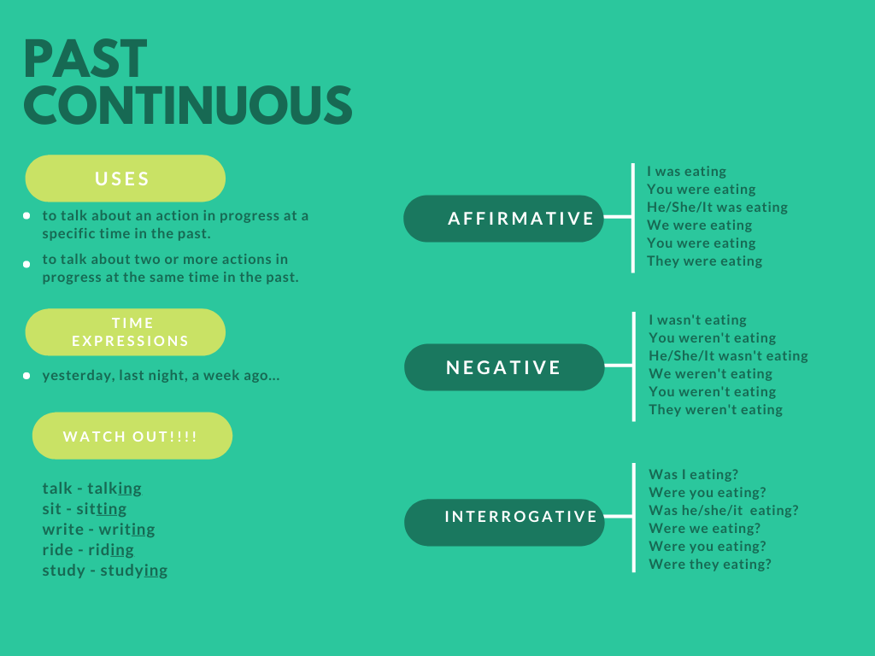

Exercise 1. Complete the sentences with the verbs in brackets. Use the Past Continuous affirmative.

- Pete ____________________ (travel) on the train to our Paris office at midnight.
- The programmers ______________________ (have) a meeting at 3.00 yesterday.
- Sara _______________________ (do) the layout for the new brochure this morning.
- The technicians ___________________ (sort) the equipment an hour ago.
- We __________________ (visit) an important customer at 12.00 today.
- The manager _________________ (check) the payroll this afternoon.

Exercise 2. Complete the questions with the verbs in brackets.

- __________ Larry and Tina ____________ (sell) hardware?
- __________ Lisa ___________ (buy) a printer?
- __________ Kate’s laptop ____________ (work)?
- __________ the women _______________ (serve) food in the cafeteria?
- _________ Steve ___________ (order) his lunch?
- _________ Sam and Andy __________ (show) the customers some software?

Exercise 3. Complete the sentences with the verbs below. Use the Past Continuous.

not work - solve - send - learn - check - not set up

- ______ the network administrator ______________ the workstations at 10.00 today?

- _______ the helpdesk technicians _______________ problems all morning?
- George ______________ the new network at 9.00 this morning.
- Dan and Cathy ________________ about the new software on Monday afternoon.
- Owen __________ on the image half an hour ago.
- Yesterday afternoon, I _________________ reminders to our customers.

Exercise 4. Write sentences about what you were doing at the following times. Use the Past Continuous.

1. 2.00 a.m. this morning

_________________________________________________

- an hour ago

_________________________________________________

- 10.00 a.m. on Monday morning

_________________________________________________

- 5.00 p.m. on Saturday afternoon

_________________________________________________

PART J. PAST SIMPLE vs PAST CONTINUOUS

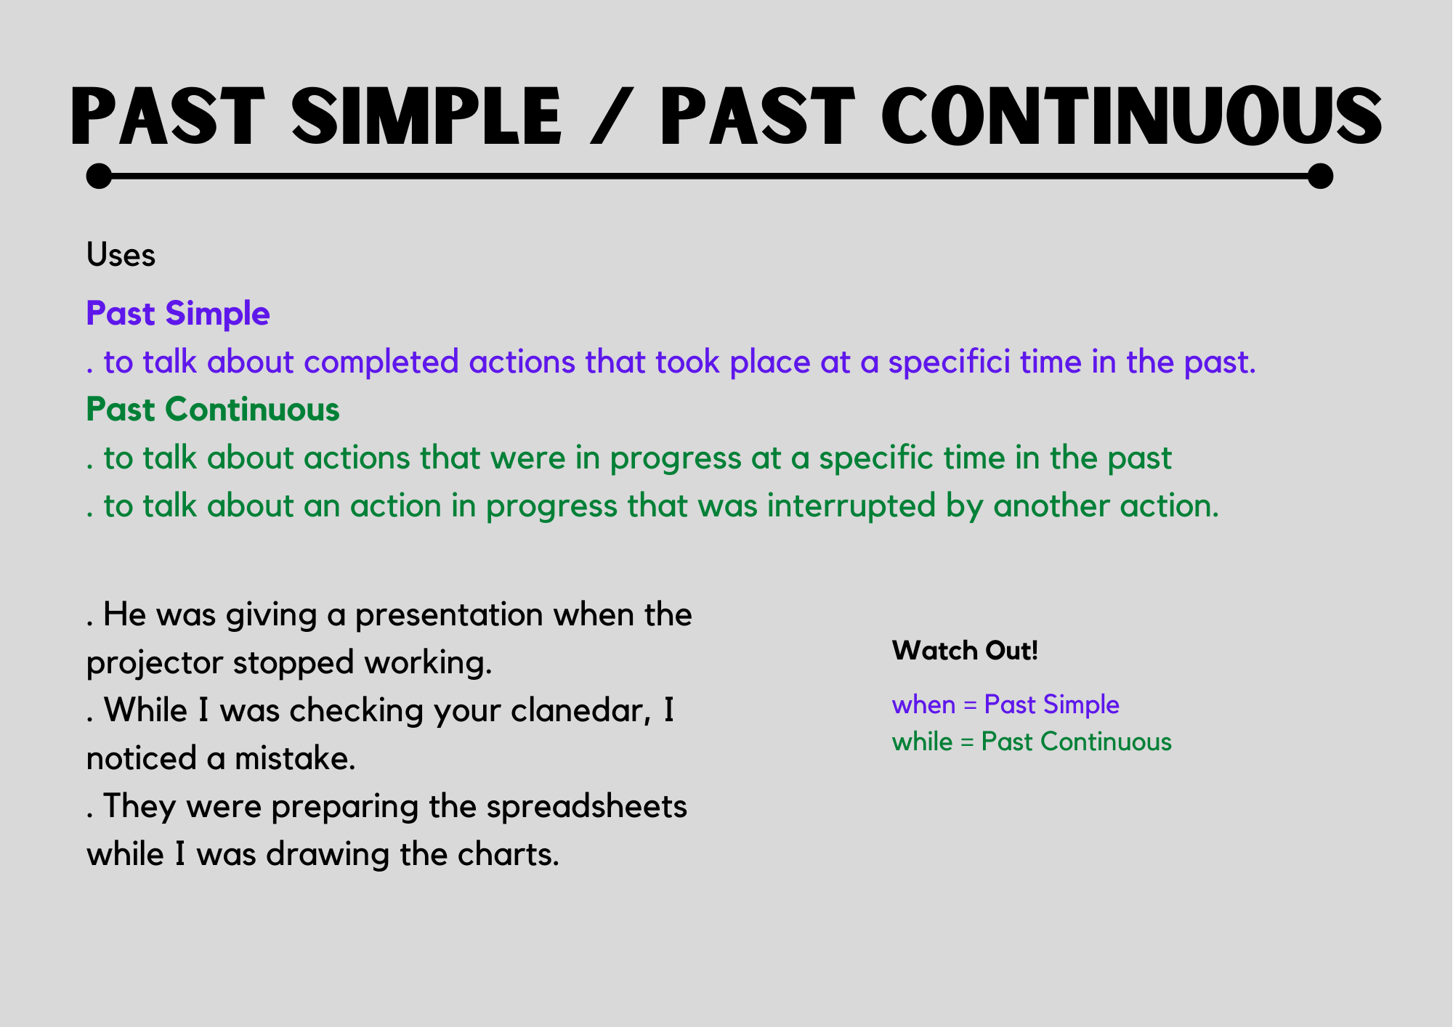

Exercise 5. Circle the correct answer.

- When / While the technician was repairing the computer, the students were watching him.
- The lift was going up to the tenth floor while / when it stopped suddenly.
- When / While the tech rep was driving to see the customer, he had an accident.
- I was writing the invoice while / when the customer cancelled the order.
- We located the problem while / when the customer was sitting in our office.

Exercise 6 - Complete the sentences with the verbs in brackets. Use the Past Continuous or Past Simple.

- Many customers _______________ (stand) outside when we _____________ (open) the doors for the sale.
- While I ____________________ (set up) the workstations, the network administrator _________________ (call) to say there was a problem.
- While the accountants __________________ (look) at the spreadsheet, the electricity _________________ (go off).
- The manager _______________ (come in) while I was _________________ (translate) for our Italian visitor.
- When the delivery _________________ (arrive), the workers _______________ (wait).
- While Sam ______________ (talk) to the customer, she _______________ (hang up).

