Grammar Quantifiers and Adverbs of frequency

QUANTIFIERS – Countable and uncountable nouns

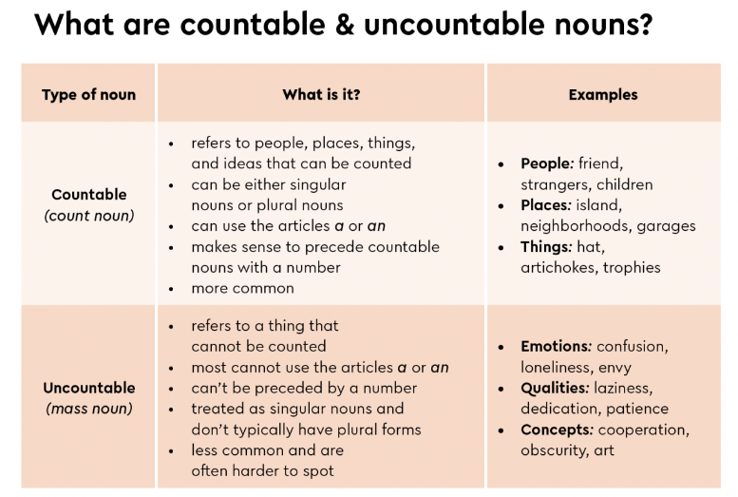

Exercise 1 – Classify the following nouns into the chart below:

airport – power – product – hardware – problem – education – password – data

Countable nouns | Uncountable nouns

Exercise 2. Write the plural of the following nouns:

1. Library: 5. Child:

2. Switch: 6. Stair:

3. Woman: 7. Company:

4. Business: 8. Person:

A, AN, THE, SOME AND ANY – Uses for countable and uncountable nouns

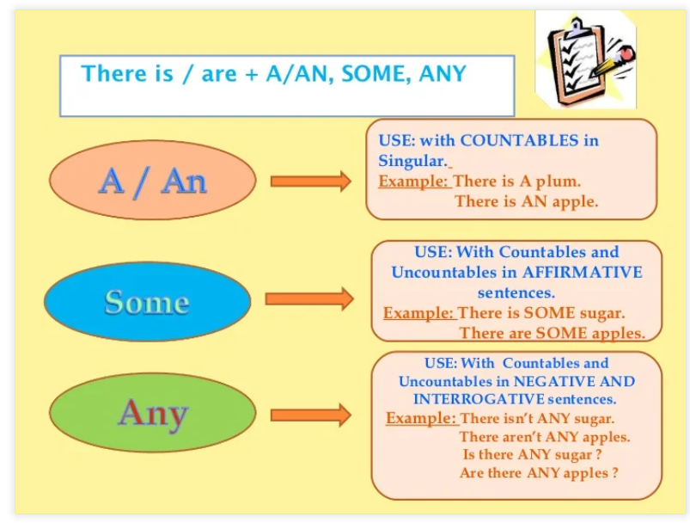

Exercise 3. Complete the sentences with a, an, the, some or any.

1. Have you got _____ big office?
2. Can you answer ____ phone?
3. She is _____ excellent designer.
4. Has Sue got ____ flash driver?
5. I’ve received _____ messages.
6. We haven’t got _____ model A scanners.
7. What is _____ date today?
8. I’ve got _____ printer at home.
9. I’ll have _____ tea.
10. We’ve got ____ office in Tokyo.

Exercise 4. Circle the correct answer.

1. There is / there are some chairs in the office.
2. There isn’t / there aren’t any invoices on my desk.
3. Is there / are there any paper in the printer?
4. There isn’t / there aren’t a subtotal on this invoice.
5. Is there / are there any fans in the IT department?
6. There is / there are a price on the webcam.

Exercise 5. Write the words in the correct order to form sentences.
1. are / boxes / of / there / screws / any / ?
2. there / a / on / desk / my / isn’t / pen / blue /.
3. sports centre / a / in / is / your / there / area / ?
4. there / any / in / shop / the / webcams / aren’t / .
5. headsets / discount / is / on / a / there / these / .

MUCH, MANY, A LOT OF vs LOTS OF – Uses for countable and uncountable nouns

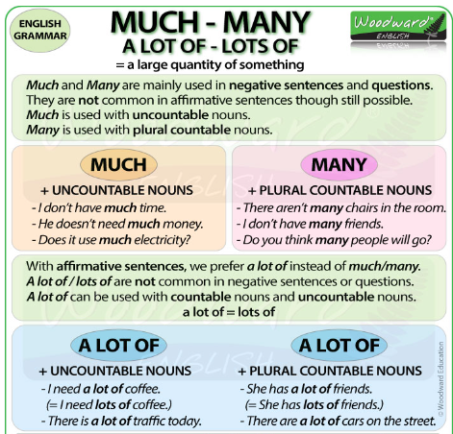

Exercises 6. Circle the correct answer.

1. We haven’t got much / many headsets.
2. Is there a lot of / many work?
3. There aren’t much / many people in the office today.
4. Eva is ordering much / a lot of microphones.
5. There isn’t many / much paper in the printer.
6. There are a lot of / much things to do, but I haven’t got many / much time to do them.

Exercise 7. Circle the correct answer.

1. There are some / any pens in the box.
2. There’s a / an airport 20 km from the city.
3. We haven’t got some / any sound cards.
4. There are much / many pencils on my desk.
5. There isn’t some / any data.
6. Are there much / a lot of shops in Lewis Street?
7. There is some / any money in the envelope.
8. There is / there are a department store opposite the train station.

ADVERBS OF FREQUENCY

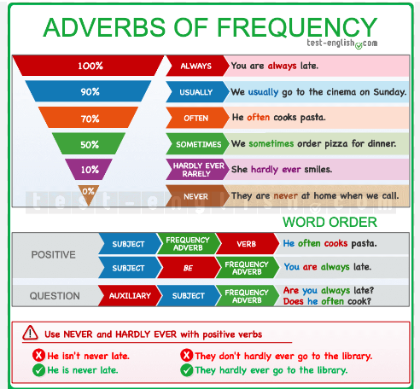

Examples:

My brother often downloads music.
She always uses skype to talk to her friends.
My father usually reads magazines about technology.
I hardly ever read blogs.
We sometimes take photos with our digital camera.
My friend Paco never prints documents.

Exercise 8. Complete the following sentence and order the adverbs from the exercise below according to their frequency:

Always, never, sometimes or often are used with the ______________ tense.

+++++
++++
+++
++
+
-

Exercise 9. Write the sentences in the correct order:

- never / plays / computer / he / games

____________________________________________________________

- sometimes / Will / funny / makes / videos

____________________________________________________________

- uses / the / Meredith / webcam / always

____________________________________________________________

- download / I / usually / music

____________________________________________________________

- print / hardly ever / photos / I

____________________________________________________________

- their / mails / send / they / often / to / friends

____________________________________________________________

