Exercise 1 - Read the rules. Why are these messages incorrect according to the rules?

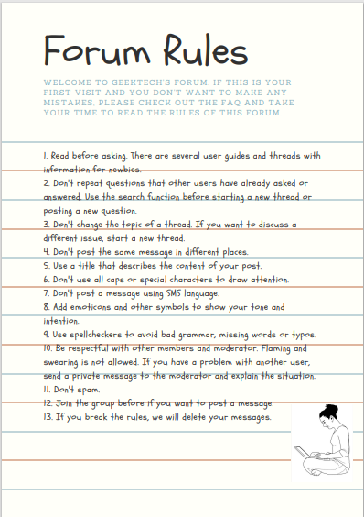

- THNQ 4 the info. CU
- Wich of these motherbaords do you recomend?
- People! I’ve got a problem with user Edelweiss32. He keeps on sending me private message.
- CHEAP PC VICEOGAMES FOR SALE!
- Edelweiss, if you think that PCs are better than Macs, you are definitely stupid.
- I don’t know if anyone has asked the same question… How can I delete cookies?

Exercise 2 - Find words in the text with these meanings

- People who are new on a forum.
- To write a message on a forum.
- A symbol to show your feelings.
- A program used to see if a text contains any spelling mistakes.
- To become a member of a group.

Exercise 3 - Read the forum rules again and remember the vocabulary done in the Domain names and Netiquette activity we have done in class:

Make a poster to hand at your school promoting good behaviour on the internet. Use some of the rules, proper images and whatever you consider convenient to aware young people.

You can use canva to do the poster.

