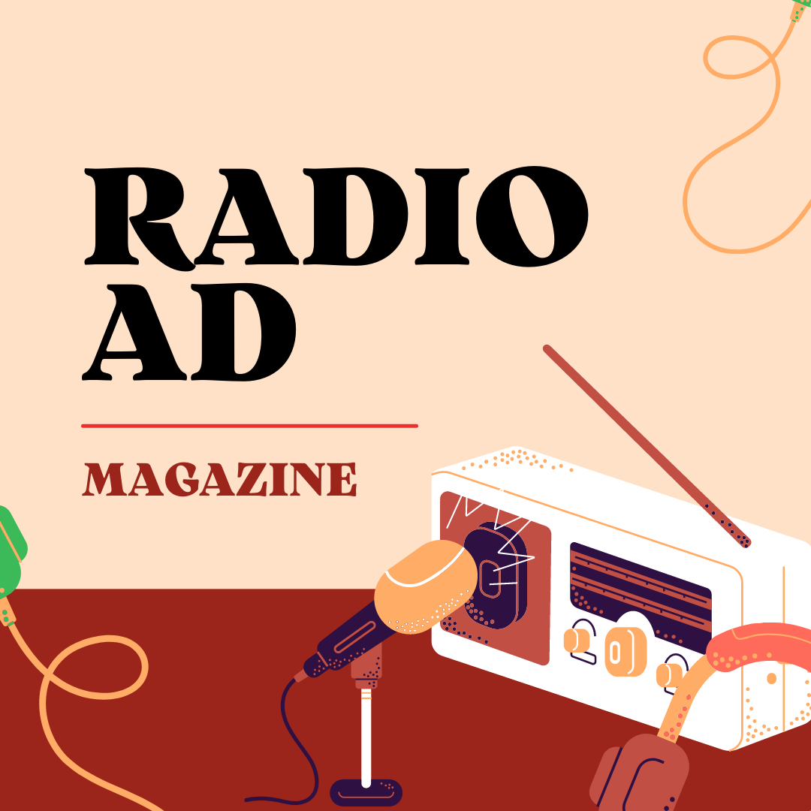
Remember you have designed a magazine in M03? Now it’s time to do the launch by making a radio ad.

Instructions:
- Length: 20 seconds
- Deliver the file or the link in the Moodle
- Choose one of these programs:
  - InShot
  - OpenShot
  - Audacity
  - Others
InShot tutorial: https://www.youtube.com/watch?v=QqJ-B5AsCVc
Audacity tutorial: https://www.youtube.com/watch?v=YZEoOfEt35g
Key components for an effective radio ad:
- Highlight the consumer's problem in an attention-grabbing way.
- Show empathy.
- Stress the pain the problem causes.
- Mention how your product solves this problem.
- Guarantee the customer's satisfaction.
- Include testimonials if possible.
- Conclude with a call to action. Ex. call now, go to… and buy it now.
- Price
Examples of Radio Ads to inspire you:
https://www.radiocentre.org/vote-for-radio-ad-of-the-year/
https://www.bestadsontv.com/best/radio

For further information:
Here you have a tutorial about how To Make a Great Radio Commercial: https://www.youtube.com/watch?v=eXYb1ZZN5NM

