Exercise 1 - Read the following email. What kind of information does each paragraph refer to?

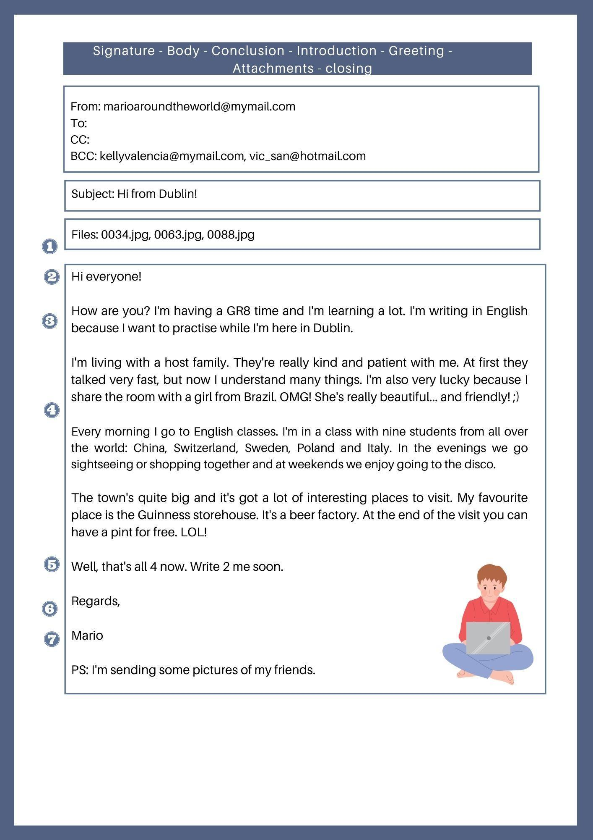

Exercise 2 - Read the email and answer the questions.

- Who is the sender? And the recipient?
- Can the recipient see the names of the other recipients? How do you know that?
- How many attached files is Mario sending?

Exercise 3 - Where would you find the following expressions in an email? Write Greeting, Introduction, Conclusion or Closing next to each sentence.

- I hope to hear from you soon.
- Thank you very much for your letter.
- How’s your family?
- Love,
- Dear Caroline,
- Well, that’s all my news.
- Best wishes,
- I have some good news.
- Give my regards to your brother.
- It was great to hear from you.
- Hi Sandy,

Exercise 4 - Find eight abbreviations in the text. What are their meanings?

Ex. BCC stands for Blind Carbon Copy

1.
2.
3.
4.
5.
6.
7.
8.

Exercise 5 - Read the description of a tablet. What does each paragraph refer
to? Complete each paragraph with the correct word from the box.

Technical details - Audience - Material - Use

This tablet is a portable device similar to a PC and a smartphone. It is used for
reading content, watching videos, playing games, etc. It has wireless connectivity for
downloading contents and applications. ___________________________

It is designed for people who want to work on the Internet, run applications and
media and don’t have much space to carry a laptop or a netbook.
_________________________

The structure is made of plastic and stainless steel, so it is strong but very thin and
light. Its screen is made of glass. __________________________

The tablet is 11.5 mm thick, weighs 330g and features a 7’’ display. It has 8 GB
memory and comes with a slot for Micro SD. It has a high resolution touch screen, a
built-in microphone, a webcam and a virtual keyboard. The device has a powerful 1.2
GHz processor and battery life of up to 36 hours. ____________________________

Exercise 6 - Writing task

Write a description of your favourite gadget. Use the structure in exercise 5.

