Pembayaran hosting fastlearningcenter.com

Masuk: 1.800.000
Tagihan: 164.183+1.403.161+143.134 = 1.710.478
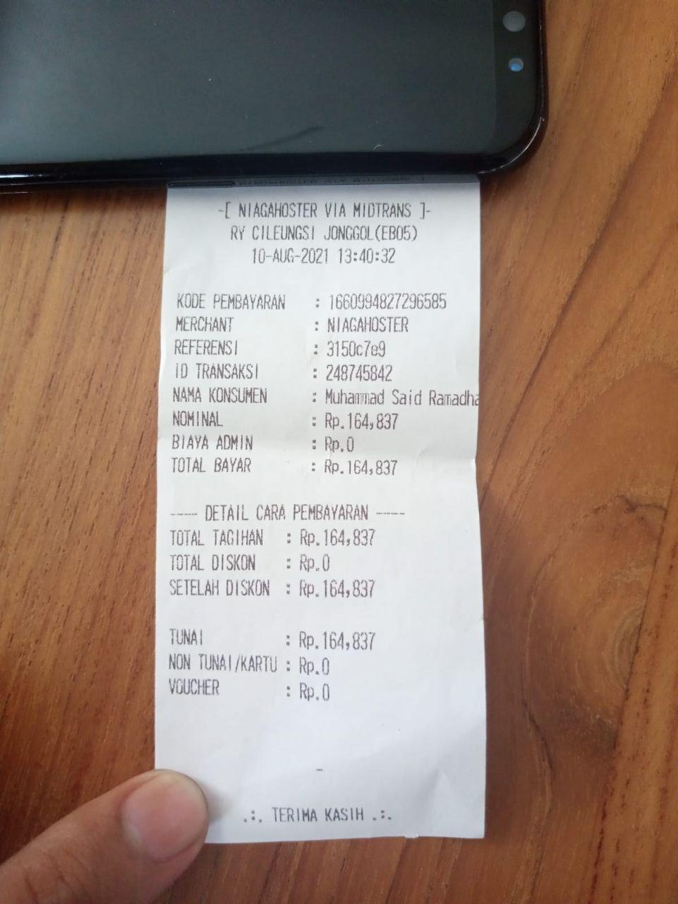
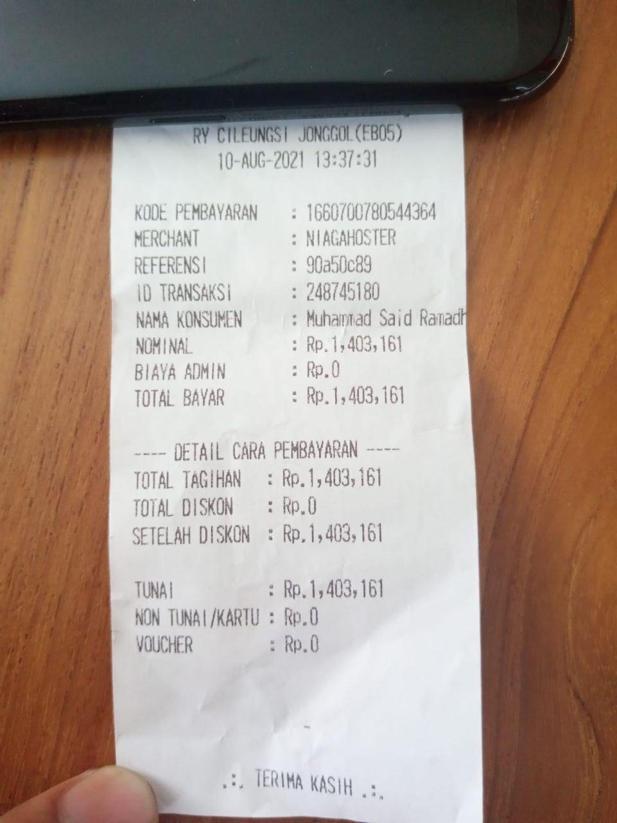
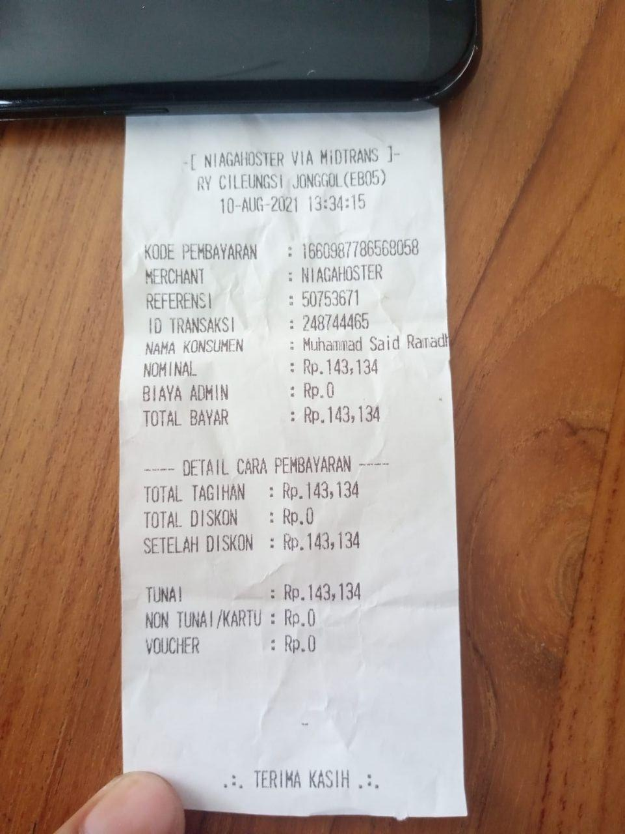
Sisa : 89.522

