1. My part of the project
Menu | Function | Lines in main2.py | What it does
9 | show_statistics | 314-322 | Calculates the number of borrowed books and the most frequently borrowed book
5 | search_records | 229-244 | Searches a book by title, or a member by name or ID
- | show_book_table and show_member_table | 162-185 | Print the search results as a table, or a message if nothing is found

2. Tables that my functions use
My functions only read data from the database, they never change it. The statistics use the tables borrowings and books, and the search uses books and members. The table borrowings is connected to books and members by foreign keys.
Table | Fields
books | book_id, title, author, genre, available (1 = on the shelf, 0 = borrowed)
members | member_id, name, email (unique), program
borrowings | borrowing_id, book_id (foreign key), member_id (foreign key), returned (0 = still borrowed, 1 = returned)
All numbers and search results come from SQL queries on the database at the moment the user chooses the menu option. Nothing is typed by hand, so the results always show the current data.

3. Task 3: Calculate Results and Statistics

3.1 Number of borrowed books (menu option 9)
The function show_statistics first counts all borrowing records with SELECT COUNT(*) FROM borrowings. Then it counts only the books that are still borrowed with SELECT COUNT(*) FROM borrowings WHERE returned=0. A borrowing with returned=0 means that the book is not back yet, so this number is the number of books that are borrowed right now.

3.2 Most frequently borrowed book
For the second calculation the function groups the table borrowings by book_id and counts the loans of each book with COUNT(*). The groups are sorted by this number from the largest to the smallest (ORDER BY COUNT(*) DESC), and LIMIT 1 keeps only the first one. The query returns the book ID and the number of loans, so a second query, SELECT title FROM books WHERE book_id=?, finds the title of this book. If there are no borrowings yet, fetchone() returns None and this line is not printed.
Statistic | SQL query | Result
Total borrowing records | SELECT COUNT(*) FROM borrowings | 30
Books currently borrowed | SELECT COUNT(*) FROM borrowings WHERE returned=0 | 12
Most frequently borrowed book | GROUP BY book_id ORDER BY COUNT(*) DESC LIMIT 1, then the title from books | Python Crash Course (8 loans)
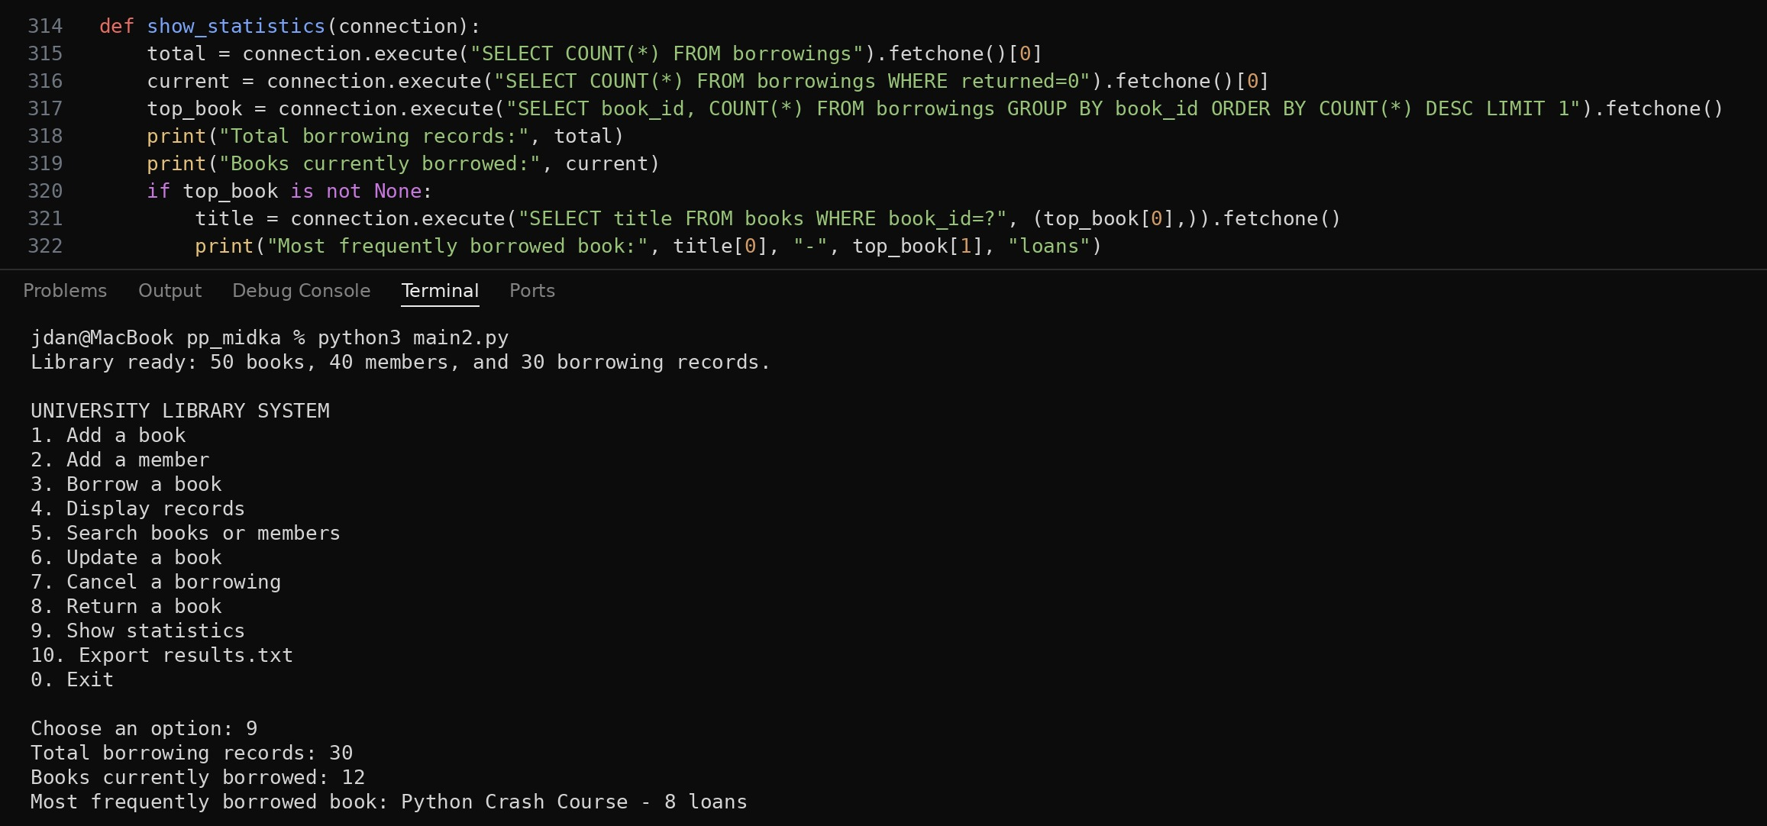
Figure 1. Code of show_statistics and a test run with the sample data.
The results match the sample data: the first 12 books have 8, 5, 4, 3, 2, 2 and 1 loans, 30 loans in total, and the last loan of each of these 12 books is not returned yet. Python Crash Course has the most loans, 8.

3.3 Test after a new borrowing
To check that the statistics change with the data, I borrowed book 21 (The Hobbit) for member 3 and chose option 9 again. Now the program shows 31 borrowing records and 13 books currently borrowed. Python Crash Course is still the most frequently borrowed book, because The Hobbit has only 1 loan.
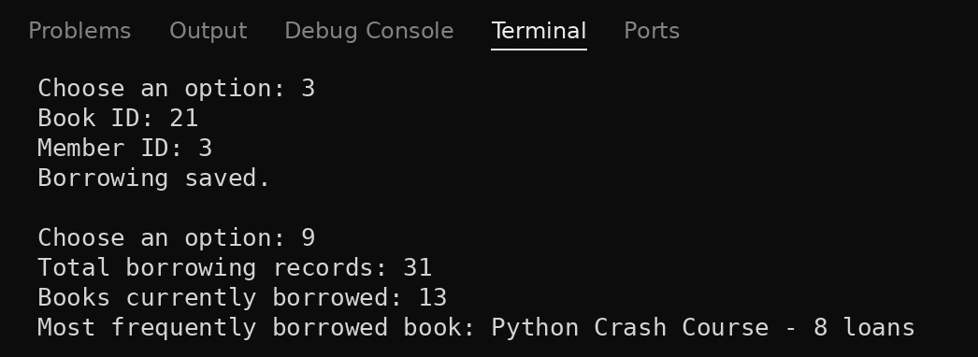
Figure 2. Statistics after a new borrowing: the two counts grew by one.

4. Task 4: Search for Information

4.1 Search a book by title (menu option 5, choice 1)
The function search_records shows two choices: 1 to search a book by title and 2 to search a member by name or ID. For a book it asks for a part of the title and runs SELECT ... FROM books WHERE title LIKE ?. The text is put between two % signs, so the book is found if its title contains the text anywhere. In SQLite LIKE does not depend on upper and lower case, so python and Python give the same result. The value is passed as a parameter (?), so the user input cannot break the SQL query.
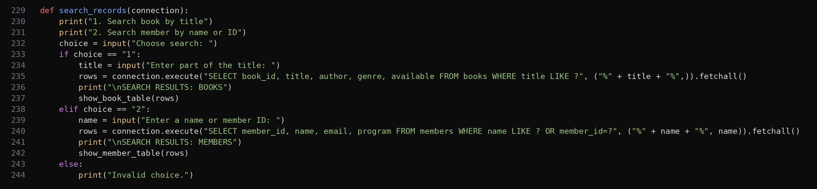
Figure 3. Code of search_records.
The found rows are printed by show_book_table. It makes a Book object for every row and calls its method show(), so the result is a clear table with the ID, title, author, genre and availability. If the list of rows is empty, the function prints "No books found." instead of the table. show_member_table works in the same way for members with the Member class.
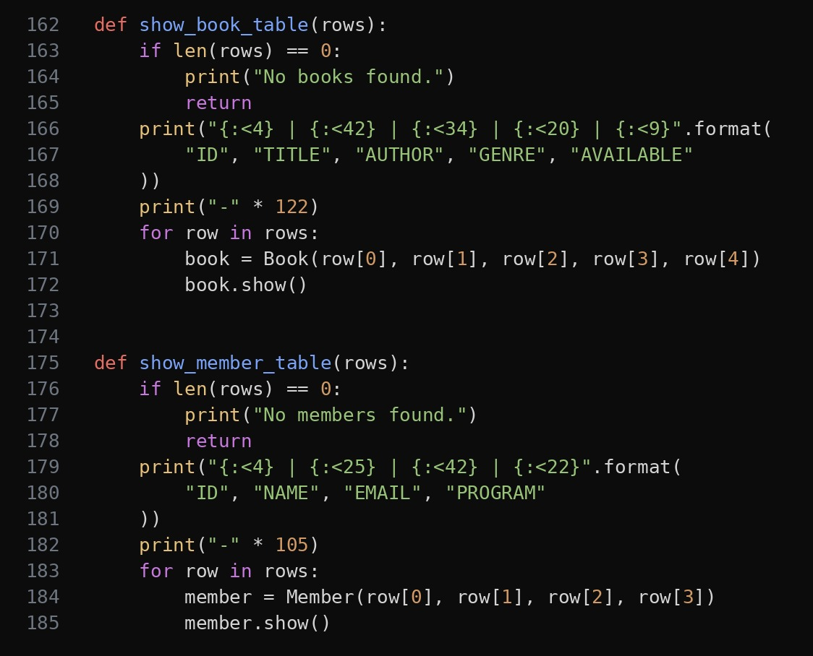
Figure 4. Code of show_book_table and show_member_table.
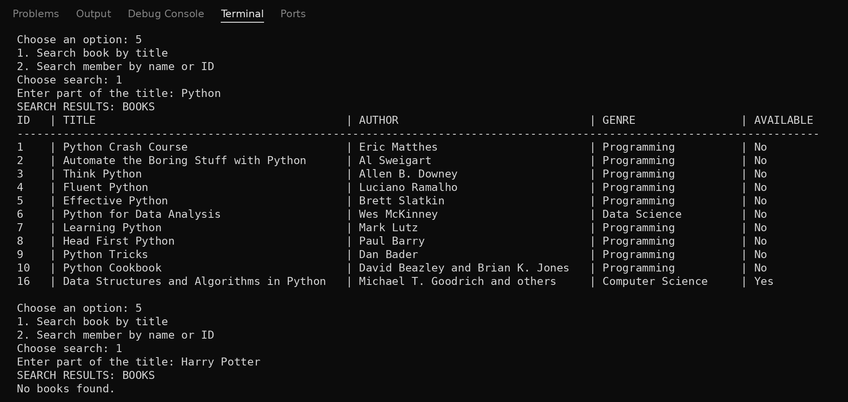
Figure 5. Search for books: "Python" finds 11 books, "Harry Potter" finds nothing.

4.2 Search a member by name or ID (menu option 5, choice 2)
For members the function runs SELECT ... FROM members WHERE name LIKE ? OR member_id=?. The first part finds members whose name contains the text, and the second part finds the member whose ID is equal to the text. So the user can type a name or an ID in the same field. For example, 7 finds only member 7 and not 17 or 27, because the ID must be equal, and the names do not contain digits.
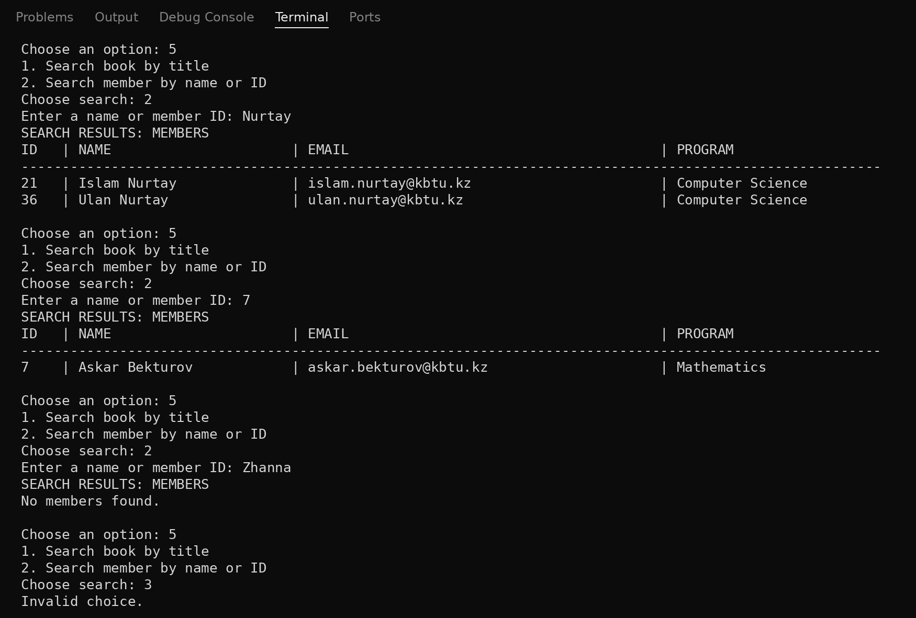
Figure 6. Search for members by name (Nurtay), by ID (7), with no result, and with a wrong choice.

4.3 Messages when nothing is found
Option | Situation | Message
Search book | No title contains the text | No books found.
Search member | No name contains the text and no ID is equal to it | No members found.
Search | The user chooses something other than 1 or 2 | Invalid choice.
Statistics | There are no borrowings yet | No error: the counts show 0 and the most borrowed book line is not printed

5. Conclusion
In this project I was responsible for Task 3 and Task 4. The function show_statistics calculates two results from the database: the number of books that are borrowed now and the most frequently borrowed book. The function search_records searches books by title and members by name or ID, and the functions show_book_table and show_member_table print the results as a table or show a clear message when nothing is found. All queries use parameters and always work with the current data. I tested every option in the running program and the results are shown in the screenshots above.

