1. My part of the project
Menu | Function | Lines in main.py | What it does
9 | show_statistics | 241-252 | Calculates the number of borrowed books and the most frequently borrowed book
5 | search_records | 175-204 | Searches books by title, or members by name or ID
6 | show_books (available_only=True) | 120-127 | Filters the list of books and shows only the available ones

2. Tables that my functions use
My functions only read data, they never change it. The statistics use the tables borrowings and books, and the search uses books and members. The table borrowings is connected to books and members by foreign keys.
Table | Fields
books | book_id, title, author, available (1 = on the shelf, 0 = borrowed)
members | member_id, name, email (unique)
borrowings | borrowing_id, book_id (foreign key), member_id (foreign key), returned (0 = still borrowed, 1 = returned)
All numbers and search results come from SQL queries on project.db at the moment the user chooses the menu option. Nothing is typed by hand or stored in Python lists, so the results are always up to date.

3. Task 3: Calculate Results and Statistics

3.1 Number of borrowed books
The function show_statistics (menu option 9) first counts all borrowing records with SELECT COUNT(*) FROM borrowings. Then it counts only the books that are still borrowed with SELECT COUNT(*) FROM borrowings WHERE returned=0. A borrowing with returned=0 means that the book is not back yet, so this number is the number of books that are borrowed right now.

3.2 Most frequently borrowed book
For the second calculation the function joins borrowings with books by book_id, groups the rows by book (GROUP BY books.book_id) and counts how many times each book was borrowed (COUNT(*) AS total). The result is sorted by total from the largest to the smallest, and LIMIT 1 keeps only the first row. If several books have the same number of loans, ORDER BY ... books.title chooses the first one in alphabetical order, so the answer is always the same. If there are no borrowings yet, fetchone() returns None and the line is not printed.
Statistic | SQL query | Result
Total borrowing records | SELECT COUNT(*) FROM borrowings | 30
Books currently borrowed | SELECT COUNT(*) FROM borrowings WHERE returned=0 | 20
Most borrowed book | JOIN books, GROUP BY book_id, ORDER BY total DESC, title, LIMIT 1 | A Long Journey 1 (1 time)
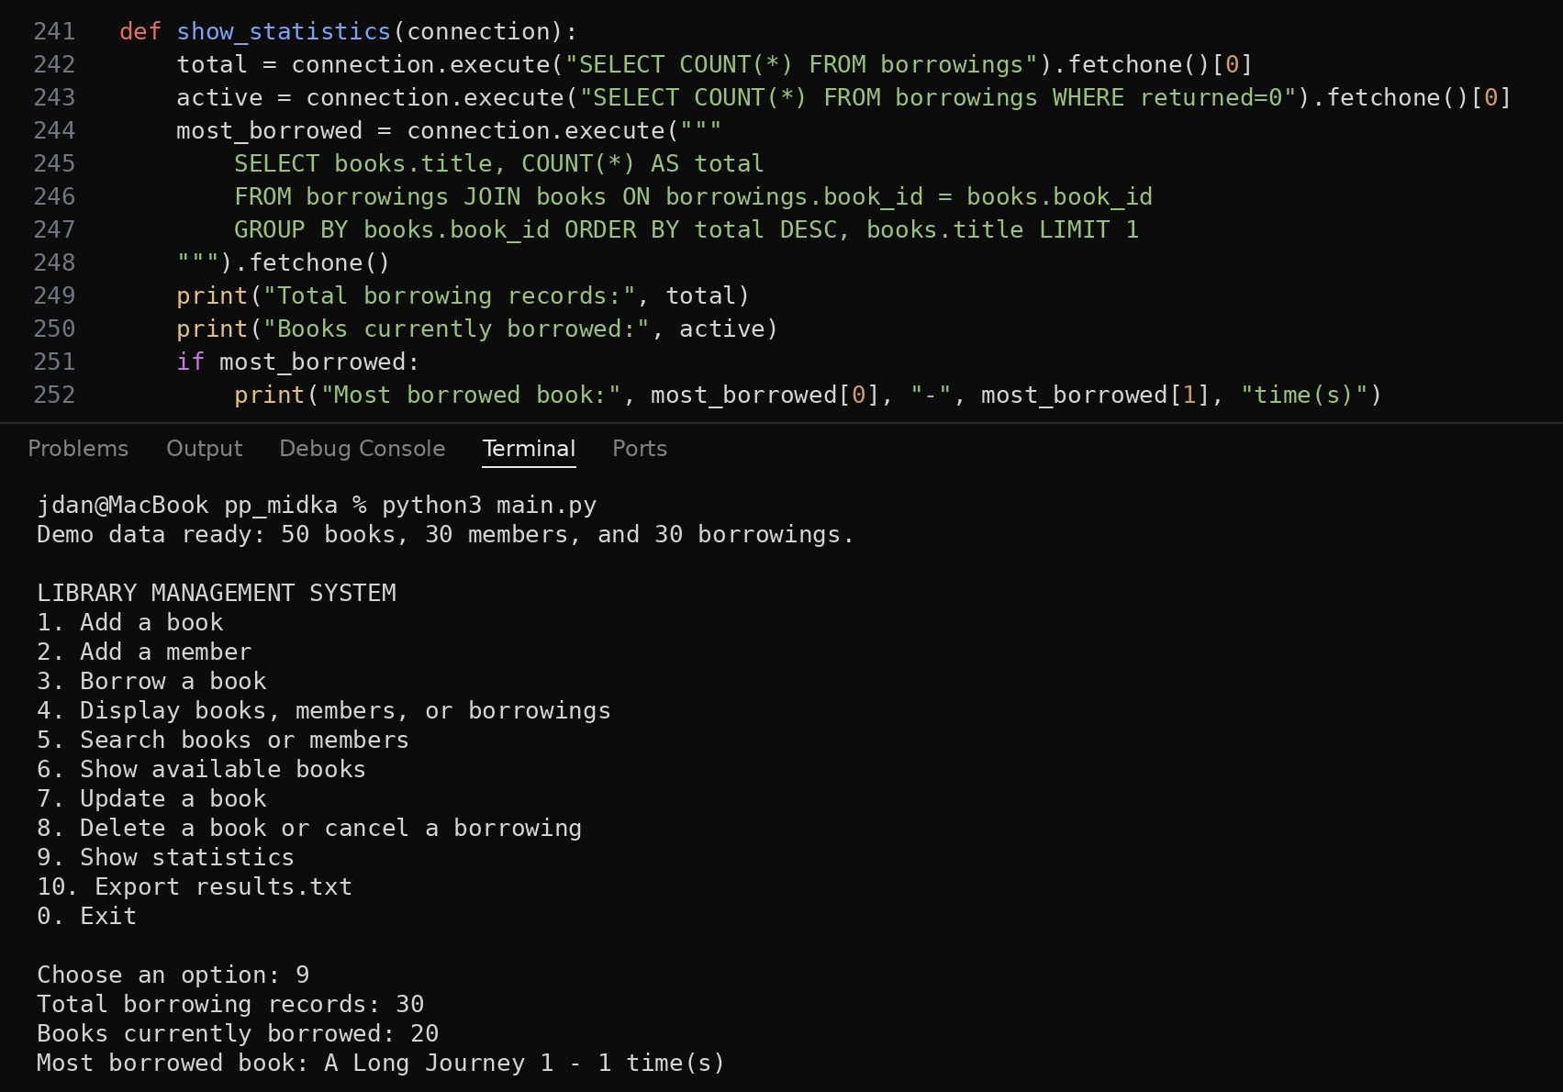
Figure 1. Code of show_statistics and a test run with the demo data.
In the demo data every book was borrowed at most once, because the borrowed books are chosen with random.sample. That is why all books have 1 loan and the program shows A Long Journey 1, which is first in alphabetical order.

3.3 Test after a new borrowing
To check that the statistics really change with the data, I borrowed book 31 (Python Basics 4) again for member 5. This book had already been borrowed once and returned. After that, option 9 shows 31 borrowing records, 21 books currently borrowed, and Python Basics 4 as the most borrowed book with 2 loans.
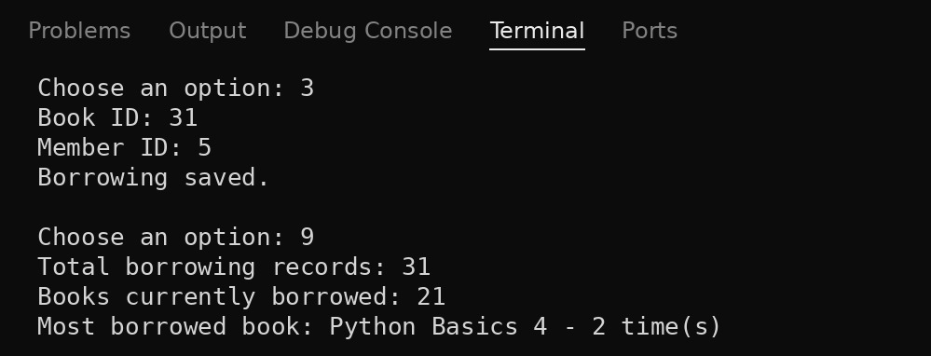
Figure 2. Statistics after a new borrowing: all three results changed.

4. Task 4: Search for Information

4.1 Search a book by title (menu option 5, b)
The function search_records first asks what to search: (b)ooks or (m)embers. For books it asks for a part of the title and runs SELECT ... FROM books WHERE title LIKE ? ORDER BY title. The text is put between two % signs, so the book is found if its title contains the text anywhere. In SQLite LIKE does not depend on upper and lower case, so python and Python give the same result. Every found row is printed through the Book class. The variable found stays False if no row was printed, and then the program prints "No books found.".
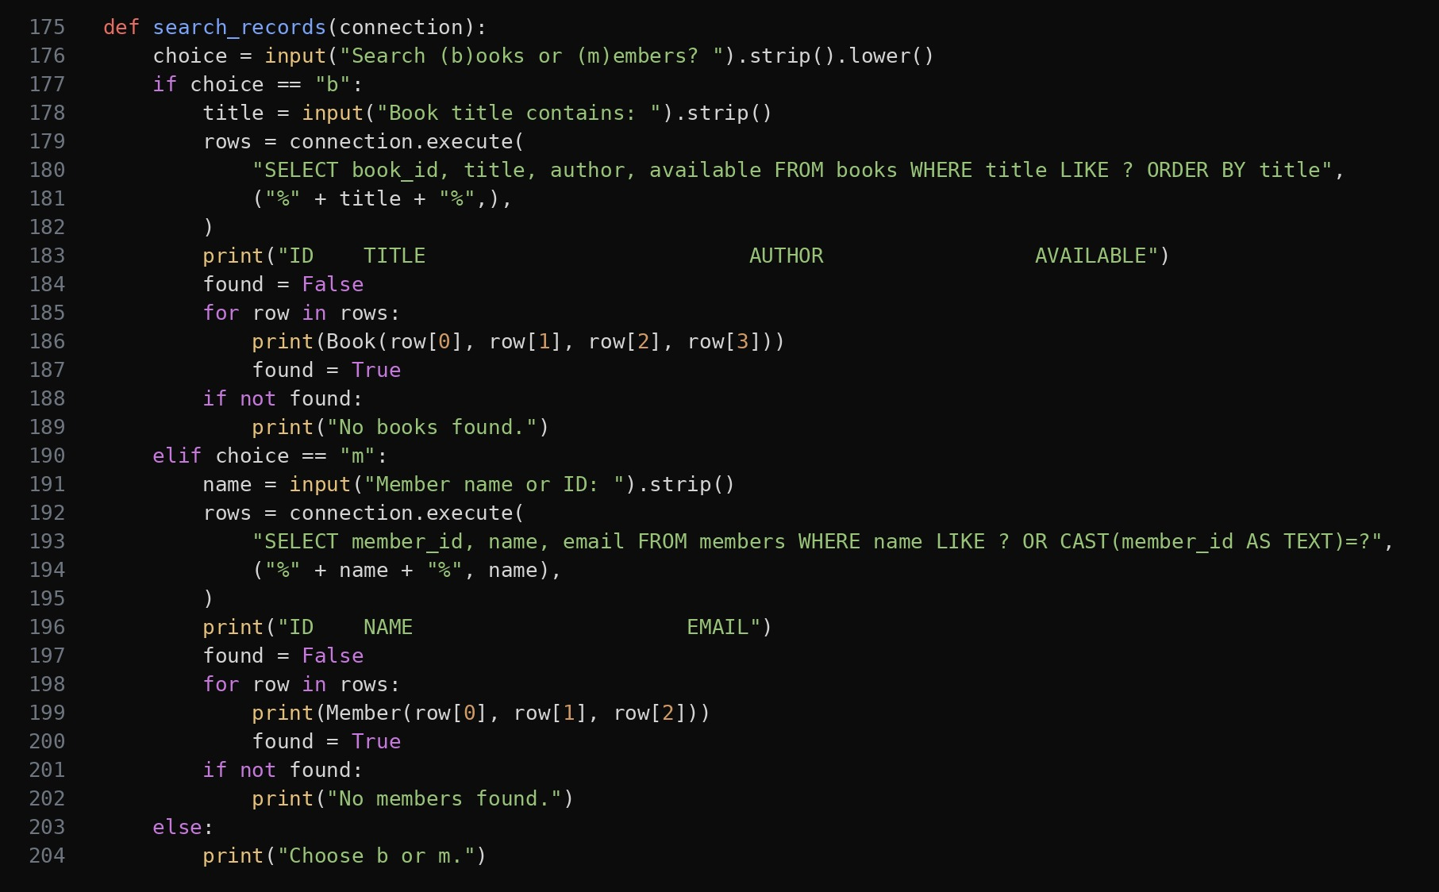
Figure 3. Code of search_records.
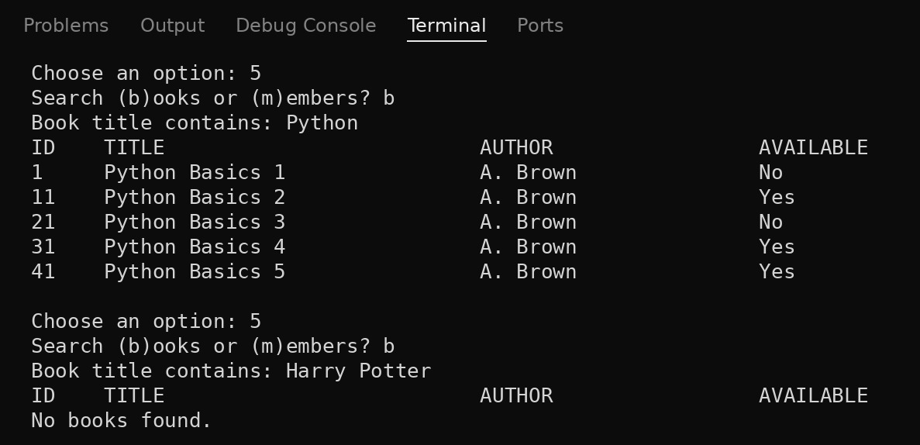
Figure 4. Search for books: "Python" finds 5 books, "Harry Potter" finds nothing.

4.2 Search a member by name or ID (menu option 5, m)
For members the same function runs SELECT ... FROM members WHERE name LIKE ? OR CAST(member_id AS TEXT)=?. The first part finds members whose name contains the text, and the second part finds the member whose ID is exactly the text. So the user can type either a name or an ID in the same field. For example, 7 finds only member 7 and not 17 or 27, because the ID must be equal, not just contain the digit. All values are passed as parameters (?), so the input cannot break the SQL query.
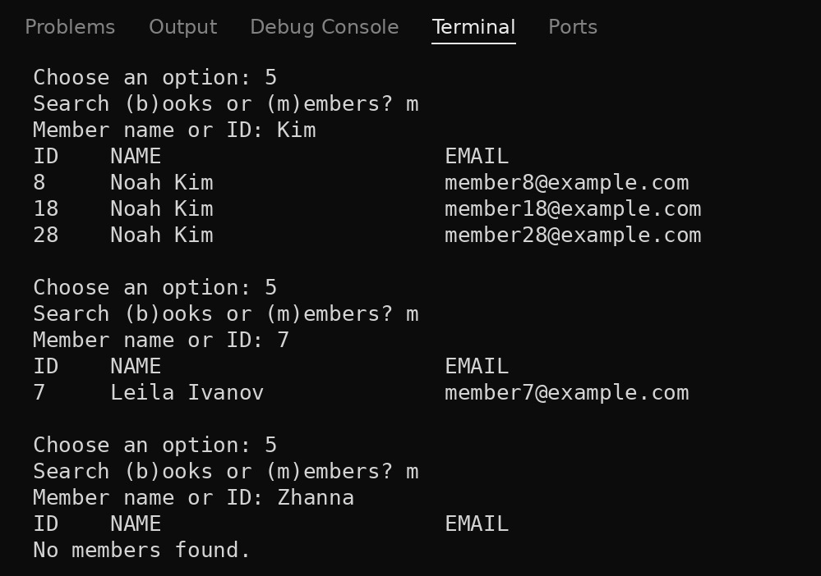
Figure 5. Search for members by name (Kim), by ID (7) and with no result.

4.3 Show available books (menu option 6)
This is a filtering option. The menu calls show_books with available_only=True, and the function adds the condition WHERE available=1 to the query. The result is sorted by title. With the demo data it shows 30 of the 50 books, because 20 books are currently borrowed, which matches the statistic in section 3.1.
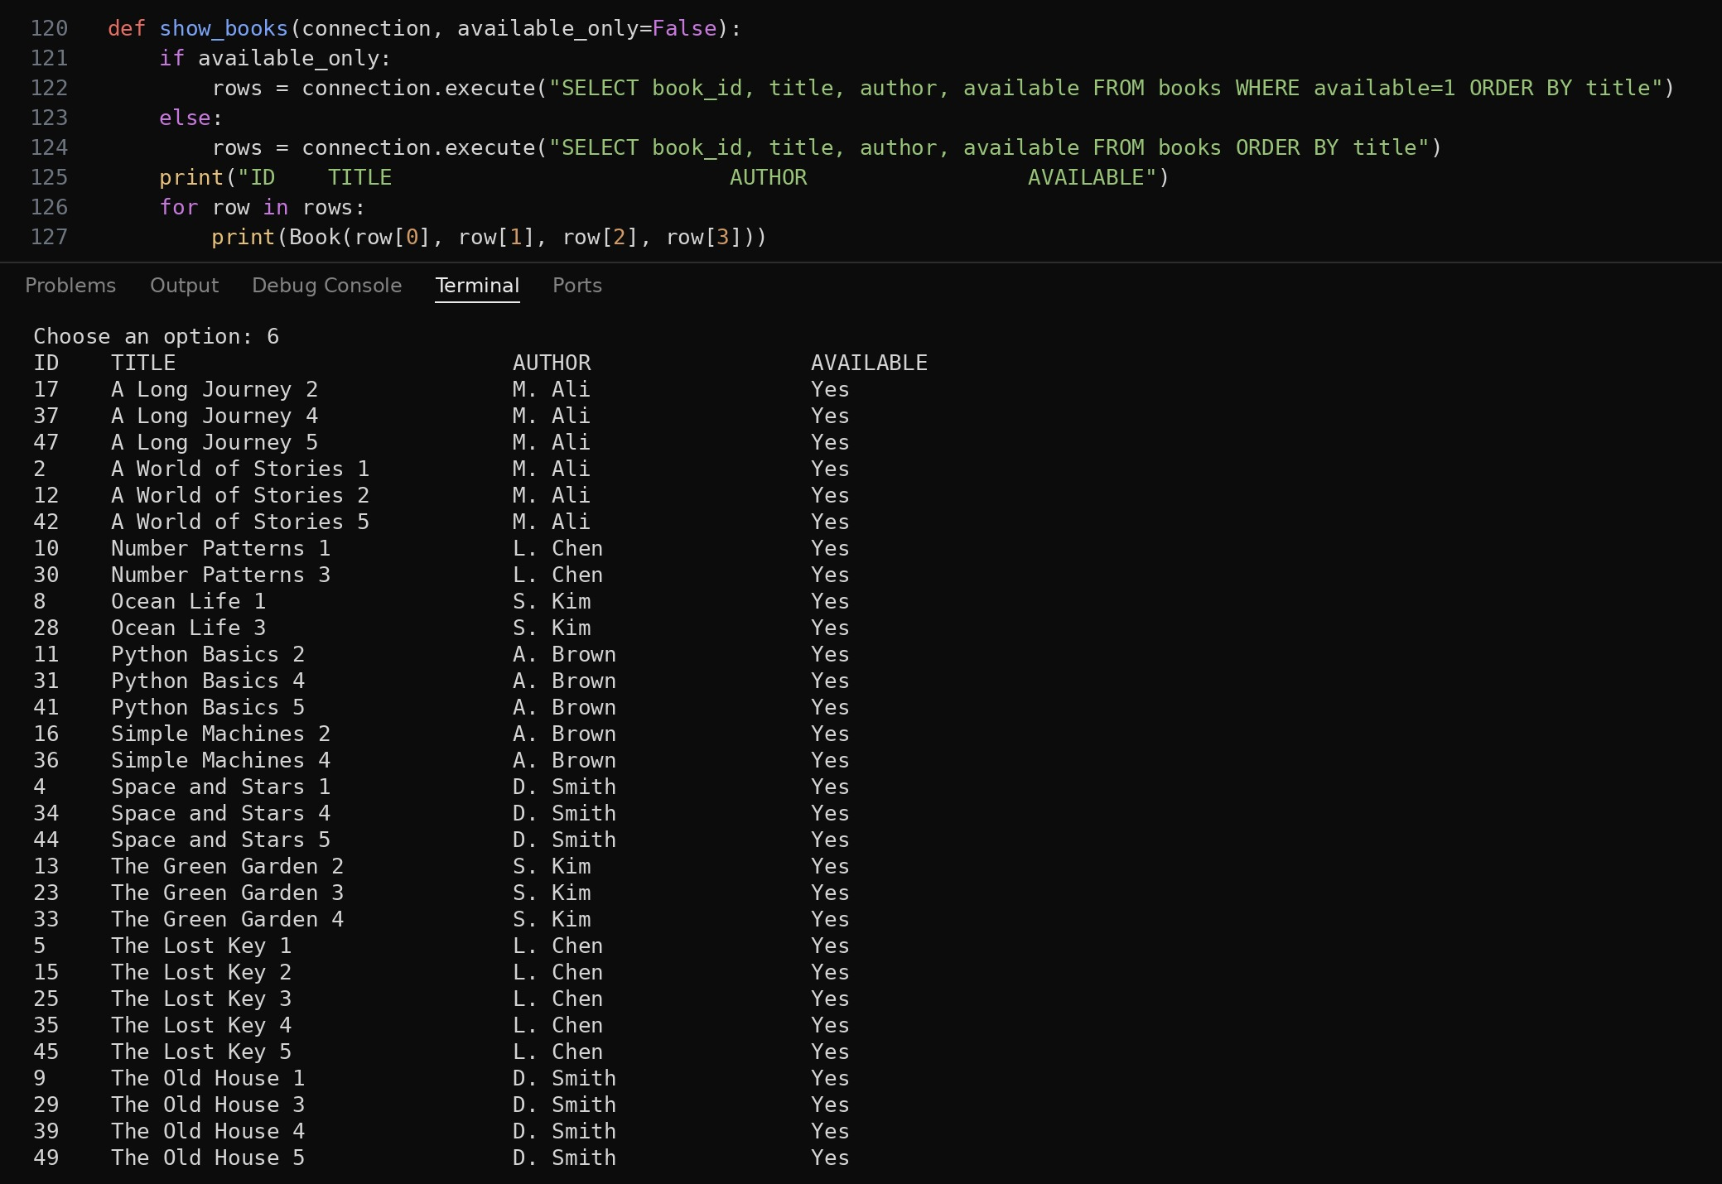
Figure 6. Code of show_books and the list of available books.

4.4 Messages when nothing is found
Option | Situation | Message
Search books | No title contains the text | No books found.
Search members | No name contains the text and no ID is equal to it | No members found.
Search | The user types something other than b or m | Choose b or m.
Statistics | There are no borrowings yet | No error: the counts show 0 and the most borrowed book line is not printed

5. Conclusion
In this project I was responsible for Task 3 and Task 4. The function show_statistics calculates two results from the database: the number of books that are borrowed now and the most frequently borrowed book. The function search_records searches books by title and members by name or ID, and the option Show available books filters the books. All of them use parameterized SQL queries, show a clear message when nothing is found, and always work with the current data. I tested every option in the running program and the results are shown in the screenshots above.

