**Part1**

1. After you complete Steps 1-1

a) Can h2 ping h3? Briefly explain why or why not. (5%)

Yes 因為h2跟h3在同一個子網路內，不須經過router就可以聯繫到對方

b) Can h2 ping h4? Briefly explain why or why not. (5%)

No 因為h2跟h4在不同子網路內，因此h2需要default gateway幫他但router的configure都還沒有做。

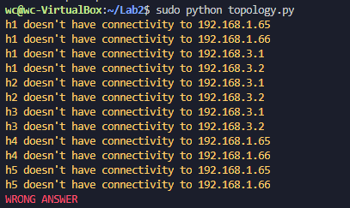

2. Take screenshot to show that your topology configuration is correct. (10%)

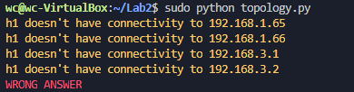

**Part2**

3.Capture DHCP messages and show the IPs and MACs (10%)

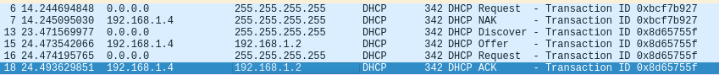

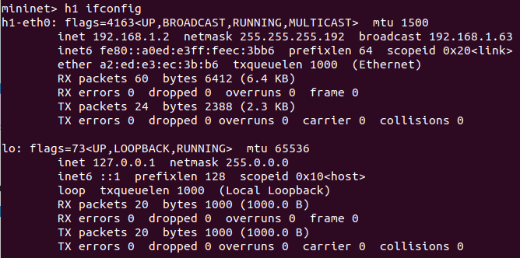

4. Can hosts other than h1 acquire IP addresses from DHCP server? Briefly explain your answer. (5%)

不行，因為DHCP的第一步Discovery是由client送出的broadcast封包，而這個封包只能在同一個subnet內傳遞，無法通過router到另一個subnet，而DHCP server只跟H1在同一個subnet，其他host都沒跟DHCP server在同一個subnet，因此拿不到IP。

**Part3**

5. What does r1 do on the packets from h1 to h5, and h5 to h1, respectively? Capture packets to explain your answers. (5%)

因為h1跟h5不在同一個subnet，所以h1會先將封包送到gateway，但h1沒有gateway的mac address所以h1會發arp broadcast去詢問gateway的mac address，等拿到gateway的mac address後就會送ICMP packet



6. Capture all ICMP messages received by h1 and explain why h1 can only derive only 1st, 2nd, and 5th hops details. (10%)

因為h1故意發送time to live比較短的UDP packet，以我測試的結果他總共從TTL為1到TTL為7個發送了三個TTL為8發送了一個，packet的TTL每經過一個router都會少1，當router收到TTL為0的packet時，他會回傳一個ICMP封包回去給Source，所以h1才可以收到1st, 2nd and 5th的detail。

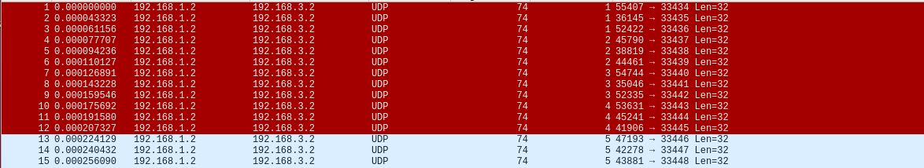

7. H1 uses some ICMP messages to derive 1st and 2nd hop details. What are the type(s) and sender(s) of the ICMP messages? (5%)

UDP with TTL=1, UDP with TTL=2 ICMP with time to live exceed

8. H1 uses some ICMP messages to derive 5th hop details. What are the type(s) and sender(s) of the ICMP messages? (5%)

UDP with TTL=5, ICMP with port unreachable