Part1

1. Take routing tables screenshot before/after on [r1-r4] (10%)

before

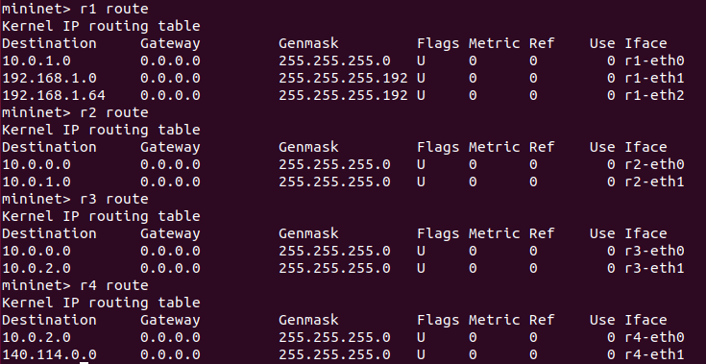

after

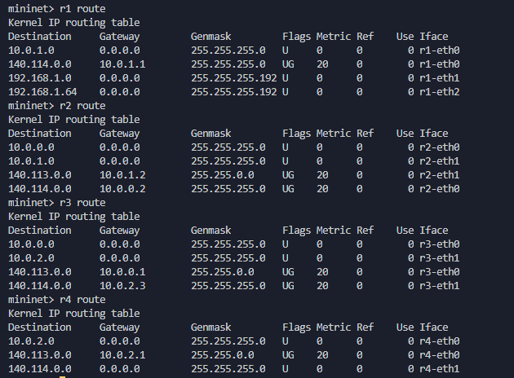

1. Telnet zebra and bgpd daemons of [r1-r4] and take screenshots of routes in zebra and bgpd daemons.

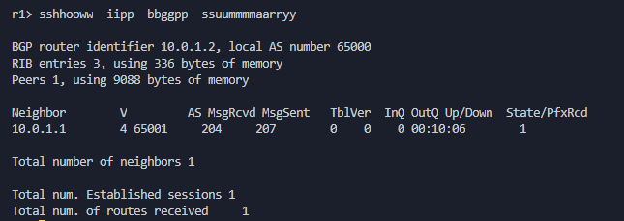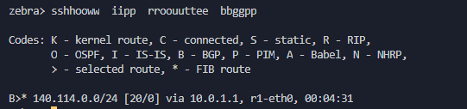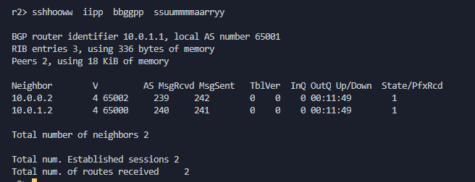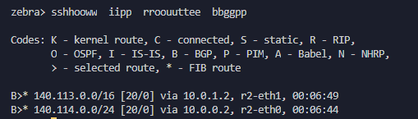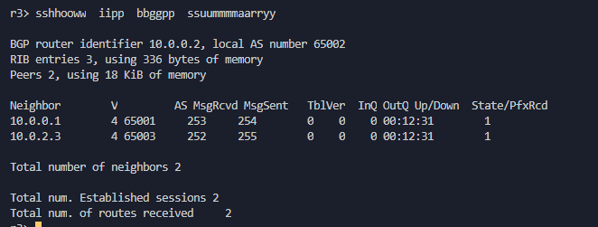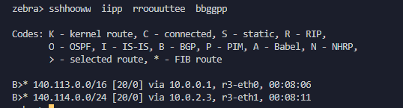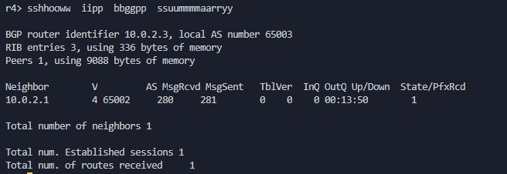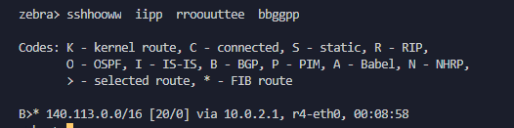

1. Capture BGP packets from wireshark and take screenshot to verify your answer for the following questions (20%)
2. Show BGP packets (OPEN, UPDATE, KEEP ALIVE) exchanged by r2 and r3

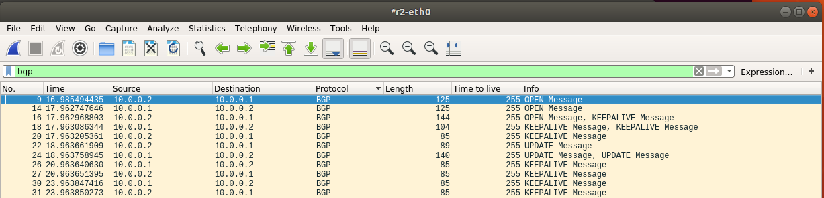

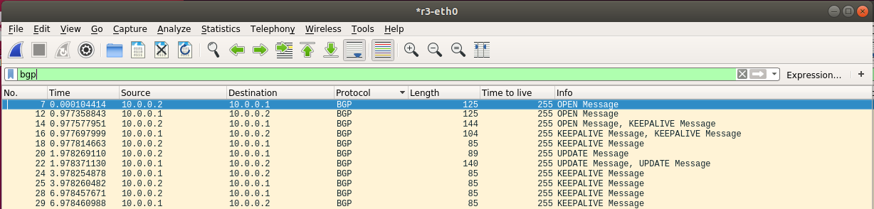

1. What will happen to the routing table if you set r4-eth0 down

關掉r4-eth0後r1, r2, r3會無法連接到140.114.0.0/24的網段和r4所以routing table會沒有他們的entry，而r4的routing table會只有140.114.0.0/24的網段。

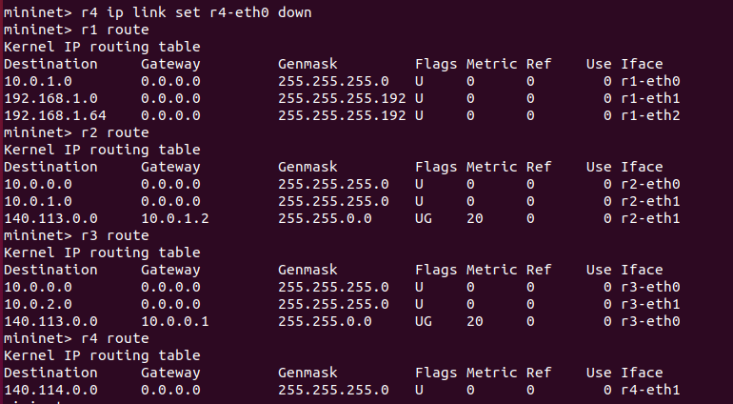

1. How does r3 know r4 is unreachable? Explain how

在r4關掉r4-eth後，r3會因為收不到r4的KEEPALIVE訊息，所以知道r4已經unreachable。

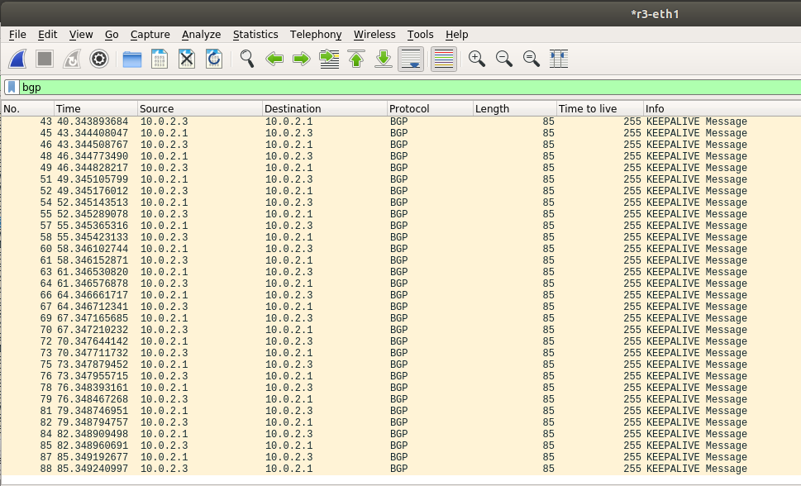

1. How does r2 know r4 is unreachable? Explain how

r3會傳BGP的UPDATE Message告訴r2，140.114.0.0/24已經unreachable。

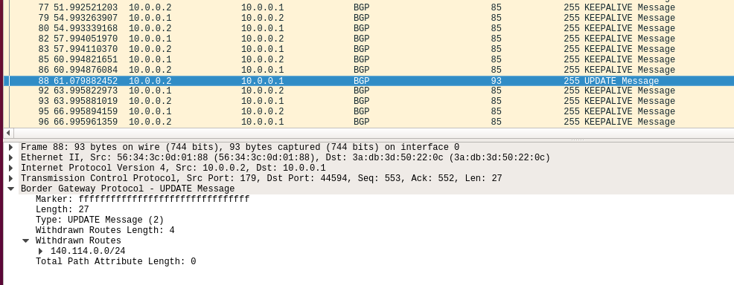

Part2

1. Take screenshot of curl result

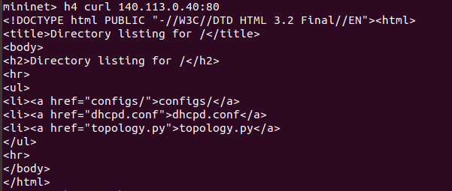

1. Check reachability and take screenshot

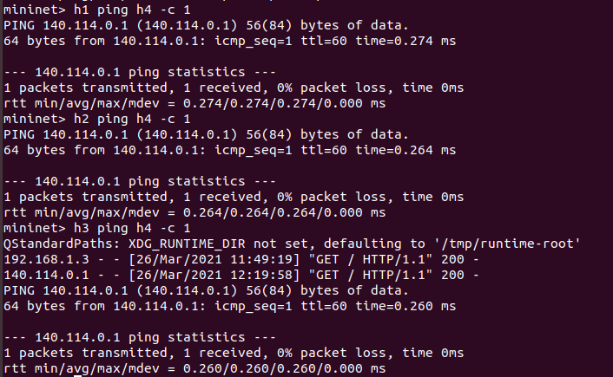

1. Run wireshark on r1 to take screenshot of input/output packet (10%)

從r1-eth0的前兩個packet是h1 ping h4的icmp packet，從r1-eth1進來的192.168.1.3因為source nat的關係，所以出去的時候變成140.113.0.30，從r1-eth0進來的要傳給140.113.0.30的packet因為destination nat的關係變成傳給192.168.1.3。

從r1-eth0的後兩個packet是h1 ping h4的icmp packet，從r1-eth2進來的192.168.1.65因為source nat的關係，所以出去的時候變成140.113.0.40，從r1-eth0進來的要傳給140.113.0.40的packet因為destination nat的關係變成傳給192.168.1.65。

