1. Show the ping results to test reachability (5%)

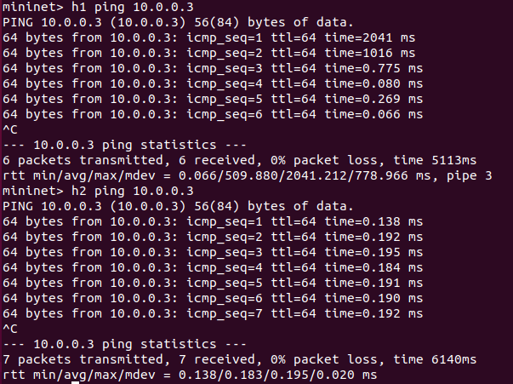

1. Show all interfaces of Node BRGr after h1 and h2 can ping GWr

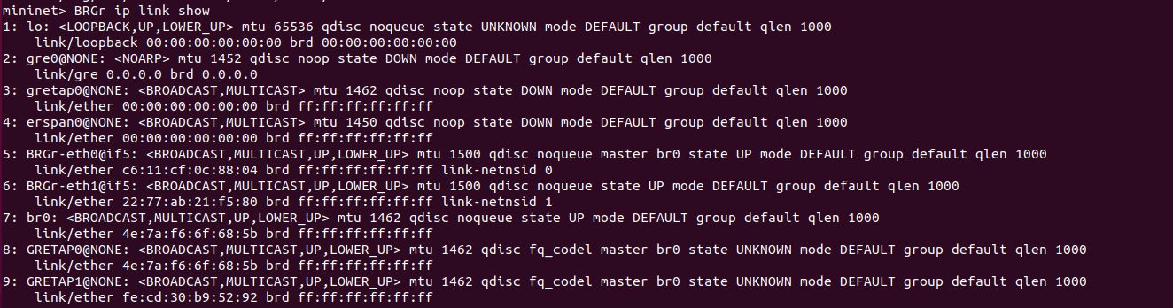

1. Draw the interconnection diagram of interfaces and Linux bridge on BRGr. Explain your diagram with the screenshot of interface list of BRGr

GRETAP0和GRETAP1是由程式自動產生的gretab interface，bridge就是br0，eth0和eth1就是router的兩個port。

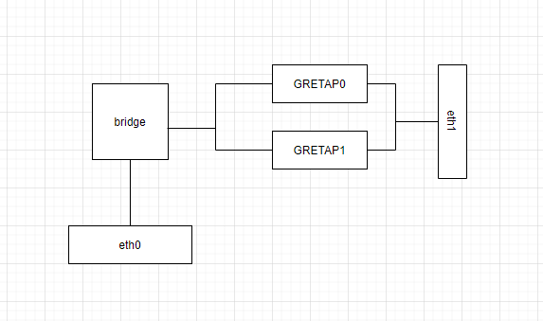

1. Explain how Linux kernel of BRGr determines which gretap interface to forward packets from GWr to hosts (h1 or h2)?

在BRGr不知道傳給哪一個GRE tunnel時他會發broadcast給全部的GRE neighbors，然後再看是收到哪一個neighbor的回覆再把它紀錄在fdb裡面。

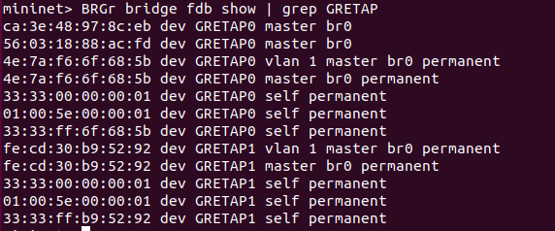

1. Run tcpdump on h1 to capture packet and take screenshot to explain why or why not h1 is aware of GRE tunneling

因為在packet經過tunnel時會自動把gre的header拿掉所以h1會沒有發現tunnel的存在。

