1 .Lab Manual: Developing a TCP Client-Server Application using Linux Socket Programming

Objective:
The objective of this lab is to gain hands-on experience in developing a basic client-server application using TCP sockets in a Linux environment. The lab focuses on establishing a TCP connection, sending a message from the client to the server, and displaying the received message on the server side.

Lab Requirements:
- Linux environment (either a physical machine or a virtual machine).
- Basic knowledge of C programming.

Lab Setup:
- Setting up the Environment:
  - Ensure that you have a Linux environment with a C compiler installed (e.g., gcc).
  - Open a terminal.
- Creating the Project Directory:
  - Create a new directory for your project.
bash
- mkdir tcp_message_lab
cd tcp_message_lab

Part 1: Server Side

Step 1: Writing the Server Code
- Create a file named server.c in the project directory.
c
- // server.c
#include <stdio.h>
#include <stdlib.h>
#include <unistd.h>
#include <string.h>
#include <arpa/inet.h>

#define PORT 8080
#define MAX_BUFFER_SIZE 1024

int main() {
int server_fd, new_socket, valread;
struct sockaddr_in address;
int addrlen = sizeof(address);
char buffer[MAX_BUFFER_SIZE] = {0};

// Create a socket
if ((server_fd = socket(AF_INET, SOCK_STREAM, 0)) == 0) {
perror("Socket creation failed");
exit(EXIT_FAILURE);
}

// Set up server address struct
address.sin_family = AF_INET;
address.sin_addr.s_addr = INADDR_ANY;
address.sin_port = htons(PORT);

// Bind the socket to the address
if (bind(server_fd, (struct sockaddr *)&address, sizeof(address)) < 0) {
perror("Bind failed");
exit(EXIT_FAILURE);
}

// Listen for incoming connections
if (listen(server_fd, 3) < 0) {
perror("Listen failed");
exit(EXIT_FAILURE);
}

// Accept incoming connection
if ((new_socket = accept(server_fd, (struct sockaddr *)&address, (socklen_t*)&addrlen)) < 0) {
perror("Accept failed");
exit(EXIT_FAILURE);
}

// Read data from the client using TCP
valread = read(new_socket, buffer, MAX_BUFFER_SIZE);
printf("Received message from client: %s\n", buffer);

// Close the connection
close(new_socket);
close(server_fd);

return 0;
}

Step 2: Compiling and Running the Server Code
- Compile the server code.
bash
- gcc server.c -o server
- Run the server.
bash
- ./server

Part 2: Client Side

Step 1: Writing the Client Code
- Create a file named client.c in the project directory.
c
- // client.c
#include <stdio.h>
#include <stdlib.h>
#include <unistd.h>
#include <string.h>
#include <arpa/inet.h>

#define PORT 8080
#define MAX_BUFFER_SIZE 1024

int main() {
int client_fd;
struct sockaddr_in server_address;
char message[MAX_BUFFER_SIZE];

// Create a socket
if ((client_fd = socket(AF_INET, SOCK_STREAM, 0)) == -1) {
perror("Socket creation failed");
exit(EXIT_FAILURE);
}

// Configure server address
server_address.sin_family = AF_INET;
server_address.sin_port = htons(PORT);
if (inet_pton(AF_INET, "127.0.0.1", &server_address.sin_addr) <= 0) {
perror("Invalid address/ Address not supported");
exit(EXIT_FAILURE);
}

// Connect to the server using TCP
if (connect(client_fd, (struct sockaddr *)&server_address, sizeof(server_address)) < 0) {
perror("Connection Failed");
exit(EXIT_FAILURE);
}

// Get user input for the message
printf("Enter a message to send to the server: ");
fgets(message, MAX_BUFFER_SIZE, stdin);

// Send the message to the server using TCP
send(client_fd, message, strlen(message), 0);

// Close the connection
close(client_fd);

return 0;
}

Step 2: Compiling and Running the Client Code
- Compile the client code.
bash
- gcc client.c -o client
- Run the client.
bash
- ./client
In both the server and client code, the SOCK_STREAM parameter in the socket function indicates the use of TCP. This sets up a reliable, connection-oriented communication channel between the client and the server. The subsequent read and send functions are used for reading from and writing to the TCP socket, respectively.
OUTPUT:
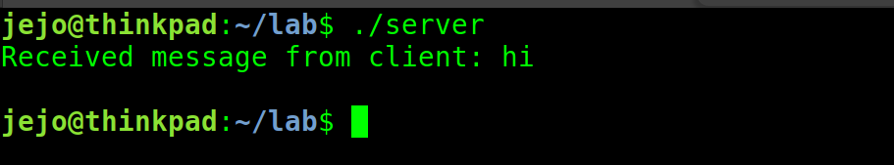
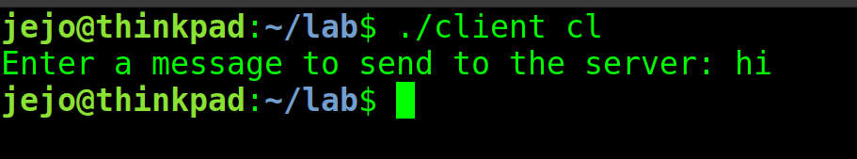
\\

2.Lab Manual: Developing a UDP Client-Server Application using UNIX Socket Programming

Objective:
The objective of this lab is to gain hands-on experience in developing a basic client-server application using UDP sockets in a UNIX environment. The lab focuses on creating a connection between a client and a server, where the client sends a message to the server, and the server displays the received message.

Lab Requirements:
- UNIX-like operating system (Linux or macOS).
- Basic knowledge of C programming.

Lab Setup:

1. Setting up the Environment:
- Ensure that you have a UNIX-like operating system.
- Open a terminal.

2. Creating the Project Directory:
bash
mkdir udp_message_lab
cd udp_message_lab

Part 1: Server Side

Step 1: Writing the Server Code
Create a file named udp_server.c in the project directory.
c
// udp_server.c
#include <stdio.h>
#include <stdlib.h>
#include <unistd.h>
#include <string.h>
#include <arpa/inet.h>
#define PORT 8080
#define MAX_BUFFER_SIZE 1024

int main() {
// Server code...
}

Step 2: Compiling and Running the Server Code
Compile the server code.
bash
gcc udp_server.c -o udp_server
Run the server.
bash
./udp_server

Part 2: Client Side

Step 1: Writing the Client Code
Create a file named udp_client.c in the project directory.
c
// udp_client.c
#include <stdio.h>
#include <stdlib.h>
#include <unistd.h>
#include <string.h>
#include <arpa/inet.h>
#define PORT 8080
#define MAX_BUFFER_SIZE 1024

int main() {
// Client code...
}

Step 2: Compiling and Running the Client Code
Compile the client code.
bash
gcc udp_client.c -o udp_client
Run the client.
bash
./udp_client

Lab Tasks:

1. Server-Client Communication:
- Modify the server and client code to establish a basic communication channel. For example, the client sends a message, and the server receives and prints it.

2. Enhancements:
- Enhance the server-client communication by exchanging more complex data structures or messages.
- Implement error handling to manage unexpected scenarios.

3. Security Considerations:
- Discuss and implement basic security measures (e.g., input validation) in the server and client code.

Explanation:
- Server Code Explanation:
  - The server code creates a UDP socket using socket() with SOCK_DGRAM.
  - The server binds the socket to a specific address using bind().
  - It then waits to receive data from the client using recvfrom().
- Client Code Explanation:
  - The client code creates a UDP socket using socket() with SOCK_DGRAM.
  - It sends data to the server using sendto().

Conclusion:
This lab provided hands-on experience in creating a simple client-server application using UDP sockets in a UNIX environment. Students are encouraged to explore and enhance the code further, implementing additional features and addressing potential security concerns.

Sample Output:
Run the server and client in separate terminals to observe the communication between them.
Sample output might look like this:
bash
Server: Waiting for client messages...
Client: Enter a message to send to the server: Hello, server!
Server: Received message from client: Hello, server!

Understanding UDP in the Code:

Server Side:
c
// Create a UDP socket
if ((server_fd = socket(AF_INET, SOCK_DGRAM, 0)) == -1) {
perror("Socket creation failed");
exit(EXIT_FAILURE);
}
In the server code, a UDP socket is created using the socket() function. The second argument, SOCK_DGRAM, specifies that this is a UDP socket.
c
// Receive data from the client using UDP
if (recvfrom(server_fd, buffer, MAX_BUFFER_SIZE, 0, (struct sockaddr*)&client_address, &client_address_len) == -1) {
perror("Receive failed");
exit(EXIT_FAILURE);
}
The recvfrom() function is used to receive data from the client. This function is specific to UDP and is used to receive a message from a specific address (in this case, the client's address).

Client Side:
c
// Create a UDP socket
if ((client_fd = socket(AF_INET, SOCK_DGRAM, 0)) == -1) {
perror("Socket creation failed");
exit(EXIT_FAILURE);
}
Similar to the server, the client code creates a UDP socket using the socket() function with SOCK_DGRAM as the second argument.
c
// Send the message to the server using UDP
if (sendto(client_fd, message, strlen(message), 0, (const struct sockaddr*)&server_address, sizeof(server_address)) == -1) {
perror("Send failed");
exit(EXIT_FAILURE);
}
The sendto() function is used to send the message to the server

4.Lab Manual: Analyzing TCP/UDP Performance with NetSim

Objective:
The objective of this lab is to use NetSim for simulating a network and analyzing the performance of TCP and UDP protocols. Participants will gain hands-on experience in creating network scenarios, observing traffic, and analyzing protocol behavior.

Lab Requirements:
- NetSim installed on a Linux system.
- Basic knowledge of networking concepts.

Lab Setup:

Task 0: Installation of NetSim
- Download NetSim:
  - Visit the NetSim download page and download the NetSim installer for Linux.
- Install NetSim:
  - Open a terminal in the directory where the installer is located.
  - Run the following commands:
bash
  - # Give execute permissions to the installer
chmod +x netsim_linux_installer.sh

# Run the installer
sudo ./netsim_linux_installer.sh
  - Follow the on-screen instructions to complete the installation.
- Activate License:
  - Activate your NetSim license using the provided activation key.

Lab Tasks:

Task 1: Create a Simple Network Topology
- Open NetSim:
  - Launch NetSim on your Linux system.
- Create a New Project:
  - Start a new project in NetSim.
- Add Devices:
  - Use NetSim's graphical interface to add devices such as routers, switches, and end devices to create a simple network topology.
- Connect Devices:
  - Connect the devices using appropriate links and configure basic IP addressing.
bash
- # Example command for device configuration
configure node <Node_ID> interface=<Interface_ID> ip=<IP_Address>

Task 2: Configure TCP/UDP Applications
- Add Applications:
  - Integrate TCP and UDP applications into your network devices using NetSim.
bash
# Example command for adding TCP application
add application <Node_ID> app=TCP/Telnet
bash
- # Example command for adding UDP application
add application <Node_ID> app=UDP/FTP
- Configure Parameters:
- Set parameters such as packet size, bandwidth, and delay for the TCP and UDP applications.
bash
- # Example command for configuring bandwidth
configure link <Link_ID> bandwidth=<Bandwidth_Value>

Task 3: Run Simulation
- Start Simulation:
  - Run the simulation in NetSim.
bash
- # Example command for starting the simulation
run
- Generate Traffic:
- Generate traffic by initiating communication between devices.
bash
- # Example command for generating traffic
start simulation traffic
- Observe Results:
  - Use NetSim's simulation results and logs to observe the performance of TCP and UDP applications.

Task 4: Analyze Protocol Behavior
- Packet Analysis:
  - Analyze packet traces and logs generated by NetSim to understand how TCP and UDP protocols behave in the simulated environment.
bash
- # Example command for analyzing packets
show packet trace
- Performance Metrics:
- Examine key performance metrics such as throughput, latency, and packet loss for both TCP and UDP.
bash
- # Example command for displaying performance metrics
show simulation metrics

Task 5: Experiment with Network Conditions
- Modify Parameters:
  - Experiment with different network conditions by modifying parameters such as bandwidth, delay, and congestion.
bash
- # Example command for modifying bandwidth
configure link <Link_ID> bandwidth=<New_Bandwidth_Value>
- Observe Impact:
  - Observe how changes in network conditions affect the performance of TCP and UDP applications.

Conclusion:
This lab provided hands-on experience in using NetSim to simulate a network, analyze the performance of TCP and UDP protocols, and experiment with different network conditions. Participants gained insights into how these protocols behave under various scenarios.

Notes:
- NetSim offers a wide range of features for detailed network simulations; explore the documentation for additional functionalities.
- Experiment with more complex network topologies and scenarios to deepen your understanding of network simulation.

Sample Output:
- Sample outputs might include simulation logs, graphs, and performance metrics provided by NetSim.

6.Lab Manual: Introduction to Network Tools - ping, traceroute, and netcat

Objective:
The objective of this lab is to introduce and demonstrate the usage of common network tools: ping, traceroute, and netcat. Participants will gain hands-on experience in testing network connectivity, tracing the path of packets, and establishing simple network connections.

Lab Requirements:
- A Linux-based system (Ubuntu, CentOS, etc.) for both client and server.

Lab Setup:
- Ensure Required Tools:
  - Make sure that the required network tools (ping, traceroute, and netcat) are installed on your Linux system. If not, install them using your system's package manager (apt, yum, etc.).
bash
- # For Ubuntu/Debian
sudo apt-get install iputils-ping traceroute netcat

# For CentOS
sudo yum install iputils traceroute nmap-ncat
- Prepare Server and Client:
  - Choose two Linux systems, one as a server and the other as a client. Ensure they are connected on the same network.

Lab Tasks:

Task 1: Ping (PCP)
- On the Client:
  - Open a terminal on the client.
- Ping the Server:
  - Use the ping command to test connectivity to the server.
bash
- ping <server_ip>
  - Observe the round-trip time and packet loss.

Task 2: Traceroute
- On the Client:
  - Open a terminal on the client.
- Traceroute to the Server:
  - Use the traceroute command to trace the path of packets to the server.
bash
- traceroute <server_ip>
  - Analyze the output to understand the route taken by packets to reach the server.

EXECUTION:
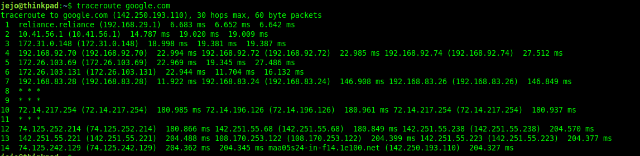

Task 3: Netcat (NC)
- On the Server:
  - Open a terminal on the server.
- Start a Netcat Server:
  - Use netcat to listen on a specific port (e.g., 8080).
bash
- nc -l -p 8080
- EXECUTION:

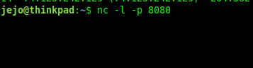

- On the Client:
- Open a terminal on the client.
- Establish a Connection:
- Use netcat to connect to the server's IP and port.
bash
- nc <server_ip> 8080
  - Type a message on the client. The message should appear on the server terminal.

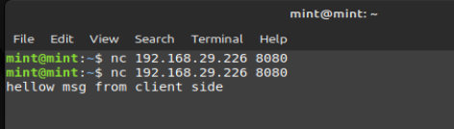
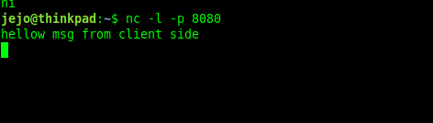

Server side:

Conclusion:
This lab introduced basic network tools (ping, traceroute, and netcat) and demonstrated their usage. Participants learned how to test network connectivity, trace the path of packets, and establish simple network connections using these tools.

Notes:
- ping is used for testing basic network connectivity.
- traceroute helps trace the route taken by packets to reach a destination.
- netcat is a versatile tool for network connections, here used to demonstrate a simple client-server connection.

Sample Output:
- Sample outputs might include ping statistics, traceroute path information, and successful netcat connection messages.

7.Lab Manual: Introduction to Packet Analysis with Wireshark

Objective:
The objective of this lab is to introduce participants to the basics of packet analysis using Wireshark. Participants will learn how to capture packets, inspect various protocols, and analyze network traffic.

Lab Requirements:
- A Linux system with Wireshark installed.
- Basic knowledge of networking concepts.

Lab Setup:
- Install Wireshark:
  - Install Wireshark on your Linux system using the package manager.
bash
- # For Ubuntu/Debian
sudo apt-get install wireshark

# For CentOS
sudo yum install wireshark
- Prepare Network Environment:
  - Ensure that your Linux system is connected to a network.

Lab Tasks:

Task 1: Capture Packets
- Open Wireshark:
  - Open Wireshark from the application menu or using the terminal.
bash
- wireshark
- Select Network Interface:
  - In Wireshark, select the network interface to capture packets.
- Start Packet Capture:
  - Click on the "Start" button to begin capturing packets.
- Generate Network Traffic:
  - Generate some network traffic by browsing a website, sending ping requests, or accessing other network resources.
- Stop Capture:
  - Click on the "Stop" button to end the packet capture.

Task 2: Inspect Captured Packets
- Analyze Packets:
  - In the Wireshark interface, inspect the captured packets.
- Filtering Packets:
  - Use display filters to focus on specific types of packets (e.g., HTTP, TCP, ICMP).
bash
- # Example: Display only HTTP traffic
http

Task 3: Protocol Analysis
- Explore Protocols:
  - Select a packet in the Wireshark interface and explore the details of various protocols such as Ethernet, IP, TCP, UDP, ICMP, etc.
- Follow TCP Stream:
  - Right-click on a TCP packet and select "Follow" > "TCP Stream" to view the entire TCP stream.

Task 4: Export and Save
- Export Packets:
  - Save specific packets or the entire capture to a file for further analysis.
- Save as a PCAP File:
  - Save the entire capture as a PCAP file.

Task 5: Additional Analysis
- Statistics:
  - Explore the "Statistics" menu to analyze packet statistics, conversations, and more.
- IO Graphs:
  - Use the "Statistics" > "IO Graphs" feature to visualize network activity.

Conclusion:
This lab provided an introduction to packet analysis using Wireshark. Participants learned how to capture packets, inspect protocols, and analyze network traffic. Wireshark is a powerful tool for troubleshooting and understanding network behavior.

Notes:
- Wireshark is a versatile tool; explore various features to deepen your understanding.
- The lab focused on basic packet analysis; Wireshark can be used for more advanced tasks, including security analysis.

Sample Output:
- Sample outputs might include packet details, protocol analysis screenshots, and exported PCAP files.

Additional Resources:
- Wireshark User Guide
- Wireshark Tutorial for Beginners

5,3,-pending sums...

