# 1. Introduction

This is the introduction of the text. In fact, this is a random test of some stuff to do with a test bibliography what I just made (Collins and Jones, 2009). This is a further test with two references (Hooten and Hobbs, 2014; Martin, 2011). As Herborn et al. (2014) pointed out, tits are pretty cool. This is a great big long block of text with a hard return after *this*. Some further text, after which I will attempt a page break.

# 2. Methods

General methods text close to heaader.

## 2.1. Methods subsection 1

Here is some more methods text with a code block.

summary(cars)

## speed dist   
## Min. : 4.0 Min. : 2.00   
## 1st Qu.:12.0 1st Qu.: 26.00   
## Median :15.0 Median : 36.00   
## Mean :15.4 Mean : 42.98   
## 3rd Qu.:19.0 3rd Qu.: 56.00   
## Max. :25.0 Max. :120.00

Here is the same table but run through tableCat():

|  |  |
| --- | --- |
| speed | dist |
| 4 | 2 |
| 4 | 10 |
| 7 | 4 |
| 7 | 22 |
| 8 | 16 |

And here is the same table (Table 1) again, but now with a caption and label:

|  |  |
| --- | --- |
| speed | dist |
| 4 | 2 |
| 4 | 10 |
| 7 | 4 |
| 7 | 22 |
| 8 | 16 |

### 2.1.2. Header level 3

You can also embed plots, for example:

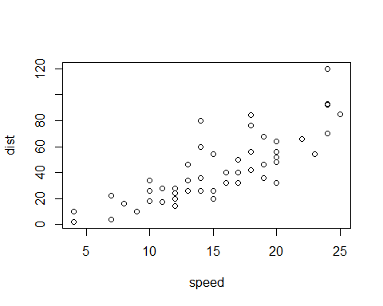

This is a test figure.

Note that the echo = FALSE parameter was added to the code chunk to prevent printing of the R code that generated the plot.

#### Header level 4

This is a sub-sub-sub section

## References

Collins, J., Jones, G., 2009. Differences in bat activity in relation to bat detector height: Implications for bat surveys at proposed windfarm sites. Acta Chiropterologica 11, 343–350. doi:[10.3161/150811009X485576](http://dx.doi.org/10.3161/150811009X485576)

Herborn, K.A., Heidinger, B.J., Alexander, L., Arnold, K.E., 2014. Personality predicts behavioral flexibility in a fluctuating, natural environment. Behavioral Ecology 25, 1374–1379. doi:[10.1093/beheco/aru131](http://dx.doi.org/10.1093/beheco/aru131)

Hooten, M.B., Hobbs, N.T., 2014. A guide to bayesian model selection for ecologists. Ecological Monographs. doi:[10.1890/14-0661.1](http://dx.doi.org/10.1890/14-0661.1)

Martin, G.R., 2011. Understanding bird collisions with man-made objects: A sensory ecology approach. Ibis 153, 239–254. doi:[10.1111/j.1474-919X.2011.01117.x](http://dx.doi.org/10.1111/j.1474-919X.2011.01117.x)