## Warning: package 'pander' was built under R version 3.1.2

## Warning: package 'knitr' was built under R version 3.1.2

# Limited evidence for cumulative effects of small wind turbines on bat activity on a landscape scale

*Jeroen Minderman, Mairi Gillis, Helen Daly & Kirsty Park*

# 1. Introduction

In this paper we aim to quantify and analyse the potential cumulative effect of SWTs on bat activity on a wider landscape scale (up to 500m from installed turbines). Specifically, using data collected at **X sites** throughout the UK we test the following predictions: (1) Bat activity is systematically lower in closer proximity (e.g. 0-100m from SWTs compared to 100-200m, 200-300m, etc) of operating SWTs, controlling for the effects of habitat and environmental conditions. (2) The effect of SWT proximity on bat activity as tested in Prediction 1 is stronger in sites with multiple (2-4) SWTs installed compared to single SWT sites. Support for this prediction would indicate evidence of cumulative effects of SWTs.

# 2. Methods

General methods text.

## Bat data

Transects; length, orientation. Time of data collection. Details of detectors.

## Habitat data

Briefly, quantification of all variables. Refer to appendix for details of "initial" habitat data model selection.

## Statistics

You can also embed plots, for example:

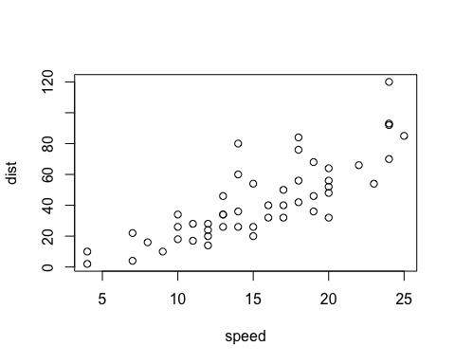

This is a test figure.

Note that the echo = FALSE parameter was added to the code chunk to prevent printing of the R code that generated the plot.

## References