# 1. Introduction

This is the introduction of the text. In fact, this is a random test of some stuff to do with a test bibliography what I just made **???**. This is a further test with two references **????**. As Herborn et al. **???** pointed out, tits are pretty cool. This is a great big long block of text with a hard return after **this**. Some further text, after which I will attempt a page break. Here is a further part-sentence in which I will test the insertion of a different type of reference **???** =10.1006/gcen.2001.7749. This is the next sentence.

# 2. Methods

General methods text close to heaader.

## 2.1. Methods subsection 1

Here is some more methods text with a code block.

summary(cars)

## speed dist   
## Min. : 4.0 Min. : 2.00   
## 1st Qu.:12.0 1st Qu.: 26.00   
## Median :15.0 Median : 36.00   
## Mean :15.4 Mean : 42.98   
## 3rd Qu.:19.0 3rd Qu.: 56.00   
## Max. :25.0 Max. :120.00

Here is the same table but run through tableCat():

|  |  |
| --- | --- |
| speed | dist |
| 4 | 2 |
| 4 | 10 |
| 7 | 4 |
| 7 | 22 |
| 8 | 16 |

And here is the same table (Table 1) again, but now with a caption and label:

Table 1. This is the actual table caption

|  |  |
| --- | --- |
| speed | dist |
| 4 | 2 |
| 4 | 10 |
| 7 | 4 |
| 7 | 22 |
| 8 | 16 |

Here is a further attempt with the same table but using kable():

test

|  |  |
| --- | --- |
| speed | dist |
| 4 | 2 |
| 4 | 10 |
| 7 | 4 |
| 7 | 22 |
| 8 | 16 |

### 2.1.2. Header level 3

You can also embed plots, for example:

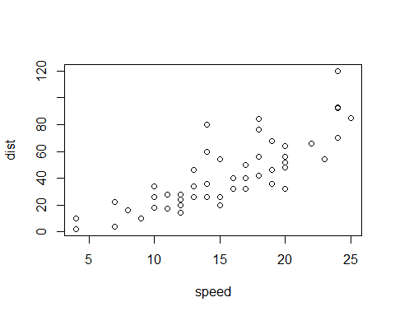

This is a test figure.

Note that the echo = FALSE parameter was added to the code chunk to prevent printing of the R code that generated the plot.

## References