Models as games: a novel approach for ‘gamesourcing’ parameter data and communicating complex models

# Summary

# Introduction

In recent years, the use and application of models has become widespread and indispensable in conservation science, ranging from demonstrating the likely effects of climate change (IPCC 2021) to supporting the understanding of fundamental processes in natural resource management (e.g. Fryxell et al. 2010; Cusack et al. 2020). Given the continued rapid global loss of biodiversity (Ceballos et al. 2015; Ceballos, Ehrlich, and Dirzo 2017), understanding the mechanisms and consequences of such loss is vital. Although a number of drivers of biodiversity loss have been identified (e.g. Maxwell et al. 2016), one of the most prevalent and widespread ones is human exploitation of habitats and natural resources, both directly (e.g. through hunting or habitat loss to agriculture) or indirectly (e.g. through international trade in natural resources) (e.g. Wilting et al. 2017). Because resource use is fundamentally driven by economic and social processes, it has long been recognised that accurate predictions thereof is reliant as much on understanding resource dynamics as it is on understanding human behaviour and decision-making (Milner-Gulland 2012; Schlüter et al. 2012). Thus, the development of socio-ecological models in which natural resource dynamics and human decision making interact is becoming increasingly urgent.

Cutting-edge modelling approaches have made significant progress towards this goal. For example, Orach, Duit, and Schlüter (2020) used an agent-based model to show how coalitions of interest groups can stabilise natural resource dynamics, whereas Cusack et al. (2020) used a novel agent-based modelling framework (Duthie et al. 2018) to assess the effect of lobbying on species extinction risk. Although such modelling efforts represent significant progress in modelling complex socio-ecological systems, their increased complexity poses to two, interlinked, challenges. First, models are often difficult to communicate clearly to non-specialist audiences in the first place, and this challenge increases with model complexity (Grimm et al. 2006). This is particularly important for models for resource use in socio-ecological systems, as they are often specifically intended for use by managers or stakeholders who may lack technical expertise. Much has been said about improving the uptake of models in such settings (e.g. Addison et al. 2013; Schuwirth et al. 2019; Will et al. 2021), and detailed documentation of the purpose, organisation and predictions has been highlighted as particularly important (Grimm et al. 2020). Even so, often the evidence for practical uptake of many models is limited (Addison et al. 2013; Zasada et al. 2017). Second, their complexity implies the need for extensive data to parameterise them effectively. In terms of socio-ecological systems, while data to parameterise the ecological component are often relatively easily available, the human decision-making components are often based on limited theory and lack a general empirical basis (Groeneveld et al. 2017). Not only may this lead to limited predictive power, a perceived lack of empirical basis may negatively affect their acceptance by stakeholders (cf. model “quality” as in Kolkman et al. 2016). To maximise the adoption of complex socio-ecological models as management tools, both appropriate representation of human decision-making and effective communication are therefore key.

Games have a long history of being in research (Sandbrook, Adams, and Monteferri 2015; Chabris 2017; Redpath et al. 2018), including as tools to aid the communication of complex ideas and processes to non-specialists (Garcia, Dray, and Waeber 2016; Tan et al. 2018; Fjaellingsdal and Kloeckner 2019). Given this long history, it is striking that the parallels between games (particularly videogames) and models are not discussed more widely. All models are abstract representations of environments, actors and relationships, with inputs (parameters) and outputs (predictions or inferences). Similarly, all games present a player with an environment in a given state (parameters), including one or more actors, which can take actions (inputs) to affect the environment for a given effect (outputs). It is worth stressing that every game has an underlying model that defines the state of the environment, relationships between objects in this environment, and inputs and outputs available to the player. However, while games are by definition designed with player (user) interaction in mind, models rarely have user-facing or even user-friendly interfaces, and running or adapting them to specific circumstances usually relies on technical expertise. Casting models as games provides an opportunity to effectively improve the communication and understandability of even relatively complex models. Inputs and outputs may be presented in a visual way and tweaked depending on the type of audience, and both potential applications and limitations of the model can be demonstrated effectively.

In addition, presenting a model as a game provides an opportunity to empirically collect data on how stakeholders make decisions in the modelled environment. Games have already been widely used for data collection to answer specific questions (e.g. Meinzen-Dick et al. 2016; Villamor and Badmos 2016; S. Rakotonarivo et al. 2021; O. S. Rakotonarivo et al. 2021) on what affects decision-making in socio-ecological systems. A less well-explored potential of using this approach is using in-game decisions directly as a “big data” source to improve the parameterisation of the underlying model itself. Many existing models represent human decision-making by relatively crude algorithms (e.g. fully rational utility maximisation) despite widespread recognition that this does not reflect real-world decision-making (Groeneveld et al. 2017). By presenting real-world stakeholders with in-game decisions that would otherwise be taken by a predefined algorithm, large data sets of actions and outcomes may be collected. Given a large enough sample of players and in-game conditions, such data might then be used to train decision-making algorithms that better reflect human decision-making in natural resource management[1]. It is notable that this “gamesourcing” or “Gamorithm” (Sipper and Moore 2020) approach has already been widely used in a number of other fields (e.g. crowdsourcing accurate protein-structure models (Khatib et al. 2011), and classification of fluorescence microscopy images (Sullivan et al. 2018)), but remains rare in conservation science (but see van den Bergh et al. 2021). Thus, model-games can be considered “virtual laboratories” (Duthie et al. 2021) to not only test specific hypotheses or predictions, but potentially also as an effective method to source data to parameterise the underlying models, based on in-game decisions by real humans.

We here aim to illustrate the potential for this model-game approach, both in terms of aiding model communication as well data collection for improved parameterisation, by introducing Animal&Farm (A&F). We developed A&F as a simple interactive game front-end for a complex socio-ecological modelling framework (GMSE), in which the player acts as the manager of a virtual environment in which a population of wild grazing animals (the natural resource) may adversely affect farming yield, with farmers acting to maximise their yield and potentially hunting the animals. We argue that that by acting as an interface between users (i.e. players) and a complex underlying model with many components and assumptions, such a game can simultaneously (1) aid the communication and useability of the underlying model and (2) can be used to gather data to improve the parameterisation of such models. We first briefly summarise the underlying modelling framework, its potential and limitations. Second, we describe both the structure of A&F itself as well as its database back-end. Third, we outline how this approach may be used to collect data on player decision-making in simulated *in silico* experiments, and present some example results of doing so; noting that these findings are intended as illustrative only. Finally, using test player feedback as a basis, we discuss both the limitations of this approach as well as its wider potential.

# Outline of approach

[A&F is available to play online](https://ochil-ds.co.uk/animalnfarm/).

Overall, it consists of two main components; (1) the underlying model(s) describing the wild grazing animal (“resource”) population dynamics, the observation of this population, and farmer (“user” or stakeholder) actions, all implemented using the GMSE framework as described below; and (2) the game interface for the underlying model, which allows the player to set management actions (specifically, costs for user actions) that would otherwise be determined by the management model in the “vanilla” GMSE set up.

## Underlying model: GMSE

### Basic introduction of GMSE principles and structures

### Brief discussion of limitations of GMSE

## Animal&Farm

### Structure as relating to GMSE

In the default implementation of GMSE 0.6.2.0, a single time step consists of a series of calls to the resource model, observation model, management model and user model, in that specific order; in other words, a time step ends after user actions have been chosen (by the GA) and implemented [**FIG Xa**]. To allow players to assess the environment and interactively choose management actions, A&F uses a modified version of GMSE.

A&F uses a development version of GMSE (v. 0.6.2.0, implemented in R version 4.1.0 (2021-05-18), code available [here](https://github.com/ConFooBio/gmse/tree/man_control) in which the management model is replaced by user (player) inputs, and the order of operations is altered to accommodate this. To initialise each game session, four time steps are run using the default GMSE implementation; i.e. in these time steps the management decisions are chosen by the default GA, and the resource, observation and user models are run using the parameters as defined for the given the scenario (**see below**). These time steps are followed by a “partial” time step where only the resource and observation models are run, skipping the management and user models. As a result, at the end of these initial time steps ([init_man_control()](./%5B%60https://github.com/ConFooBio/gmse/blob/0e8aab2fb325421915a7c3615820812e45f42a74/R/gmse_apply_control.R" \l "L368`%5D(https://github.com/ConFooBio/gmse/blob/0e8aab2fb325421915a7c3615820812e45f42a74/R/gmse_apply_control.R%23L368))), the simulated system has five population and observation time steps and is ready for the next choice of management action at , pending the first player input. This is done both to set up all the required GMSE data structures using existing code, as well as to provide the player with a short time series on which to base management decisions going forward.

The current GMSE simulations used by A&F simulates a landscape of 100x100 cells, divided into farms owned by 4-12 farmers (stakeholders; the precise number and land distribution is randomly varied per session, see **section XXX** below). Farmers can take three possible actions; tending crops, hunting (culling) animals, or scaring animals off their land. All submodels used in A&F are currently the default GMSE models (with the exception of the management model in time steps , where the player assumes control over the management decisions (see below). Thus, we only give brief details here, for full details and descriptions of all models, see **XXX** and **XXX**. The **animal population** model uses the logistic growth form with , and , meaning that in the absence of any management the population is likely to increase from the initial population size (1000) to carrying capacity (5000). The **observation model** uses the default GMSE model (density-based sampling of a subset of the environment); only *observed* numbers of animals are available to the manager to base decisions on (and thus population trajectory plots in the game interface reflect observations only, which are subject to an unknown level of uncertainty). Both the **management model** (in the initialisation steps) and **user model** use the GA algorithms with default parameter settings. User (farmer) budgets are set to 1500 units per time step, manager budgets to 1000 units (both for the initial 5 time steps and the subsequent game play). The users (farmers) aim to maximise yield from their land, their annual budget is reset each year and is unaffected by yield. Yield is positively affected by tending crops, and may be negatively affected by the presence of grazing wild animals - thus hunting or scaring may offset any potentially negative effects on yield. Note that the choice of models and parameter values here serve as an example only; it is expected that future implementations and development of A&F will focus on specific research questions / case studies, and will adjust models and parameter settings accordingly (**see XXX below**).

Each following A&F time step then consists of (1) user input, taking the place of the default management model, in which the player can assess the environment using outputs provided (see below) and choose management actions (costs for user actions), and, (2) and once the player confirms their choice, a modified GMSE time step including sequential calls to the default user, resource and observation models ([gmse_apply_UROM()](https://github.com/ConFooBio/gmse/blob/0e8aab2fb325421915a7c3615820812e45f42a74/R/gmse_apply_control.R" \l "L146)) [**FIG Xb**].

### User interface

The user interface for A&F is a web application is coded in R, using [Shiny](https://CRAN.R-project.org/package=shiny) (1.6.0), and packages [shinyjs](https://CRAN.R-project.org/package=shinyjs) (2.0.0), [shinyBS](https://CRAN.R-project.org/package=shinyBS) (0.61), and [waiter](https://CRAN.R-project.org/package=waiter) (0.2.2).

On starting a new game session, the player is presented with a series of introductory screens explaining the background, flow and objective of the game , after which they are asked to enter a player name, which is stored and used to show player scores as the end of a session, compared to previous sessions by other players.

The main game screen consists of four components (**FIG X**). First, a trajectory plot (**Fig Xa**) showing (1) observed animal population numbers and (2) agricultural yield for each farmer in each time step, up to time (at the start of the game this will show five observations from the initialisation steps described above). Agricultural yield is expressed as a % of “maximum unaffected yield,” i.e. yield in the absence of damage from wildlife or investment in tending crops. Second, a plot of the landscape (**Fig Xb**) showing the distribution of farm ownership as well as the position of animals at time . Third, a bar plot of the number of actions taken by each farmer at time (**Fig Xc**). Fourth, a report of the current management budget available (not allocated), player scores (**see below**), and player inputs (**Fig Xd**). The player (manager) inputs consist of two sliders, setting the cost for two out of the three actions available[2] to farmers in time : killing animals (presented as the cost of a hunting licence) and scaring animals off their land (presented as the cost of a scaring licence). Management budget allocated to one of these cannot be allocated to another, and any budget not allocated is not rolled over to the next time step. The third action available to farmers (tending crops) cannot be directly[3] affected by the manager (player), so no input is available for this .

The game progresses to the next time step once the player confirms their choice of cost inputs. At this point (1) the user, resource and observation models are run using the updated action costs set by the player, (2) selected environment state data are stored in the database (**see below**), and (3) trajectory, landscape and action plots are updated and budget allocation is reset. The current implementation of A&F continues for a maximum of 20 time steps (following the initial five) at which point the game session is ended and the player is presented with a scoreboard. If the resource population reaches extinction, the game session is also terminated.

### Game objective, scores and scoreboard

Other than preventing extinction of the animal population, A&F does not have a particular game objective; instead, the player is asked to make management decisions reflecting their preference of animal population and agricultural yield trajectory. The player is, however, presented with two scores which allows them to assess their performance relative to their own previous game sessions as well as those of other players.

The scores are arbitrarily defined to reflect performance in terms of the animal population (“animal score,” ) on the one hand, and overall agricultural yield (“yield score,” ) on the other. Both scores can be interpreted as the mean % of the initial (i.e. at time ) true size of the animal population and landscape yield , with calculated as the mean yield over all landscape cells at time .

and where and the total number of time steps for the game session. Both scores are intitialised as when the game is first initialised, to ensure score development over a session can be interpreted as a change from that baseline.

Players can choose to either balance both scores, or score highly on one or the other. They are updated and displayed on each time step, and the final scores are displayed on a score board after the final time step (, so after 20 time steps played) is complete, or once the animal population goes extinct. The scoreboard is a top 10 “leaderboard” of scores over all sessions played by all players to date; if the current player’s score is not included in the top 10, it is displayed at the bottom of the board with the correct rank relative to other players.

### Data collection & database

Game play data (e.g. session variables, player inputs, environment state variables) are stored in a MySQL relational database. Database structure is summarised in **Fig X** and a full list of parameter values stored and their description is listed in **Table X**. The current version of A&F stores only a subset of GMSE parameters (**Table X**); this may be easily extended in the future by adding additional fields to the relevant database table and ensuring the database interface functions append the extra parameters. For any GMSE parameters that are not stored currently, the default GMSE parameter values are used.

In summary, six main tables are used to store data (see **XXX** for a full description). Tables are linked by the unique session ID present in each table.

* run
* Holding player name, start- and end times for the session and a flag for whether or not the animal population reached extinction or not (single record per session).
* run_par
* Holding all game parameters for the GMSE simulation for a session. As per section **XXX**, in the example application presented here, the majority of these will be constants, with only ownership_var and remove_pr varying per session.
* scores
* Holding the number of time steps achieved per session and the animal and yield score.
* gdata
* A record per time step for each session, recording the true and observed population state, the number of actions of each type taken, and the costs set by the manager (player), as well as the total yield in the environment.
* yield
* The yield achieved by each farmer in each time step, per session.

Records in tables run, run_par and scores are only updated at the start and end of each session, whereas gdata and yield are the “live” tables that are appended to at each time step during a game session. End times are recorded for each session where the player either reaches , manually resets the game during a session, or as the animal population reaches extinction; i.e. when this field remains blank (NULL), it means that a session was not terminated “normally,” i.e. by the browser being closed manually or timing out due to inactivity.

# Example application

### “Sandbox” for *in silico* experiments

The combination between the underlying modelling framework, game interface and the database back-end, provides a platform to collect data on player interaction with the models in a range of simulated environments. This might include *in silico* tests of the effect of specific variability in the environment on simulation animal population extinction, or collecting “big data” on player decision-making given a set of (more or less) variable parameters in terms of population, observation or user (farmer) models. For example, a user of the platform may be interested in testing how human decision-making varies depending on the extent of observed variation in either the ecological (e.g. more or less uncertainty in animal population trajectories) or social (e.g. higher or lower variability in land ownership or sizes of farmer budgets) parts of the modelled system. Data from such experiments may then be combined with debriefing interviews with players to further investigate what may drive such decision-making (e.g. S. Rakotonarivo et al. 2021). Alternatively, by collating large amounts of decision-making data under varying parameter settings as well as the outcome of each game session (e.g. animal population extinction and/or trajectories), it may be possible to develop algorithms that can make decisions that are most likely to lead to a desired outcome (e.g. minimising extinction probability while maintaining agricultural yield, or maximising one or the other score). While the genetic algorithm for manager decision-making currently implemented in GMSE is effective, it does not currently balance multiple objectives, nor does it necessarily accurately reflect variability in real-life decision-making processes. Parameterising an alternative algorithm directly based on empirical decision-making data has the potential to address these shortcomings.

### Example scenario & method

#### Rationale & methods

We here illustrate one aspect of this potential by collecting decision-making data from a small sample of test players, during a short period. We chose to focus on a scenario that systematically varies one focal parameter, farmer land ownership distribution. While inequity in land ownership is commonplace and of interest to conservation strategies (**REF**), the current manager decision-making algorithm implemented in GMSE cannot explicitly take the extent of such variation in account. Thus, collecting empirical data on how decisions and resultant population trajectories may be affected by variable land distribution is important.

On starting a new session, the player is presented with one of three possible scenarios: equal land ownership, moderate variability, or high variability (ownership_var = 0, 0.25 or 0.5, respectively, resulting landscape patterns illustrated in **Fig X**). In addition to this variability, each session also has a small amount of random population mortality (), sampled from a uniform distribution. Although the landscape ownership distribution is clearly shown to the player throughout the game (**see XX above**), the player is not told explicitly that ownership will vary before a session starts, or what the extent of this variability will be. This was done to ensure that a player would not selectively abort sessions. Other than this scenario-based parameter variation, game play progresses as described above, with the player able to make management decisions (setting costs for farmer actions) over 20 time steps following the initial five.

We circulated a link to the game with scenarios configured as above to a sample of XXX collegues working in conservation science and practical conservation and management, covering a range of academic institutions, research institutes, NGO’s and government. The main aim was to (1) obtain feedback on the model-game set up, and (2) collect example data to illustrate the potential of the approach, with specific emphasis on how communication of it may be improved in the future. An accompanying covering letter explained this aim, the background to the work, and a request to respond with any feedback. Note that the data collected here should not be interpreted as comprehensive research on a specific question, and is intended as illustrative only.

#### Ethics

The work described here was approved by the University of Stirling’s General University Ethics Panel (GUEP), project no. **X**. While the game link is publicly accessible, it was not publicised beyond the direct contacts described above. On accessing the link, players are presented with a series of introductory screens explaining the background and purpose of the game, followed by a digital constent form, which has to be agreed to by ticking a confirmation tick box, before a new session can be started. No personally identifiable data are collected or stored, other than a player name - the latter is only requested so that scores can be shown in context and compared to other players; however this can be left as a default placeholder, and players explicitly told that this is not expected to be their real name.

### Illustrative results

Between 21 July 2021 and 19 August 2021, we collated data on 76 play session by 28 unique players. Sessions lasted minutes on average 4.5 minutes (0.2 - 179.4 minutes). As per the scenario set up, these sessions were roughly equally distributed between land ownership variability (0, 0.25 or 0.5, N = 21 [28%], 32 [42%], and 23 [30%], respectively) and number of stakeholders (4-12).

The animal population reached extinction in 23 out of the 76 sessions (30.3%). Extinction probability appeared to be higher at both higher levels of land ownership variability ( and ), particularly so at intermediate () levels (**Figure Xa**). Differences in extinction probability with variability in farmer (stakeholder) number was less pronounced (**Figure Xb**).

These extinction probabilities were reflected in the animal population trajectories in each parameter scenario. **Figure X** show trajectories per level of landownership variability, with cases where the population reached extinction highlighted in red. Both higher levels of variablility ( and ) show fewer cases with rapid increasing trends.

Management actions taken by the players (over time, ) are summarised in Figure X. It is notable that when land ownership variability was higher (), chosen costs for hunting licences appeared to be more stable (i.e. less variable), particularly toward the end of playing sessions (Figures Xc vs. Xa-b). It should be noted that this may in part be an artifact of somewhat lower sample size at higher time steps (because in some sessions the population would have gone extinct part way through a session). On average, hunting licence costs also appeared to be set lower overall at higher land ownership variability. By comparison, costs set for scaring licences appeared to more stable over time (Figures Xd-f).

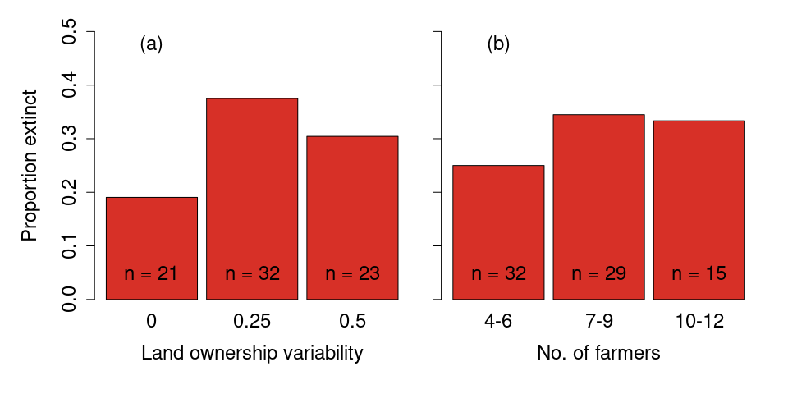

Figure X. Proportion of game sessions where animal population reached extinction, as a function of (a) land ownership variability and (b) the number of farmers (stakeholders) in the game session.

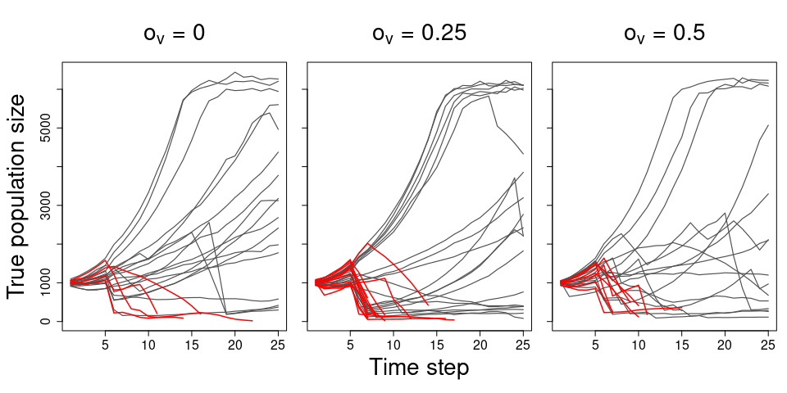

Figure X. Animal population trajectories per game session, split by levels of land ownership variability. Trajectories highlighted in red are sessions where the population reached extinction.

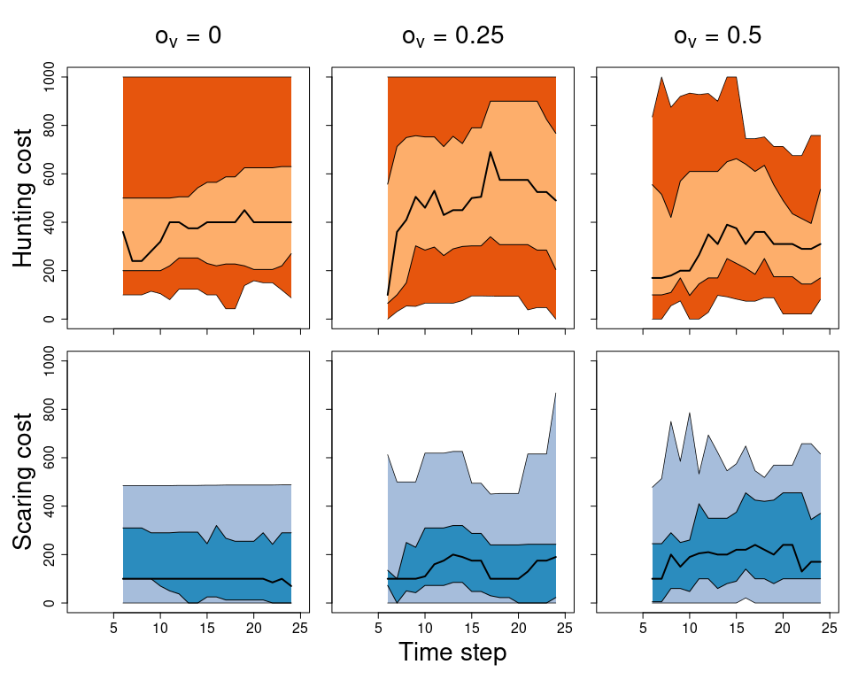

Figure X. Summary of player management actions (costs set for hunting- and scaring licences) over time, per ownership variability scenario. Solid black line is the mean cost per time step, with lighter and darker polygons representing the 25-75% and 2.5% and 97.5% quantiles of the cost distribution per time step.

# Discussion

## Brief summary of aims, process and outcome of example scenarios

## Revisit player feedback

## Discussion of limitations of overall approach, with reference to player feedback

## (Potentially general discussion of issues with games approach?)

## Discussion of potential

### Communication/education: highlight player feedback as very point of approach: game may be abstract, restrictive and not representative of reality, but this is case for any model, yet latter point often “hidden.” By taking game approach, shortcomings more obvious to non-specialists.

### Yes, problematic when expecting direct application to real life, but again this is/should be clear for all models.

### Highlight expandability of approach, sandboxing ideas in flexible simulated environment

## 

# References

Addison, Prue F. E., Libby Rumpff, S. Sana Bau, Janet M. Carey, Yung En Chee, Frith C. Jarrad, Marissa F. McBride, and Mark A. Burgman. 2013. “Practical Solutions for Making Models Indispensable in Conservation Decision-Making.” *Diversity and Distributions* 19 (5-6): 490–502. <https://doi.org/10.1111/ddi.12054>.

Ceballos, Gerardo, Paul R. Ehrlich, Anthony D. Barnosky, Andrés García, Robert M. Pringle, and Todd M. Palmer. 2015. “Accelerated Modern Humaninduced Species Losses: Entering the Sixth Mass Extinction.” *Science Advances* 1 (5): e1400253. <https://doi.org/10.1126/sciadv.1400253>.

Ceballos, Gerardo, Paul R. Ehrlich, and Rodolfo Dirzo. 2017. “Biological Annihilation via the Ongoing Sixth Mass Extinction Signaled by Vertebrate Population Losses and Declines.” *Proceedings of the National Academy of Sciences* 114 (30): E6089–96. <https://doi.org/10.1073/pnas.1704949114>.

Chabris, Christopher F. 2017. “Six Suggestions for Research on Games in Cognitive Science.” *Topics in Cognitive Science* 9 (2): 497–509. <https://doi.org/10.1111/tops.12267>.

Cusack, Jeremy, A. Duthie, Jeroen Minderman, Isabel Jones, Rocío Pozo, O. Rakotonarivo, Steve Redpath, and Nils Bunnefeld. 2020. “Integrating Conflict, Lobbying, and Compliance to Predict the Sustainability of Natural Resource Use.” *Ecology and Society* 25 (2). <https://doi.org/10.5751/ES-11552-250213>.

Duthie, A. Bradley, Jeremy J. Cusack, Isabel L. Jones, Jeroen Minderman, Erlend B. Nilsen, Rocío A. Pozo, O. Sarobidy Rakotonarivo, Bram Van Moorter, and Nils Bunnefeld. 2018. “GMSE: An R Package for Generalised Management Strategy Evaluation.” Edited by Samantha Price. *Methods in Ecology and Evolution*, October. <https://doi.org/10.1111/2041-210X.13091>.

Duthie, A. Bradley, Jeroen Minderman, O. Sarobidy Rakotonarivo, Gabriela Ochoa, and Nils Bunnefeld. 2021. “Online Multiplayer Games as Virtual Laboratories for Collecting Data on Social-Ecological Decision Making.” *Conservation Biology* 35 (3): 1051–53. <https://doi.org/10.1111/cobi.13633>.

Fjaellingsdal, Kristoffer S., and Christian A. Kloeckner. 2019. “Gaming Green: The Educational Potential of Eco - a Digital Simulated Ecosystem.” *Frontiers in Psychology* 10 (December): 2846. <https://doi.org/10.3389/fpsyg.2019.02846>.

Fryxell, J. M., C. Packer, K. McCann, E. J. Solberg, and B.-E. Saether. 2010. “Resource Management Cycles and the Sustainability of Harvested Wildlife Populations.” *Science* 328 (5980): 903–6. <https://doi.org/10.1126/science.1185802>.

Garcia, Claude, Anne Dray, and Patrick Waeber. 2016. “Learning Begins When the Game Is over: Using Games to Embrace Complexity in Natural Resources Management.” *GAIA - Ecological Perspectives for Science and Society* 25 (4): 289–91. <https://doi.org/10.14512/gaia.25.4.13>.

Grimm, Volker, Uta Berger, Finn Bastiansen, Sigrunn Eliassen, Vincent Ginot, Jarl Giske, John Goss-Custard, et al. 2006. “A Standard Protocol for Describing Individual-Based and Agent-Based Models.” *Ecological Modelling* 198 (1): 115–26. <https://doi.org/10.1016/j.ecolmodel.2006.04.023>.

Grimm, Volker, Alice S. A. Johnston, H.-H. Thulke, V. E. Forbes, and P. Thorbek. 2020. “Three Questions to Ask Before Using Model Outputs for Decision Support.” *Nature Communications* 11 (1): 4959. <https://doi.org/10.1038/s41467-020-17785-2>.

Groeneveld, J., B. Müller, C. M. Buchmann, G. Dressler, C. Guo, N. Hase, F. Hoffmann, et al. 2017. “Theoretical Foundations of Human Decision-Making in Agent-Based Land Use Models A Review.” *Environmental Modelling & Software* 87 (January): 39–48. <https://doi.org/10.1016/j.envsoft.2016.10.008>.

IPCC. 2021. “Climate Change 2021: The Physical Science Basis. Contribution of Working Group i to the Sixth Assessment Report of the Intergovernmental Panel on Climate Change.” <https://www.ipcc.ch/report/ar6/wg1/>.

Khatib, Firas, Seth Cooper, Michael D. Tyka, Kefan Xu, Ilya Makedon, Zoran Popović, David Baker, and Foldit Players. 2011. “Algorithm Discovery by Protein Folding Game Players.” *Proceedings of the National Academy of Sciences* 108 (47): 18949–53. <https://doi.org/10.1073/pnas.1115898108>.

Kolkman, Daniel Antony, Paolo Campo, Tina Balke-Visser, and Nigel Gilbert. 2016. “How to Build Models for Government: Criteria Driving Model Acceptance in Policymaking.” *Policy Sciences* 49 (4): 489–504. <https://doi.org/10.1007/s11077-016-9250-4>.

Maxwell, Sean L., Richard A. Fuller, Thomas M. Brooks, and James E. M. Watson. 2016. “Biodiversity: The Ravages of Guns, Nets and Bulldozers.” *Nature* 536 (7615): 143–45. <https://doi.org/10.1038/536143a>.

Meinzen-Dick, Ruth, Rahul Chaturvedi, Laia Domènech, Rucha Ghate, Marco Janssen, Nathan Rollins, and K. Sandeep. 2016. “Games for Groundwater Governance: Field Experiments in Andhra Pradesh, India.” *Ecology and Society* 21 (3). <https://doi.org/10.5751/ES-08416-210338>.

Milner-Gulland, E. J. 2012. “Interactions Between Human Behaviour and Ecological Systems.” *Philosophical Transactions of the Royal Society B: Biological Sciences* 367 (1586): 270–78. <https://doi.org/10.1098/rstb.2011.0175>.

Orach, Kirill, Andreas Duit, and Maja Schlüter. 2020. “Sustainable Natural Resource Governance Under Interest Group Competition in Policy-Making.” *Nature Human Behaviour* 4 (9): 898–909. <https://doi.org/10.1038/s41562-020-0885-y>.

Rakotonarivo, Onjamirindra S., Isabel L. Jones, Andrew Bell, Alexander B. Duthie, Jeremy Cusack, Jeroen Minderman, Jessica Hogan, Isla Hodgson, and Nils Bunnefeld. 2021. “Experimental Evidence for Conservation Conflict Interventions: The Importance of Financial Payments, Community Trust and Equity Attitudes.” *People and Nature* 3 (1): 162–75. <https://doi.org/10.1002/pan3.10155>.

Rakotonarivo, Sarobidy, Andrew Bell, Katharine Abernethy, Jeroen Minderman, A. Duthie, Steve Redpath, Aidan Keane, et al. 2021. “The Role of Incentive-Based Instruments and Social Equity in Conservation Conflict Interventions.” *Ecology and Society* 26 (2). <https://doi.org/10.5751/ES-12306-260208>.

Redpath, Steve M., Aidan Keane, Henrik Andrén, Zachary Baynham-Herd, Nils Bunnefeld, A. Bradley Duthie, Jens Frank, et al. 2018. “Games as Tools to Address Conservation Conflicts.” *Trends in Ecology & Evolution* 33 (6): 415–26. <https://doi.org/10.1016/j.tree.2018.03.005>.

Sandbrook, Chris, William M. Adams, and Bruno Monteferri. 2015. “Digital Games and Biodiversity Conservation.” *Conservation Letters* 8 (2): 118–24. <https://doi.org/10.1111/conl.12113>.

Schlüter, M., R. R. J. Mcallister, R. Arlinghaus, N. Bunnefeld, K. Eisenack, F. Hölker, E. J. Milner-Gulland, et al. 2012. “New Horizons for Managing the Environment: A Review of Coupled Social-Ecological Systems Modeling.” *Natural Resource Modeling* 25 (1): 219–72. <https://doi.org/10.1111/j.1939-7445.2011.00108.x>.

Schuwirth, Nele, Florian Borgwardt, Sami Domisch, Martin Friedrichs, Mira Kattwinkel, David Kneis, Mathias Kuemmerlen, Simone D. Langhans, Javier Martínez-López, and Peter Vermeiren. 2019. “How to Make Ecological Models Useful for Environmental Management.” *Ecological Modelling* 411 (November): 108784. <https://doi.org/10.1016/j.ecolmodel.2019.108784>.

Sipper, Moshe, and Jason H. Moore. 2020. “Gamorithm.” *IEEE Transactions on Games* 12 (1): 115–18. <https://doi.org/10.1109/TG.2018.2867743>.

Sullivan, Devin P., Casper F. Winsnes, Lovisa Akesson, Martin Hjelmare, Mikaela Wiking, Rutger Schutten, Linzi Campbell, et al. 2018. “Deep Learning Is Combined with Massive-Scale Citizen Science to Improve Large-Scale Image Classification.” *Nature Biotechnology* 36 (9): 820–+. <https://doi.org/10.1038/nbt.4225>.

Tan, Cedric Kai Wei, Jiin Woei Lee, Adeline Hii, Yen Yi Loo, Ahimsa Campos-Arceiz, and David W. Macdonald. 2018. “The Effect of Using Games in Teaching Conservation.” *PeerJ* 6 (April): e4509. <https://doi.org/10.7717/peerj.4509>.

van den Bergh, Jarrett, Ved Chirayath, Alan Li, Juan L. Torres-Pérez, and Michal Segal-Rozenhaimer. 2021. “NeMO-Net Gamifying 3d Labeling of Multi-Modal Reference Datasets to Support Automated Marine Habitat Mapping.” *Frontiers in Marine Science* 0. <https://doi.org/10.3389/fmars.2021.645408>.

Villamor, Grace, and Biola Badmos. 2016. “Grazing Game: A Learning Tool for Adaptive Management in Response to Climate Variability in Semiarid Areas of Ghana.” *Ecology and Society* 21 (1). <https://doi.org/10.5751/ES-08139-210139>.

Will, Meike, Gunnar Dressler, David Kreuer, Hans-Hermann Thulke, Adrienne Grêt-Regamey, and Birgit Müller. 2021. “How to Make Socio-Environmental Modelling More Useful to Support Policy and Management?” *People and Nature* 3 (3): 560–72. <https://doi.org/10.1002/pan3.10207>.

Wilting, Harry C., Aafke M. Schipper, Michel Bakkenes, Johan R. Meijer, and Mark A. J. Huijbregts. 2017. “Quantifying Biodiversity Losses Due to Human Consumption: A Global-Scale Footprint Analysis.” *Environmental Science & Technology* 51 (6): 3298–3306. <https://doi.org/10.1021/acs.est.6b05296>.

Zasada, Ingo, Annette Piorr, Paula Novo, Anastasio J. Villanueva, and István Valánszki. 2017. “What Do We Know about Decision Support Systems for Landscape and Environmental Management? A Review and Expert Survey Within EU Research Projects.” *Environmental Modelling & Software* 98 (December): 63–74. <https://doi.org/10.1016/j.envsoft.2017.09.012>.

1. Note that there are of course limitations to this, and that data on decisions made would only be relevant to the context of the game (i.e. internally valid in the game context). Wider external validity depends on a number of factors; we discuss limitations in more detail below.
2. A&F currently focuses only on hunting animals, scaring animals or tending crops as available actions to farmers; this may be expanded in the future to other actions available in GMSE.
3. It can be affected *indirectly* by setting the cost for the two actions prohibitively high, so that tending crops becomes more likely to be most beneficial to maximising yield (the farmer’s goal). See **XXX**.