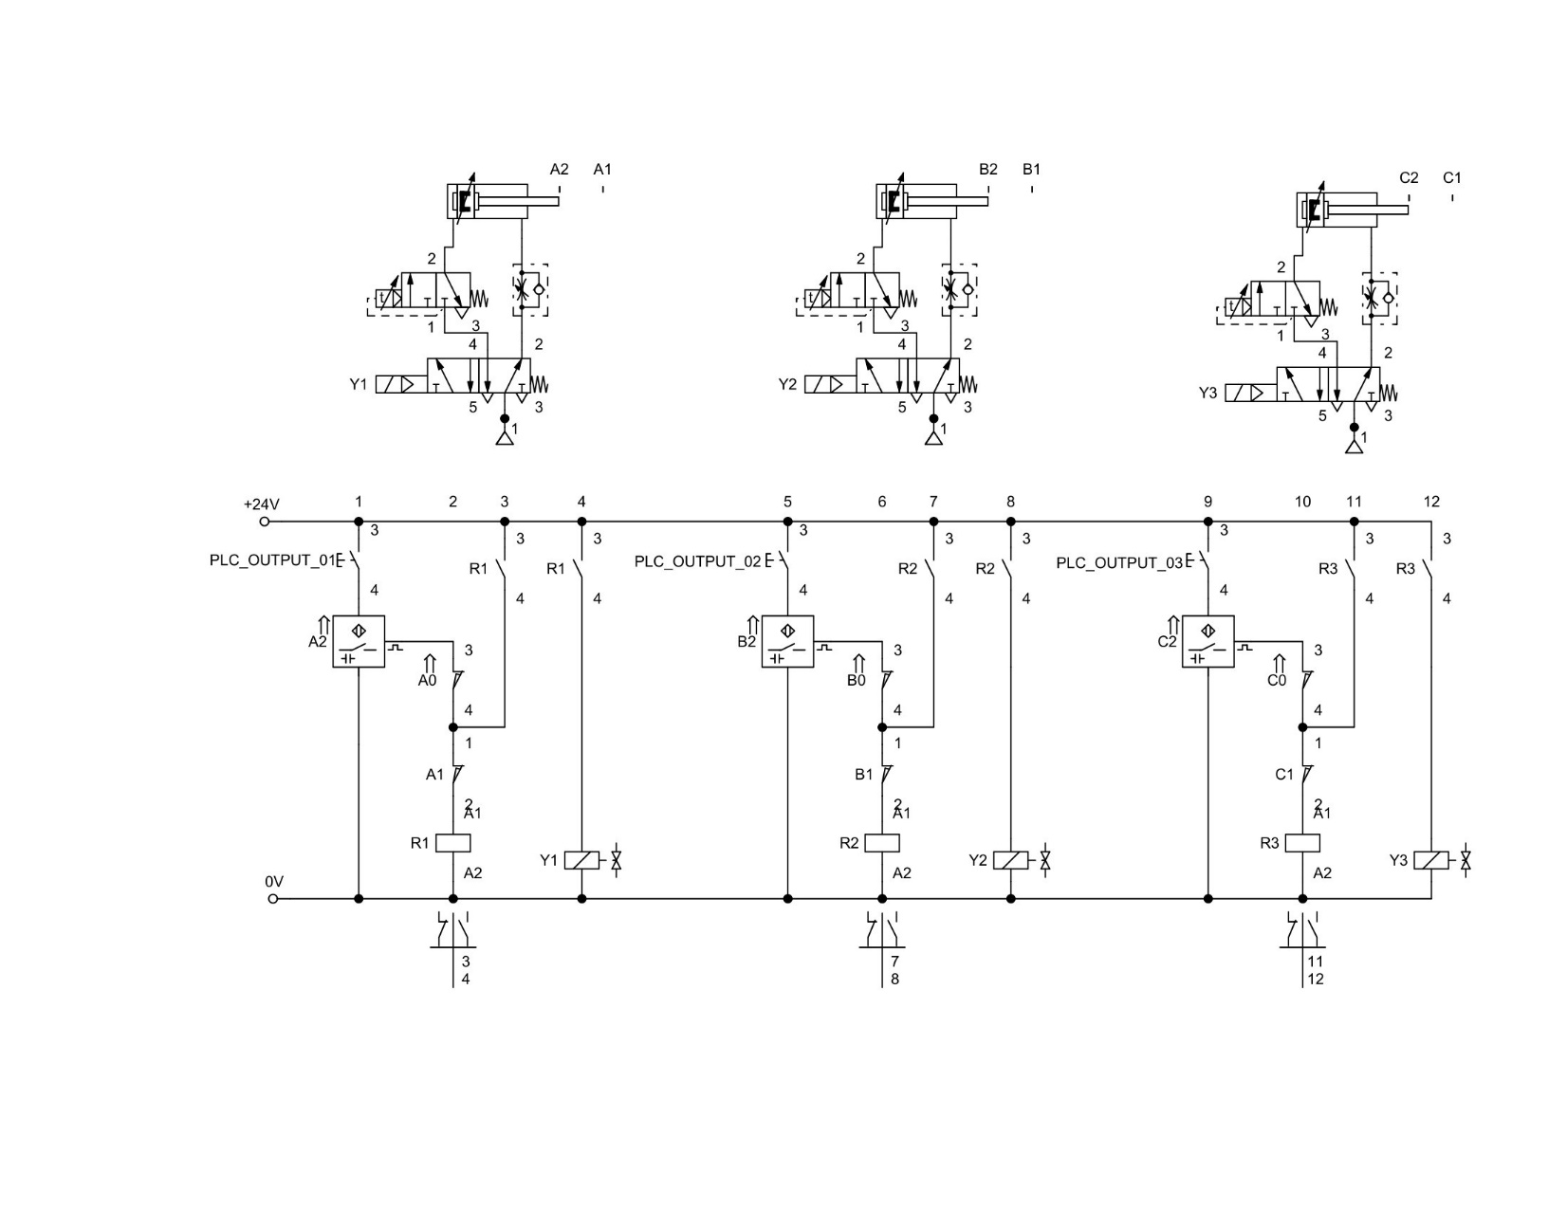

Circuit Diagram in Fluidsim

|  |
| --- |
| Components used |
| Double acting cylinder |
| Pneumatic timer |
| One-way flow control valve |
| 5/2 way valve |
| capacitive proximity sensor |
| compressed air supply |
| Break switch |
| make switch |
| relay |
| valve solinoid |