# General Processing Workflow (LipidSearch and QuanBrowser)

## Move data to LipidSearch PC and personal computer (with Xcalibur)

* PC with LipidSearch currently located in Low Field NMR bay (left PC)
* Place files in “C:\LipidSearch\data\[yourFolder]
* Can workup all data on this PC if desired *[I will need to install R before this is the case]*
* Fix sequence data path for computer that Xcalibur will be used on (don’t need for LipidSearch)
  + Doesn’t matter where data is stored if Path is correct
  + Path selection shown below (in XCalibur Sequence Setup, right click-> browse…)
  + Filldown button to apply to all rows (button highlighted below)
  + Save Sequence (File🡪 Save or Save As…)



## Verify mass accuracy using internal standards (MS1 and MS2)

* Mass accuracy is important for:

1. LipidSearch MS1 and MS2 database matching (ideally <5/10ppm error for MS1/MS2)
2. QuanBrowser Processing (default to 10ppm tolerance on Int Std maxes)

* 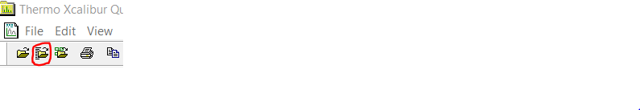Open Sequence in QualBrowser
* Check mass error with 2 lipid IS’s at MS1 and 1 lipid IS for MS2 (in each polarity, *need to verify for entire sequence*) using QualBrowser *[may make a better tool later]*
* Example mass error check using EquiSplash internal standard mixture (Avanti_Equisplash.xlsx)
  + Positive Mode (RTs for default 20minute polarity switching BEHC18 100mm gradient)
    - MS1
      * LPC-d7(Protonated) at m/z 529.3999 (RT = 3.17 min)
      * SM-d7(Protonated) at m/z 738.6475 (RT = 9.36 min)
    - MS2: m/z 184.0739 from PC-d7(Protonated) [MS2 filter 753.6139, RT~9.64min]
  + Negative Mode
    - MS1
      * LPE-d7(Deprotonated) at m/z 485.3373
      * PI-d7(Deprotonated) at m/z 828.5620
    - MS2: m/z 241.2173 from PG-d7(Deprotonated) [MS2 filter 740.5459, RT~8.79min]
* If the data contains EquiSplash Int Std and uses default LC method can apply layout: [MORE INSTRUCTIONS] MassAccuracyCheck_EquiSplash.lyt (faster than starting from scratch)
  + If MS parameters change need to adjust filters (mass range, lock mass on, etc.)
  + Likely need to re-select MS2 filters, unlikely to match perfectly
* An example of checking mass error is provided in Appendix 1: Checking Mass Accuracy
* Avanti_Equisplash.xlsx Sheet 2 (Mass Accuracy Check) has a pre-built form to enter/calculate mass error using the default layout
* If data was collected with unacceptably high mass error (>10ppm for MS1, >20ppm for MS2) will need to retroactively correct using recalibrate_mz.R script (see Appendix 2: Correct Mass Error)
* Use mass error data to choose LipidSearch parameters to ensure matches are possible, note that higher tolerances impact false identification rates

## QuanBrowser Processing

* With mass accuracy verified can use processing method with 10 ppm mass error tolerance
* The default processing method (for the 20minute BEH C18 100mm gradient) is:
  + Default_20min_100mmC18.pmd
  + See Appendix 3: Processing Methods for help customizing this as projects evolve
  + If need to adjust mass tolerance (not ideal): Options 🡪 Masses…
* 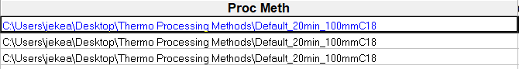Setup processing in Sequence Setup as shown in image below:
* 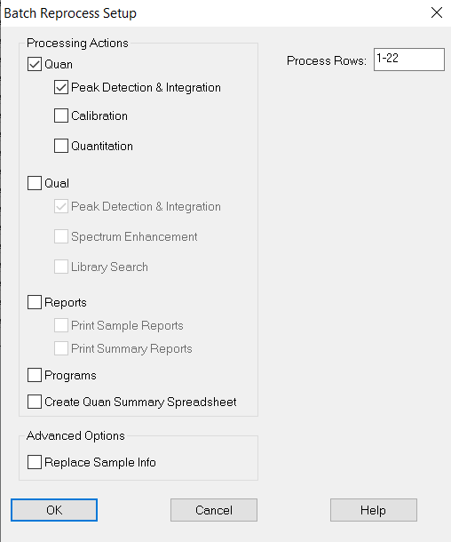Batch reprocess (pictures below) once Proc Meth is loaded (and Data Path is correct)
* Xcalibur Queue manager will popup, allow to finish before loading the sequence in QuanBrowser

## Verify peaks QuanBrowser for IS components, Export data

* Following Batch Reprocess – open the Sequence list in QuanBrowser
* Popup will ask about samples to view – select Show all sample types
* Your QuanBrowser should be similar to the image below:

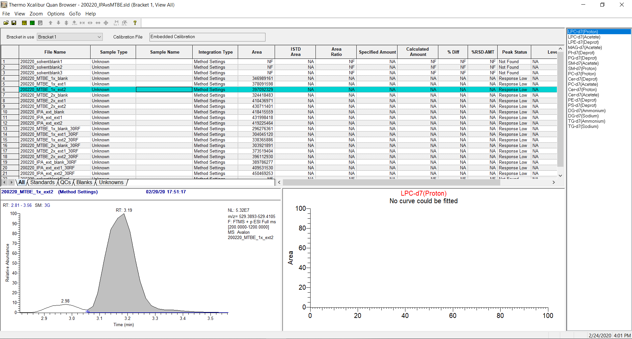

* Important features:
  + Sequence list: Click a sample to show the related peak
  + Component list (Right hand side) switches between lipid ions (Class+Adducts from EquiSplash)
* Go through files (ignoring solvent blanks) and components to ensure good peak shape and integrations
* If integration is poor can manually adjust it (blue boxes on the Chromatogram)
* Note: if you need to adjust mass tolerance can do so at this stage by Options🡪Masses…
* Export data: File 🡪 Export data to Excel 🡪 Export Short Excel Report
* Saves a csv in same folder as sequence with default name: ExcelExp_Short.xlsx
* Structured as follows:
* 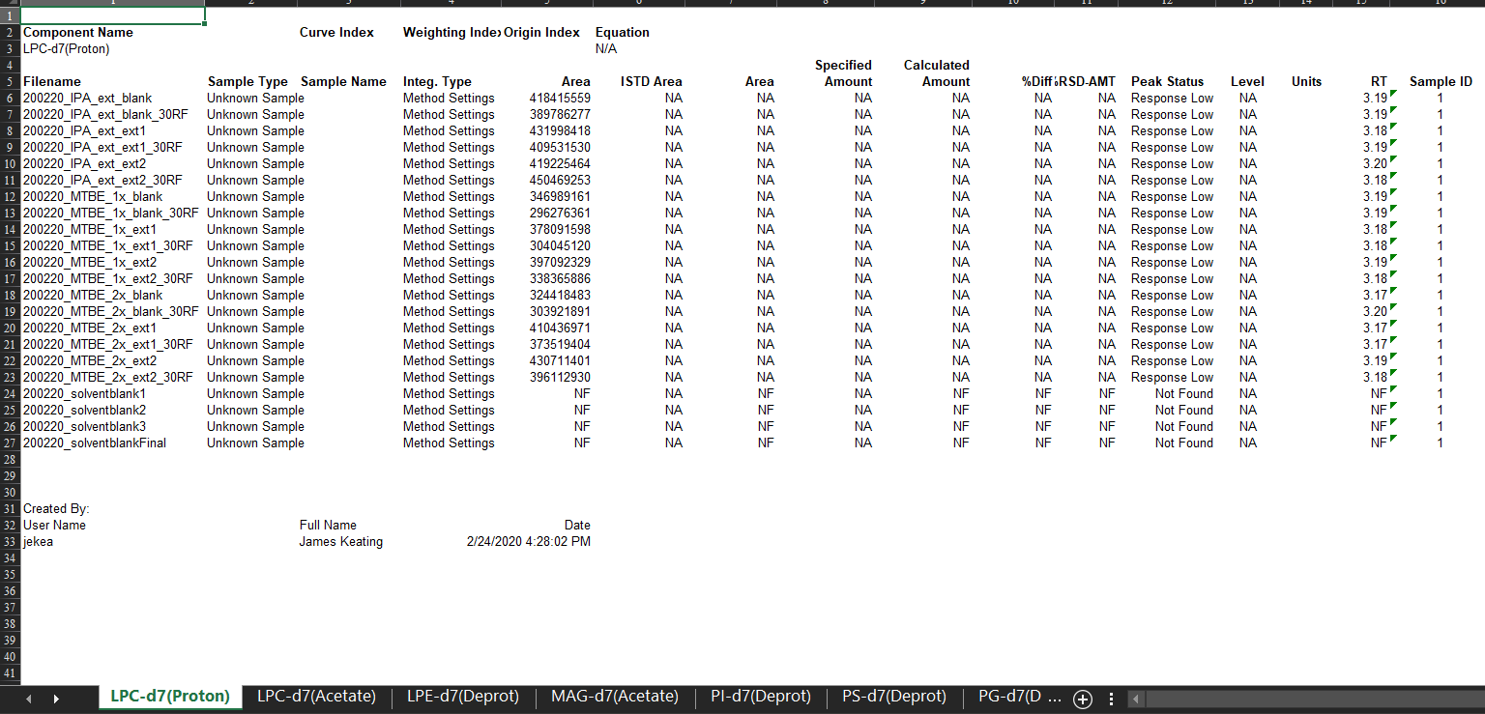Each excel sheet is a different component (internal standard)
* Mainly interested in Filename and Area columns, not using the others
* This file will be loaded into RMarkdown scripts for correction of endogenous lipid areas and can be used for QC purposes as well

# Appendices

## Check mass accuracy

* Open sequence in QualBrowser
* Apply MassAccuracyCheck_EquiSplash.lyt layout (File 🡪 Layout 🡪 Apply…
  + Alternatively: Generate extracted ion chromatograms for 2 lipid Int Std’s at MS1 level in positive and negative mode and 1 lipid Int Std. at MS2 level in positive and negative mode
  + All lipids in EquiSplash and associated masses are in Avanti_Equisplash.xlsx
* In the newly applied layout fix the 4th and 8th (from the top of left side) boxes filters
  + Ensure chromatograms are pinned
  + 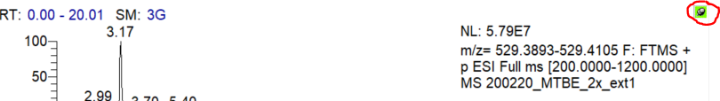Highlight 4th box (from the top) by left clicking (will turn grey)
  + Right-click in 4th box, select Ranges…
  + In Scan filter drop down select most appropriate filter for targeted MS2
  + Box 4 should be FTMS+ (Positive mode)_ Full ms2 ### where ### is close to 753.6139)
    - Verify correct filter by pinning the Mass Spectrum (right side) and clicking on the 4th box near RT=9.64 min (if using 20 min default method)
    - The tandem mass spectrum should look like the image below:
  + Repeat this process for the 8th box
    - Filter should be FTMS- (Negative mode)_Full ms2 ### where ### is close to 740.5459, can check near RT = 8.79
    - The tandem mass spectrum should look like the image below:
* 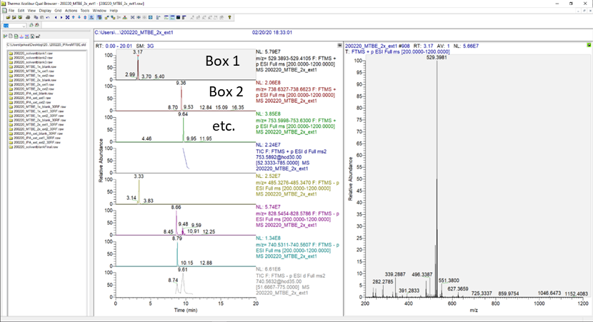Your screen should be similar to the image below (minus box labels, and your spectrum likely different)
* Check mass accuracy of first file (that has internal standard, not solvent blanks) and last file (that has internal standard)
  + Pin mass spectrum
  + Click on Chromatogram Box 1, should have a spectrum with high abundance m/z 529.3__
  + Compare measured mass to the calculated exact mass for the lipid
  + Avanti_Equisplash.xlsx Sheet 2 (Mass Accuracy Check) has a pre-built form to use (image below) or can do manually if using different standards
* Relative error (ppm) used to select LipidSearch parameters
* Allow some error on the selection, e.g., if relative error measured at -3.5 ppm don’t set tolerance at 3.6ppm, 5ppm is probably fine (don’t have a quantitative way to decide this)