- (Chapter 4) Write a program that shows the color trackbar as follows by modifying the source file Example-04-15-C#.
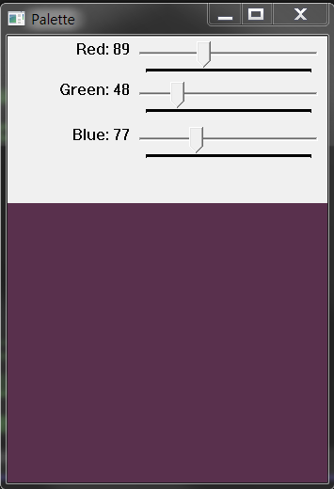
- (Chapter 4) (Chapter 4) Write a program that shows the color trackbar as follows by modifying the source file Example-04-17-C#.
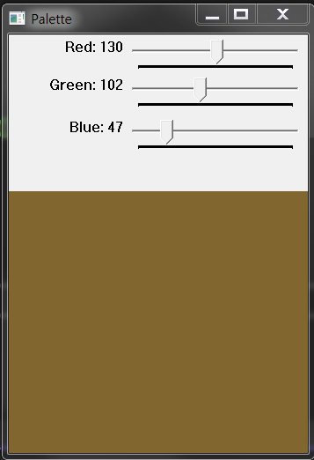
using System;
using OpenCvSharp;
namespace Project
{
class Program
{
static int r = 0;
…
static void Main(string[] args)
{
int value = 0;
Mat src = new Mat(new Size(500, 500), MatType.CV_8UC3);
TrackbarCallbackNative trackbarCallbackR = new TrackbarCallbackNative(EventR);//byeon 01
…..
Cv2.NamedWindow("Palette");
Cv2.CreateTrackbar("Red", "Palette", ref value, 255, trackbarCallbackR, src.CvPtr);
……
Cv2.WaitKey();
Cv2.DestroyAllWindows();
}

private static void EventR(int pos, IntPtr userdata)//byeon 01
{
Mat color = new Mat(userdata);
r = pos;
color.SetTo(new Scalar(b,g,r));
Cv2.ImShow("Palette", color);
}
….
}
}

- (Chapter 5) Write a python program which detects skin area using Example-05-06-Py. Use sample images injongs0.jpg ~injongs05.jpg in the webhard.

4. (Chapter 5) Write a python program which removes the salt and pepper errors in an image. Use lena_salt.jpg and lena_pepper.jpg, in the webhard.
