AO-SOC Command Center — User Manual
Writer | J.Ekrami
Co-writer | Claude (Opus 5)
Copyright | © J.Ekrami-Labs
Date | Summer 2026
Document version | 1.0
Applies to | ao-soc 2.8.8

This manual is for the people who use AO-SOC: the SOC analyst on shift, the shift lead,
and whoever installs it. It covers how to install it, how to sign in, what each menu and
page shows, and how to work an incident from the queue to the archive.
It is a how-to guide. For design, APIs and configuration details, see
README.md, orchestrator/README.md
and the staged rollout in docs/PILOT-RUNBOOK.md.
All screenshots come from the built-in demo (Section 2.1), so the incidents shown are
sample data.
Contents
- What AO-SOC is, in one minute
- Installation
- Signing in
- The screen layout and the top bar
- Command Center (home page)
- Working an incident: the AI Tier-2 Decision
- Live Alerts and the Incident Playbook
- Incidents list and Incident details
- Archive and rolling actions back
- Entity Risk
- System Health
- Language: English and Persian
- A daily routine
- Glossary: badges, colours and statuses
- Troubleshooting
1. What AO-SOC is, in one minute
AO-SOC is the decision layer of a Security Operations Center. It does not collect
logs, store logs or detect attacks. Your existing tools do that (Splunk, Wazuh, Elastic,
Sentinel, CrowdStrike, or anything that sends CEF). AO-SOC does four things with what
those tools send it:
- Correlates. Detections from different tools about the same user, host or address
in the same time window become one Security Situation. For example, a Splunk
brute-force alert, a Wazuh privilege escalation and a firewall egress hit on the same
account become one incident, not three.
- Decides. A local AI model (run through Ollama, fully on-prem) reads the situation
and proposes a Tier-2 decision: CONTAIN, ESCALATE, INVESTIGATE, MONITOR or
IGNORE. It also proposes a bundled action plan, such as Block IP, Isolate
host or Disable account.
- Asks a person. You review the plan once and click Approve plan, Edit or
Reject.
- Executes and records. Approved actions go to your response tools (SOAR, EDR,
firewall, identity provider). Every step is audited, and an action that can be undone
can be rolled back from the dashboard.
Detection tools → AO-SOC correlation → AI Tier-2 decision → YOU (approve / edit / reject)
→ policy guardrails → response tools → audit, archive, rollback
Playbooks in AO-SOC. In this product a playbook is the action plan attached to
each decision. It is visible in two places: the Bundled action plan in the AI
Tier-2 Decision panel, where you approve it and it runs, and the Incident Playbook
checklist on the Live Alerts page, which is a read-only containment summary. You do not
write playbooks by hand. The AI proposes one for each incident, and you approve it,
correct it or reject it.
2. Installation
There are two ways to run AO-SOC:
 | Use it for | Section
Demo | Trying it out, training, recordings. Sample alerts, no real model needed | 2.1
Production (Docker) | A real pilot or deployment with real detections | 2.2

2.0 Requirements
Component | Version | Needed for
Python | 3.11 or later | Broker (demo)
Node.js + npm | 20 or later | UI API and dashboard (demo)
Docker + Docker Compose | recent | Production
Ollama + model qwen3.5:latest (or qwen2.5:7b) | optional | Real AI decisions. Without a model, AO-SOC runs in model-free mode and a rule fallback decides
Browser | Current Edge, Chrome or Firefox | Dashboard. Designed for 1920×1080 and larger; works on tablets and phones

Ports
Service | Port | Notes
Broker (AI decision engine) | 8500 | Receives detections
UI API | 4317 | Serves the dashboard's data
Dashboard (demo, Vite) | 5173 | http://localhost:5173
Dashboard (production, Docker) | 8080 | The only port Docker publishes. Change it with DASHBOARD_PORT

2.1 Demo installation (Windows, Linux, macOS)
Step 1. Get the code and open a terminal in the ao-soc folder.
Step 2. Start everything with one command.
Windows (PowerShell):
.\scripts\start-demo.ps1
Linux / macOS:
chmod +x scripts/start-demo.sh scripts/stop-demo.sh
./scripts/start-demo.sh
The script:
- checks that Python and Node are installed,
- installs the dependencies (-SkipInstall / --skip-install skips this on later runs),
- starts the broker, the UI API and the dashboard, each in its own window,
- loads 12 sample alerts, including one situation correlated across three tools,
- prints the operator key you sign in with.
Sign in at the dashboard with this operator key:
Xy7...your-key...Qp
Copy the key. You need it in Section 3.
Step 3. Open http://localhost:5173 in your browser.
Demo variations
Command (Windows / Linux) | What you get
start-demo.ps1 / start-demo.sh | 12 alerts loaded at once
start-demo.ps1 -Live / start-demo.sh --live | Alerts arrive live over about 2 minutes, so you can watch the queue fill
start-demo.ps1 -Ai -Count 6 / start-demo.sh --ai --count 6 | Real AI: the local Ollama model analyses each alert. Budget 10–40 s per alert

Stop the demo:
.\scripts\stop-demo.ps1
./scripts/stop-demo.sh
Each demo start resets the demo alerts. Do not run the demo scripts against a
production database.
2.2 Production installation (Docker)
Production follows the staged rollout in docs/PILOT-RUNBOOK.md.
In short:
Step 1. Create the settings file.
cp deploy/.env.example deploy/.env
Step 2. Generate one key per person and per system. Run this once for each key:
python -c "import secrets; print(secrets.token_urlsafe(32))"
Fill them into deploy/.env:
Setting | Who holds the key | Example
BROKER_API_KEYS | Machines: the SIEM (ingest), the UI API (service) | ui-api:service:<key>,siem:ingest:<key>
UI_API_BROKER_KEY | The UI API: the same secret as its service entry above | <key>
AOSOC_API_KEYS | Each analyst personally, for signing in to the dashboard | soclead:analyst:<key>,dutydesk:viewer:<key>

The format is name:role:secret, with entries separated by commas. Give every analyst
their own key. Approvals, edits and rollbacks are recorded under the key's name, so a
shared key leaves an audit trail that names nobody.
Step 3. Check the settings, then start.
python deploy/check_env.py
docker compose --env-file deploy/.env -f deploy/docker-compose.yml up -d
check_env.py warns when a variable left in your shell (for example from a demo)
silently overrides deploy/.env.
Step 4. Open the dashboard at http://<server>:8080 and sign in with your analyst key.
Step 5. Point your detection tools at the broker. For example, Splunk sends to
POST http://<broker-host>:8500/splunk-alert, and any other vendor sends to
POST http://<broker-host>:8500/detections. Each request carries the ingest key in the
X-API-Key header. A detection sent without a key is rejected.
Safe defaults. A fresh install starts with LLM_PROVIDER=echo (no model),
TIER2_AUTOPILOT=false (a person approves everything) and RESPONSE_DRY_RUN=true
(nothing is sent to any real tool). Turn these on one at a time, as the runbook
describes.
2.3 Roles
Role | Can do
viewer | See everything. Cannot approve, edit, reject or roll back
analyst | See and act: approve, edit, reject, record outcomes, roll back, work cases
ingest | Machine role: may only send detections
service | Machine role: the UI API acting for the signed-in analyst
admin | Everything. Do not hand it out by default

3. Signing in
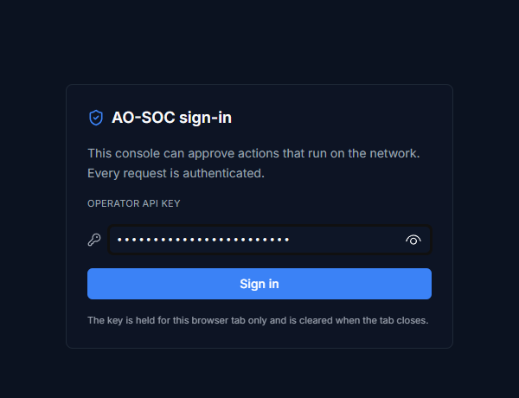
Sign-in screen
- Open the dashboard URL.
- Paste your Operator API key into the box.
- Click Sign in.
The key is kept for this browser tab only. Closing the tab signs you out, so a shared
SOC workstation does not stay signed in for the next shift. If the key is wrong or has
been revoked, the sign-in screen comes back.
4. The screen layout and the top bar
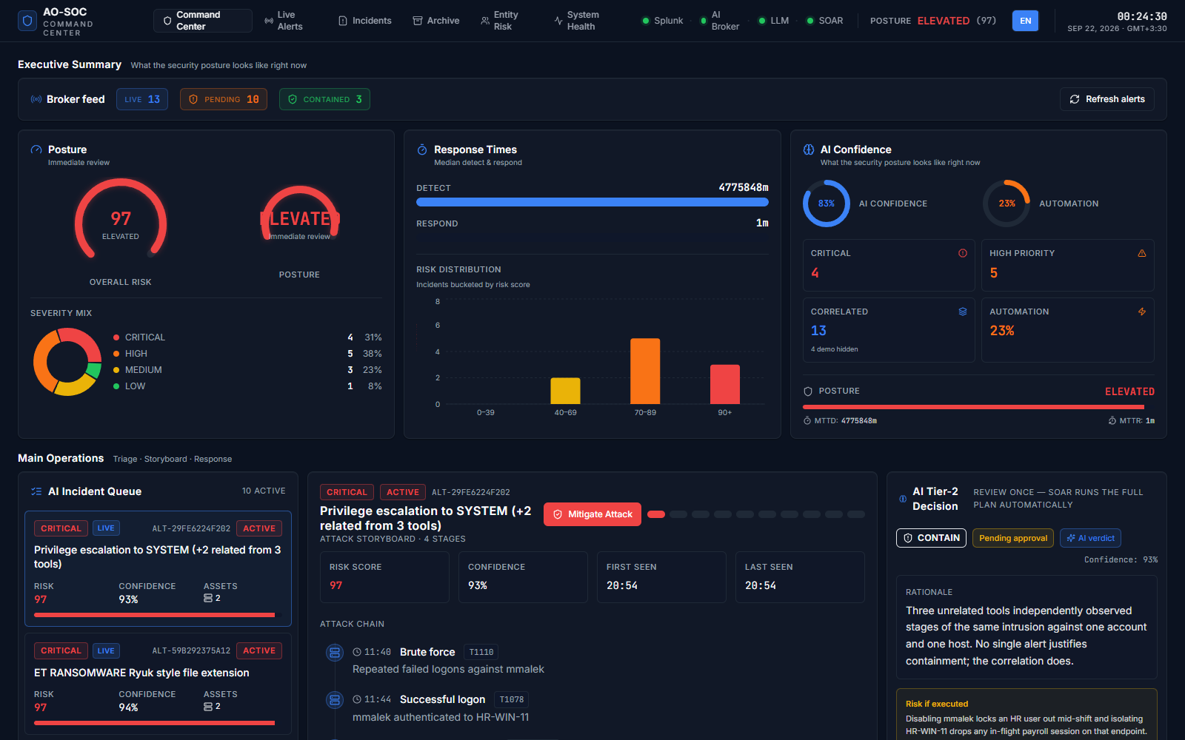
Command Center overview
Every page has the same top bar:
Top bar
# | Element | What it does
1 | AO-SOC logo | Returns to the Command Center
2 | Main menu | The six pages (table below)
3 | Pipeline status (Splunk · AI Broker · LLM · SOAR) | A green dot means the part is online, amber degraded, red offline, grey unknown. Refreshed every 5 seconds
4 | Posture | Overall security posture (LOW / GUARDED / HEIGHTENED / ELEVATED) with its score from 0 to 100
5 | EN / FA | Switches the language between English and Persian (right-to-left layout)
– | Clock | Local time and date with the time-zone offset

The main menu
Menu item | Page | Use it to…
Command Center | / | See everything at once and work incidents. This is your home screen
Live Alerts | /alerts | Scan the raw alert log and see each alert's containment playbook
Incidents | /incidents | See the full list of active incidents and open one in detail
Archive | /archive | Review cleared incidents: what was decided, who approved it, what ran
Entity Risk | /entities | See the riskiest users, hosts and IP addresses
System Health | /health | Check that the pipeline is alive and look at its telemetry

The footer shows the application version (for example v2.8.8) and the pipeline
Splunk → AI Broker → Local LLM (Qwen) → SOAR. Quote the version when you report a
problem.
5. Command Center (home page)
The Command Center answers five questions from top to bottom: What needs attention now?
How serious is it? Why does the AI think so? What should be done? What is our posture?
It has six rows.
5.1 Executive Summary: "how are we doing right now?"
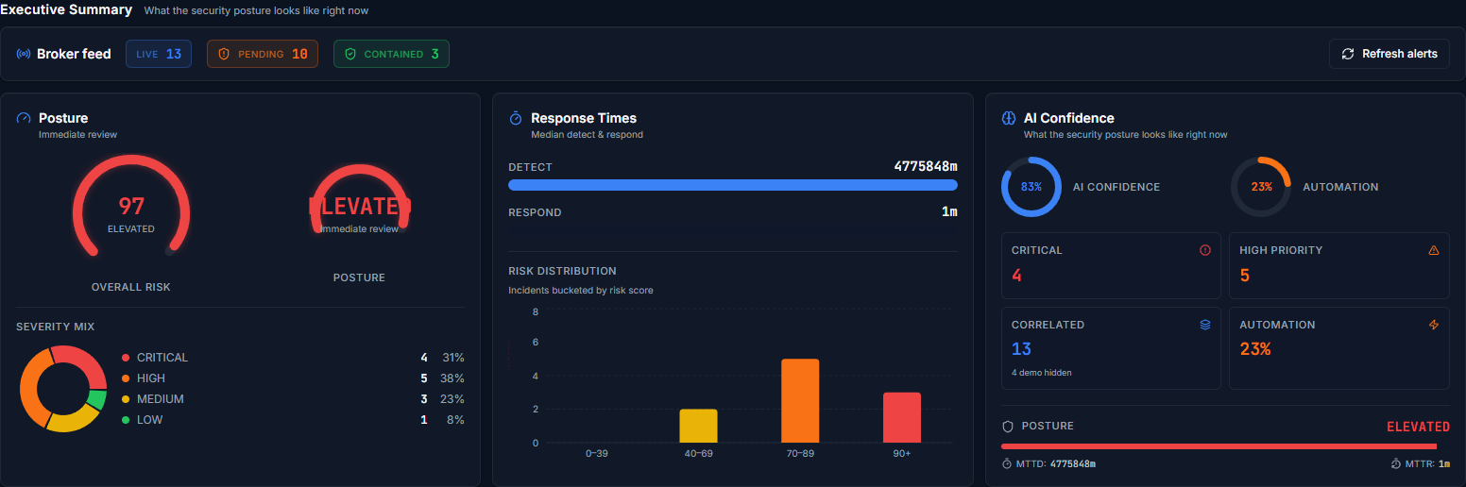
Executive Summary
- Broker feed. Counts of LIVE incidents, incidents PENDING a human decision,
and CONTAINED ones. Refresh alerts reloads them immediately. The page also
refreshes by itself every 15 seconds.
- Posture. The overall risk gauge (0–100) with its label, plus the Severity Mix
donut of open incidents.
- Response Times. MTTD (mean time to detect) and MTTR (mean time to respond),
plus the Risk Distribution histogram of incidents by risk score.
- AI Confidence. The average model confidence, the automation rate, and counts of
Critical, High Priority and Correlated incidents.
AI confidence is shown, never used to decide. Local models report 75–98 %
confidence almost regardless of the input. Use the number to sort your work, not as a
reason to approve.
5.2 Main Operations: triage, storyboard and response
This is where you work incidents.
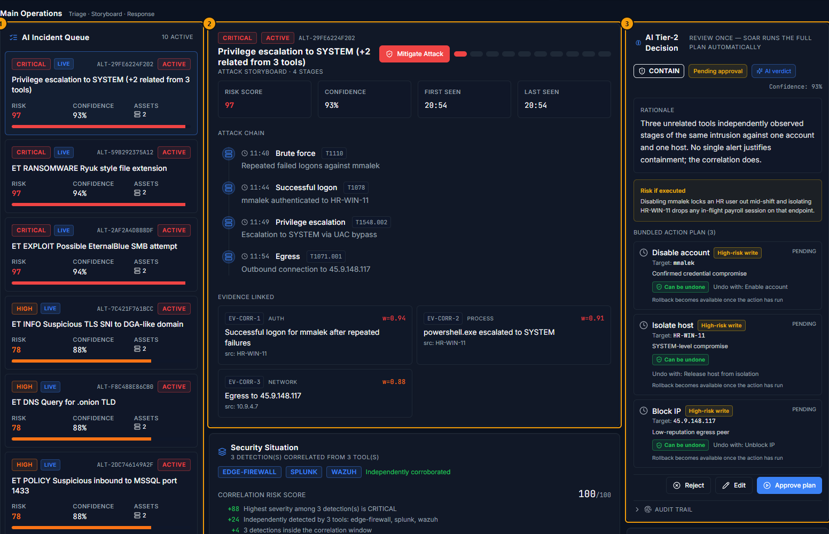
Main Operations
# | Panel | What it shows
1 | AI Incident Queue | Active incidents, most urgent first. Click one to select it; everything to its right then shows that incident
2 | Attack storyboard and the panels below it | What happened, in order, and the evidence behind it
3 | AI Tier-2 Decision and AI Recommended Actions | What the AI proposes, and the buttons you act with (Section 6)

AI Incident Queue
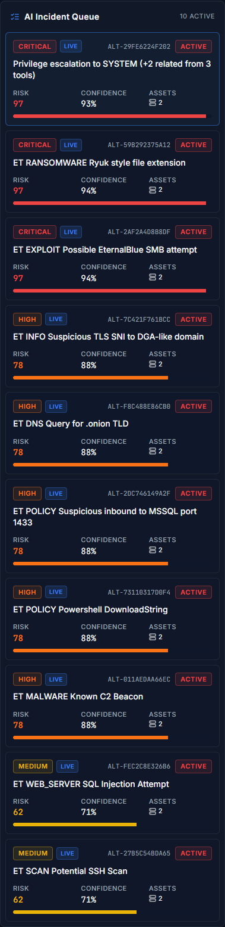
AI Incident Queue
Each card shows the severity (CRITICAL, HIGH, MEDIUM, LOW), a LIVE badge
(real broker data; DEMO marks sample data), the incident id, its status, the
title, the risk score, the AI confidence and the number of affected assets.
The bar at the bottom of each card is the risk score, coloured by severity.
A title such as "Privilege escalation to SYSTEM (+2 related from 3 tools)" means
AO-SOC joined three detections from three different tools into one situation.
Attack storyboard
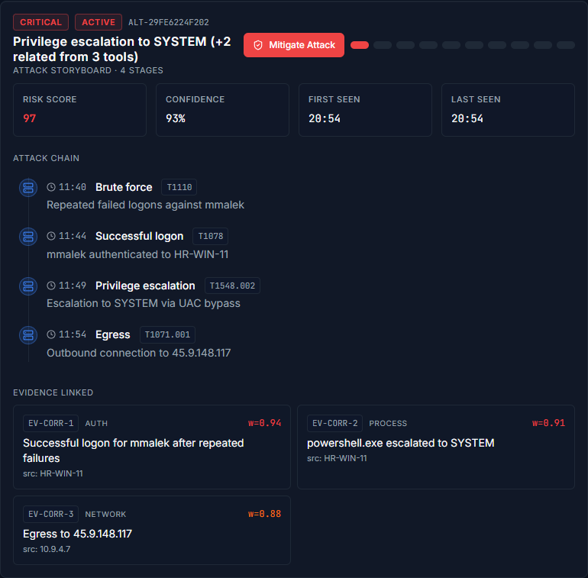
Attack storyboard
- The header row shows the risk score, confidence, first seen and last seen.
- Attack chain. Each stage of the attack in time order, with its MITRE ATT&CK
technique id (for example T1110 Brute force).
- Evidence linked. The individual pieces of evidence, their type (auth, process,
network) and weight.
- Mitigate Attack (red button). Marks the incident CONTAINED by hand, without
running the plan. Use it only when the threat was already contained outside AO-SOC. The
normal route is Approve plan (Section 6).
Security Situation: why several alerts became one incident
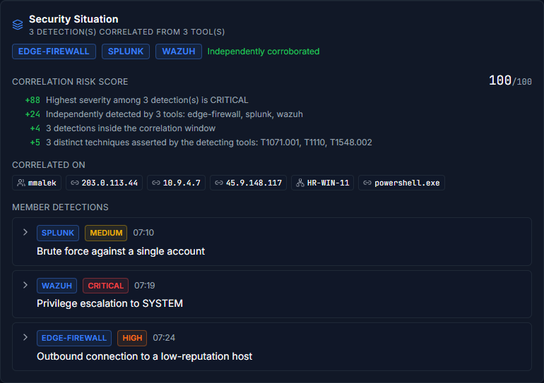
Security Situation
- Tool badges (for example EDGE-FIREWALL, SPLUNK, WAZUH) name the tools that
reported it. Independently corroborated means more than one tool saw it.
- Correlation risk score. Shows the arithmetic, line by line: the points for the
highest severity, for cross-tool corroboration, for the number of detections and for the
number of techniques. The score is a count of facts, not the AI's opinion.
- Correlated on. The shared users, addresses, hosts and processes that joined the
detections.
- Member detections. Every original detection. Click > to expand one and see its
entities, techniques and a link back to the tool that raised it.
Verification and precedent
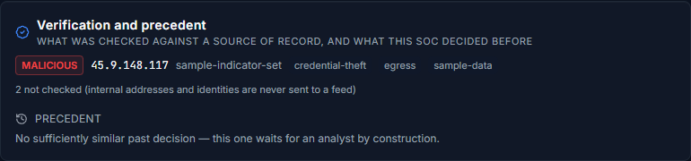
Verification and precedent
- Indicators checked against threat intelligence. MALICIOUS means the indicator is
on a feed. Checked and not found is not proof that it is safe. Not checked
covers internal addresses and identities, which are never sent to a feed.
- Precedent. What this SOC decided in similar past cases. "No sufficiently similar
past decision" means the incident waits for a person by design.
A quiet panel is not a clean result. If no intelligence feed is configured, the panel
says so.
Case: who owns this incident
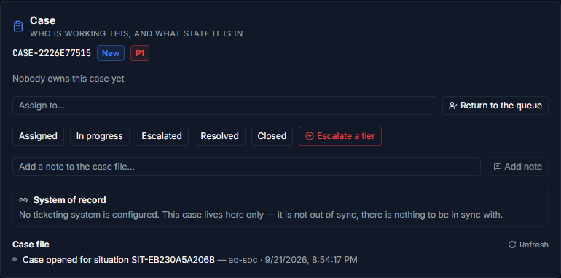
Case panel
- The case id, its state and its priority (P1 is the highest).
- Assign to… Type a name and click Assign. Return to the queue unassigns it.
- State buttons move the case through its lifecycle:
New → Assigned → In progress → Escalated → Resolved → Closed, and
Reopened from Resolved or Closed. Only the valid next states are shown.
- Escalate a tier raises the case to the next tier.
- Add a note writes to the Case file, the case's timeline, which cannot be edited
afterwards.
- System of record. Shows whether the case is synced to a ticketing system (for
example TheHive). "No ticketing system is configured" is a normal state, not an error.
Nothing in the Case panel can approve or reject a decision. Owning a case and deciding
what to do about it are deliberately separate.
AI Recommended Actions
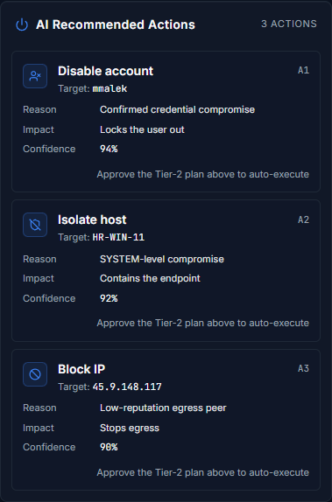
AI Recommended Actions
The same actions as the plan, each with its target, reason, impact and
confidence. For live incidents you do not run these one by one. The note
"Approve the Tier-2 plan above to auto-execute" tells you to use Approve plan.
5.3 Risk Analytics
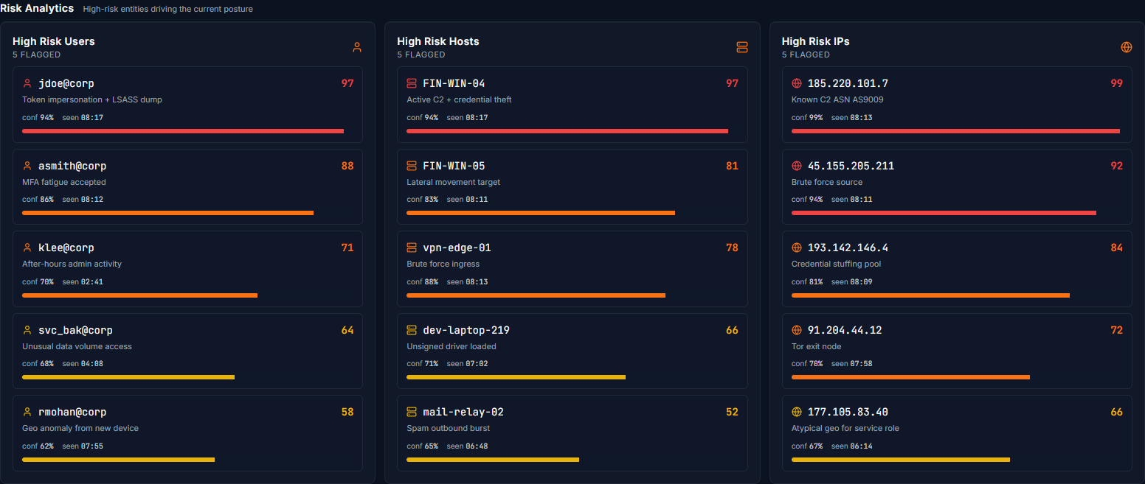
Risk Analytics
The highest-risk users, hosts and IP addresses driving the current posture.
The Entity Risk page (Section 10) has the full, searchable list.
5.4 MITRE ATT&CK
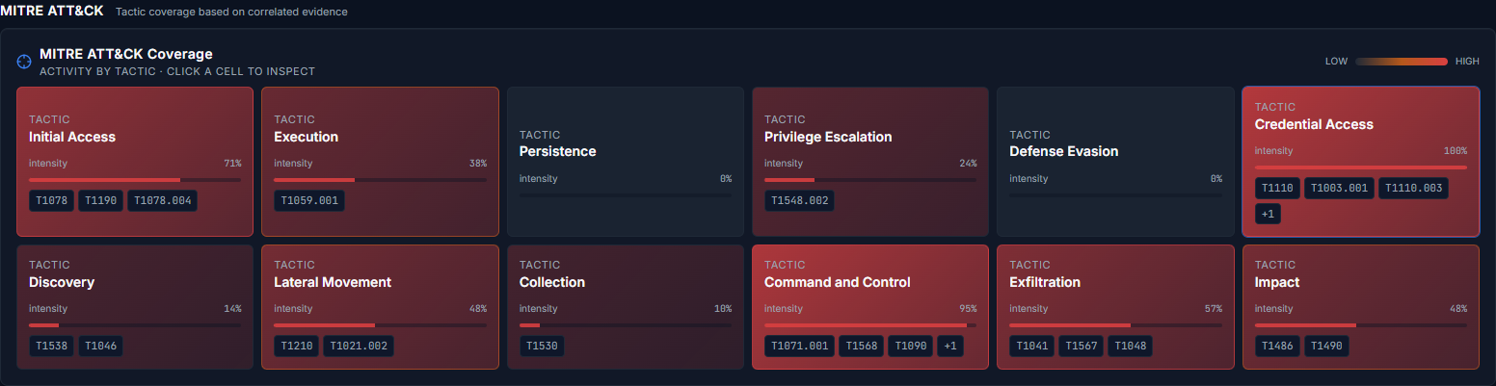
MITRE ATT&CK coverage
Activity by ATT&CK tactic. Redder cells mean more intensity. Each cell lists the
technique ids seen. Click a cell to inspect it. Techniques are checked against a local
ATT&CK catalogue, and an id the catalogue does not list is flagged as unlisted rather
than presented as fact.
5.5 AI Explanation
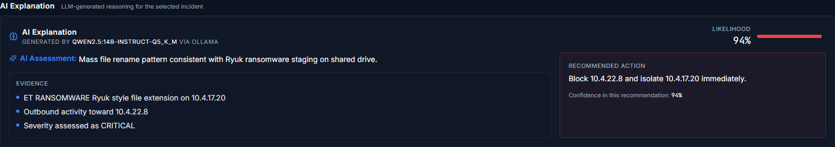
AI Explanation
The local model's reasoning for the selected incident: its assessment, the
evidence it relied on, its recommended action and its likelihood. The panel
also names the model that wrote it (for example qwen2.5:14b-instruct via Ollama).
5.6 System Health (panel)
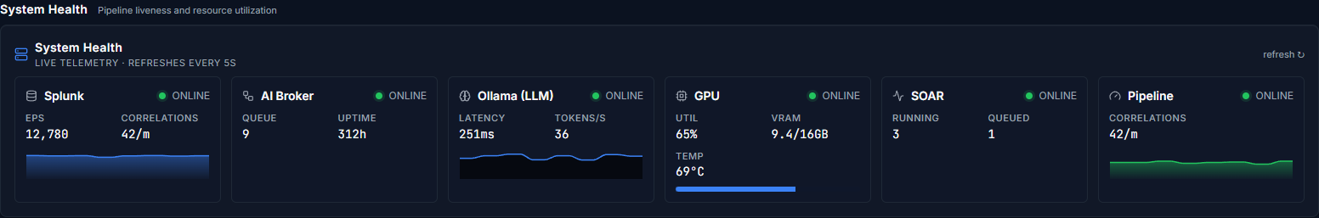
System Health panel
A compact version of the System Health page (Section 11).
6. Working an incident: the AI Tier-2 Decision
This panel is the heart of AO-SOC. You review once, and the response tools then run
the whole plan.
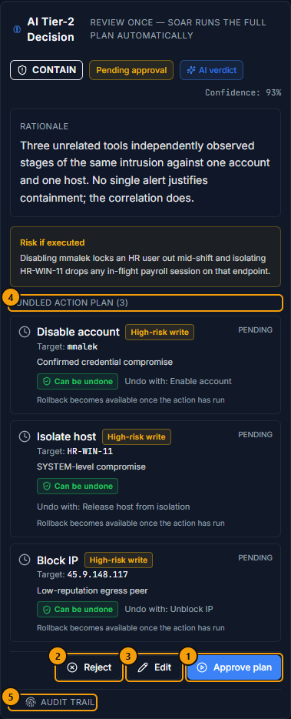
AI Tier-2 Decision
Reading the panel from top to bottom
- Verdict: CONTAIN, ESCALATE, INVESTIGATE, MONITOR or IGNORE.
- Status: Pending approval → Approved → Executing → Complete. Also possible:
Rejected, Failed, Dry run, Superseded.
- Who decided:
  - AI verdict: the model produced the decision.
  - Rule fallback: the model gave no usable answer, so a severity rule decided. Read
these more carefully.
  - Analyst corrected: a person edited it.
- Rationale: why, in plain language.
- Risk if executed (amber box): what the plan could break. For example, disabling an
HR user in the middle of their shift.
- (4) Bundled action plan: each action with:
  - its target (IP address, host or account) and reason,
  - its risk class: Read, Low-risk write, High-risk write or Destructive,
  - its reversibility: Can be undone (with the undo action shown), Cannot be
undone, or Nothing to undo,
  - a guard badge where it applies: Critical asset, Privileged account or
Service account. Autopilot never runs these; a person must approve them.
- Buttons: (1) Approve plan, (2) Reject, (3) Edit.
- (5) Audit trail: how the decision was produced (Section 6.4).
6.1 Approve the plan
- Read the rationale, the Security Situation and the Risk if executed box.
- Check every target in the plan. Is it the right host, account or address?
- Click Approve plan.
Every action is queued and runs automatically. The status of each action changes from
PENDING to EXECUTING and then DONE. When they all succeed, the incident is
cleared: it leaves the queue, moves to the Archive, and a green banner announces
it.
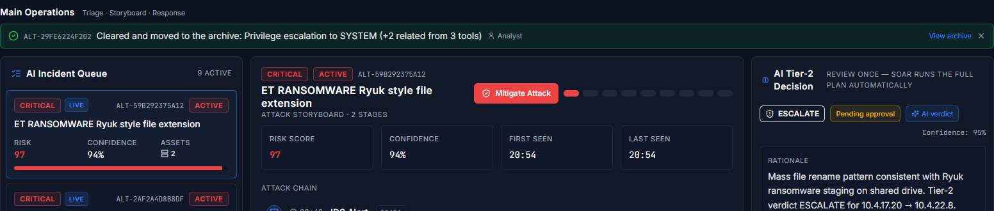
Incident cleared banner
Click View archive to see it, or ✕ to dismiss the banner.
Dry run. When the deployment runs with RESPONSE_DRY_RUN=true, actions show
Dry run (amber) instead of Complete: "nothing was sent to any executor". The
incident is not marked contained. This is deliberate, because a simulated
containment must never look like a real one.
6.2 Edit the plan (correct the AI)
Use Edit when the AI is partly right: the verdict is wrong, a target is wrong, or an
action is missing or unnecessary.
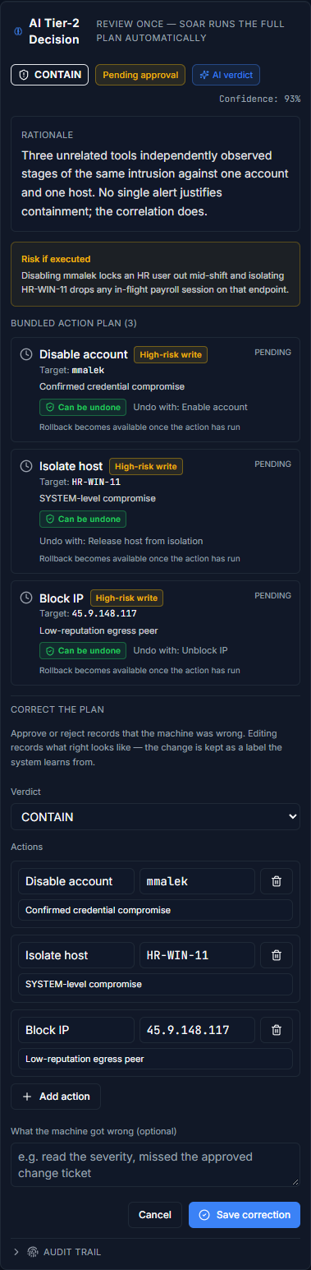
Editing the plan
- Click Edit.
- Change the Verdict if needed.
- Change any action's name, target or reason. Add action adds a row, and the bin
icon removes one.
- Optionally, write what the machine got wrong, for example "missed the approved
change ticket".
- Click Save correction, then approve the corrected plan.
Your correction is stored as a label that the system learns from. It feeds the
precedent that later decisions are compared with. Editing is how the system gets better,
so an edit is more useful than a silent reject.
AO-SOC refuses an edit that could never run, for example a Block IP action whose target
is not an IP address. A plan that has already been executed cannot be edited, because it
is the record of what was sent.
6.3 Reject the plan
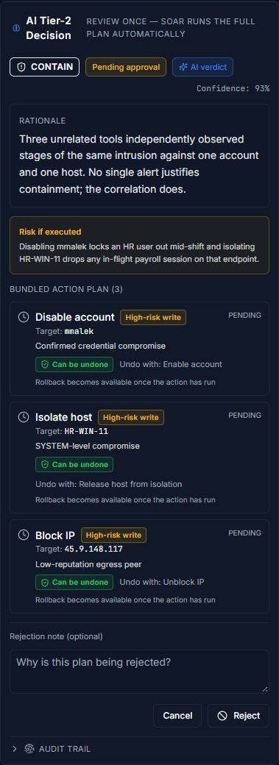
Rejecting the plan
- Click Reject.
- Optionally, write why in the rejection note.
- Confirm with Reject.
Nothing runs. Use Reject when no action is warranted, for example for an authorised
scanner or a known false positive.
6.4 Audit trail
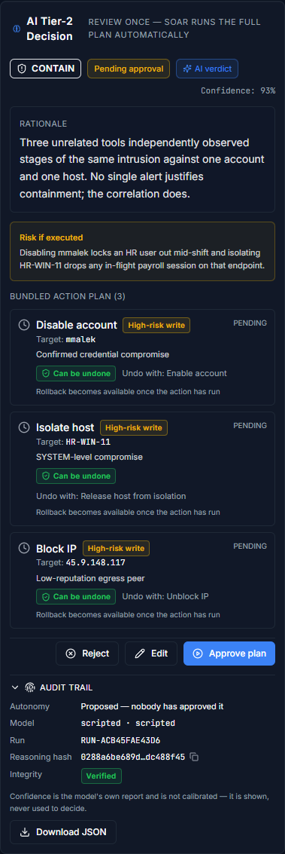
Audit trail
Click Audit trail to expand it. It shows:
- Autonomy: Proposed (nobody has approved it yet), Supervised (a person approved
it) or Autonomous (autopilot approved it on precedent).
- Model and Run: which model produced the decision, and the id of that run.
- Reasoning hash (copy button) and Integrity: Verified means the stored prompt
and answer still match their hash. Mismatch means the record was altered.
- Download JSON: the complete decision envelope (situation, decision, actions and
audit trail), for reports or evidence.
6.5 Record what actually happened
After a decision settles, the panel asks What actually happened, and you can answer
for 72 hours (configurable):
- True positive: it was a real attack.
- False positive: it was not.
- Reopened: it came back.
Please record an outcome. These answers decide which detection sources and verdicts are
trustworthy enough ever to be automated.
6.6 Autopilot (if enabled)
When a site turns autopilot on, some decisions run without a click. Autopilot does
this only when enough similar past cases were confirmed by people with the same
verdict, none were reversed, and the newest is recent. It never automates:
- actions on a critical asset (domain controllers, databases and anything else the
site lists),
- disabling or resetting a privileged or service account,
- an action that cannot be undone,
- a destructive action.
In the Archive, incidents that autopilot cleared carry an Autopilot badge instead of
Analyst.
7. Live Alerts and the Incident Playbook
Menu: Live Alerts. The raw alert log from the broker, for fast scanning.
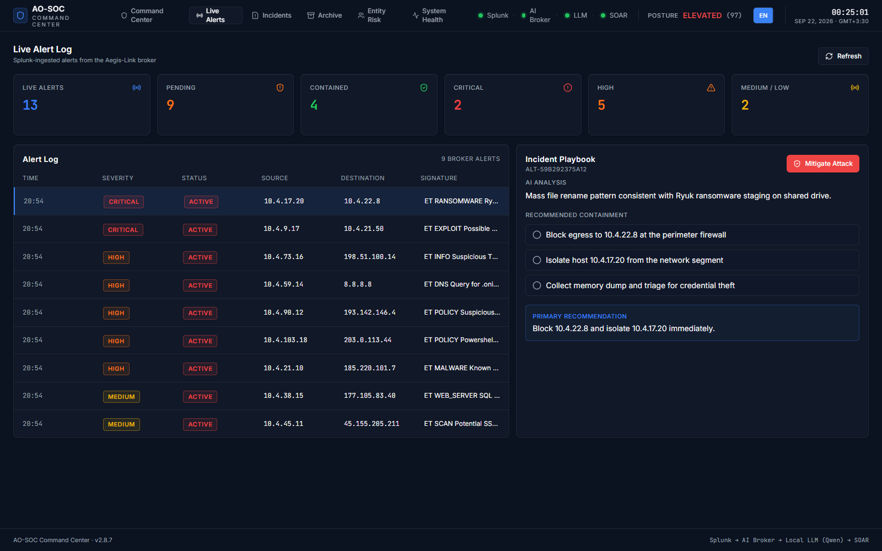
Live Alerts
- Top tiles: counts of Live alerts, Pending, Contained, Critical,
High and Medium / Low.
- Alert Log: time, severity, status, source and destination addresses, and the
signature. Refresh reloads the log.
Click an alert to open its Incident Playbook on the right:
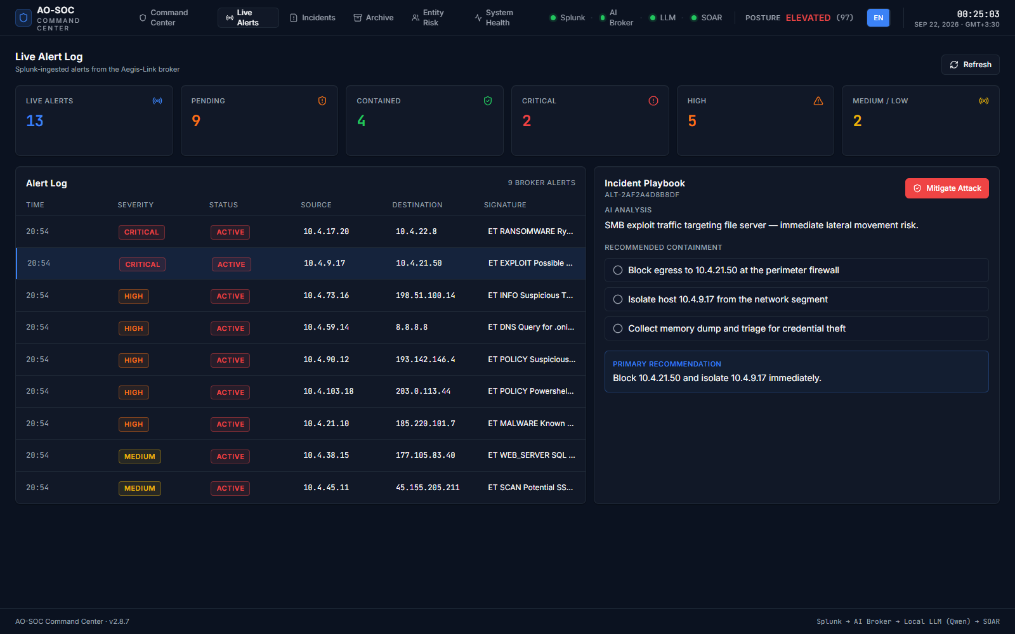
Incident Playbook
- AI analysis: a one-line summary.
- Recommended containment: the playbook steps as a checklist. A step turns green with
a tick once it has been done.
- Primary recommendation: the single most important step.
- Mitigate Attack: marks the alert contained by hand (see Section 5.2).
To approve and run the playbook, open the incident in the Command Center or on
its details page and use Approve plan (Section 6).
8. Incidents list and Incident details
8.1 Incidents
Menu: Incidents. Every active incident in one table.
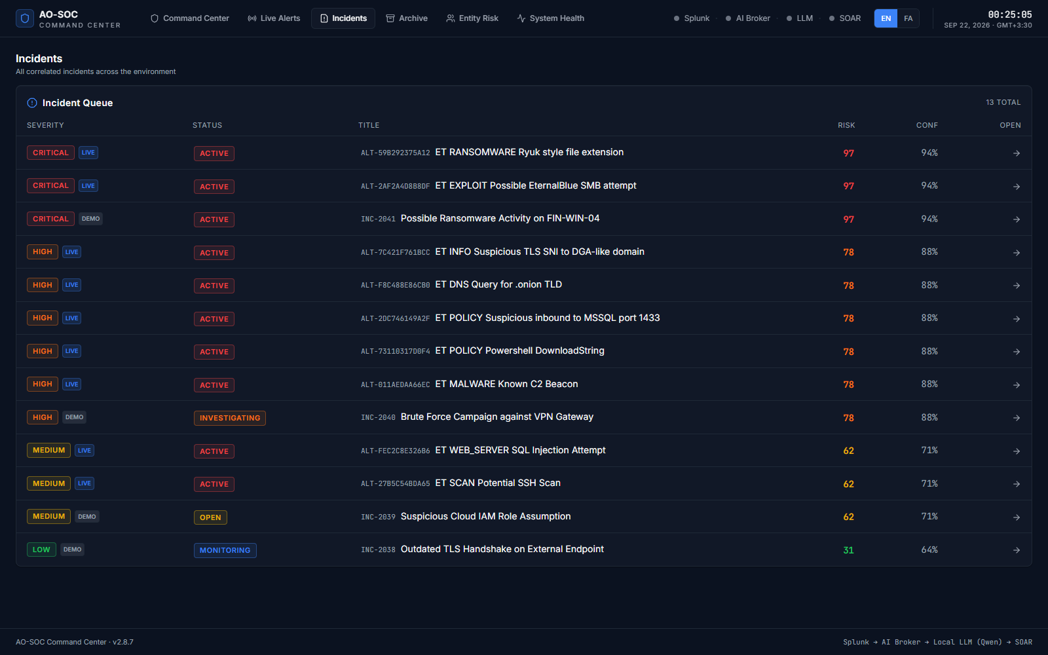
Incidents list
The columns are severity, status (with a LIVE or DEMO badge), title, risk, AI
confidence, and Open. Click a row to open the incident's details page.
8.2 Incident details
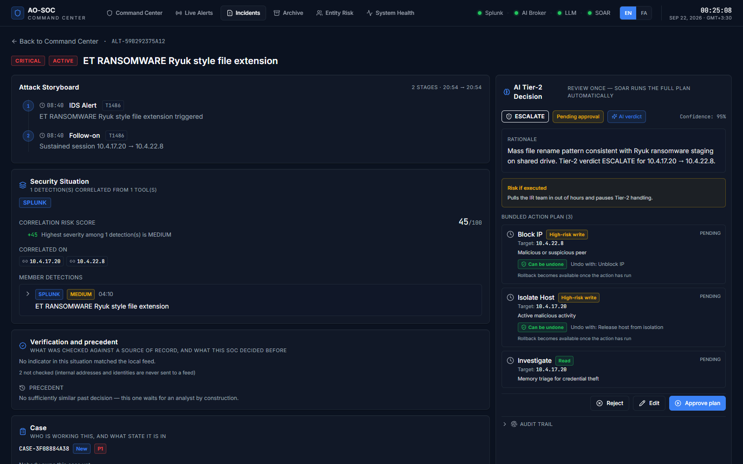
Incident details
One page per incident, with everything in one place:
- Back to Command Center link, the incident id, severity, status and title.
- Left column: the Attack Storyboard, Security Situation, Verification and
precedent, Case and AI Explanation.
- Right column: the AI Tier-2 Decision (with all its buttons), Affected
Assets, MITRE Techniques and AI Recommended Actions.
Use this page when you want to share a link to one incident, or to roll back an
action on an incident that is already contained (Section 9.2).
9. Archive and rolling actions back
9.1 Archive
Menu: Archive. Cleared incidents, newest first.
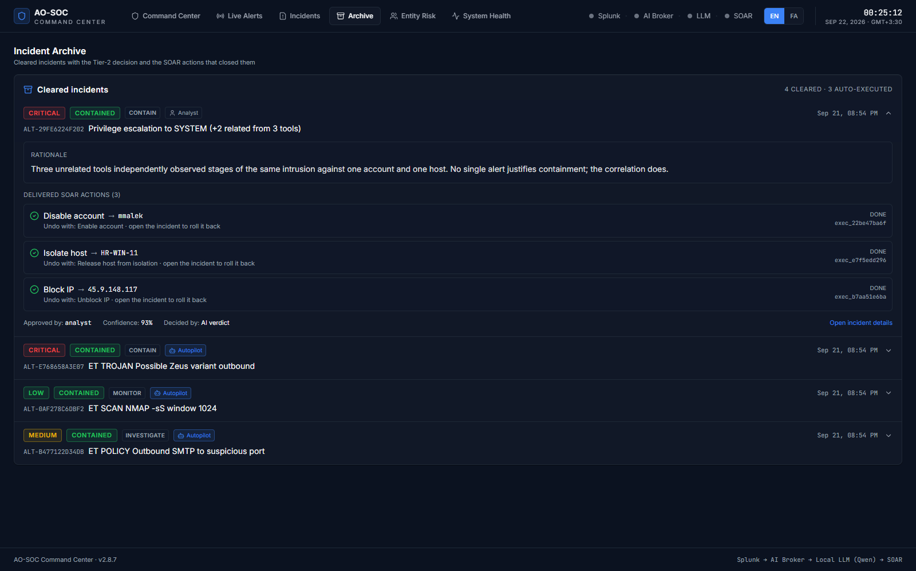
Archive
- The header counts the incidents cleared and how many were auto-executed.
- Each row shows the severity, CONTAINED, the verdict, and Analyst or
Autopilot: who approved it.
- Click a row to expand it and see the rationale, every delivered SOAR action
with its status and execution id, who approved it, its confidence and its decision
source.
- Open incident details opens the full incident page.
9.2 Roll back an action
Any action marked Can be undone can be reversed after it has run. For example, a
Block IP is undone with Unblock IP.
- From the Archive, click Open incident details. You can also use the Command Center
if the incident is still active.
- In the AI Tier-2 Decision panel, find the action and click Roll back.
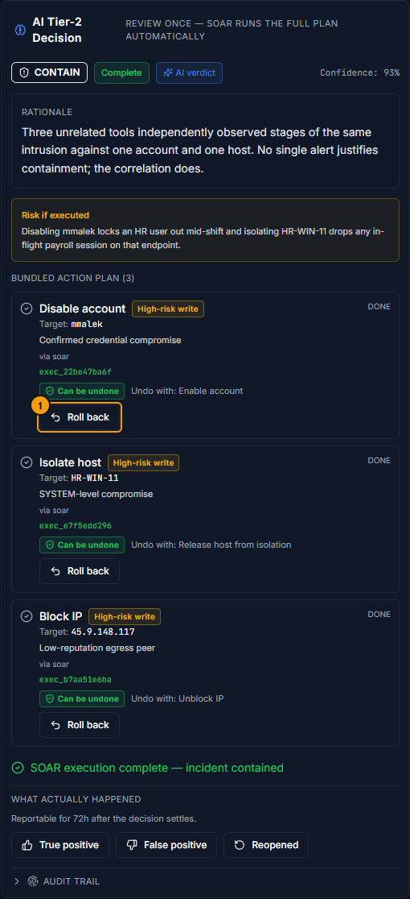
Roll back button
- Optionally, write why, for example "change window CHG-2211 approved this
traffic".
- Click Roll back again to confirm.
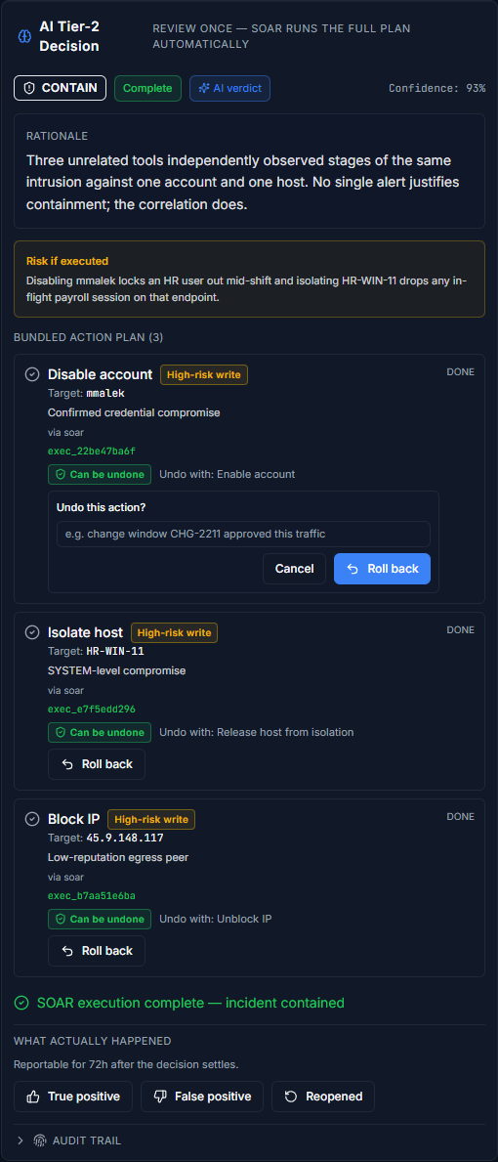
Confirm roll back
The undo action goes through the same route as the original. The action then shows
Rolled back by your name, and the incident reopens instead of staying
"contained". The case file records who undid what.
- The Roll back button appears only after the action has run.
- An action marked Cannot be undone has no Roll back button.
- "The executor refused the rollback" means the response tool has no undo command
configured. Undo the action in that tool directly.
10. Entity Risk
Menu: Entity Risk. The highest-scoring entities across the environment.
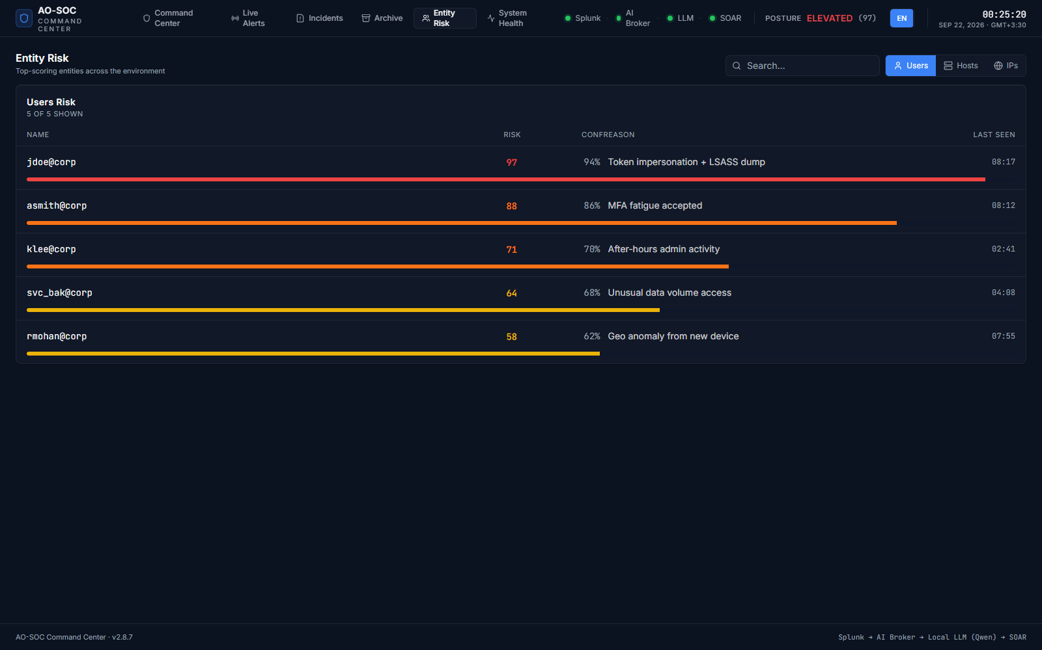
Entity Risk
- Use the tabs on the right to switch between Users, Hosts and IPs.
- Search… filters the list as you type.
- Each row shows the name, the risk score (with a coloured bar), the model's
confidence, the reason and when it was last seen.
Use this page to answer "who or what is most at risk right now?", and to check whether
an account or host from an incident already has a history.
11. System Health
Menu: System Health. Is the pipeline alive?
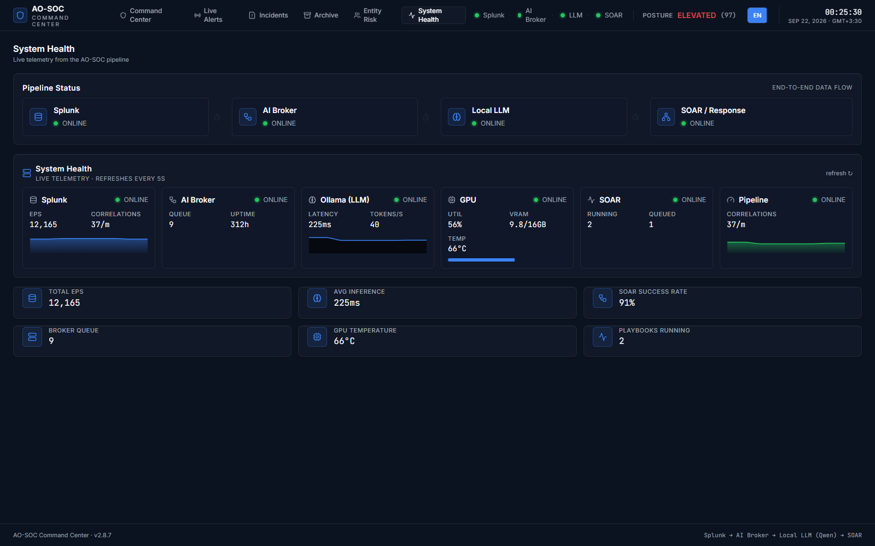
System Health
- Pipeline Status: Splunk → AI Broker → Local LLM → SOAR / Response, each
ONLINE, DEGRADED, OFFLINE or UNKNOWN.
- Live telemetry (refreshed every 5 seconds): events per second and correlations
(Splunk), queue depth and uptime (AI Broker), latency and tokens per second (the
model), GPU utilisation, VRAM and temperature, and SOAR actions running and queued.
- Summary tiles: total EPS, average inference time, SOAR success rate, broker queue,
GPU temperature and playbooks running.
If a component is red or grey, see Section 15.
12. Language: English and Persian
Click FA in the top bar to switch to Persian, and EN to switch back. The whole
interface changes to right-to-left, including labels, dates and risk explanations. The
choice is remembered in this browser.
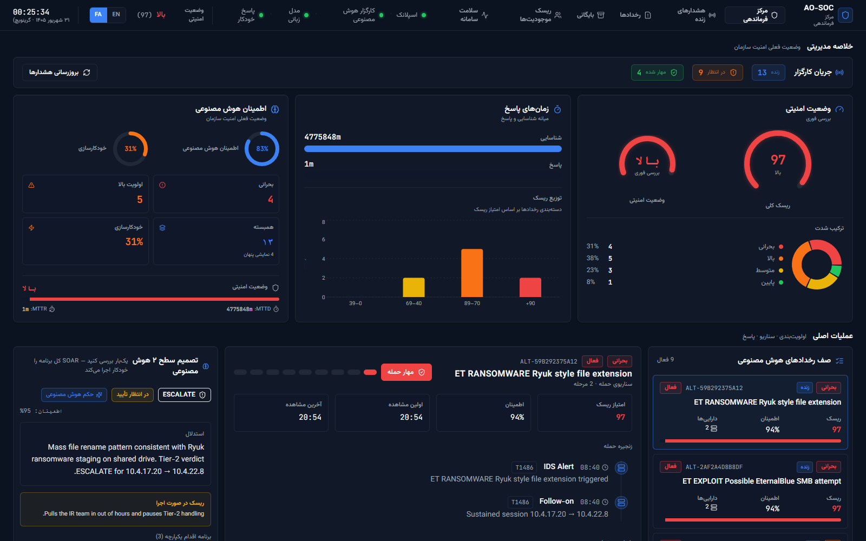
Persian interface
13. A daily routine
At the start of a shift
- Sign in with your own key.
- Look at the top bar: are all four pipeline dots green? If not, open System
Health.
- Read the Executive Summary: the posture, how many incidents are PENDING, and
the severity mix.
During the shift, for each incident in the AI Incident Queue (top first)
- Select it.
- Read: the storyboard, then the Security Situation (what joined it together),
then Verification and precedent.
- Take ownership: in Case, assign it to yourself and set it to In progress.
- Decide, in the AI Tier-2 Decision panel:
  - the plan is right → Approve plan,
  - the plan is partly wrong → Edit, then approve,
  - nothing should run → Reject, with a note,
  - it needs a higher tier → Escalate a tier in the Case panel.
- Note anything useful in the case file.
- When it clears, check the Archive entry.
At the end of the shift
- For decisions that settled today, record True positive / False positive /
Reopened.
- Hand over any case that is still In progress: add a note and reassign it.
- Close the browser tab. This signs you out.
For the shift lead (weekly): take and verify a backup (see the runbook, section 7),
and review which detection sources produce false positives.
14. Glossary: badges, colours and statuses
Severity colours: CRITICAL red · HIGH orange · MEDIUM yellow · LOW green.
Posture: LOW → GUARDED → HEIGHTENED → ELEVATED (the worst).
Term | Meaning
LIVE / DEMO | Real data from the broker / built-in sample data
Situation | One or more detections, possibly from several tools, about the same entities within a time window
Tier-2 decision | The verdict: CONTAIN (act now), ESCALATE (bring in a higher tier or IR), INVESTIGATE (look deeper), MONITOR (watch), IGNORE (no action)
Bundled action plan | The playbook: the set of actions attached to a decision, approved and run together
AI verdict / Rule fallback / Analyst corrected | Whether the model, a severity rule or a person produced the decision
Read / Low-risk write / High-risk write / Destructive | How much an action changes. Destructive actions are refused unless a site enables them deliberately
Can be undone / Cannot be undone / Nothing to undo | Whether the action can be rolled back
Critical asset / Privileged account / Service account | Targets autopilot never touches
Pending approval → Approved → Executing → Complete | The normal status sequence of a plan
Failed | The response tool answered and declined. The reason is in the receipt
Blocked | The action never left AO-SOC. The target was malformed, or no tool performs it
Dry run | Simulated only. Nothing was sent to any tool
Superseded | The situation was merged into another one, and the live decision is there
Precedent | Similar past cases that people decided, which autopilot relies on
Case states | New, Assigned, In progress, Escalated, Resolved, Closed, Reopened
MTTD / MTTR | Mean time to detect / mean time to respond

15. Troubleshooting
Symptom | What to do
The sign-in screen keeps coming back | The key is wrong, revoked, or belongs to the broker rather than the dashboard. Ask your administrator for a key from AOSOC_API_KEYS
"Failed to load dashboard … port 4317" | The UI API is not running. Demo: restart with start-demo. Docker: docker compose -f deploy/docker-compose.yml ps
The queue is empty | Check that the detection tools are sending to the broker with an ingest key. Demo: rerun start-demo, or on Windows run orchestrator\trigger-alert.ps1
New incidents stopped getting decisions | The analysis queue may hold failed jobs. Ask the administrator to check GET /api/queue on the broker. Detections are stored regardless and can be retried
Every decision says Rule fallback | The model is not answering. Check the LLM dot and System Health; make sure Ollama is running and the model is pulled
An action shows Failed | The response tool refused it. The reason is in the delivery receipt. Fix it in that tool, or edit the plan
An action shows Blocked | The target is not valid for that action, or no connector performs it. Edit the plan and correct the target
Everything shows Dry run | The deployment is still in dry-run mode (RESPONSE_DRY_RUN=true). This is by design until the pilot runbook's Stage 2
A case will not change state | That transition is not allowed. Only the buttons shown are valid next states
Pipeline dots are grey (UNKNOWN) | The health check has not answered yet. Wait 5 seconds or reload. If they stay grey, check that the broker is running

When you report a problem, include the version from the footer, the incident id
(for example ALT-8AE6D52F8208), and if possible the Download JSON file from the
Audit trail.
Change log
Version | Date | What changed | Author
1.0 | Summer 2026 | First edition, for ao-soc 2.8.8: installation (demo and Docker), sign-in, every menu and page, the Tier-2 workflow (approve, edit, reject, audit, outcome, rollback), Live Alerts playbook, daily routine, glossary and troubleshooting. 31 screenshots from the demo stack | J.Ekrami, Claude (Opus 5)

