BAN 502 Project - Part 2

Predictive Modeling

Jorge Londono

Data Preparation

Loading Data
library(tidyverse)
library(mice)
library(naniar)
library(gridExtra)
library(usemodels)
library(xgboost)
library(tidymodels)
library(caret)
library(doMC)
train <- read_csv("train.csv")
## Rows: 26570 Columns: 26
## ── Column specification ────────────────────────────────────────────────────────
## Delimiter: ","
## chr (4): product_code, attribute_0, attribute_1, failure
## dbl (22): id, loading, attribute_2, attribute_3, measurement_0, measurement_...
##
## ℹ Use `spec()` to retrieve the full column specification for this data.
## ℹ Specify the column types or set `show_col_types = FALSE` to quiet this message.
test <- read_csv("test.csv")
## Rows: 20775 Columns: 25
## ── Column specification ────────────────────────────────────────────────────────
## Delimiter: ","
## chr (3): product_code, attribute_0, attribute_1
## dbl (22): id, loading, attribute_2, attribute_3, measurement_0, measurement_...
##
## ℹ Use `spec()` to retrieve the full column specification for this data.
## ℹ Specify the column types or set `show_col_types = FALSE` to quiet this message.

Initial Data Exploration
glimpse(train)
## Rows: 26,570
## Columns: 26
## $ id <dbl> 0, 1, 2, 3, 4, 5, 6, 7, 8, 9, 10, 1…
## $ product_code <chr> "A", "A", "A", "A", "A", "A", "A", …
## $ loading <dbl> 80.10, 84.89, 82.43, 101.07, 188.06…
## $ attribute_0 <chr> "material_7", "material_7", "materi…
## $ attribute_1 <chr> "material_8", "material_8", "materi…
## $ attribute_2 <dbl> 9, 9, 9, 9, 9, 9, 9, 9, 9, 9, 9, 9,…
## $ attribute_3 <dbl> 5, 5, 5, 5, 5, 5, 5, 5, 5, 5, 5, 5,…
## $ measurement_0 <dbl> 7, 14, 12, 13, 9, 11, 12, 4, 9, 10,…
## $ measurement_1 <dbl> 8, 3, 1, 2, 2, 4, 2, 8, 6, 4, 3, 3,…
## $ measurement_2 <dbl> 4, 3, 5, 6, 8, 0, 4, 8, 5, 7, 6, 2,…
## $ measurement_3 <dbl> 18.040, 18.213, 18.057, 17.295, 19.…
## $ measurement_4 <dbl> 12.518, 11.540, 11.652, 11.188, 12.…
## $ measurement_5 <dbl> 15.748, 17.717, 16.738, 18.576, 16.…
## $ measurement_6 <dbl> 19.292, 17.893, 18.240, 18.339, 15.…
## $ measurement_7 <dbl> 11.739, 12.748, 12.718, 12.583, 11.…
## $ measurement_8 <dbl> 20.155, 17.889, 18.288, 19.060, 18.…
## $ measurement_9 <dbl> 10.672, 12.448, 12.715, 12.471, 10.…
## $ measurement_10 <dbl> 15.859, 17.947, 15.607, 16.346, 17.…
## $ measurement_11 <dbl> 17.594, 17.915, NA, 18.377, 19.932,…
## $ measurement_12 <dbl> 15.193, 11.755, 13.798, 10.020, 12.…
## $ measurement_13 <dbl> 15.029, 14.732, 16.711, 15.250, 16.…
## $ measurement_14 <dbl> NA, 15.425, 18.631, 15.562, 12.760,…
## $ measurement_15 <dbl> 13.034, 14.395, 14.094, 16.154, 13.…
## $ measurement_16 <dbl> 14.684, 15.631, 17.946, 17.172, 16.…
## $ measurement_17 <dbl> 764.100, 682.057, 663.376, 826.282,…
## $ failure <chr> "No", "No", "No", "No", "No", "No",…
summary(train)
## id product_code loading
## Min. : 0 Length :26570 Min. : 33.16
## 1st Qu.: 6642 N.unique : 5 1st Qu.: 99.99
## Median :13284 N.blank : 0 Median :122.39
## Mean :13284 Min.nchar: 1 Mean :127.83
## 3rd Qu.:19927 Max.nchar: 1 3rd Qu.:149.15
## Max. :26569 Max. :385.86
## NAs :250
## attribute_0 attribute_1 attribute_2
## Length :26570 Length :26570 Min. :5.000
## N.unique : 2 N.unique : 3 1st Qu.:6.000
## N.blank : 0 N.blank : 0 Median :6.000
## Min.nchar: 10 Min.nchar: 10 Mean :6.754
## Max.nchar: 10 Max.nchar: 10 3rd Qu.:8.000
## Max. :9.000
##
## attribute_3 measurement_0 measurement_1
## Min. :5.00 Min. : 0.000 Min. : 0.000
## 1st Qu.:6.00 1st Qu.: 4.000 1st Qu.: 5.000
## Median :8.00 Median : 7.000 Median : 8.000
## Mean :7.24 Mean : 7.416 Mean : 8.233
## 3rd Qu.:8.00 3rd Qu.:10.000 3rd Qu.:11.000
## Max. :9.00 Max. :29.000 Max. :29.000
##
## measurement_2 measurement_3 measurement_4
## Min. : 0.000 Min. :13.97 Min. : 8.008
## 1st Qu.: 4.000 1st Qu.:17.12 1st Qu.:11.051
## Median : 6.000 Median :17.79 Median :11.733
## Mean : 6.257 Mean :17.79 Mean :11.732
## 3rd Qu.: 8.000 3rd Qu.:18.47 3rd Qu.:12.410
## Max. :24.000 Max. :21.50 Max. :16.484
## NAs :381 NAs :538
## measurement_5 measurement_6 measurement_7
## Min. :12.07 Min. :12.71 Min. : 7.968
## 1st Qu.:16.44 1st Qu.:16.84 1st Qu.:11.045
## Median :17.13 Median :17.52 Median :11.712
## Mean :17.13 Mean :17.51 Mean :11.717
## 3rd Qu.:17.80 3rd Qu.:18.18 3rd Qu.:12.391
## Max. :21.43 Max. :21.54 Max. :15.419
## NAs :676 NAs :796 NAs :937
## measurement_8 measurement_9 measurement_10
## Min. :15.22 Min. : 7.537 Min. : 9.323
## 1st Qu.:18.34 1st Qu.:10.757 1st Qu.:15.209
## Median :19.02 Median :11.430 Median :16.127
## Mean :19.02 Mean :11.431 Mean :16.118
## 3rd Qu.:19.71 3rd Qu.:12.102 3rd Qu.:17.025
## Max. :23.81 Max. :15.412 Max. :22.479
## NAs :1048 NAs :1227 NAs :1300
## measurement_11 measurement_12 measurement_13
## Min. :12.46 Min. : 5.167 Min. :10.89
## 1st Qu.:18.17 1st Qu.:10.703 1st Qu.:14.89
## Median :19.21 Median :11.717 Median :15.63
## Mean :19.17 Mean :11.702 Mean :15.65
## 3rd Qu.:20.21 3rd Qu.:12.709 3rd Qu.:16.37
## Max. :25.64 Max. :17.663 Max. :22.71
## NAs :1468 NAs :1601 NAs :1774
## measurement_14 measurement_15 measurement_16
## Min. : 9.14 Min. : 9.104 Min. : 9.701
## 1st Qu.:15.06 1st Qu.:13.957 1st Qu.:15.268
## Median :16.04 Median :14.969 Median :16.436
## Mean :16.05 Mean :14.996 Mean :16.461
## 3rd Qu.:17.08 3rd Qu.:16.018 3rd Qu.:17.628
## Max. :22.30 Max. :21.626 Max. :24.094
## NAs :1874 NAs :2009 NAs :2110
## measurement_17 failure
## Min. : 196.8 Length :26570
## 1st Qu.: 619.0 N.unique : 2
## Median : 701.0 N.blank : 0
## Mean : 701.3 Min.nchar: 2
## 3rd Qu.: 784.1 Max.nchar: 3
## Max. :1312.8
## NAs :2284

Removing id column
The id column is not a useful predictor
train = train %>% select(-id)

Categorical Variables
Changing attribute 2, 3, and the other character values to factors
train = train %>%
mutate(attribute_2 = as_factor(attribute_2)) %>%
mutate(attribute_3 = as_factor(attribute_3)) %>%
mutate_if(is.character,as_factor)
glimpse(train)
## Rows: 26,570
## Columns: 25
## $ product_code <fct> A, A, A, A, A, A, A, A, A, A, A, A,…
## $ loading <dbl> 80.10, 84.89, 82.43, 101.07, 188.06…
## $ attribute_0 <fct> material_7, material_7, material_7,…
## $ attribute_1 <fct> material_8, material_8, material_8,…
## $ attribute_2 <fct> 9, 9, 9, 9, 9, 9, 9, 9, 9, 9, 9, 9,…
## $ attribute_3 <fct> 5, 5, 5, 5, 5, 5, 5, 5, 5, 5, 5, 5,…
## $ measurement_0 <dbl> 7, 14, 12, 13, 9, 11, 12, 4, 9, 10,…
## $ measurement_1 <dbl> 8, 3, 1, 2, 2, 4, 2, 8, 6, 4, 3, 3,…
## $ measurement_2 <dbl> 4, 3, 5, 6, 8, 0, 4, 8, 5, 7, 6, 2,…
## $ measurement_3 <dbl> 18.040, 18.213, 18.057, 17.295, 19.…
## $ measurement_4 <dbl> 12.518, 11.540, 11.652, 11.188, 12.…
## $ measurement_5 <dbl> 15.748, 17.717, 16.738, 18.576, 16.…
## $ measurement_6 <dbl> 19.292, 17.893, 18.240, 18.339, 15.…
## $ measurement_7 <dbl> 11.739, 12.748, 12.718, 12.583, 11.…
## $ measurement_8 <dbl> 20.155, 17.889, 18.288, 19.060, 18.…
## $ measurement_9 <dbl> 10.672, 12.448, 12.715, 12.471, 10.…
## $ measurement_10 <dbl> 15.859, 17.947, 15.607, 16.346, 17.…
## $ measurement_11 <dbl> 17.594, 17.915, NA, 18.377, 19.932,…
## $ measurement_12 <dbl> 15.193, 11.755, 13.798, 10.020, 12.…
## $ measurement_13 <dbl> 15.029, 14.732, 16.711, 15.250, 16.…
## $ measurement_14 <dbl> NA, 15.425, 18.631, 15.562, 12.760,…
## $ measurement_15 <dbl> 13.034, 14.395, 14.094, 16.154, 13.…
## $ measurement_16 <dbl> 14.684, 15.631, 17.946, 17.172, 16.…
## $ measurement_17 <dbl> 764.100, 682.057, 663.376, 826.282,…
## $ failure <fct> No, No, No, No, No, No, Yes, Yes, N…

Checking for Missingness
gg_miss_var(train)
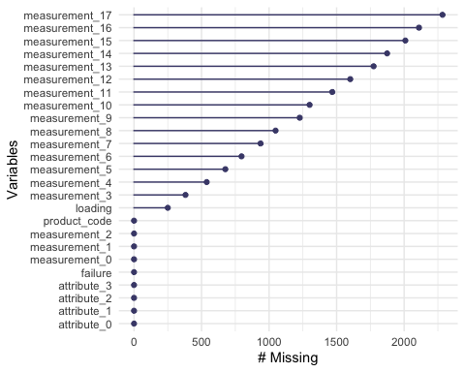
gg_miss_case(train)
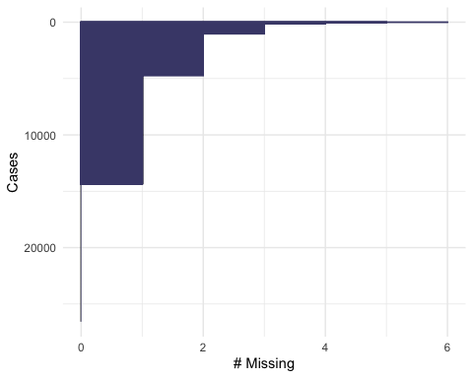
gg_miss_fct(x = train, fct = failure)
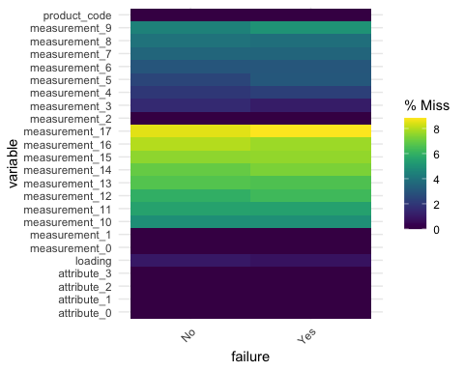
There are a large number of missing values in the numerical variables that will need to be imputed.

Imputing missing values
set.seed(1234) #sets seed for random number generator
imp = mice(train, m=5, method='pmm', printFlag=FALSE)
## Warning: Number of logged events: 799

Merging imputed values back to training set
train = complete(imp)
summary(train)
## product_code loading attribute_0
## A:5100 Min. : 33.16 material_7:21320
## B:5250 1st Qu.: 99.88 material_5: 5250
## C:5765 Median :122.12
## D:5112 Mean :127.63
## E:5343 3rd Qu.:148.84
## Max. :385.86
## attribute_1 attribute_2 attribute_3
## material_8:10865 5: 5765 5: 5100
## material_5:10362 6:10455 6: 5112
## material_6: 5343 8: 5250 8:11015
## 9: 5100 9: 5343
##
##
## measurement_0 measurement_1 measurement_2
## Min. : 0.000 Min. : 0.000 Min. : 0.000
## 1st Qu.: 4.000 1st Qu.: 5.000 1st Qu.: 4.000
## Median : 7.000 Median : 8.000 Median : 6.000
## Mean : 7.416 Mean : 8.233 Mean : 6.257
## 3rd Qu.:10.000 3rd Qu.:11.000 3rd Qu.: 8.000
## Max. :29.000 Max. :29.000 Max. :24.000
## measurement_3 measurement_4 measurement_5
## Min. :13.97 Min. : 8.008 Min. :12.07
## 1st Qu.:17.12 1st Qu.:11.072 1st Qu.:16.44
## Median :17.78 Median :11.719 Median :17.13
## Mean :17.79 Mean :11.727 Mean :17.13
## 3rd Qu.:18.46 3rd Qu.:12.396 3rd Qu.:17.80
## Max. :21.50 Max. :16.484 Max. :21.43
## measurement_6 measurement_7 measurement_8
## Min. :12.71 Min. : 7.968 Min. :15.22
## 1st Qu.:16.86 1st Qu.:11.006 1st Qu.:18.37
## Median :17.55 Median :11.687 Median :19.07
## Mean :17.58 Mean :11.697 Mean :19.08
## 3rd Qu.:18.25 3rd Qu.:12.385 3rd Qu.:19.75
## Max. :21.54 Max. :15.419 Max. :23.81
## measurement_9 measurement_10 measurement_11
## Min. : 7.537 Min. : 9.323 Min. :12.46
## 1st Qu.:10.764 1st Qu.:15.088 1st Qu.:18.24
## Median :11.467 Median :16.073 Median :19.32
## Mean :11.431 Mean :16.046 Mean :19.31
## 3rd Qu.:12.125 3rd Qu.:17.015 3rd Qu.:20.41
## Max. :15.412 Max. :22.479 Max. :25.64
## measurement_12 measurement_13 measurement_14
## Min. : 5.167 Min. :10.89 Min. : 9.14
## 1st Qu.:10.662 1st Qu.:14.95 1st Qu.:15.08
## Median :11.692 Median :15.72 Median :16.13
## Mean :11.635 Mean :15.91 Mean :16.13
## 3rd Qu.:12.756 3rd Qu.:16.58 3rd Qu.:17.13
## Max. :17.663 Max. :22.71 Max. :22.30
## measurement_15 measurement_16 measurement_17
## Min. : 9.104 Min. : 9.701 Min. : 196.8
## 1st Qu.:13.897 1st Qu.:15.017 1st Qu.: 593.2
## Median :14.873 Median :16.326 Median : 689.6
## Mean :14.859 Mean :16.278 Mean : 680.5
## 3rd Qu.:15.998 3rd Qu.:17.610 3rd Qu.: 777.4
## Max. :21.626 Max. :24.094 Max. :1312.8
## failure
## No :20921
## Yes: 5649
##
##
##
##

Exploratory Data Analysis

Class Imbalance
train %>%
count(failure) %>%
mutate(pct = n / sum(n) * 100) %>%
ggplot(aes(x = failure, y = pct, fill = failure)) +
geom_col() +
geom_text(aes(label = sprintf("%.1f%%", pct)), vjust = -0.5) +
labs(y = "Percentage", title = "Class Distribution of Failure") +
ylim(0, 90)
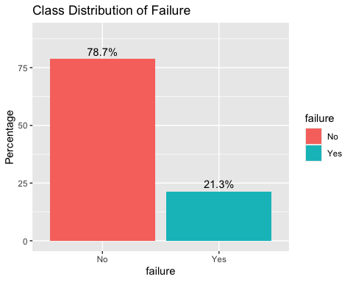
table(train$failure)
##
## No Yes
## 20921 5649
prop.table(table(train$failure))
##
## No Yes
## 0.7873918 0.2126082
This class imbalance will have to be taken into consideration when building the models

Categorical Variables
c1 = ggplot(train, aes(x=product_code , fill= failure)) + geom_bar(position="fill")
c2 = ggplot(train, aes(x=attribute_0 , fill= failure)) + geom_bar(position="fill")
c3 = ggplot(train, aes(x=attribute_1 , fill= failure)) + geom_bar(position="fill")
c4 = ggplot(train, aes(x=attribute_2 , fill= failure)) + geom_bar(position="fill")
c5 = ggplot(train, aes(x=attribute_3 , fill= failure)) + geom_bar(position="fill")
c1
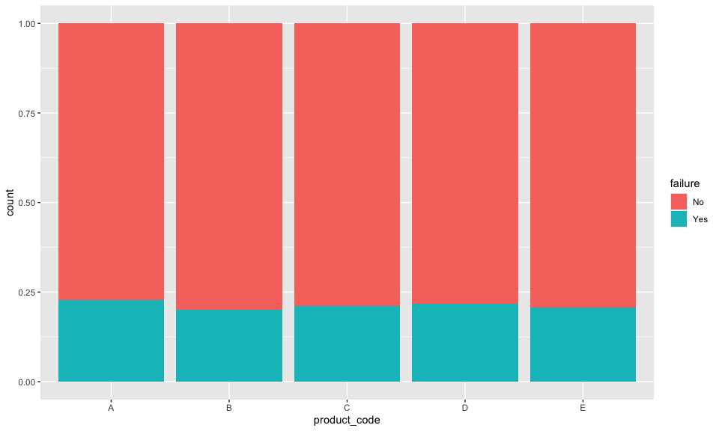
grid.arrange(c2,c3,c4,c5)
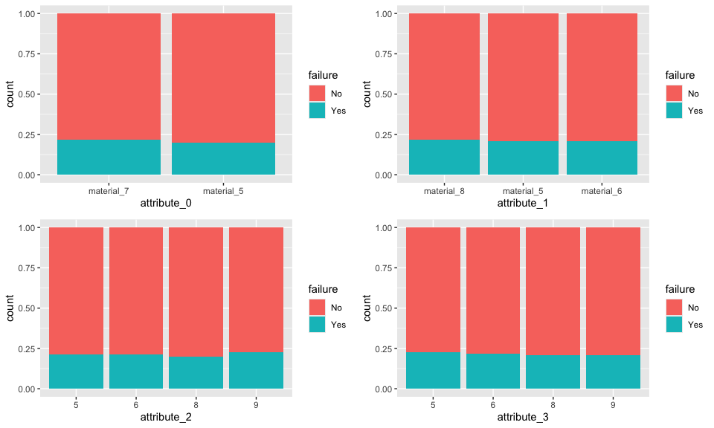

Numeric Variables
n1 = ggplot(train, aes(y=loading , x= failure)) + geom_boxplot()
n2 = ggplot(train, aes(y=measurement_0 , x= failure)) + geom_boxplot()
n3 = ggplot(train, aes(y=measurement_1 , x= failure)) + geom_boxplot()
n4 = ggplot(train, aes(y=measurement_2 , x= failure)) + geom_boxplot()
n5 = ggplot(train, aes(y=measurement_3 , x= failure)) + geom_boxplot()
n6 = ggplot(train, aes(y=measurement_4 , x= failure)) + geom_boxplot()
n7 = ggplot(train, aes(y=measurement_5 , x= failure)) + geom_boxplot()
n8 = ggplot(train, aes(y=measurement_6 , x= failure)) + geom_boxplot()
n9 = ggplot(train, aes(y=measurement_7 , x= failure)) + geom_boxplot()
n10 = ggplot(train, aes(y=measurement_8 , x= failure)) + geom_boxplot()
n11 = ggplot(train, aes(y=measurement_9 , x= failure)) + geom_boxplot()
n12 = ggplot(train, aes(y=measurement_10 , x= failure)) + geom_boxplot()
n13 = ggplot(train, aes(y=measurement_11 , x= failure)) + geom_boxplot()
n14 = ggplot(train, aes(y=measurement_12 , x= failure)) + geom_boxplot()
n15 = ggplot(train, aes(y=measurement_13 , x= failure)) + geom_boxplot()
n16 = ggplot(train, aes(y=measurement_14 , x= failure)) + geom_boxplot()
n17 = ggplot(train, aes(y=measurement_15 , x= failure)) + geom_boxplot()
n18 = ggplot(train, aes(y=measurement_16 , x= failure)) + geom_boxplot()
n19 = ggplot(train, aes(y=measurement_17 , x= failure)) + geom_boxplot()
n1
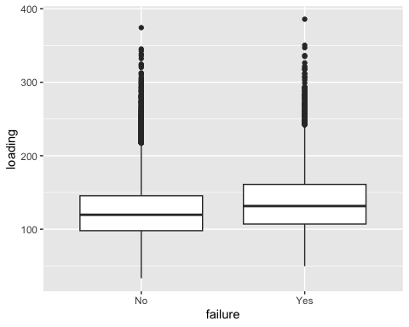
grid.arrange(n2,n3,n4,n5)
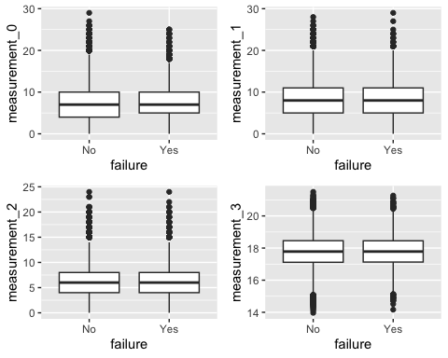
grid.arrange(n6,n7,n8,n9)
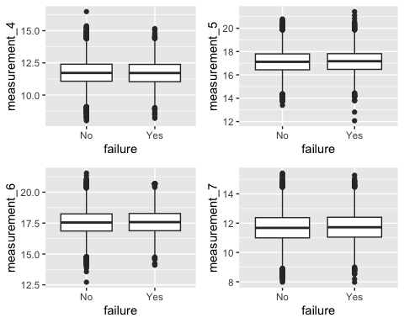
grid.arrange(n10,n11,n12,n13)
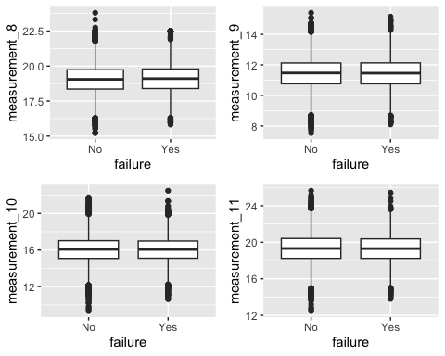
grid.arrange(n14,n15,n16,n17)
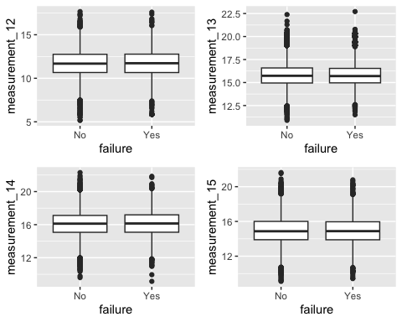
grid.arrange(n18,n19)
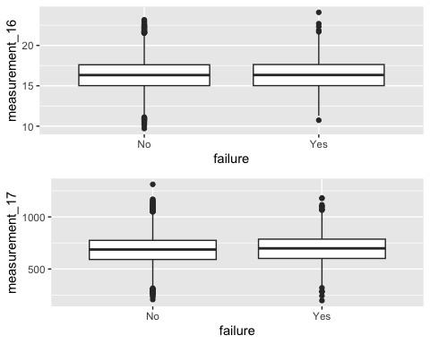
Aside from the loadings variable, all other variables don’t seem to have good individual predictive power for the failure variable.

Train/Test Split and Cross-Validation

Splitting Into Sets
set.seed(123)
data_split = initial_split(train, prop = 0.8, strata = failure)
train_set = training(data_split)
test_set = testing(data_split)

Cross Validation
set.seed(123)
folds = vfold_cv(train_set, v = 5, strata = failure)

Model #1 XGBoost Baseline

Model Build #1
registerDoMC(cores = parallel::detectCores() - 1) # this will help with performance
xgboost_recipe <-
recipe(formula = failure ~. , data = train_set) %>%
step_unknown(all_nominal(), -all_outcomes()) %>% # This will help if the test data has unseen categorical variables.
step_dummy(all_nominal(), -all_outcomes(), one_hot = TRUE)
xgboost_model <-
boost_tree() %>%
set_mode("classification") %>%
set_engine("xgboost", scale_pos_weight = 3.54) # this will adress the 78/22 class imbalance I noted earlier
xgboost_workflow <-
workflow() %>%
add_recipe(xgboost_recipe) %>%
add_model(xgboost_model)

Training Set Performance #1
xgboost_fit <- fit(xgboost_workflow, data = train_set)
trainpredxgb = predict(xgboost_fit, train_set)
confusionMatrix(trainpredxgb$.pred_class, train_set$failure,
positive = "Yes")
## Confusion Matrix and Statistics
##
## Reference
## Prediction No Yes
## No 16736 4477
## Yes 0 42
##
## Accuracy : 0.7894
## 95% CI : (0.7838, 0.7948)
## No Information Rate : 0.7874
## P-Value [Acc > NIR] : 0.2436
##
## Kappa : 0.0146
##
## Mcnemar's Test P-Value : <2e-16
##
## Sensitivity : 0.009294
## Specificity : 1.000000
## Pos Pred Value : 1.000000
## Neg Pred Value : 0.788950
## Prevalence : 0.212609
## Detection Rate : 0.001976
## Detection Prevalence : 0.001976
## Balanced Accuracy : 0.504647
##
## 'Positive' Class : Yes
##

Testing Set Performance #1
testpredxgb = predict(xgboost_fit, test_set)
confusionMatrix(testpredxgb$.pred_class, test_set$failure,
positive = "Yes")
## Confusion Matrix and Statistics
##
## Reference
## Prediction No Yes
## No 4184 1130
## Yes 1 0
##
## Accuracy : 0.7872
## 95% CI : (0.776, 0.7981)
## No Information Rate : 0.7874
## P-Value [Acc > NIR] : 0.5213
##
## Kappa : -4e-04
##
## Mcnemar's Test P-Value : <2e-16
##
## Sensitivity : 0.0000000
## Specificity : 0.9997611
## Pos Pred Value : 0.0000000
## Neg Pred Value : 0.7873542
## Prevalence : 0.2126058
## Detection Rate : 0.0000000
## Detection Prevalence : 0.0001881
## Balanced Accuracy : 0.4998805
##
## 'Positive' Class : Yes
##
This model is not particularly strong. It is having a hard time predicting any failures.

Saving Model #1
saveRDS(xgboost_fit,"xgb_fit_1.rds")

Model #2 XGBoost Random Search Tuning

Model Build #2
xgboost_model <-
boost_tree(trees = tune(), min_n = tune(), tree_depth = tune(), learn_rate = tune(),
loss_reduction = tune(), sample_size = tune()) %>%
set_mode("classification") %>%
set_engine("xgboost", scale_pos_weight = 3.54) # class imbalance
xgboost_workflow <-
workflow() %>%
add_recipe(xgboost_recipe) %>%
add_model(xgboost_model)
set.seed(123)
xgboost_tune <-
tune_grid(xgboost_workflow,
resamples = folds,
grid = 25,
metrics = metric_set(accuracy))
best_xgb = select_best(xgboost_tune,metric= "accuracy")
final_xgb = finalize_workflow(
xgboost_workflow,
best_xgb
)
show_best(xgboost_tune, metric = "accuracy")
## # A tibble: 5 × 12
## trees min_n tree_depth learn_rate loss_reduction sample_size .metric
## <int> <int> <int> <dbl> <dbl> <dbl> <chr>
## 1 667 16 3 0.121 0.000000681 0.5 accuracy
## 2 1 6 6 0.0287 1.15 0.729 accuracy
## 3 84 17 4 0.0140 0.0000000001 0.792 accuracy
## 4 167 38 8 0.0178 0.00154 0.562 accuracy
## 5 334 27 4 0.001 0.00464 0.896 accuracy
## # ℹ 5 more variables: .estimator <chr>, mean <dbl>, n <int>, std_err <dbl>,
## # .config <chr>
autoplot(xgboost_tune)
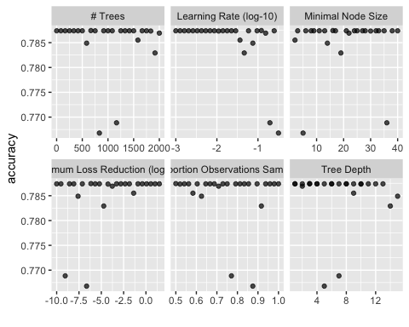
From this graph I can try and focus the range of the tunings to have a more refined search

Training Performance #2
xgboost_fit <- fit(final_xgb, data = train_set)
trainpredxgb = predict(xgboost_fit, train_set)
confusionMatrix(trainpredxgb$.pred_class, train_set$failure,
positive = "Yes")
## Confusion Matrix and Statistics
##
## Reference
## Prediction No Yes
## No 16736 4503
## Yes 0 16
##
## Accuracy : 0.7881
## 95% CI : (0.7826, 0.7936)
## No Information Rate : 0.7874
## P-Value [Acc > NIR] : 0.3981
##
## Kappa : 0.0056
##
## Mcnemar's Test P-Value : <2e-16
##
## Sensitivity : 0.0035406
## Specificity : 1.0000000
## Pos Pred Value : 1.0000000
## Neg Pred Value : 0.7879844
## Prevalence : 0.2126088
## Detection Rate : 0.0007528
## Detection Prevalence : 0.0007528
## Balanced Accuracy : 0.5017703
##
## 'Positive' Class : Yes
##

Testing Performance #2
testpredxgb = predict(xgboost_fit, test_set)
confusionMatrix(testpredxgb$.pred_class, test_set$failure,
positive = "Yes")
## Confusion Matrix and Statistics
##
## Reference
## Prediction No Yes
## No 4184 1129
## Yes 1 1
##
## Accuracy : 0.7874
## 95% CI : (0.7761, 0.7983)
## No Information Rate : 0.7874
## P-Value [Acc > NIR] : 0.508
##
## Kappa : 0.001
##
## Mcnemar's Test P-Value : <2e-16
##
## Sensitivity : 0.0008850
## Specificity : 0.9997611
## Pos Pred Value : 0.5000000
## Neg Pred Value : 0.7875024
## Prevalence : 0.2126058
## Detection Rate : 0.0001881
## Detection Prevalence : 0.0003763
## Balanced Accuracy : 0.5003230
##
## 'Positive' Class : Yes
##
This model is not particularly strong. It is having a hard time predicting any failures.

Saving Model #2
saveRDS(final_xgb,"xgb_fit_2.rds")

Model #3 XGBoost Refined Search Tuning

Model Build #3
refined_grid <- grid_regular(
trees(range = c(100, 500)),
learn_rate(range = c(-2, -1)),
tree_depth(range = c(3, 8)),
min_n(range = c(2, 20)),
levels = 3
)
xgboost_model <-
boost_tree(
trees = tune(),
learn_rate = tune(),
tree_depth = tune(),
min_n = tune()
) %>%
set_mode("classification") %>%
set_engine("xgboost", scale_pos_weight = 3.54)
xgboost_workflow <-
workflow() %>%
add_recipe(xgboost_recipe) %>%
add_model(xgboost_model)
set.seed(123)
xgboost_tune <-
tune_grid(xgboost_workflow,
resamples = folds,
grid = refined_grid,
metrics = metric_set(accuracy))
best_xgb = select_best(xgboost_tune,metric= "accuracy")
final_xgb = finalize_workflow(
xgboost_workflow,
best_xgb
)

Training Performance #3
xgboost_fit <- fit(final_xgb, data = train_set)
trainpredxgb = predict(xgboost_fit, train_set)
confusionMatrix(trainpredxgb$.pred_class, train_set$failure,
positive = "Yes")
## Confusion Matrix and Statistics
##
## Reference
## Prediction No Yes
## No 16736 4498
## Yes 0 21
##
## Accuracy : 0.7884
## 95% CI : (0.7828, 0.7939)
## No Information Rate : 0.7874
## P-Value [Acc > NIR] : 0.3661
##
## Kappa : 0.0073
##
## Mcnemar's Test P-Value : <2e-16
##
## Sensitivity : 0.004647
## Specificity : 1.000000
## Pos Pred Value : 1.000000
## Neg Pred Value : 0.788170
## Prevalence : 0.212609
## Detection Rate : 0.000988
## Detection Prevalence : 0.000988
## Balanced Accuracy : 0.502324
##
## 'Positive' Class : Yes
##

Testing Performance #3
testpredxgb = predict(xgboost_fit, test_set)
confusionMatrix(testpredxgb$.pred_class, test_set$failure,
positive = "Yes")
## Confusion Matrix and Statistics
##
## Reference
## Prediction No Yes
## No 4184 1130
## Yes 1 0
##
## Accuracy : 0.7872
## 95% CI : (0.776, 0.7981)
## No Information Rate : 0.7874
## P-Value [Acc > NIR] : 0.5213
##
## Kappa : -4e-04
##
## Mcnemar's Test P-Value : <2e-16
##
## Sensitivity : 0.0000000
## Specificity : 0.9997611
## Pos Pred Value : 0.0000000
## Neg Pred Value : 0.7873542
## Prevalence : 0.2126058
## Detection Rate : 0.0000000
## Detection Prevalence : 0.0001881
## Balanced Accuracy : 0.4998805
##
## 'Positive' Class : Yes
##
This model is not particularly strong. It is having a hard time predicting any failures.

Saving Model #3
saveRDS(final_xgb,"xgb_fit_3.rds")

Model #4 RandomForest Baseline

Model Build #4
rf_recipe <-
recipe(formula = failure ~. , data = train_set) %>%
step_unknown(all_nominal(), -all_outcomes()) %>%
step_dummy(all_nominal(), -all_outcomes(), one_hot = TRUE)
rf_model <-
rand_forest() %>%
set_engine("ranger") %>%
set_mode("classification")
rf_workflow <-
workflow() %>%
add_recipe(rf_recipe) %>%
add_model(rf_model)

Training Performance #4
rf_fit = fit(rf_workflow, train_set)
trainpredrf = predict(rf_fit, train_set)
confusionMatrix(trainpredrf$.pred_class, train_set$failure,
positive = "Yes")
## Confusion Matrix and Statistics
##
## Reference
## Prediction No Yes
## No 16736 323
## Yes 0 4196
##
## Accuracy : 0.9848
## 95% CI : (0.9831, 0.9864)
## No Information Rate : 0.7874
## P-Value [Acc > NIR] : < 2.2e-16
##
## Kappa : 0.9534
##
## Mcnemar's Test P-Value : < 2.2e-16
##
## Sensitivity : 0.9285
## Specificity : 1.0000
## Pos Pred Value : 1.0000
## Neg Pred Value : 0.9811
## Prevalence : 0.2126
## Detection Rate : 0.1974
## Detection Prevalence : 0.1974
## Balanced Accuracy : 0.9643
##
## 'Positive' Class : Yes
##

Testing Performance #4
testpredrf = predict(rf_fit, test_set)
confusionMatrix(testpredrf$.pred_class, test_set$failure,
positive = "Yes")
## Confusion Matrix and Statistics
##
## Reference
## Prediction No Yes
## No 4185 1130
## Yes 0 0
##
## Accuracy : 0.7874
## 95% CI : (0.7761, 0.7983)
## No Information Rate : 0.7874
## P-Value [Acc > NIR] : 0.508
##
## Kappa : 0
##
## Mcnemar's Test P-Value : <2e-16
##
## Sensitivity : 0.0000
## Specificity : 1.0000
## Pos Pred Value : NaN
## Neg Pred Value : 0.7874
## Prevalence : 0.2126
## Detection Rate : 0.0000
## Detection Prevalence : 0.0000
## Balanced Accuracy : 0.5000
##
## 'Positive' Class : Yes
##
This model is not particularly strong. While the training performance seemed very strong, the tesing shows that it was in fact overfitting.

Saving Model #4
saveRDS(rf_fit, "rf_fit_1.rds")

Model #5 RandomForest Random Search Tuning

Model Build #5
rf_model = rand_forest(mtry = tune(), min_n = tune(), trees = 100) %>%
set_engine("ranger") %>%
set_mode("classification")
rf_workflow <-
workflow() %>%
add_recipe(rf_recipe) %>%
add_model(rf_model)
set.seed(123)
rf_res = tune_grid(
rf_workflow,
resamples = folds,
grid = 25,
metrics = metric_set(accuracy))
## i Creating pre-processing data to finalize 1 unknown parameter: "mtry"
best_rf = select_best(rf_res, metric= "accuracy")
final_rf = finalize_workflow(
rf_workflow,
best_rf
)
show_best(rf_res, metric = "accuracy")
## # A tibble: 5 × 8
## mtry min_n .metric .estimator mean n std_err .config
## <int> <int> <chr> <chr> <dbl> <int> <dbl> <chr>
## 1 11 36 accuracy binary 0.787 5 0.000280 pre0_mod07_post0
## 2 1 24 accuracy binary 0.787 5 0.0000359 pre0_mod01_post0
## 3 2 13 accuracy binary 0.787 5 0.0000359 pre0_mod02_post0
## 4 4 33 accuracy binary 0.787 5 0.0000359 pre0_mod03_post0
## 5 7 19 accuracy binary 0.787 5 0.0000598 pre0_mod05_post0
autoplot(rf_res)
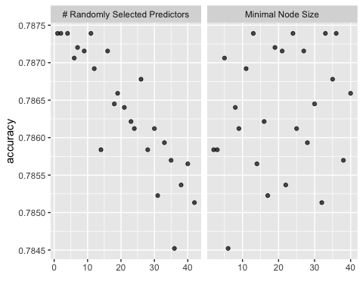
From this graph I can try and focus the range of the tunings to have a more refined search

Training Performance #5
rf_fit = fit(final_rf, train_set)
trainpredrf = predict(rf_fit, train_set)
confusionMatrix(trainpredrf$.pred_class, train_set$failure,
positive = "Yes")
## Confusion Matrix and Statistics
##
## Reference
## Prediction No Yes
## No 16736 3414
## Yes 0 1105
##
## Accuracy : 0.8394
## 95% CI : (0.8344, 0.8443)
## No Information Rate : 0.7874
## P-Value [Acc > NIR] : < 2.2e-16
##
## Kappa : 0.3376
##
## Mcnemar's Test P-Value : < 2.2e-16
##
## Sensitivity : 0.24452
## Specificity : 1.00000
## Pos Pred Value : 1.00000
## Neg Pred Value : 0.83057
## Prevalence : 0.21261
## Detection Rate : 0.05199
## Detection Prevalence : 0.05199
## Balanced Accuracy : 0.62226
##
## 'Positive' Class : Yes
##

Testing Performance #5
testpredrf = predict(rf_fit, test_set)
confusionMatrix(testpredrf$.pred_class, test_set$failure,
positive = "Yes")
## Confusion Matrix and Statistics
##
## Reference
## Prediction No Yes
## No 4182 1129
## Yes 3 1
##
## Accuracy : 0.787
## 95% CI : (0.7758, 0.798)
## No Information Rate : 0.7874
## P-Value [Acc > NIR] : 0.5347
##
## Kappa : 3e-04
##
## Mcnemar's Test P-Value : <2e-16
##
## Sensitivity : 0.0008850
## Specificity : 0.9992832
## Pos Pred Value : 0.2500000
## Neg Pred Value : 0.7874223
## Prevalence : 0.2126058
## Detection Rate : 0.0001881
## Detection Prevalence : 0.0007526
## Balanced Accuracy : 0.5000841
##
## 'Positive' Class : Yes
##
Similar scenario to the previous model. It is over fitting and does not have good enough predictive power on unseen data.

Saving Model #5
saveRDS(final_rf, "rf_fit_2.rds")

Model #6 RandomForest Refined Search Tuning

Model Build #6
rf_grid = grid_regular(
mtry(range = c(1, 10)),
min_n(range = c(20, 50)),
levels = 5
)
rf_model = rand_forest(mtry = tune(), min_n = tune(), trees = 100) %>%
set_engine("ranger") %>%
set_mode("classification")
rf_workflow <-
workflow() %>%
add_recipe(rf_recipe) %>%
add_model(rf_model)
set.seed(123)
rf_res = tune_grid(
rf_workflow,
resamples = folds,
grid = rf_grid,
metrics = metric_set(accuracy))
best_rf = select_best(rf_res, metric= "accuracy")
final_rf = finalize_workflow(
rf_workflow,
best_rf
)

Training Performance #6
rf_fit = fit(final_rf, train_set)
trainpredrf = predict(rf_fit, train_set)
confusionMatrix(trainpredrf$.pred_class, train_set$failure,
positive = "Yes")
## Confusion Matrix and Statistics
##
## Reference
## Prediction No Yes
## No 16736 3783
## Yes 0 736
##
## Accuracy : 0.822
## 95% CI : (0.8168, 0.8271)
## No Information Rate : 0.7874
## P-Value [Acc > NIR] : < 2.2e-16
##
## Kappa : 0.2345
##
## Mcnemar's Test P-Value : < 2.2e-16
##
## Sensitivity : 0.16287
## Specificity : 1.00000
## Pos Pred Value : 1.00000
## Neg Pred Value : 0.81563
## Prevalence : 0.21261
## Detection Rate : 0.03463
## Detection Prevalence : 0.03463
## Balanced Accuracy : 0.58143
##
## 'Positive' Class : Yes
##

Testing Performance #6
testpredrf = predict(rf_fit, test_set)
confusionMatrix(testpredrf$.pred_class, test_set$failure,
positive = "Yes")
## Confusion Matrix and Statistics
##
## Reference
## Prediction No Yes
## No 4185 1129
## Yes 0 1
##
## Accuracy : 0.7876
## 95% CI : (0.7763, 0.7985)
## No Information Rate : 0.7874
## P-Value [Acc > NIR] : 0.4946
##
## Kappa : 0.0014
##
## Mcnemar's Test P-Value : <2e-16
##
## Sensitivity : 0.0008850
## Specificity : 1.0000000
## Pos Pred Value : 1.0000000
## Neg Pred Value : 0.7875423
## Prevalence : 0.2126058
## Detection Rate : 0.0001881
## Detection Prevalence : 0.0001881
## Balanced Accuracy : 0.5004425
##
## 'Positive' Class : Yes
##
Same as the other 2 models. More over fitting.

Saving Model #6
saveRDS(final_rf, "rf_fit_3.rds")

Model #7 Logistic Regression

Model Build #7
lr_recipe = recipe(failure ~ loading + product_code , train_set) %>%
step_unknown(all_nominal(), -all_outcomes()) %>%
step_dummy(all_nominal(), -all_outcomes(), one_hot = TRUE) %>%
step_normalize(all_predictors(), -all_nominal())
lr_model =
logistic_reg(mode = "classification") %>%
set_engine("glm")
lr_wf = workflow() %>%
add_recipe(lr_recipe) %>%
add_model(lr_model)

Training Set Performance #7
lr_fit = fit(lr_wf, train_set)
## Warning: ! The following column has zero variance so scaling cannot be used:
## product_code_unknown.
## ℹ Consider using ?step_zv (`?recipes::step_zv()`) to remove those columns
## before normalizing.
summary(lr_fit$fit$fit$fit)
##
## Call:
## stats::glm(formula = ..y ~ ., family = stats::binomial, data = data)
##
## Coefficients: (2 not defined because of singularities)
## Estimate Std. Error z value Pr(>|z|)
## (Intercept) -1.336393 0.017138 -77.979 <2e-16 ***
## loading 0.307541 0.016086 19.118 <2e-16 ***
## product_code_A 0.050159 0.021166 2.370 0.0178 *
## product_code_B -0.005862 0.021649 -0.271 0.7866
## product_code_C 0.009344 0.021727 0.430 0.6671
## product_code_D 0.036462 0.021219 1.718 0.0857 .
## product_code_E NA NA NA NA
## product_code_unknown NA NA NA NA
## ---
## Signif. codes: 0 '***' 0.001 '**' 0.01 '*' 0.05 '.' 0.1 ' ' 1
##
## (Dispersion parameter for binomial family taken to be 1)
##
## Null deviance: 21994 on 21254 degrees of freedom
## Residual deviance: 21623 on 21249 degrees of freedom
## AIC: 21635
##
## Number of Fisher Scoring iterations: 4
lr_predictions <- predict(lr_fit, train_set)
confusionMatrix(lr_predictions$.pred_class, train_set$failure,
positive = "Yes")
## Confusion Matrix and Statistics
##
## Reference
## Prediction No Yes
## No 16720 4506
## Yes 16 13
##
## Accuracy : 0.7873
## 95% CI : (0.7817, 0.7927)
## No Information Rate : 0.7874
## P-Value [Acc > NIR] : 0.524
##
## Kappa : 0.003
##
## Mcnemar's Test P-Value : <2e-16
##
## Sensitivity : 0.0028767
## Specificity : 0.9990440
## Pos Pred Value : 0.4482759
## Neg Pred Value : 0.7877132
## Prevalence : 0.2126088
## Detection Rate : 0.0006116
## Detection Prevalence : 0.0013644
## Balanced Accuracy : 0.5009604
##
## 'Positive' Class : Yes
##

Testing Set Performance #7
lr_fit = fit(lr_wf, test_set)
## Warning: ! The following column has zero variance so scaling cannot be used:
## product_code_unknown.
## ℹ Consider using ?step_zv (`?recipes::step_zv()`) to remove those columns
## before normalizing.
summary(lr_fit$fit$fit$fit)
##
## Call:
## stats::glm(formula = ..y ~ ., family = stats::binomial, data = data)
##
## Coefficients: (2 not defined because of singularities)
## Estimate Std. Error z value Pr(>|z|)
## (Intercept) -1.32969 0.03409 -39.004 < 2e-16 ***
## loading 0.25577 0.03211 7.966 1.64e-15 ***
## product_code_A 0.04425 0.04168 1.062 0.288
## product_code_B -0.05158 0.04344 -1.187 0.235
## product_code_C 0.01275 0.04326 0.295 0.768
## product_code_D -0.03015 0.04299 -0.701 0.483
## product_code_E NA NA NA NA
## product_code_unknown NA NA NA NA
## ---
## Signif. codes: 0 '***' 0.001 '**' 0.01 '*' 0.05 '.' 0.1 ' ' 1
##
## (Dispersion parameter for binomial family taken to be 1)
##
## Null deviance: 5499.8 on 5314 degrees of freedom
## Residual deviance: 5431.0 on 5309 degrees of freedom
## AIC: 5443
##
## Number of Fisher Scoring iterations: 4
lr_predictions <- predict(lr_fit, test_set)
confusionMatrix(lr_predictions$.pred_class, test_set$failure,
positive = "Yes")
## Confusion Matrix and Statistics
##
## Reference
## Prediction No Yes
## No 4183 1127
## Yes 2 3
##
## Accuracy : 0.7876
## 95% CI : (0.7763, 0.7985)
## No Information Rate : 0.7874
## P-Value [Acc > NIR] : 0.4946
##
## Kappa : 0.0034
##
## Mcnemar's Test P-Value : <2e-16
##
## Sensitivity : 0.0026549
## Specificity : 0.9995221
## Pos Pred Value : 0.6000000
## Neg Pred Value : 0.7877589
## Prevalence : 0.2126058
## Detection Rate : 0.0005644
## Detection Prevalence : 0.0009407
## Balanced Accuracy : 0.5010885
##
## 'Positive' Class : Yes
##
Similar results as the other models

Saving Model #7
saveRDS(lr_fit,"lr_fit_1.rds")

Creating the submission
I transform the test data to make sure it matches what was fed to my models.
test = test %>%
mutate(attribute_2 = as_factor(attribute_2)) %>%
mutate(attribute_3 = as_factor(attribute_3)) %>%
mutate_if(is.character,as_factor)
imp_test = mice(test, m=5, method='pmm', printFlag=FALSE)
## Warning: Number of logged events: 797
test = complete(imp_test)
test_predictions = predict(rf_fit, test)
## Warning: Novel levels found in column "product_code": "F", "G", "H", and "I".
## ℹ The levels have been removed, and values have been coerced to <NA>.
## Warning: Novel level found in column "attribute_1": "material_7".
## ℹ The level has been removed, and values have been coerced to <NA>.
## Warning: Novel level found in column "attribute_2": "7".
## ℹ The level has been removed, and values have been coerced to <NA>.
## Warning: Novel levels found in column "attribute_3": "4" and "7".
## ℹ The levels have been removed, and values have been coerced to <NA>.
test_raw = read_csv("test.csv")
## Rows: 20775 Columns: 25
## ── Column specification ────────────────────────────────────────────────────────
## Delimiter: ","
## chr (3): product_code, attribute_0, attribute_1
## dbl (22): id, loading, attribute_2, attribute_3, measurement_0, measurement_...
##
## ℹ Use `spec()` to retrieve the full column specification for this data.
## ℹ Specify the column types or set `show_col_types = FALSE` to quiet this message.
submission = tibble(
id = test_raw$id,
failure = test_predictions$.pred_class
)
write_csv(submission, "submission.csv")

