CCS CLASS RECORD MANAGEMENT SYSTEM

submitted to

Mr. Archievald Boi Ranay College of Computer Studies

University of Southern Philippines Foundation November 00, 2022

by Abegail Gador

Janna Bonior

Jojie Lanete

BSIT -4

This report determines the learning gaps between the traditional learning and online learning among USPF-CCS students, who had experienced traditional teaching and now presently enrolled for online class. Furthermore, this can help the college to improve t he educational learning platform.

# Introduction

According to Akash Rawat (July 2020) that we're dealing with an exquisite recession, and there's unemployment everywhere. Every instructional institute has been closed because of this pandemic. In addition, this led to a first-rate disruption to the general public schooling system and soon all levels of education. Since then, online education has become a viable and alluring option in dealing with pandemic that affected our daily life activities. At the same time, despite the rising popularity of online courses, traditional learning is fighting back and trying to adopt newer means of retaining learners' interest in dealing with online class. There are always two sides of a coin and for some individuals, online training is more appropriate, while for others classroom training is the preferred delivery method. On that account, learning gap between the schools and students is getting wider day-by-day. Thus, this report aims to make the issue relevant to address the importance in improving education learning platform for the benefits of the students as well as the faculty and college administration.

# Summary

This report determines the learning gaps between the traditional learning and online learning among USPF-CCS students, who had experienced traditional teaching and now presently enrolled for online class. Furthermore, this can help the college to identify the factors to improve the educational learning platform.

# Experimental Details

This is based on survey result presented by University of Potomac of the quality of education among online and traditional learning platform.

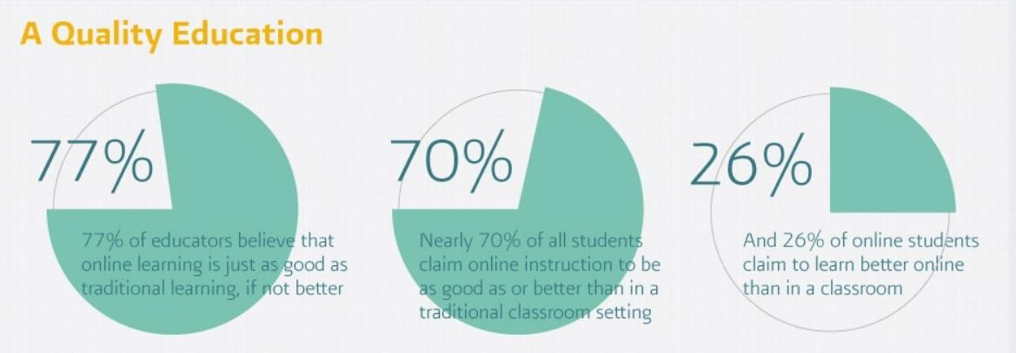

# Results and Discussions

Based on published research presented by University of the Potomac 77% of educators believe that online learning is just as good as traditional learning, if not better. Nearly 70% of all students claim online instruction to be as good as or better than in a traditional classroom setting. 26% of online students claim to learn better online than in a classroom.

A 5:1 ratio by which learners differ means that the slowest student takes 5 times as long to learn as the fastest student. 90% of these learners will successfully reach higher levels, but only if given enough attention.

# Online Learning vs Traditional Learning

These are the obvious differences between online learning and traditional learning platform.

|  |  |
| --- | --- |
| Online Learning | Traditional Learning |
| Data Connection Budget is a must. | Data Connection Budget is not necessary in attending traditional classes. |
| Students have hard time in asking questions because it might interrupt the instructor discussion. | Students may ask questions real time. |
| Anytime, anyplace as long as there’s good data connectivity. | Forced in a schedule and place. |
| Flexible in terms of synchronous online meeting with activities. | Imposed pace of daily attendance and lecture. |
| Supports an independent learning style. | Learning from and with each other. |
| The primary source of information is online content. | The primary source of information is the teacher/professor. |
| Limited interaction with classmates and the instructor. | Extensive interaction between instructor and classmates. |
| Daily dose of pending online activities. | Less number of activities given. |

Also, according to the study presented by University of the Potomac, the quality education differs in both educational learning platform. Student’s perception of online education survey yields these results; 77% of educators believe that [online learning](https://potomac.edu/how-to-succeed-in-online-classes/) is just as good as traditional learning, if not better. Nearly 70% of all students claim online instruction to be as good as or better than in a traditional classroom setting. 26% of online students claim to learn better online than in a classroom. In addition, survey result of online learners’ score on standardized test that there is a 5:1 ratio by which learners differ. A 5:1 ratio by which learners differ means that the slowest student takes 5 times as long to learn as the fastest student. 90% of these learners will

successfully reach higher levels, but only if given enough attention. Therefore, face-to-face instruction is the best approach to providing these levels of attention.

**Conclusion**

After gathering published works of other authors with similar research, it can be able to

convince the college department to identify which factors to improve on their educational platforms. Moreover, to present an effective educational learning platform for the benefits of the students, faculty and college department.

# Recommendations

This report does not stand the idea of online learning is more effective than traditional learning, or vice versa. It certainly depends on the learning topic and how its effectiveness has been measured. But overall, it all comes down to personal preference and knowing how you learn best. These [learning formats](http://www.rasmussen.edu/ways-to-learn/) can all be very effective, no matter your personal learning style and situation.

# References

Barinda De: Online learning vs. traditional learning. Retrieved November 2020, from

<https://bit.ly/2Iojjn7>

University of Potomac: Online learning vs. traditional learning. Retrieved November 2020, from <https://bit.ly/2Ul4yU7>

Caroline C. (July 2020): Online learning vs. traditional learning. Retrieved November 2020, from <https://bit.ly/3eVBwEn>

Will Erstad (August 2017): Online vs. Traditional Education: What You Need to Know. Retrieved November 2020, from <https://bit.ly/35pFNMR>

Akash Rawat (July 2020): How Online Education Bridges Learning Gaps. Retrieved November 2020, from <https://bit.ly/3f1AyGv>