Title: Norlin Walk

Who: Michael Tang, Dalton Morrow, Jeong Min Lee, Owen Wattenmaker, Adian Bohenick

Project Tracker:

* https://github.com/mita4829/Project3308/issues
* Project Tracker Screen Shot:

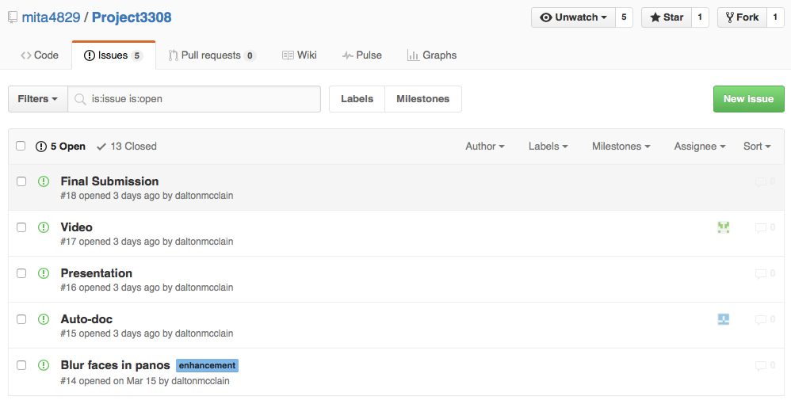

Project Video: <https://www.dropbox.com/s/d78rkchkz82e6cx/NorlinWalkVideo.mp4?dl=0>

VCS: https://github.com/mita4829/Project3308.git

Semester Contributions Screen Shot:

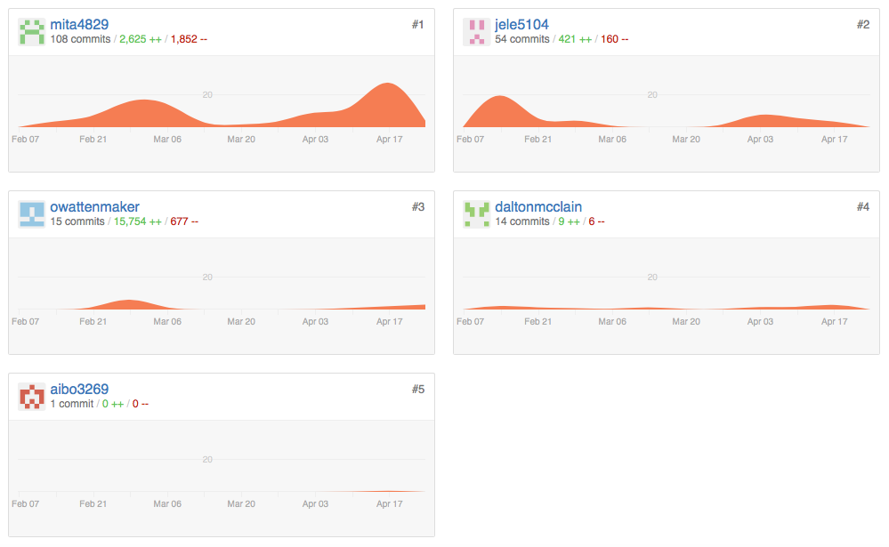

Deployment Environment: <http://norlinwalk.herokuapp.com>

Auto-Doc:

* Program: JSDoc
* <https://github.com/mita4829/Project3308/tree/master/JSDoc>