1. Starting the application

For the aplication you will need to install MongoDB, as it is used as the aplication database. Configure the connection string as "mongodb://localhost:27017". Open comand prompt and type mongosh to start the shell and then type use Internship which will create a database named Internship on your PC. Next enter the commans

db.Employees.insertOne({"FullName":"Jenna Pen","Email":"jennapen@yahoo.com","PhoneNumber":"887294819","DateOfBirth":"2000-03-03","MonthlySalary":1500,"CompletedTasks":0})

db.Tasks.insertOne({"Title":"Start","Description":"Firtst data update","Assignee":"640e58e8c191d1e7b3c9344b","DueDate":"2023-03-31","Status":"In progress"})

This will create the database and collections, as well as the data schema which will be used int the application.

Next, pull the repository from this GitHub link : <https://github.com/jelenas00/InternshipIPrime.git>

Open the folder and inside you will see a folder named Internship, open it with Visual Studio Code. Then pres CTRL+~ and type dotnet watch run. Start the index.html file with a Live Server. The following should be displayed:

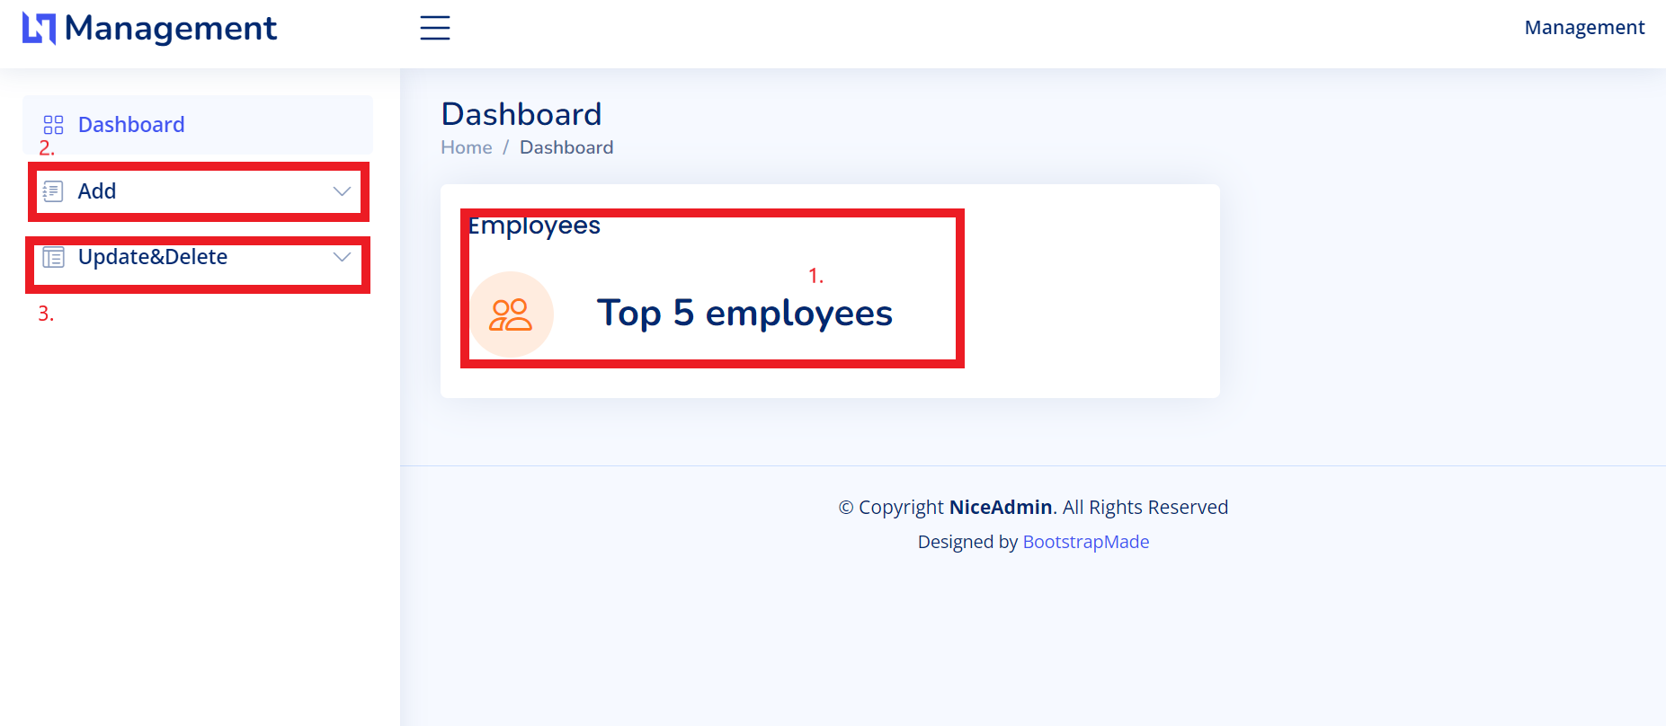

1. The top 5 employees should be displayed here once you add some data to the database, as well as the number of employees in the database.
2. Add menu has two options Add Employee in which you can add an employee and Add Task to add a task.
3. Update and deleta has two options for employees and task.

This bootstrap template is very intuitive and alows quick and easy adaptation and intuitive usage.

This application was made with .NET Core, MongoDB, JavaScript and a free Bootstrap template.

Mongo is used because of its flexibility. It allows the data and models to be independetly modified because Mongo stores data as documents so when changing the model, olda data won’t be changed and they can still exist in the form in which they were originaly saved.

The application logic is divided into 3 folders, Models, Services and Controllers.

Models folder contains 3 files, Employee and Tasks which are used for entities, and InternshipDatabaseSettings which stores information for database connectivitie.

Services folder contains 2 files EmployeeService and TaskService in which the functions for data maipulation are implemented and they use database instances to store and fetch data.

Controllers folder contains EmployeesController and TasksController which have CRUD operations for the web application.