**Program Execution, Screenshots, and Comments**

**Group Three: Coile, Eliceiri, and Wood-Norman**

**Comments**

The program utilizes an ArrayList to hold the collection of persons. While searching for a person, the Big O performance of the ArrayList function get (int index) is O(1), which is one of the main benefits of using ArrayList. While adding a person to this collection, the Big O performance of the ArrayList add function is O(1). These two features make the program very effecient when handling large data sizes.

*\* Please see the source code .java files for additional comments that provide further explanations for classes, methods, and variables*

**Sample Program Screenshots**

The following image is a screenshot of adding a person:

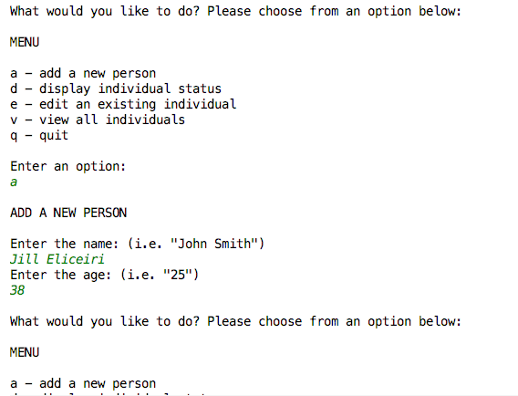

The following image displays a list view of all individuals, where sample data has already been added:

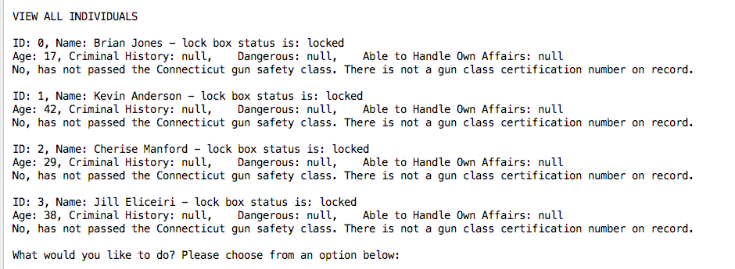

The following image displays editing a person:

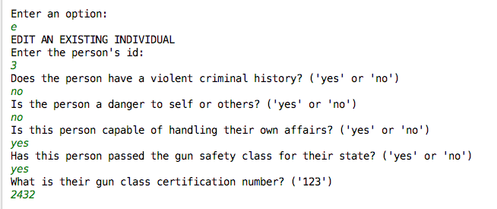

The following image displays a person’s status after all appropriate measures have been taken, and where the lock box is now unlocked.

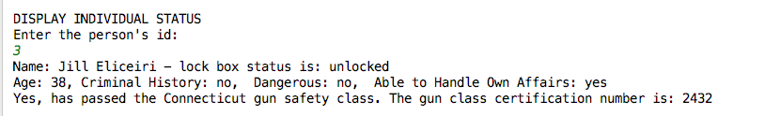

**Sample Program Execution**

Welcome to the digital gun lock box manager!  
  
What would you like to do? Please choose from an option below:   
  
MENU  
  
a - add a new person  
d - display individual status  
e - edit an existing individual  
v - view all individuals  
q - quit  
  
Enter an option:   
v  
  
VIEW ALL INDIVIDUALS  
  
ID: 0, Name: Brian Jones - lock box status is: locked  
Age: 17, Criminal History: null, Dangerous: null, Able to Handle Own Affairs: null  
No, has not passed the Connecticut gun safety class. There is not a gun class certification number on record.  
  
ID: 1, Name: Kevin Anderson - lock box status is: locked  
Age: 42, Criminal History: null, Dangerous: null, Able to Handle Own Affairs: null  
No, has not passed the Connecticut gun safety class. There is not a gun class certification number on record.  
  
ID: 2, Name: Cherise Manford - lock box status is: locked  
Age: 29, Criminal History: null, Dangerous: null, Able to Handle Own Affairs: null  
No, has not passed the Connecticut gun safety class. There is not a gun class certification number on record.  
  
What would you like to do? Please choose from an option below:   
  
MENU  
  
a - add a new person  
d - display individual status  
e - edit an existing individual  
v - view all individuals  
q - quit  
  
Enter an option:   
a  
  
ADD A NEW PERSON  
  
Enter the name: (i.e. "John Smith")  
Jill Eliceiri  
Enter the age: (i.e. "25")  
38  
  
What would you like to do? Please choose from an option below:   
  
MENU  
  
a - add a new person  
d - display individual status  
e - edit an existing individual  
v - view all individuals  
q - quit  
  
Enter an option:   
v  
  
VIEW ALL INDIVIDUALS  
  
ID: 0, Name: Brian Jones - lock box status is: locked  
Age: 17, Criminal History: null, Dangerous: null, Able to Handle Own Affairs: null  
No, has not passed the Connecticut gun safety class. There is not a gun class certification number on record.  
  
ID: 1, Name: Kevin Anderson - lock box status is: locked  
Age: 42, Criminal History: null, Dangerous: null, Able to Handle Own Affairs: null  
No, has not passed the Connecticut gun safety class. There is not a gun class certification number on record.  
  
ID: 2, Name: Cherise Manford - lock box status is: locked  
Age: 29, Criminal History: null, Dangerous: null, Able to Handle Own Affairs: null  
No, has not passed the Connecticut gun safety class. There is not a gun class certification number on record.  
  
ID: 3, Name: Jill Eliceiri - lock box status is: locked  
Age: 38, Criminal History: null, Dangerous: null, Able to Handle Own Affairs: null  
No, has not passed the Connecticut gun safety class. There is not a gun class certification number on record.  
  
What would you like to do? Please choose from an option below:   
  
MENU  
  
a - add a new person  
d - display individual status  
e - edit an existing individual  
v - view all individuals  
q - quit  
  
Enter an option:   
e  
EDIT AN EXISTING INDIVIDUAL  
Enter the person's id:   
3  
Does the person have a violent criminal history? ('yes' or 'no')  
no  
Is the person a danger to self or others? ('yes' or 'no')  
no  
Is this person capable of handling their own affairs? ('yes' or 'no')  
yes  
Has this person passed the gun safety class for their state? ('yes' or 'no')  
yes  
What is their gun class certification number? ('123')  
2432  
  
What would you like to do? Please choose from an option below:   
  
MENU  
  
a - add a new person  
d - display individual status  
e - edit an existing individual  
v - view all individuals  
q - quit  
  
Enter an option:   
d  
  
DISPLAY INDIVIDUAL STATUS  
Enter the person's id:   
3  
Name: Jill Eliceiri - lock box status is: unlocked  
Age: 38, Criminal History: no, Dangerous: no, Able to Handle Own Affairs: yes  
Yes, has passed the Connecticut gun safety class. The gun class certification number is: 2432  
  
What would you like to do? Please choose from an option below:   
  
MENU  
  
a - add a new person  
d - display individual status  
e - edit an existing individual  
v - view all individuals  
q - quit  
  
Enter an option:   
v  
  
VIEW ALL INDIVIDUALS  
  
ID: 0, Name: Brian Jones - lock box status is: locked  
Age: 17, Criminal History: null, Dangerous: null, Able to Handle Own Affairs: null  
No, has not passed the Connecticut gun safety class. There is not a gun class certification number on record.  
  
ID: 1, Name: Kevin Anderson - lock box status is: locked  
Age: 42, Criminal History: null, Dangerous: null, Able to Handle Own Affairs: null  
No, has not passed the Connecticut gun safety class. There is not a gun class certification number on record.  
  
ID: 2, Name: Cherise Manford - lock box status is: locked  
Age: 29, Criminal History: null, Dangerous: null, Able to Handle Own Affairs: null  
No, has not passed the Connecticut gun safety class. There is not a gun class certification number on record.  
  
ID: 3, Name: Jill Eliceiri - lock box status is: unlocked  
Age: 38, Criminal History: no, Dangerous: no, Able to Handle Own Affairs: yes  
Yes, has passed the Connecticut gun safety class. The gun class certification number is: 2432  
  
What would you like to do? Please choose from an option below:   
  
MENU  
  
a - add a new person  
d - display individual status  
e - edit an existing individual  
v - view all individuals  
q - quit  
  
Enter an option: