624HW3

Joseph Elikishvili

September 16, 2017

# 624 HW3 HA6 Ex 6.2

### a. Plot the time series of sales of product A. Can you identify seasonal fluctuations and/or a trend?

plot(plastics)

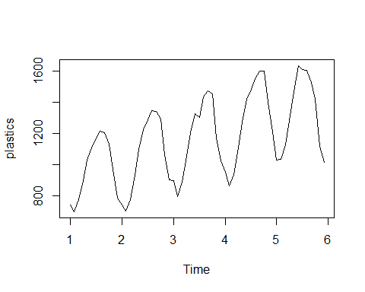

There appears to be an upward trend and seasonal fluctuations are clearly visible on the chart.

### b. Use a classical multiplicative decomposition to calculate the trend-cycle and seasonal indices.

fit <- decompose(plastics, type="multiplicative")  
plot(fit)

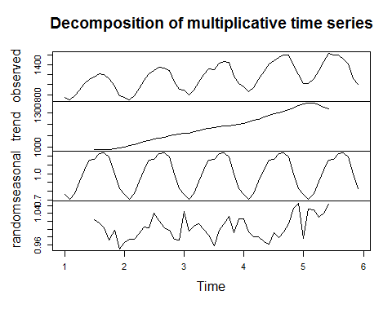

### c. Do the results support the graphical interpretation from part (a)?

Yes they do. There is an uptrend present and seasonality is also present just like we observed in part A.

### d. Compute and plot the seasonally adjusted data.

season = seasadj(fit)  
plot(season)

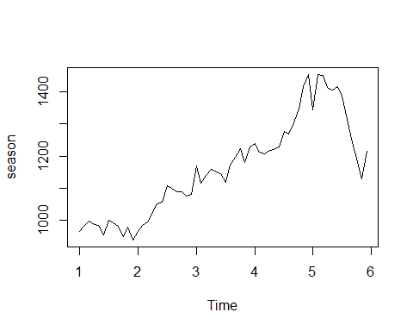

### E. Change one observation to be an outlier (e.g., add 500 to one observation), and recompute the seasonally adjusted data. What is the effect of the outlier?

p1 = plastics  
p1[50] = p1[50] + 500  
fit_p1 = decompose(p1, type="multiplicative")  
p1_s = seasadj(fit_p1)  
plot(p1_s)

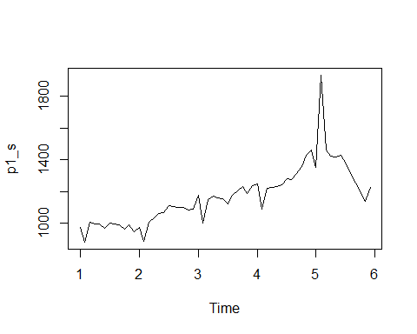

### F. Does it make any difference if the outlier is near the end rather than in the middle of the time series?

p2 = plastics  
p2[30] = p2[30] + 500  
fit_p2 = decompose(p2, type="multiplicative")  
p2_s = seasadj(fit_p2)  
plot(p2_s)

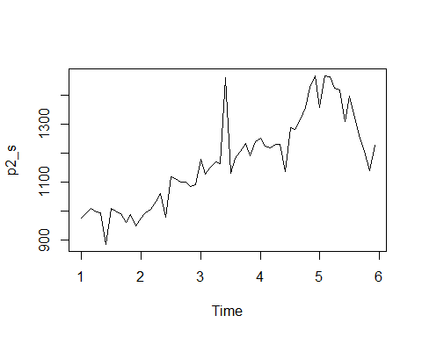

The outlier in the end seems to be affecting the data more then then outlier in the middle.

### G. Use a random walk with drift to produce forecasts of the seasonally adjusted data.

fit <- stl(plastics, t.window=15, s.window="periodic", robust=TRUE)  
eeadj <- seasadj(fit)  
plot(naive(eeadj),  
 main="Naive forecasts of seasonally adjusted data")

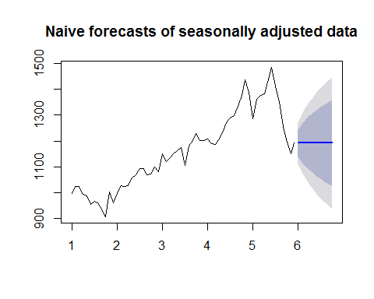

### H. Reseasonalize the results to give forecasts on the original scale.

fcast <- forecast(fit, method="naive")  
plot(fcast, ylab="New orders index")

